

Bindery Management System

NASTech, Inc.

User
Guide

Version 6.00
The software described in this document is furnished under a license agreement or nondisclosure agreement. The software may be used or copied only in accordance with the terms of the agreement. It is against the law to copy the software on any medium except as specifically allowed in the license or nondisclosure agreement. No part of this manual may be reproduced or transmitted in any form or by any means, electronic or mechanical, including photocopying and recording for any purpose without the express written permission of NASTech.

NASTech, Inc. reserves the right to make changes to this document and the software described herein at any time and without notice.

Copyright © 2001 - 2008 NASTech, Inc. All Rights Reserved.

NASTech, Inc.
2201 Long Prairie Rd.
Suite 107-338
Flower Mound, TX 75022
(888) 9-NASTECH

IBM is a registered trademark of International Business Machines Corporation.
Microsoft, MS, and MS-DOS are registered trademarks of Microsoft Corporation.
Pentium is a registered trademark of Intel Corporation.
NI-DAQ is a trademark of National Instruments, Inc.
Windows is a trademark of Microsoft Corporation.
Table of Contents

Chapter 1 Introduction 1
Overview 2
System Features 3
Basic Measurements 3
Statistics 3
Events Recorded 3
Chapter 2 Hardware Installation 1
NASTech Supplied Devices 1
Customer Supplied Devices 2
Electrical Outlets 3
Input Signals 4
Gross books 4
Net Books 4
Load Tickets 4
Output Signals 5
Install Bindery Computer Devices 6
System Cabling 7
Chapter 3 Software Installation 1
NASTech Supplied Software 1
Customer Supplied Software 1
Initial Installation 2
Server Installation 2
Server Configuration 3
Server SQL Setup 4
Bindery Installation 5
Bindery SQL Setup 5
Start B-DAQ 6
Client Installation 7
Client SQL Setup 7
Start BDAQ Client 8
Software Updates 9
Manual Updates 9
Automatic Updates 10
Initialization File 11
Constants Section 11
Database Section 14
Shop-Floor Interface 14
Messages Section 18
Edit Section 19
Label Section 20
Config Data 21
Chapter 4 Bindery Module 1
Main Screen 1
Job Information Panel 2
New Job Button 2
New Version Button 4
Configure Button 5
Status Folder 6
Operator Section 8
Center Section 9
Operations Section 10
Count Adjust 12
Pallet Maintenance 13
Machine Stops 14
Reason Codes 15
Multiple-Stop 16
Chapter 5 Scheduling Module 1
Detail Screen 1
Menu Options 2
Job / Version Folder 3
Configuration Folder 4
Summary Screen 6
Menu Options 6
Chapter 6 Machine Status Module 1
Summary Screen 1
Detail Screen 2
Chapter 7 Management / Reporting Module 1
Overview 1
System Logs 3
Shift Log 3
Speed Log 4
Pallet Log 5
Job Statistics 6
Job Statistics Report 6
Machine Statistics 11
Production Detail by Machine 11
Production Analysis Report 14
Bindery Statistics Report (Weekly) 16
Bindery Statistics Report (Monthly) 18
Net Production Report 20
Stop Analysis Report 21
Machine Run Chart 22
Chapter 8 Utilities 1
Overview 1
P-Maint 1
DataComp 6
DataCopy 7
DataDump 8
DataLoad 9
DataPurg 10
DataSync 11
P-Check 12
Appendix A Hardware Devices 1
EP-210 1
Modular Cables 3
Proximity Sensors 5
Appendix B Glossary of Terms 1

Chapter 1 Introduction
The NASTech Bindery Data Acquisition system (B-DAQ) performs real-time data acquisition using advanced electronic monitoring techniques.

B-DAQ is comprehensive system designed to provide management at all levels with the information needed to ensure maximum bindery efficiency.

B-DAQ supports all aspects of bindery management including bindery productivity, performance, and accurate skid counts. A real-time machine status module increases efficiency in many areas outside the bindery as well.

Many years of experience have gone into the design and development of this system. Simplicity, flexibility and high availability were the main criteria under which the software was developed. The system utilizes all the latest technology to provide a sound and long-term solution for your business.

We at NASTech are committed to designing and developing the highest quality software possible and are confident that you will enjoy working with B-DAQ. We look forward to working with you and wish you every success in the future.

Visit our web site at www.nastechinc.com for current news and updates.

Overview
B-DAQ consists of four primary modules, all operating together to provide the highest level of real-time data possible without compromising the fail-safe requirements of the system. Using our unique Bi-directional Data Synchronization Technology, (BDST), the local and remote databases are continuously synchronized.
- The Bindery Module collects real-time data from each machine. The operator records labor and down-time reason codes.
- The Scheduling Module is used to define the requirements of the jobs prior to going to the bindery. Data may be provided automatically via an automated scheduling system if present.
- The Machine Status Module is used throughout the company to view real-time bindery status information.
- The Management / Reporting Module is used to define the various master files used by the system and to produce the various charts and reports necessary to track and measure bindery performance.

The File Server contains databases common to all modules. The Management computer may be used as the server on small Peer-to-Peer networks.

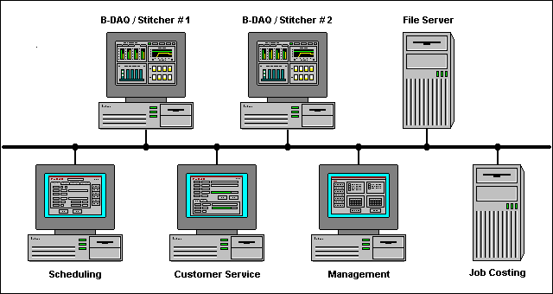

System Features
- Utilizes standard PC computer hardware
- Microsoft Windows-NT/2000/XP graphical interface
- Touch-screen technology
- Client / Server technology

Basic Measurements
- Machine speed
- Gross count
- Good count
- Good count by pallet

Statistics
(Maintained by machine, by date, by shift, by job, and by version)
- Makeready I time
- Makeready II time + gross count
- Run time + gross count
- Down time (by reason code)
- Number of unscheduled stops
- Good count by version

Events Recorded
- Shift change
- Version started
- Makeready I started
- Makeready II started
- Run started
- Machine stopped
- Machine re-started
- Machine speed change
- Pallet complete (Ticket printed)
- Count complete
- Clean-Up
- Version complete

Chapter 2 Hardware Installation
Hardware components necessary for data acquisition are provided and vary depending on the actual machine configuration and the features to be implemented.

NASTech Supplied Devices
NASTech is responsible for providing the following hardware devices when applicable:
- B-DAQ Console (Optional) for each machine, pre-installed with the following:
- ELO Touch Screen Monitor.
- APC UPS Battery Backup System.
- B-DAQ Press Interface Module.
- National Instruments Data Acquisition Card(s).
- Various cables as outlined on the System Cabling page of this guide. (Chapter 2 - Page 7)

Customer Supplied Devices
B-DAQ utilizes standard PC hardware. Since the machine is being monitored in real-time, the faster the machine the faster the computer should be.
The customer is responsible for providing the following hardware devices:
- Server computer
- Windows NT, Windows 2000, or Windows XP.
- At Least a 450 MHz CPU, 40GB HD, 128MB RAM.
- SVGA Video Card, Network Interface Card.
- CD-ROM Drive, Floppy Drive.
- Data Back-Up device.
- Bindery Computers:
- Windows NT, Windows 2000, or Windows XP.
- At Least a 450 MHz CPU, 20GB HD, 128MB RAM.
- SVGA Video Card, Network Interface Card.
- CD-ROM Drive, Floppy Drive (Optional).
- 2 Serial Ports, 1 Parallel Port.
- Stack Lights.
- Sensors, Buttons, Switches and associated Electrical wiring.
- Laser Printer for Pallet Load Tickets and for Stock Tags as needed. (HP LaserJet 2300n - recommended)
- Parallel line drivers when used as local printer and printer exceeds recommended distance from computer.
- Various cables as outlined on the System Cabling page of this guide. (Chapter 2 - Page 7)

Electrical Outlets
- The customer is responsible for providing power to the system.
- The B-DAQ Press Interface Module is mounted on a swing out frame providing access to the back of the computer, keep this in mind when routing the wiring and when Installing AC power outlets in the B-DAQ Console.
- AC power outlets must be installed, knockouts in the B-DAQ console are provided to accommodate conduit. 4 AC outlets are recommended.
- AC power outlets are required for the Laser Printer.

Input Signals

The customer is responsible for providing all input Sensor, PLC, and Control connections between the press and the B-DAQ Bindery Interface Module. (Note: All input wiring should be shielded to prevent noise)

The input signals to be used vary depending on the configuration of the Machine and the features of B-DAQ to be utilized. This section outlines the available options, and explains some common installation procedures. Upon installation, more detailed instructions and the necessary wiring diagrams will be provided.

Gross books
- Gross Count - An inductive proximity sensor, which monitors revolutions of the machine. This signal is used to count gross books produced and to derive machine speed.

Net Books
- Good Count - An electric eye, or laser used to indicate that good books have been produced.

Load Tickets
- End of Load – A button (momentary contact) to indicate that the pallet is complete.

Output Signals
The customer is responsible for providing all output Sensor, PLC, and Control connections between the B-DAQ Press Interface Module and the press. (Note: All wiring should be shielded to prevent noise)

The output signals to be used vary depending on the configuration of the machine and the features of B-DAQ to be utilized. This section outlines the available options, and explains some common installation procedures. Upon installation, more detailed instructions and the necessary wiring diagrams will be provided.

Output signals may be used to control any external function such as lighting an indicator, sounding an alarm, initiating a machine shutdown sequence, etc… In order to utilize these signals, a relay will be provided and the external device must be wired accordingly.

The available output signals are as follows:
- Waste - Waste being accumulated (red stack light).
- Count Complete - Count Complete (white stack light).
- Shutdown Machine - Count & overrun complete (Optional).

The output signals can be set to behave as follows:
- Remain on while condition exists.
- Alternate on and off at a specified rate.
- Turn on for a specified time and then turn off.
- Trigger other output signals.

Install Bindery Computer Devices
- Install the network interface card. Refer to manufacturer’s documentation for details.
- Install the Data Acquisition Card(s), the “Measurement and Automation” software and configure. Refer to National Instrument’s documentation for more details.
- Install the ELO Touch monitor software and configure. The monitor should be configured to use Serial Port 1. Refer to ELO’s documentation for more details.
- Install the Laser Printer and software drivers. Refer to the Manufacturer’s documentation for details.
- Connect the UPS to Serial Port 2.

System Cabling
The following diagram illustrates the basic cabling requirements of the bindery management system.

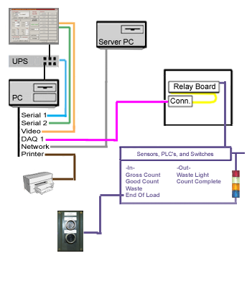
Electrical Wiring, supplied by user.
Video Cable, M14 to M14 supplied by manufacturer.
Serial Cable, F9 to M9 supplied by manufacturer.
Serial Cable, F9 to M9 supplied by manufacturer.
Ribbon Cable, F68 to F68 supplied by NASTech.
CAT5 Cables (straight through), supplied by user.
Parallel Printer Cable supplied by manufacturer.
Parallel Line Drivers supplied by user (Optional).

Chapter 3 Software Installation

NASTech Supplied Software
NASTech is responsible for providing the following software:
- National Instruments Measurement and Automation Software.
- ELO Touch Tools Software. (Optional)
- APC Power Chute Software. (Optional)
- B-DAQ Installation CDROM.

Customer Supplied Software
The customer is responsible for providing the following software:
- Server computer
- Windows NT, Windows 2000, or Windows XP.
- Microsoft Access.
- Microsoft SQL Server. (Optional)

- Bindery Computers:
- Windows NT, Windows 2000, or Windows XP

Initial Installation
B-DAQ is installed onto your hard disk (drive C) using a special installation program. The contents of the installation CD may be copied to your file server to simplify the installation for multiple machines. This must be done if a CD-ROM drive is not available on the B-DAQ bindery computer(s). The B-DAQ directory on the file server into which the system is installed must have read/write access from each of the client computers.

Server Installation
- Set Control Panel \ Regional Settings \ Short Date to “MM/dd/yy” and enter the correct date.
- Set Control Panel \ Regional Settings \ Time to “HH:mm:ss” and enter the correct time.
- Insert the installation CD in the CD-ROM drive.
- Locate the B-DAQ-Server installation directory on the CD.
- Execute Setup.exe and follow the directions on the screen to set up B-DAQ.
- Select the location for the B-DAQ directory and Finish the installation.
- Note: After Installation, you may be prompted to restart the server as various DLL and OCX files may need to be registered in Windows. You may continue the installation and schedule this restart at a more convenient time if necessary.
- Copy the directories from the CD to the BDAQ\Install directory
- Copy the “B-###” directories from the Floppy Disk, to the BDAQ directory.
- Install SQL Database Software. Refer to Microsoft’s documentation for more information (Only if you will be using SQL databases).

Server Configuration
- Open the “System.ini” file located in the C:\BDAQ\Shared directory. Edit and save the file as follows:
- Init Path = "Init"
- Local Base Path = "\BDAQ"
- Network Base Path = "YourServer\BDAQ”
- ‘ DBTYPE = "SQL" (If you are using a SQL server Database, remove the ‘ (apostrophe) at the beginning of the line.
- Edit Security.ini in the PDAQ\Shared\Init directory. This will allow users to have read/write access to various programs. For example:
- [B-Sched]
- Default = "Read"
- Administrator = "Update"
- JOHN SMITH = “Update”
- Edit DataPurge.ini in the BDAQ\Shared\Init directory. DataPurge.exe allows redundant data to be deleted from the server. The entries made to this file should be specified in military time, a short period of time right after the scheduled network backup. The “DataPurge.exe” file may be left running on the server at all times, or you may schedule the task using Windows Scheduler to perform the purge on a weekly or monthly basis. For example:
- BegPurgeTime = 05:00
- EndPurgeTime = 06:00
- Edit DataSync.ini in the BDAQ\Shared\InitMachine directory. “DataSync.exe” automatically transfers data to and from each press computer and the server. While this is a necessary function of the system, data should not be transferred while the server is performing its scheduled backup. The entries made to this file should be specified in military time, as a window of time at which the network backup occurs. For example, if the network backup begins at 2AM:
- Beg Save Time = 01:00
- End Save Time = 04:00
- Run P-Maint.exe from the BDAQ\Shared directory and update the Following Tables. These tables may be set up by NASTech personnel prior to installation. (For more help on running P-Maint, refer to the Utilities section of this guide):
- Press
- Cost Center
- OperCode
- Form Type
- Pallet Type

Server SQL Setup
- (Skip this section if you are not running SQL server).
- Install Microsoft SQL Server on B-DAQ Server.
- Execute “Start…Programs…Microsoft SQL Server…Query Analyzer”.
- Open “BDAQ\Shared\Database\BDAQ6.SQL.
- Execute SQL script to create BDAQ database(s).
- Set permissions for B-DAQ press and client computers.
- Execute “Start…Programs…Microsoft SQL Server…Import and Export Data”.
- Select Source = Microsoft Access = “BDAQ\Shared\Database\Remote.mdb”.
- Select Destination = “BDAQ” database.
- Select ALL tables. Un-select ALL Queries.
- Continue with import.
- Execute “Start…Programs…Microsoft SQL Server…Import and Export Data”.
- Select Source = Microsoft Access = “BDAQ\Shared\Database\Stats.mdb”.
- Select Destination = “BDAQ” database.
- Select ALL tables. Un-select ALL Queries.
- Continue with import.

Bindery Installation
- Set Control Panel \ Regional Settings \ Date to “MM/dd/yy” and enter the correct date.
- Set Control Panel \ Regional Settings \ Time to “HH:mm:ss” and enter the correct Date & Time.
- Execute “Setup.exe” from the BDAQ/Install/BDAQ-Machine directory on the file server, or from the BDAQ-Machine directory on the CD.
- Follow the directions on the screen to set up B-DAQ. Install the software in the C:/Program Files directory, and finish the installation.
- Open the “System.ini” file located in the C:/Program Files/BDAQ directory. Edit and save the file as follows:
- Init Path = "Init"
- Local Base Path = "C:\Program Files\PDAQ"
- Network Base Path = "YourServer\PDAQ"
- ‘ DBTYPE = "SQL" (If you are using a SQL server Database, remove the ‘ (apostrophe) at the beginning of the line.

Bindery SQL Setup
- Create ODBC Data Source Name (DSN) called BDAQ for new BDAQ SQL Server database.
- Start - Settings - Control Panel - Administrative Tools - Data Sources - ODBC. Click “Add”. Select SQL Server, Click “Finish”.
- Name the database (BDAQ), and select the NASTech Server.
- NT or SQL authentication? It is recommended that NT authentication is used. If so, the NT password setup on the computer will allow access to the SQL database.
- NT or SQL authentication? If SQL authentication is used, the following lines of code MUST be added to the C:/ProgramFiles/BDAQ/System.ini file:
- DB Name = BDAQ
- Database = BDAQ
- User Name = your computer’s User Name
- Password = your SQL Password
- Click “Change Default DB to”, Select BDAQ Database, Click Next.

Start B-DAQ
- Go to Start Menu → Programs → BDAQ-Press Module → SysUpd, right-click the SysUpd icon and select Properties. Edit and save the shortcut as follows:
- Target: YourServer/BDAQ/Shared/SysUpd.exe
- Start In: C:/Program Files/BDAQ/
- Run Start Menu → Programs → BDAQ-Machine Module → SysUpd and click the Update button.
- Run DataSync from the Desktop and click the Continue button.
- Data Sync will now transfer data from the server and populate the Remote database at the press. Please allow a few minutes for this process to take place.
- Start B-DAQ, when prompted; enter the pallet ID format. NASTech personnel will provide a list of pallet ID numbers prior to installation. You may also find the load ticket format in the associated Pressman.ini file located in the C:\Program Files\ BDAQ\Init directory.
- If you are using a check digit on your Load Tickets enter the prefix letter followed by 7 zeros. If you are not using a check digit, enter the letter prefix followed by 6 zeros.

Client Installation
- Execute “Setup.exe” from the BDAQ/Install/PDAQ-Client directory on the file server, or from the BDAQ-Client directory on the CD.
- Follow the directions on the screen to set up B-DAQ. Install the software in the C:/Program Files directory.
- Open the “System.ini” file located in the C:/Program Files/BDAQ directory. Edit and save the file as follows:
- Init Path = "Init"
- Local Base Path = "C:\Program Files\BDAQ"
- Network Base Path = "YourServer\BDAQ"
- ‘ DBTYPE = "SQL" (If you are using a SQL server Database, remove the ‘ (apostrophe) at the beginning of the line.

Client SQL Setup
- Create ODBC Data Source Name (DSN) called BDAQ for new BDAQ SQL Server database.
- Start - Settings - Control Panel - Administrative Tools - Data Sources - ODBC
- Click “Add”. Select SQL Server, Click “Finish”.
- Name database (BDAQ), and select NASTech Server.
- NT or SQL authentication? It is recommended that NT authentication is used. If so, the NT password setup on the computer will allow access to the SQL database.
- NT or SQL authentication? If SQL authentication is used, the following lines of code MUST be added to the C:/ProgramFiles/BDAQ-Client/System.ini file:
- DB Name = BDAQ
- Database = BDAQ
- User Name = your computer’s User Name
- Password = your SQL Password
- Click “Change Default DB to”, Select BDAQ Database, Click Next.

Start BDAQ Client
- Go to Start Menu → Programs → BDAQ-Client Module → SysUpd, right-click the SysUpd icon and select Properties. Edit and save the shortcut as follows:
- Target: YourServer/BDAQ/Shared/SysUpd.exe
- Start In: C:/Program Files/BDAQ/
- Run Start Menu → Programs → BDAQ-Client Module → SysUpd and click the Update button.
- Start B-Sched, B-Status, and P-Admin, from Start Menu → Programs → BDAQ-Client

Software Updates
Customers will be notified by email when software updates are available for download. It is recommended that you update the software within a reasonable time frame as to avoid redundant support issues.

Our website BDAQ support page (www.nastechinc.com) always contains the latest updates, as well as version specific information relating to each updated program. Check our support pages periodically for additional information.

Manual Updates
Manual Updates to the software are handled as follows:
- Delete all files from the BDAQ/Shared/SoftwareUpdate directory.
- Download and save the .zip file to the BDAQ/Shared/SoftwareUpdate directory.
- Unzip the downloaded file and save its contents to the BDAQ/Shared/SoftwareUpdate directory.
- If Install.exe is now in the SoftwareUpdate directory, move it to the Shared directory and overwrite.
- Updates can be installed on a machine by machine basis for testing purposes. To do so, edit and save the
Update.ini file located in the BDAQ/Shared/Init directory to include the cost center number(s) to receive the update, for example:
  - Update = 345
  - Update = 456
  - Update = All (Change back to this when testing is complete, to update all presses)
- Run Install.exe from the BDAQ/Shared directory, click the Update button, and wait for completion.
- Run DataComp.exe from the BDAQ/Shared directory, and click the Continue button. If database
field mismatches are present...
  - With SQL: Run the included Update.SQL script in SQL Query Analyser, and run DataCopy.exe
from the Start Menu at EACH press between forms.
  - Without SQL: Run DataCopy.exe from the BDAQ/Shared directory on the server, and from the
Start Menu at EACH press between forms.
- The updated files will be transferred to each client computer automatically between sessions, and to each associated bindery computer between forms.

Automatic Updates
Automatic software updates from our FTP site are handled as follows:

- Execute the NASTechFTP program from the BDAQ\Shared directory on the server. The updates will be downloaded to the server and the new files will be transferred automatically to each press/client computer.

- Allowing the NASTechFTP program to be continually running on the server ensures the latest versions of the software will be installed automatically as they become available.

- Automatic updates may be restricted to specified days of the week and at specified times during the day via the NASTechFTP.ini file located in the BDAQ\Shared\Init directory on the server.

- Using Windows “Scheduled Tasks”, you may schedule the NASTechFTP program to run at the specified time(s). The following is the procedure to set up the task:

- Choose Start\ControlPanel\SheduledTasks.
- Click “Add Scheduled Task”.
- Click “Next”.
- Click the “Browse” button and browse the server to the BDAQ\Shared directory and select NASTechFTP.exe.
- Follow the instructions to select the time and enter the user name and password when prompted if necessary.
- Check the box marked “Open Advanced Properties for this Task when I click Finish” button and click the Finish button.
- In the Run field, change the path to read exactly as in the following: C:\BDAQ\Shared\NASTechFTP.exe AUTO
- In the Start In field, make sure the path is as following: C:\BDAQ\Shared

Initialization File
After installing B-DAQ, the Bindery.ini text file contains default values for your configuration. The parameters are divided into multiple sections as described below. Entries may be added or modified as required. Upper and lower case may be used as desired with additional spacing for readability since all characters are converted to lower case and imbedded spaces are discarded prior to evaluation.

Constants Section
Parameter | Default | Description
Application |  | “B-DAQ”
Auto Lift Gen | No | Causes the system to force an end of “Carton” when the number of books specified by the “Books / Carton” parameter on the Config panel has been delivered to the pallet.  Example: AutoLiftGen = Yes
Auto Ticket Gen | No | Causes the system to force an end of pallet when the number of Cartons specified by the “Cartons / Pal” parameter on the Config panel has been delivered to the pallet.  Example: AutoTicketGen = Yes
Cost Center | ??? | Cost center ID.  Example: Cost Center = “451”
Cost Center Desc | ??? | Type and model of machine.  Example: Cost Center Desc = “Harris 330”
Cutoff Speed | 3000 | This is the minimum speed (Books/HR) which must be reached by the machine in order to be considered running by B-DAQ.  Example: Cutoff Speed = 4000
Default MR1 Code  Default MR2 Code  Default Run Code  Default Clean-Up Code  Default Idle Code |  | B-DAQ needs to know the operation codes to use when passing information on to job costing. These entries define the default codes to be used.  Example: Default MR1 Code = “1234” | **
Emp Overlap Code |  | B-DAQ needs to know the non-chargeable operation code to use for shift overlap when passing information on to job costing. This is done to prevent double charging job.  Example: Emp Overlap Code = “8001” | **
Enable Minimize | No | Allows the B-DAQ screen to be minimized when the B-DAQ logo is clicked.  Example: Enable Minimize = Yes
Force Shift | 0 | Allows all Labor transactions to be sent to cost accounting with the specified shift number.  Example: Force Shift = 1
Hide Job Status | No | Hides the Job Status folder on the left center of the mainscreen.  Example: Hide Job Status = Yes
Job Sched Desc | C | B-DAQ normally displays the customer name to identify scheduled jobs. This parameter can be used to display the (J)ob or (V)ersion description instead.  Example: Job Sched Desc = “V” | **
Job Sched Present | No | Allows the jobs to be selected via the B-DAQ Scheduling Module instead of Shop Floor.  Job Sched Present = Yes
Job Sched Sort | S | How the order of jobs is displayed when you enter the new job screen.  (S)equence, (J)ob  Example: Job Sched Sort = J
Load Ticket Copies | 0 | Specifies the number of Load Tickets to be printed for completed pallets.  Example: Load Ticket Copies = 2 | **
Machine Type | P | Designates the type of machine used by the system.  (Stitcher, Perfect Binder, Other)  Example: Machine Type = Stitcher
Maintenance Log Interval | 0 | The number of seconds between updates to the Maintenance Log. This log is used to record the total number of machine cycles counted since B-DAQ was installed.  Example: Maintenance Log Interval = 120
Oper Display Type | Valid | Used to indicate weather only he valid operation code buttons or all operation code buttons are displayed.  (All, Valid)  Example Oper Display Type = All
Pocket Count | 25 | Represents the number of available pockets on the gatherer or stitcher.  Example: Pocket Count = 32
Quality Count Constant | 2 | Used to specify the number of books produced for quality control. This is the number to be used for ALL jobs.  Example: Quality Count Constant = 4
Rated Speed | 10000 | The rated speed of the machine. This entry is not used for any internal calculations.  Example: Rated Speed = 9000
Sched Cost Centers |  | B-DAQ displays the job scheduled on all available machines when selecting a job to run. To limit the cost centers displayed, the cost centers desired may be specified separated by commas.  Example: Sched Cost Centers = “451,452” | **
Scheduling System |  | This entry is used for passing job related information to scheduling systems such as:  (Primac)  Example: Scheduling System = Primac
Shift Time-1  Shift Time-2  Shift Time-3 |  | Specifies the start time for shift 1, 2 and 3. At least 2 shifts must be defined and the elapsed time for each shift must be the same.  Example: ShiftTime-1 = 07:00  ShiftTime-2 = 15:00  ShiftTime-3 = 23:00
Shift Detail Desc | C | Used to specify the format used for the shift detail report.  (C)ustomer,(J)ob,(V)ersion.  Example: Shift Detail Desc = J
Show Config Panel | No | Used to enable the “Config” Panel on the right side of the screen when multiple trimmers are used by the associated machine.  Example: Show Config Panel = Yes
Show Perform Panel | No | Used to enable the “Perform” Panel on the right side of the screen.  Example: Show Perform Panel = Yes
Speed Timer Interval | 100 | The interval in milliseconds at which to read the hardware counters. Entries less than 100 should not be used on computers running at less than 400 megahertz. Valid intervals are 10 to 1000 inclusive.  Example: Speed Timer Interval = 250
Start Pallet ID |  | This entry is required and should have a unique alphabetic prefix for each machine followed by 6 digits. An “x” suffix may be defined to request the system to generate a mod-10 check-digit.  Example: Start Pallet ID = “C000000x”
Stop Minimum Time | 0 | Specifies the amount of elapsed time (seconds) needed to consider the machine down.  Example: Stop Minimum Time = 120
Trimmer Count | 1 | Specifies the number of trimmers.  Example: Trimmer Count = 2
Warn Count Complete |  | Not Used

Database Section
Parameter | Default | Description
Base Path |  | Specifies the location of the Local Executable.
Data Path 1 |  | Specifies the location and name of the B-DAQ working database.  Example: Data Path 1=”Bindery.mdb”
Data Path 2 |  | Specifies the location and name of the Master File and Scheduler database.  Example: Data Path 1=”Remote.mdb”
Data Path 3 |  | Specifies the location and name of the Statistical database.  Example: Data Path 1=”Stats.mdb”

Shop-Floor Interface
Parameter | Default | Description
Auto Shift Report | No | Enables the automatic viewing of the Shift Detail report when signing off. (Yes, No)  Example: Auto Shift Report = Yes
Auto Start Tran | No | If reporting labor, this entry specifies whether or not to send “Operation Started” transactions to the NASTech shop-floor data collection system.
Company |  | The company identifier to be used when reporting activity to the Job Costing system.  Example: Company = “001”
Department |  | The department identifier to be used when reporting activity to the Job Costing system.  Example: Company = “04”
Division |  | The division identifier to be used when reporting activity to the Job Costing system.  Example: Division = “02”
Info Button Font Color | Black | Used to set the default color for buttons located in the Operations section.  (Black, Red, Yellow)  Example: Info Button Font Color = Red
Info Button Font Size | 10 | Used to set the default font size for buttons located in the Operations section.  Example: Info Button Font Size = 8
Labor | no | Specifies whether or not to pass Job Costing & Labor data to the NASTech shop-floor data collection system. Also, the EmpLog table is used to record each employee’s activity for the shift. This parameter can also be used to force or warn the operator if the make-ready and run operation codes are not specified.  Example: Labor = yes, force  Labor = yes, warn
Labor Minimum Time | 0 | The minimum number of seconds that the machine must be down before reporting the fault to the Job Costing system.  Example: Labor Minimum Time = 120
Manual Shift Report | Yes | Enables the “Report” button on the operator section. (Yes, No)  Example: Manual Shift Report = No
Non-Charge Job Number | no | Causes a job number to be associated with non-chargeable transactions. If the parameter is “no”, the job number, form ID, etc are left blank.  Example: Non-Charge Job Number = yes
Oper Button Font Color | Black | Used to indicate the color used for the operation code buttons.(Black, Red, Yellow)  Example: Oper Button Font Color = Red
Oper Button Font Size |  | Used to indicate the Font Size used for the operation code buttons.
Oper Display Type | Valid | Used to indicate weather only he valid operation code buttons or all operation code buttons are displayed.  (All, Valid)  Example Oper Display Type = All
Port | 0 | Specifies the PC serial port to be connected to the NASTech shop-floor data collection system.
Report Idle Time |  | Not Used at this time
Shell Command |  | Command called when Shell button is selected.
Speed | 9600 | Specifies the baud rate to be used to communicate with ShopFloor.  Example: Speed = 9600
Work in Process | No | Used to indicate that pallet information is being reported to the cost accounting or WIP system.(Yes, No)  Example: Work in Process = Yes
Op-Code |  | The op-code number.  Example: Op-code = 6789
Description |  | Used to name the various operation codes represented by the buttons which are presented to the operator.  Example: Description = “Stitcher | Makeready”
Button Type |  | Used to specify which type of button is to be added to the “Operations” section of the screen based on a list of system button types as described here:  ADJUST COUNT – Opens the adjust count screen.  ADJUST PALLET – Opens the pallet maintenance screen.  BEG-BULK – Used to indicate that Bulk (non- mail) product is being produced.  BEG-MAIL – Used to indicate that Mail product is being produced.  BEG-STORE-Used to indicate that Store copies are being produced.  BEG-VIP- Used to indicate that samples are being produced.  BREAK- Used to indicate that a non-lunch break has begun.  END-BULK- Used to indicate that Bulk (non- mail) product is no longer being produced.  END-MAIL- Used to indicate that Mail product is no longer being produced.  END-STORE- Used to indicate that Store copies are no longer being produced.  END-VIP- Used to indicate that samples are no longer being produced.  LUNCH- Used to indicate that the lunch break has begun.  MAKE-READY- Used to define the button as a makeready code.  MULTI-STOP-Used to open the Multi-Stop screen for selecting machine stops.  SHELL- Used to invoke command specified by the “Shell Command” Parameter. Used to call Help documentation etc…
Oper-Color | Black | Used to specify the color of the button.  (Black, Red, Yellow)  Example: Oper-Color = Red
Enabled | ALL | Used to indicate at which machine state the code is enabled.  (ALL, IDL, MR1, MR2, DWN, CMP, WSH, FRM)  Example: Enabled = MR1, MR2
Append Data |  | Additional data that can be passed to the cost accounting system in conjunction with the labor transactions.  Example: Append Data = “A99 = Reset”
Chargeable | No | Used to indicate that the code is chargeable or non-chargeable.  Example: Chargeable = Yes
Sub Menu |  | Used to define the associated Sub-Menu to be used.  Example: “MKRDY-PB-MENU”
Sub-Menu |  | Used to define the codes to be displayed.  Example: “MKRDY-PB-MENU”
Oper Info |  | Used to specify the group of codes to display when using multilevel control. Codes are then defines as part of their associated group.  Example: Oper-Info = 88
Info Group |  | Used to define the group number for multi level control of Op-code selection.  Example: Info Group = “87, Waiting For…”
Info Code |  | Used to indicate the additional code to be sent with the transaction to cost accounting.
Info Desc |  | Used to name the various operation codes represented by the buttons which are presented to the operator within a group.  Example: Info-Desc = “Wait For | Crew”
Info Color | Black | Used to indicate the color of the Op-code when using multi level control.  (Black, Red, Yellow)  Example: Info Color = Red

Messages Section
Parameter | Default | Description
End Pallet Message |  | Allows the user to define the error message to be presented to the operator when trying to load a new version without printing the last ticket on the previous version. Example:  End Pallet Message = Incomplete Pallet. Please adjust or end pallet!
Shortage Message |  | Allows the user to define the error message to be presented to the operator when trying to load a new version when the previous version quantity was not produced. Example:  Shortage Message = Version Incomplete, Continue?
Sign Off Active Message |  | Allows the user to define the error message to be presented to the operator when trying to sign off without shift relief, and without entering an idle code. Example:  Sign Off Active Message = “Cannot leave active machine unattended. Please correct and try again.”
Sign Off Running Message |  | Allows the user to define the error message to be presented to the operator when trying to sign off without shift relief, and without entering an idle code. Example:  Sign Off Running Message = “Cannot leave running machine unattended. Please try again later.”
Sign On Error Message |  | When interfacing to the shop floor system, upon sign on, system will check if employee is already signed on, this parameter gives you the ability to change the message that is presented to the operator. Example:  Sign On Error Message = “Please Sign-Off Shop-Floor Data Collection System.”

Edit Section
This section is used to alter the data edit criteria of the system. The entries in this section consist of a Field Name followed by an equal sign, followed by a series of keywords and their associated values. The keyword and values sets are separated by semicolons. The use of spaces is optional.

Keyword | Default | Description
type | 1 | 0 = display only  1 = alphanumeric  2 = alphabetic  3 = integer  4 = decimal  5 = date  6 = time  8 = yes/no
minl | 1 | Minimum number of characters which may be entered.
maxl |  | Maximum number of characters which may be entered.
optreq | R | “R” = required, entry is required.  “O” = optional, entry may be left blank.  When left blank, the value defined by the “default” keyword” is inserted as if it were keyed by the operator.
default |  | Default value to be used if used leaves entry blank. If the data is optional this entry is displayed automatically.
minv |  | Minimum numeric value which may be entered.
maxv |  | Maximum numeric value which may be entered.
scaler | 2 | Maximum number of digits which may follow decimal point.
pattern |  | A sequence of element size, type and constants. Multiple patterns are separated by commas. A telephone number pattern might be: “type=1; pattern=3N-4N, 3N-3N-4N”
level | 1 | 0 = field may not be changed.  1 = field may only be changed when B-DAQ is in STOP mode.  2 = field may be changed at any time. (Check with NASTech before using).
The following describes the default edit criteria for each entry field. The last group defines the edit criteria for entry fields on the remote terminals. To alter the edit criteria, place the command in the Edit section of the Bindery.ini file. To force a 7 digit numeric job number, enter the following command.

JobNo = “type=3; minl=7; maxl=7”

Parameter | Default Edit Criteria
JobNo | “type=1; minl=2; maxl=8; level=2”
JobTicketNo | “type=1; minl=2; maxl=8; level=2”
JobDesc | “type=1; minl=2; maxl=30; level=2”
JobCustID | “type=1; minl=2; maxl=6; optreq=0; level=2”
JobCustName | “type=1; minl=2; maxl=30; level=2”
JobVersion | “type=1; maxl=6; level=2”
JobQuantity | “type=3; maxl=9; minv=100; maxv=9999999; level=2”
OperID | “type=1; minl=2; maxl=4; optreq=0; level=2”
OperName | “type=1; minl=2; maxl=30; level=2”
OperShift | “type=3; minv=1; maxv=3; level=2”
PayRate | “type=3; minl=2; maxl=2; level=2”
ClassCode | “type=3; minl=2; maxl=2; level=2”
ProductType | “type=1; minl=1; maxl=6; level=2”
PocketCount | “type=3; minl=1; maxl=2; minv=1; maxv=99; level=2”
CrewSize | “type=3; minl=1; maxl=1; minv=1; maxv=9; level=2””
SchedSpeed | “type=3; minl=4; maxl=5; minv=8000; maxv=24000; level=2”
QualityCount | “type=3; minl=1; maxl=1; minv=0; maxv=8; level=2”
QualityFrequency | “type=3; minl=3; maxl=4; minv=500; maxv=2000; level=2”
3or5Knife | “type=3; minl=1; maxl=1; valdat=3,5; level=2”
NumberUp | “type=3; minl=1; maxl=1; minv=1; maxv=2; level=2”

Label Section
A Label section may be used to change selected headings within the system to match those used by your company. Although this is not recommended, we can provide you with the ability to do so if necessary. Please contact us for more information regarding this capability.

Config Data
This section is used to list the entries to be displayed in the configuration dialog box. Those entries that are not used by your plant or by the individual machine may be deleted from the .ini file. The order at which the entries are entered are the order in which the entries are displayed to the operator.

Config Data =

Parameter | Default Edit Criteria
Product Type | Used to enter the product type as defined in P-Maint.
Pocket Count | Used to enter the number of pockets to be used for the job.
Crew Size | Used to enter the crew size.
Sched Speed | Used to enter the scheduled speed of the run.
Quality Count | Used to enter the number of quality copies to be produced each time quality copies are produced.
Quality Frequency | Used to define how often quality copies are produced.
Class Code | Used to enter the class code or payroll code.
3 or 5 Knife | Used to define how the books are cut at the output of the machine.
Number Up | Used to enter the number of books produced per revolution of the machine.

Chapter 4 Bindery Module

Main Screen
To initiate the system, double-click the desktop B-DAQ icon. To terminate, ensure that the system is in the Stop mode, then click the Terminate button.

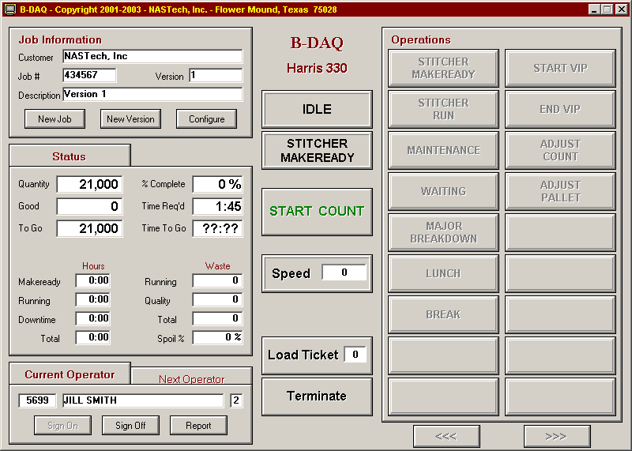

The following pages will describe each section of the Main Screen in detail.

Job Information Panel
The Job Information Panel displays the current Job, and allows Job parameters to be edited. Buttons are also provided to change the current Job or Version, and to change configuration parameters as described in the following:

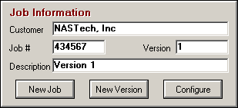

New Job Button
The Job Schedule screen allows the Operator to select a job to be run from the schedule. If the job is not in the schedule, the Close button will display a series of dialog boxes that will prompt the operator for the required job information. The tabs at the top of the screen represent the machines that the job was scheduled for. Jobs can be selected from other machine schedules if necessary, using parameter control as defined by the customer.
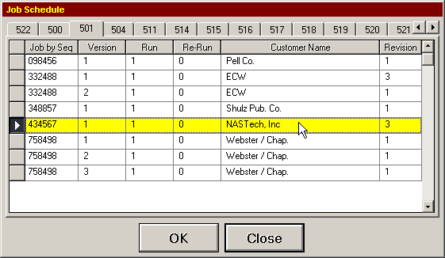
Details
Job by Seq Displays the job number sorted numerically by the Sequence number as defined in the Scheduling Module (B-Sched.exe). Clicking this heading allows jobs to be displayed numerically by Job number instead. (Job by Job)
Version The version number.
Run The run number.
Re-Run The Re-Run number.
Customer Name The customer name. Clicking this heading allows the job description or the version description to be displayed instead.
Revision The revision number.
OK Enters the selected job data into the system and closes the dialog box.
Close Used to close the dialog box, without loading a new job.

New Version Button
The New Version button allows the Operator to select a new version to be run from the schedule. The versions displayed will be only those versions that share the same job number as previously entered. If the version is not in the schedule, the Close button will display a series of dialog boxes that will prompt the operator for the required version information.
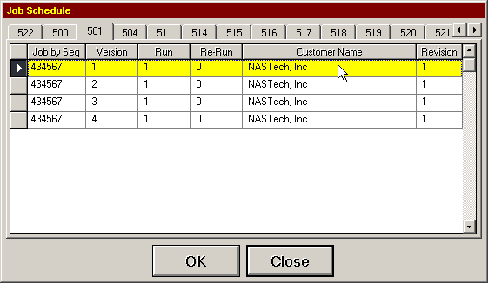
Details
Job by Seq Displays the job number.
Version The version number sorted numerically.
Run The run number.
Re-Run The re-run number.
Customer Name The customer name. Clicking this heading allows the job description or the version description to be displayed instead.
Revision The revision number.
OK Enters the selected version data into the system and closes the dialog box.
Close Used to close the dialog box, without loading a new version.

Configure Button
This dialog box is presented to the operator upon loading a new job or version from the schedule, or by clicking the Configure button. This data may be pre-loaded by the scheduling department. These necessary parameters must be checked for accuracy before each run. If any required information is missing, clicking in the field heading will display a dialog box in which to enter the required information. The parameters to be entered are user defined in the Bindery.ini file. Below are all of the parameters that may be included in the Configuration screen.
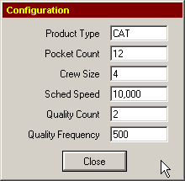
Details
Product Type The type of product to be produced.
Pocket Count The number of pockets to be used.
Crew Size The crew size.
Sched Speed The scheduled speed of the run.
Quantity Count The number of quality copies to be produced.
Quantity Frequency The frequency of quality copies to be produced.
Class Code The payroll class code.
3 or 5 Knife Defines how the product is cut.
Number-Up The number of copies to be produced per revolution of the machine.

Status Folder
This folder is used to display the current status of the version being run. The current status of the entire job may also be displayed if necessary, by entering the appropriate parameter into the Bindery.ini file.
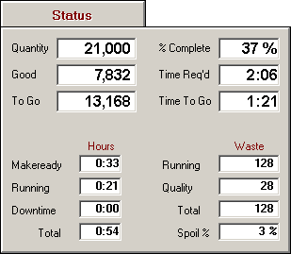
Details
Quantity The order quantity.
Good The number of good books produced.
To Go The remaining quantity.
% Complete The percent complete.
Time Req’d Time remaining based on the scheduled speed.
Time To Go Time remaining based on the current speed.
Makeready Hours Total makeready hours.
Running Hours Total running hours.
Downtime Hours Total downtime hours.
Running Waste Total running waste.
Quality Waste Total quality copies produced.
Total Waste Total waste.
Spoil % Waste percentage of total gross.

Operator Section
This section identifies the various operators on the associated shift. This information should be defined prior to the start of each shift.
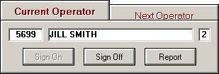
Details
Employee # Employee ID number.
Employee Name Employee name.
Shift # Shift number.
Sign-On Used to sign on to the system.
Sign-Off Used to sign off the system
Report Used to view or print a shift detail report for the lead operator.

Center Section
The center section of the screen displays the current status of the run, and the current operation being performed. Controls are also provided here as described in the following:
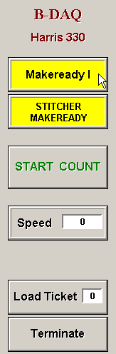
Details
Start Count Used to initialize the counters once the machine has been set up.
Speed Displays the current machine speed.
Load Ticket Used to print the load ticket once a pallet has been completed. This box also displays the number of pallets produced during the run.
Terminate Used to terminate the application.

Operations Section
This section is used to provide for the selection of operation codes.
The buttons displayed here are user defined and used controlled. Therefore, only those codes that are valid for your plant are presented to the operator.
These codes are also dynamically displayed, for example, only those codes that are valid at any particular point in the run are displayed. Fig.1
The buttons used for operation codes can also be presented to the operator using multi level control. Fig.2 shows the operations displayed after the Waiting button has been pressed.
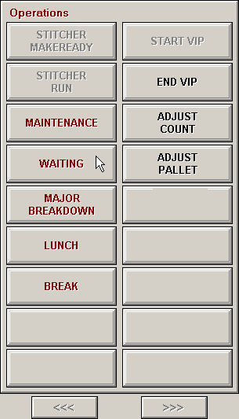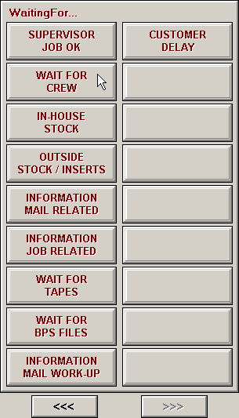
Figure 1 Figure 2
Functions

In addition to the various operation codes, buttons can also be provided here to control various functions of the system. Descriptions of all available functions are as follows:

Adjust Count Used to open the Adjust Count dialog box.
Adjust Pallet Used to open the pallet maintenance screen.
Beg Store Used to indicate that store copies are now being produced.
Beg Vip Used to indicate that samples are now being produced.
Break Used to indicate that a Break has begun.
End Store Used to indicate that store copies are no longer being produced.
End Vip Used to indicate that samples production is complete.
Force EOP Used to Print Load Tickets.
Lunch Used to indicate that Lunch has begun.
Make-Ready Used to place the machine back into it’s makeready status.
Pallet Log Used to open the Pallet Log.
Shell Used to invoke command specified by the “Shell Command” Parameter. Used to call Help documentation etc….

Count Adjust
This dialog box is used to make Adjustments to counts as needed. To open, click the “Adjust Count” button from the Operations Panel.

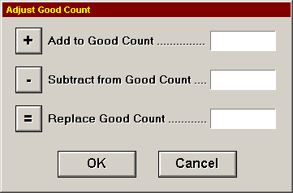
Details
Add to Good Count Used to enter the number of books to add to the good count.
Subtract from Good Count Used to enter the number of books to subtract from the good count.
Replace Good Count Used to enter the good count, this will replace the current good count figure.
OK Used to make the adjustment, and close the dialog box.
Cancel Used to close the dialog box without making changes.

Pallet Maintenance
This dialog box is used to make Adjustments to pallet counts as needed. To open, click the “Adjust Pallet” button from the Operations Panel.
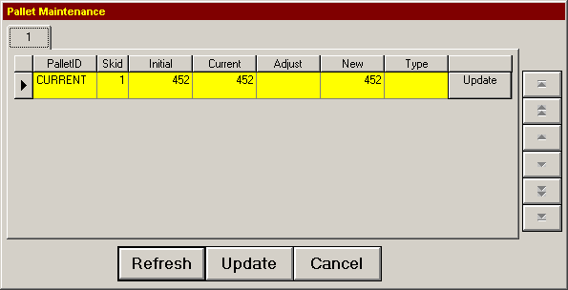
Details
Pallet ID The Current Pallet.
Skid The Pallet sequence number.
Initial Initial count on the Current Pallet.
Current Current count on the Pallet.
Adjust Opens the dialog box allowing positive or negative pallet count adjustments.
New The Adjusted count.
Type Used to allow the Pallet to be defined, this info appears on the Load Ticket. (EG…”Samples”)
Refresh Used to refresh the screen.
Update Used to complete the transaction, and to close the dialog box.
Cancel Used to close the dialog box without making changes.

Machine Stops
When the machine stops, an entry is made in the log to record the exact date and time of the event. Downtime entries are placed on HOLD in the reporting system, awaiting operator entry of the cause of the downtime. These entries are RELEASED to the reporting system when a reason is provided.

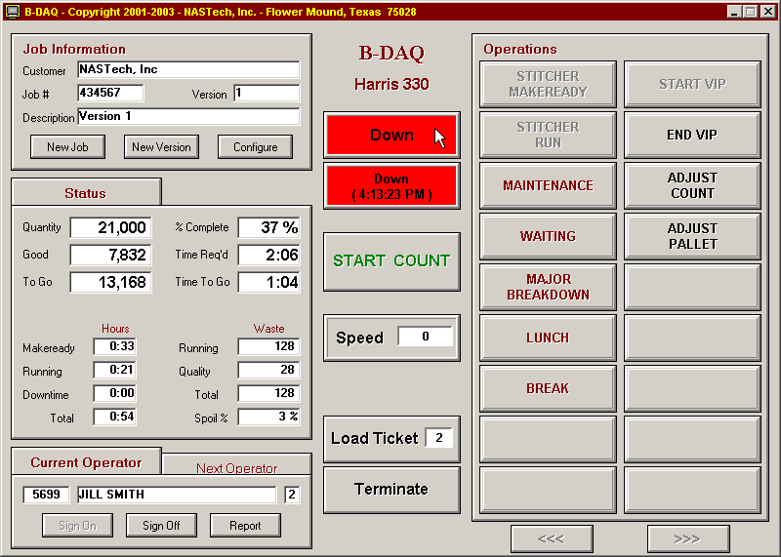
B-DAQ will periodically attempt to complete processing of released entries. All entries up to the first entry on HOLD will be transferred to the Management / Reporting module. Once completed, an entry may no longer be modified.

Reason Codes
As mentioned in the previous page, a HOLD generated by a Machine Stop event can only be RELEASED when the Operator enters the Down-Time reason code. The operations section of the screen allows for the selection of op-codes. To release the stop, the operator simply selects the code that most accurately describes the problem that has occurred.

Multiple-Stop
The Multiple-Stop Release dialog box is used when selecting a single reason code to describe multiple stops. This is useful when the machine goes down more than once due to the same problem. When there are multiple stops to report, the Multi Stop button will be presented to the operator. Clicking the multi stop button opens the following screen:
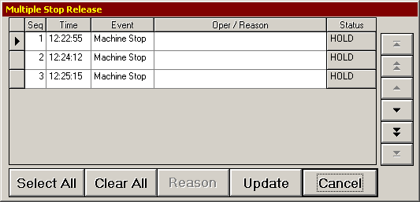
Details
y Used to select the codes to be released.
Seq The sequence number to describe all stops currently on HOLD.
Time The time of the down event.
Event On this Dialog Box, this will display Machine Stop in all cases.
Oper/Reason Clicking in this field displays a list of codes to be selected.
Status The current status of the transaction.
Select All This button allows all events to be selected for editing.
Clear All This button de-selects all events.
Reason This button displays a list of codes to be selected and edits all selected codes.
Update Allows all changes to be uploaded to the server by changing the transaction status to RELEASED.
Cancel This button closes the Dialog Box without making changes.

Chapter 5 Scheduling Module

Detail Screen
The Scheduling module is used to store the jobs that are scheduled to run in the bindery. The data defined here is stored until the operator selects the job from the B-DAQ Bindery Module.
The Detail Screen is used to define the Job and Version to be run, and to describe the configuration of a number of parameters prior to the run.
The parameters to be defined via the Detail Screen are outlined in the following pages.
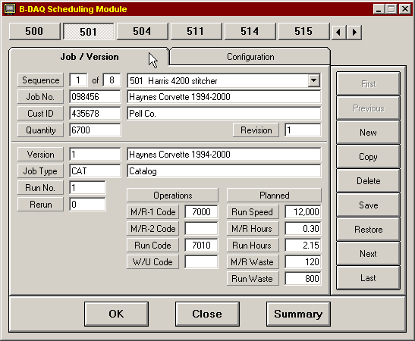

Menu Options
First View first job in the schedule.
Previous View prior job in the schedule.
New Creates a new job sequence number and clears all fields for subsequent entry.
Copy Copies the data from the currently displayed job to a new job sequence number. The copied job definition may then be selectively modified to define the specifications of the new job.
Delete Deletes the currently displayed job from the schedule. A warning message is displayed to help eliminate accidental deletions.
Save Saves the current job schedule in the database.
Restore Reads the data from the database for the current job. This function is used to negate any and all changes made to the current job since the last time it was saved to the database.
Next View next job in the schedule.
Last View last job in the schedule.
OK Saves the current schedule and exits the program.
Cancel Exits the program without saving the current schedule.
Summary Displays the Job Summary screen. The current job remains selected.

Job / Version Folder
Sequence The current job being viewed and the total number of jobs in the schedule.
Machine Desc. The machine the job is scheduled to run on. The job may be moved to different machine by selecting the machine from the drop down list.
Job No. The job number and description of the job being run. The job description is displayed automatically if present on the job master file.
Cust ID The customer ID and customer name. The customer name is displayed automatically if present on the customer master file.
Quantity The order quantity.
Version The version number and version description.
Job Type The job type and description.
Run No. The run number.
Re-run The re-run number.
Operations The scheduled operation codes for MR-1, MR-2, Run, and Clean-Up.
Planned The scheduled hours and waste figures are used by B-DAQ to compare actual hours and waste to that of the schedule. These figures are available at the machine for the operator to determine whether or not he or she is performing on schedule.

Configuration Folder
This folder is used to define machine parameters. The data displayed here is can be defined by scheduling personnel, or may be left up to the operator to define.
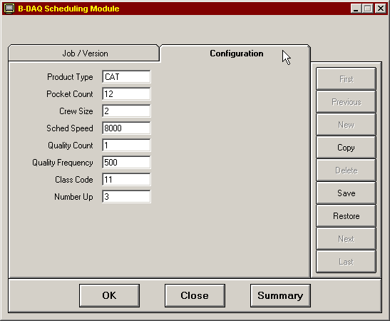

The parameters to be edited are user defined; therefore, only those parameters that are valid for your plant and for each machine will be presented here. The available parameters are explained on the following page.
Parameters

Product Type The product type.
Pocket Count The number of pockets to be used.
Crew Size The crew size.
Sched Speed The scheduled speed of the run.
Quality Count The number of quality copies to be produced each time quality copies are produced.
Quality Frequency The frequency at which the quality copies are produced..
Class Code The payroll class code.
Sched Speed The scheduled speed of the run.
Quality Count The number of quality copies to be produced each time quality copies are produced.
Quality Frequency The frequency at which the quality copies are produced.
Class Code The payroll class code.

Summary Screen
This screen is used to locate a job to be edited, to delete jobs from the schedule, and to re-prioritize the sequence of jobs. The buttons at the top of the screen represent the various machines being scheduled.
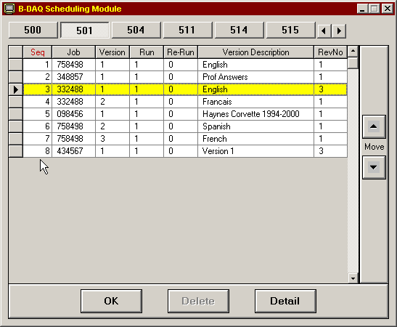

Menu Options
OK Saves the current job and exits the program.
Delete Deletes the currently displayed job from the schedule. A warning message is displayed to help eliminate accidental deletions.
Detail Displays the detail screen. The current job remains selected.
Move Increase or decrease the priority of the currently selected record by changing the sequence number.
Parameters
Seq The sequence number. Clicking this heading allows the jobs to be presented in order by sequence number.
Job The job number. Clicking this heading allows the jobs to be presented in order by job number.
Version The version number.
Run The run number.
Re-Run The re-run number.
Version desc. The version description.
Rev No The revision number.

Chapter 6 Machine Status Module

Summary Screen
The Machine Status Module is used by the scheduling department and management to determine the current status of jobs in the bindery.

The Summary Screen is used to view the status for up to 20 machines simultaneously.

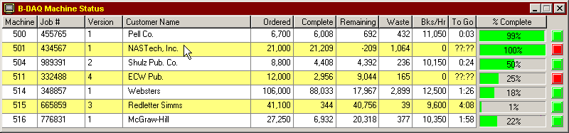
Details
Machine The cost center number.
Job # The job number.
Version The version number.
Customer Name The customer name.
Ordered The quantity requested.
Complete The total number of completed books.
Remaining The number of remaining books.
Waste The current waste.
Imp/Hr. The speed of the machine in books per hour.
To Go The time to go based on the current speed.
% Complete The percent complete.

Detail Screen
The Detail Screen can be viewed to provide additional details. To open, click the associated job from within the Status Summary Screen.
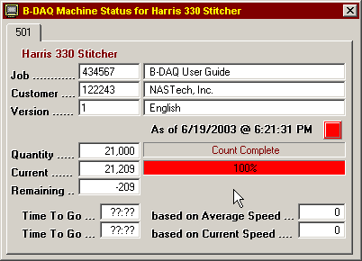
Details
Job The job number and description.
Customer The customer number and name.
Version The version number and description.
Quantity The quantity requested.
Current The total number of completed books.
Remaining The number of remaining books.
Time To Go The time to go based on the average speed.
Time To Go The time to go based on the current speed.

Chapter 7 Management / Reporting Module

Overview
The Management / Reporting module is used to display and/or print selected reports. Each report contains selection criteria that may be specified to limit the amount of data reported.
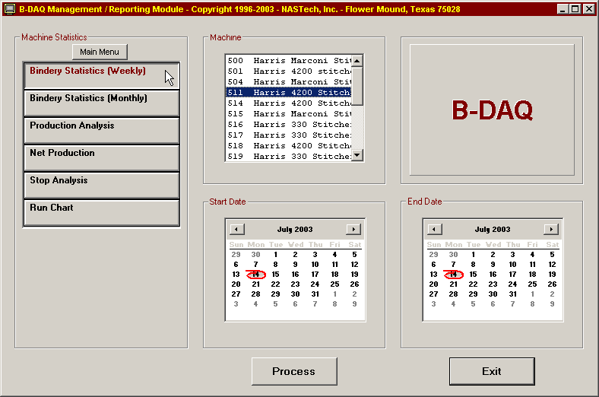
The reports available are presented as a series of buttons, each of which may be selected when required. As new reports are made available, additional buttons are automatically added.
When a report is selected, the four panels to the right are used to specify the selection criteria required for the particular report. Once the selection criterion has been specified, the report may be displayed by clicking on the Summary, Detail, or Process button. Once a report has been displayed, you may open a new report by clicking the Open Report button. Opened reports can be reviewed by using the drop down list. Reports are closed using the Close Report button.
Once a report is displayed, it may be printed in its entirety or selectively by page.

Upon selecting a report and by clicking the Process, Summary, or Detail button, the B-DAQ reporting system analyzes the system logs and builds a summary database which summarizes all data needed for the selected report.

When a report is not run periodically, the next time you run the report, the system needs to update the summary databases. Depending on the amount of data to be summarized, this process may take a while and the given report may not display right away. There are a few ways to make sure that the summary databases are up to date as outlined in the following procedures:

- From the P-Admin main screen, without selecting a report, click the Process button. This will summarize all data for all reports at one time.

- Using Windows “Scheduled Tasks”, you may schedule the P-Admin.exe program to run periodically. This ensures that the summary databases are up to date. The following is the procedure to set up the task:

- Choose Start\ControlPanel\SheduledTasks.
- Click “Add Scheduled Task”.
- Click “Next”.
- Click the “Browse” button and browse the server to the BDAQ\Shared directory and select the P-Admin.exe file.
- Follow the instructions to select the time and enter the user name and password when prompted.
- Check the box marked “Open Advanced Properties for this Task when I click Finish” button and click the Finish button.
- In the Run field, change the path to the following: C:\BDAQ\Shared\P-Admin.exe AUTO
- In the Start In field, make sure the path is as following: C:\BDAQ\Shared

System Logs

Shift Log
This report shows the events that have occurred on each machine for a specified period of time. The report is displayed in chronological order.
Heading
Heading The machine cost center number, description, and the time period for the report.
Body
Date The actual date on which the associated event occurred.
Time The actual time at which the associated event occurred.
Elapsed The elapsed time of the event.
Event The description of the event.
Oper/Reason The description of the operation performed or the reason for the Down-Time.
Speed The speed of the machine at the time the event occurred.
Gross The gross book count for the currently running version at the time the event occurred.
Comments The comments entered by the operator to provide additional information about the associated event.
Footing
Footing The date and time the report was run, the page number and the company name.

Speed Log
This report shows the machine speed fluctuations that occurred for a specified period of time. The speed must change by the amount specified by the Speed Variance parameter in the Bindery.ini file. The report is displayed in chronological order.
Heading
Heading The machine cost center number, description, and the time period for the report.
Body
Date The actual date on which the associated event occurred.
Time The actual time at which the associated event occurred.
Elapsed The elapsed hours, minutes and seconds of the event.
Event The description of the event.
Speed The speed of the machine at the time the event occurred.
Gross The gross book count for the currently running version at the time the event occurred.
Net The calculated good count for the currently running version at the time of the event.
Footing
Footing The date and time the report was run, the page number and the company name.

Pallet Log
This report shows the pallets that were produced during a specified period of time. Adjustments made to the pallets are also reported. The report is displayed in chronological order.
Heading
Heading The machine cost center number, description, and the time period for the report.
Body
Date The actual date on which the associated pallet was created or adjusted.
Time The actual time at which the associated pallet was created or adjusted.
Event Indicates whether the pallet was created or adjusted.
Seq The pallet sequence number.
Pallet ID The unique pallet identifier for the pallet.
Quantity The original pallet quantity or the quantity after the adjustment was made.
Job # The job number for which the pallet was produced.
Sig ID The Signature identifier for the associated Job.
Description The version description.
Type The type of product on the pallet. Used to indicate samples, VIP’s etc.
Footing
Footing The date and time the report was run, the page number and the company name.

Job Statistics

Job Statistics Report
This report shows makeready and run statistics for a specified job. All versions, runs and re-runs for the specified job are printed. Totals are provided for the entire job.
Demographics
Job Number The job number.
Customer # The customer ID and name for which the job was run.
Body
Ver-Run The version and run number.
Description The version description.
Start Date The date this occurrence of the version was started.
Start Time The time this occurrence of the version was started.
M/R Hours The number of hours expended for Makeready I and Makeready II.
Run Hours The number of hours expended for the Run.
Down-Time The number of hours expended for Down-Time including machine restarts.
M/R Qty. The number of waste books accumulated during Makeready.
Gross Qty The total gross books produced.
Order Qty The order quantity.
Net Qty The total net books produced.
Run/Waste % The percentage of waste which occurred during the run. =( Run Waste + Restart Waste) / Net Books * 100
Footing
Footing The date and time the report was run, the page number and the company name.
Production Detail by Version
This report shows makeready, run, and down-time statistics for one or more versions within a specified job. If all versions for the job are selected, a summary report will also be displayed for the entire job. The following describes both the Detail and Summary report options. The Summary report does not break out down-time statistics and does not break out stop codes.
Heading
Heading The machine cost center number
Demographics
Job Number The job number and associated description.
Version The version ID for each of the versions associated with the job being reported.
Run The run and re-run numbers for each of the associated versions.
Customer The customer ID and associated customer name.
Ordered The order quantity.
Shift Detail
Shift The shift number.
Gross (Imp) The total accumulated gross count by shift.
Net (Imp) The total accumulated net count by shift.
Waste (Imp) The total accumulated waste count by shift.
% Waste Net = Waste Count / Net Count * 100
Print-Time = (MR2 + Run) in hours.
Event Detail
Gross (Imp) Includes gross books accumulated during MR2. Also includes gross books accumulated during Production (Run + Down-Time +Restarting), Production/DT, and Non/Charge.
Net (Imp) Includes net books accumulated during Production (Run + Down-Time +Restarting).
Waste (Imp) Includes waste books accumulated during MR2. Also includes Gross books accumulated during Production (Run + Down-Time +Restarting) Production/DT, and Non-Charge.
Hours Total Time for the associated event in hours.
Pct The percentage of time for the associated event.
Num The number of occurrences for the associated event.
Speed Detail
Gross The average gross books per hour during Run (Run + Restart). = Gross Books / Run Hours.
Net The average net books per hour during Production/Run (MR3 + Run + Restart). = Net Books / Run Hours.
Yield
Gross The average number of gross books per hour during Run (MR3 + Run + Restart). = Gross Books / Run Hours.
Net The average number of Net books per hour during Run (MR3 + Run + Restart). = Net Books / Run Hours.
Stop Detail
Stops M = Makeready, I = Idle. (Detail Report only)
Code The down time code.
Description The code description.
Waste (Imp) The total waste books accumulated for the associated event.
Hours The total time for the associated event in hours.
Pct The percentage of the total time for the associated event.
Num The number of occurrences for the associated event.
Manual Entries Waste books, hours, time percentage, and number of occurrences by version (Detail Report only).
System Entries Waste books, hours, time percentage, and number of occurrences by version. (Detail Report only).
Idle Entries Waste books, hours, time percentage, and number of occurrences by version. (Detail Report only).
Down-Time Summary of all Down-Time by waste books, hours, time percentage and occurrences. Summarizes all Down-Time including Manual Entries, System Entries and Idle Entries. (Summary Report only).
Footing
Footing The date and time the report was run, the page number and the company name.

Machine Statistics

Production Detail by Machine
This report summarizes bindery activity by operation and down-time for the associated shift(s) and machine during the specified period. The following describes both the Detail and Summary reports. The Summary report does not break out down-time statistics and does not break out stop codes.
Heading
Heading The machine the version was run on, and the start and end dates for the version.
Shift Detail
Shift The shift number.
Gross The total accumulated gross count by shift.
Net Books The total accumulated net count by shift.
Waste (Imp) The total accumulated waste count by Shift.
% Waste Net = Waste Count / Net Count * 100.
Run-Time = (MR2 + Run) in hours.
Event Detail
Gross Includes gross books accumulated during MR2. Also includes gross books accumulated during Production (Run + Down-Time +Restarting), Production/DT, and Non/Charge.
Net Includes net books accumulated during Production (Run + Down-Time +Restarting).
Waste Includes waste books accumulated during MR2. Also includes gross books accumulated during Production (Run + Down-Time +Restarting), Production/DT, and Non/Charge.
Hours Total time for the associated event in hours.
Pct The percentage of time for the associated event.
Num The number of occurrences for the associated event.
Speed Detail
Gross The average gross books per hour during Run (Run + Restart). = Gross Books / Run Hours.
Net The average net books per hour during Run (Run + Restart). = Net Books / Run Hours.
Yield
Gross The average gross books per hour during Run (Run + Restart). = Gross Books / Run Hours + Downtime + Washup.
Net The average net books per hour during Run (Run + Restart). = Net Books / Run Hours + Downtime + Washup.
Stop Detail
Stops I = Idle
D = Downtime (Summary Report)
M = Manual Entry Downtime (Detail Report)
S = Press Stopped Downtime (Detail Report)
Code The Down-Time code.
Description The code description.
Waste (Imp) The total waste books accumulated for the associated event.
Hours The total time for the associated event in hours.
Pct The percentage of the total time for the associated event.
Num The number of occurrences for the associated event.
Manual Entries Waste books, hours, time percentage, and number of occurrences by version. (Detail Report only).
System Entries Waste books, hours, time percentage, and number of occurrences by version. (Detail Report only).
Idle Entries Waste books, hours, time percentage, and number of occurrences by version. (Detail Report only).
Down-Time Summary of all Down-Time by waste books, hours, time percentage and occurrences. (Summary Report).
Footing
Footing The date and time the report was run, the page number and the company name.

Production Analysis Report
This report summarizes key operating indicators for the specified period. The report may include statistical data for multiple machines and/or shifts. The following describes both the Detail and Summary report options. The Summary report combines shift statistics for all shifts.
Heading
Heading The machine cost center number, description, and the time period for the report.
Shift The shift number(s).
Counts
Gross The total number of gross books accumulated for the specified period.
Net The total number of net books accumulated for the specified period.
Makeready
Number The number of Initial, Subsequent and Total Makereadies.
Time The total number of makeready hours expended for the specified period.
Stops
Number The number of machine stops which occurred for the specified period. Only those stops incurred during Running are included
Time The total number of Down-Time hours expended for the specified period. Only the Down-Time incurred during Running are included.
Productivity
Run Time The total run time in hours and the run time percentage for the selected shifts, for the selected period.
Sched The total number of scheduled hours for the selected period.
Un-Sched The total number of un-scheduled hours for the selected period.
Shift Detail
Period Ending The date.
Shift The shift number.
Gross Books Gross books.
Net Books Total net books.
MR Count Total number of make-readies for the shift.
MR Hours Total make-ready hours for the shift.
Stop Count Number of machine stops.
Down Hours Total down time in hours.
Footing
Footing The date and time the report was run, the page number and the company name.

Bindery Statistics Report (Weekly)
This report shows bindery statistical information summarized weekly by machine and by shift. The following describes both the Detail and Summary report options. The Summary report combines shift statistics for all shifts.
Heading
Heading The machine cost center number, description, and the time period for the report.
Charts
- Average Makeready Time is charted for each week in the specified period. Goal and Trend lines are also charted.
- Yield / Hour is charted for each week in the specified period. Goal and Trend lines are also charted.
- Books Bound is charted for each week in the specified period. Goal and Trend lines are also charted.
Body
Period Ending The date of the last day of the week. The first and last days of the week are defined in the P-Admin.ini file.
Shift The shift number(s).
M/R Count The number of Makereadies performed during the specified period.
M/R Hours The number of hours expended for Makeready for the specified period.
Run Hours The number of hours expended during Running for the specified period.
Down Hours The total Down-Time which occurred during Running for the specified period.
Total Hours The total hours expended from the start of the version to the end of the version. This includes all Makeready, Run and Down-Time hours.
Net Yield = Net Books / (Run + Down-Time hours)
Yield/Run Hr. The total books produced per run hour. Net Books / (Run + Down-Time hours)
Yield/Tot Hr. The total books produced per run hour. Net Books / (Total hours)
Footing
Footing The date and time the report was run, the page number and the company name.

Bindery Statistics Report (Monthly)
This report shows bindery statistical information summarized monthly by machine and by shift. The following describes both the Detail and Summary report options. The Summary report combines shift statistics for all shifts.
Heading
Heading The machine cost center number, description, and the time period for the report.
Charts
- Average Makeready Time is charted for each month in the specified period. Goal and Trend lines are also charted.
- Yield / Hour is charted for each month in the specified period. Goal and Trend lines are also charted.
- Books Bound is charted for each month in the specified period. Goal and Trend lines are also charted.
Body
Period Ending The date of the last day of the month. The first and last days of the month are defined in the P-Admin.ini file.
Shift The shift number(s).
M/R Count The number of Makereadies performed during the specified period.
M/R Hours The number of hours expended for Makeready for the specified period.
Run Hours The number of hours expended during Running for the specified period.
Down Hours The total Down-Time which occurred during Running for the specified period.
Total Hours The total hours expended from the start of the version to the end of the version. This includes all Makeready, Run and Down-Time hours.
Net Yield = Net Books / (Run + Down-Time hours)
Yield/Run Hr. The total books produced per run hour. Net Books / (Run + Down-Time hours)
Yield/Tot Hr. The total books produced per run hour. Net Books / (Total hours)
Footing
Footing The date and time the report was run, the page number and the company name.

Net Production Report
This report lists all jobs run on the specified machine for the requested period. The jobs are listed in the order in which they were run.
Heading
Heading The machine cost center number, description, and the time period for the report.
Body
Job # The job number.
Customer Name The customer’s name.
Job Description The description of the job.
Version The version number.
Job Type The job type.
Net Books The number of good books produced.
Ordered The order quantity.
Last Activity The date and time of the last activity for this version.
Footing
Footing The date and time the report was run, the page number and the company name.

Stop Analysis Report
This report is used to analyze machine stops based on several different criteria. Several charts are produced which rank the reasons for the stops.
Heading
Heading The selected machine cost center numbers, description, and the start and end dates for the report.
Charts
- Top 10 causes of Machine-Stops based on frequency of the stop.
- Top 10 causes of Machine-Stops based on Down-Time hours.
- Top 10 causes of Machine-Stops based on aggregate cost.

Body
Code The associated operation code.
Description The reason for the stop.
Count The number of stops for the specified period.
Hours The total number of Down-Time hours expended for the Machine-Stop.
$ Value The dollar value based on the machine rate and the cost based on the values defined in P-Maint.exe.
Footing
Footing The date and time the report was run, the page number and the company name.

Machine Run Chart
This daily report charts books per hour for all shifts on a selected machine. This report also includes down-time and reason codes for stops occurring during the specified period.
Heading
Heading The selected machine cost center number, description, and the start and end date for the report.
Demographics
Job Number The job number and associated description.
Customer The customer ID and associated customer name.
Goals The goals for machine speed and books per hour as defined in P-Maint.
Chart
Books / Hour Books per hour, also includes goal lines.
Body
Shift The shift number.
Operator The lead operators name.
Count The number of good books produced.
Period Ending The period ending representing each point on the chart.
Minutes Down The total minutes the machine was down.
Reason The down time reason code.
Footing
Footing The date and time the report was run, the page number and the company name.

Chapter 8 Utilities

Overview
The B-DAQ system contains several programs designed to perform system maintenance, to perform system updates, and to be used when B-DAQ is to communicate with other systems. These programs can be executed from any computer that has the B-DAQ Client Module installed, and by those individuals that have permission as defined in the Security.ini file on the server. The following describes these programs in detail.

P-Maint
P-Maint is used to update tables that are stored in the Remote Database.

To execute, double click the P-Maint.exe icon from the BDAQ/Shared directory on the server.

The buttons on the left side of the screen represent the tables to be edited. To edit a table, click on its associated button and use the center of the screen to enter the associated data.
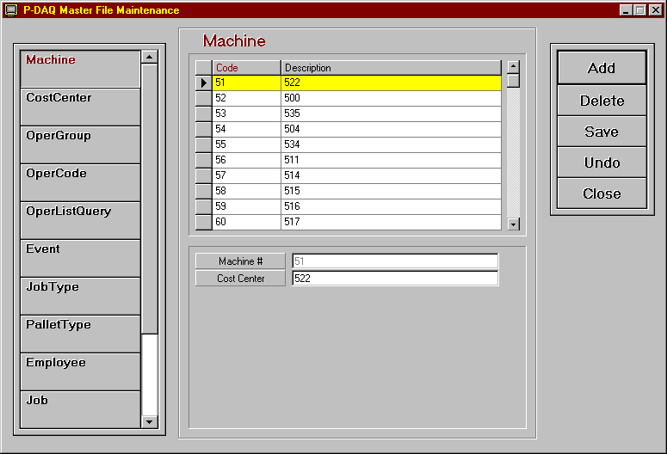
The following pages list the fields to be edited and give a brief explanation of the required entries.
Code / Description fields
Code This field is used to display the operation code, machine number, employee number, etc…
Description This field is used to provide a description of the code to be used.
Machine
Machine The unique machine number assigned by NASTech.
Cost Center The cost center number assigned to the machine.
Cost Center
Cost Center The cost center number assigned to the machine.
Description A description of the machine. (IE. “Harris-Marconi”)
Type/Model The model number.
Rate/Hour The hourly rate of the machine in dollars.
Rate/M Imp The average cost of materials per 1000 books.
Oper Group
Group Code The group code.
Description A description of the associated group.
Oper Code
Oper Code The cost center number designated for the machine.
Description A description of the code.
Group Code The associated group the code belongs to.
Alternate The code to be used to report the associated activity to the Cost Accounting system.
Type Indicates whether the code is a Makeready, Run, Downtime code etc…
Machine Related Not Used.
Man Related Not Used.
Material Related Not Used.
External Cause Not Used.
Makeready 1 Indicates that the code is a makeready 1 code.
Makeready 2 Indicates that the code is a makeready 2 code.
Run Indicates that the code is a run code.
Wash-up Indicates that the code is a Wash-up (Clean-Up) code.
Machine Stop Indicates that the code is a Machine Stop code.
Data 1 Used to define additional data to be sent to Cost Accounting.
Data2 Used to define Makeready as Initial (I), or Subsequent (S).
OperListQuery
Center The cost center number assigned to the machine.
Oper Code The associated operation code.
Description The description of the operation code.
Active Indicates that the code is valid for the associated machine. Y or N.
Event
Event Code The NASTech assigned Event Code.
Description The description of the code.
Reason Reqd Denotes whether a reason is required for the associated event. True or False.
OperCode The default Operation Code for the associated event.
Job Type
Job Type The Job Type code.
Description The description of the job type.
PalletType
Pallet Type The Pallet Type code.
Description The description of the Pallet Type.
Employee
Emp ID The Employee number.
Name The Employee’s name.
Job
Job Number The Job number.
Description The description of the Job.
Cust ID The customer number.
Cust Name The customer name.
Quantity The required quantity to be produced.
Customer
Cust ID The Customer ID number.
Company Name The Company name.
Standards
Type-Pockets Machine Type and number of pockets.
Description Description of the machine.
Type/Model Machine Type.
# of Pockets Number of pockets.
# of Helpers Number of helpers.
Speed Goal The speed goal.
Machine Goal
Cost Center The cost center number designated for the machine.
MR Waste Books Expected MR waste.
Run Waste % Expected Run Waste percentage.
Net Yield Imps Expected Net Yield.
Run Time % Run Time / Scheduled Time * 100.

DataComp
In some cases when the software is updated, new fields are added, deleted or changed in the B-DAQ database. DataComp is used to compare tables in the current database to the new tables in the updated database to indicate any changes that have been made.

DataComp should be executed on the Server and on the Bindery Computer whenever a system update is provided.

To execute on the Server, double click the DataComp.exe icon in the BDAQ\Shared directory.

To execute on the Bindery Computer, choose Start/Programs/B-DAQ Machine Module/DataComp.
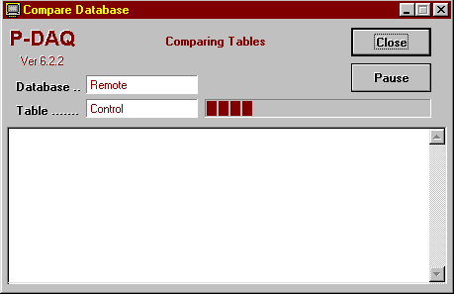

To begin the compare process, click the Continue button. Any table that has been changed will appear in the display area of the screen.
If new fields have been added, use the DataCopy.exe program to copy the old data to the new table as described in the following pages.

DataCopy
In some cases when the software is updated, new fields are added, deleted or changed in the B-DAQ database. DataCopy is used to copy tables in the current database to the new tables in the updated database.

DataCopy should be executed on the server and on the Bindery Computer whenever DataComp shows a difference between the current and new database structures. However, when using SQL server, Data Copy is not required to be run on the server.

To execute, on the Server, double click the DataComp.exe icon in the BDAQ\Shared directory.

To execute, on the Bindery Computer, choose Start/Programs/B-DAQ Machine Module/DataComp.
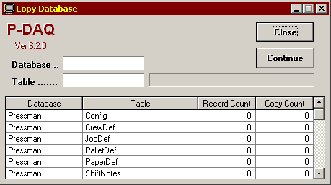
To begin the copy process, click the Continue button. Any table that has been copied will appear in the display area of the screen.

DataDump
Data Dump is used to extract data from BDAQ databases to be sent via email to NASTech personnel for troubleshooting purposes.

To execute, double click the DataDump.exe icon in the BDAQ\Shared directory on the server.

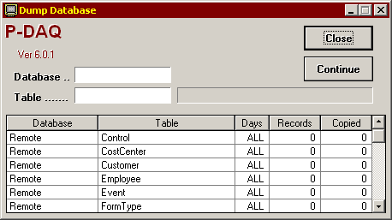

The default records to be copied are pre-determined by the DataDump.ini file located in the BDAQ\Shared\Init directory of the server. Under normal circumstances, the default values will suffice. However, during troubleshooting, a NASTech representative may ask the customer to include more or less data. To do so, on the Data Dump screen, enter the number of days prior to the current date to include in the Days field for each table to be copied.

To begin the dump process, click the Continue button. Any table that has been copied will appear in the body of the program.

When completed, the copied databases will appear in the BDAQ\Shared\DataDump directory of the server. These two .mdb files may then be Zipped and e-mailed to NASTech personnel for evaluation.

DataLoad
Data Load is used to extract data from Primac databases to be transferred to B-DAQ remote databases.

To execute, double click the DataLoad.exe icon in the BDAQ\Shared directory on the server.

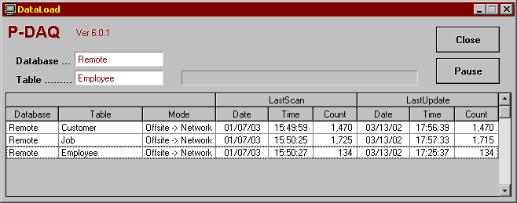

To begin the copy process, click the Continue button. DataLoad can be left running on the server, however it is recommended that you Schedule the task as outlined in the following:

Using Windows “Scheduled Tasks”, you may schedule the DataLoad.exe program to run periodically. This ensures that the hard drive is not inundated with unnecessary data. The following is the procedure to set up the task:

- Choose Start\ControlPanel\SheduledTasks.
- Click “Add Scheduled Task”.
- Click “Next”.
- Click the “Browse” button and browse the server to the BDAQ\Shared directory and select the DataLoad.exe file.
- Follow the instructions to select the time and enter the user name and password when prompted.
- Check the box marked “Open Advanced Properties for this Task when I click Finish” button and click the finish button.
- In the Run field, change the path to the following: C:\BDAQ\Shared\DataLoad.exe AUTO
- In the Start In field, make sure the path is as following: C:\BDAQ\Shared

DataPurg
DataPurg is used to delete unnecessary data from the system.

The tables to be purged and the data to be retained are both pre-determined by the DataPurg.ini file located in the BDAQ\Shared\Init directory of the server. Under normal circumstances, the default values should suffice.

To execute, double click the DataPurg.exe icon in the BDAQ\Shared directory on the server.

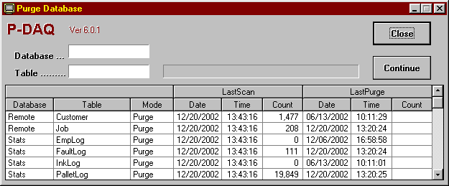
To begin the Purge process, click the Continue button. DataPurg can be left running on the server, however it is recommended that you Schedule the task as outlined below:

Using Windows “Scheduled Tasks”, you may schedule the DataPurg.exe program to run periodically. This ensures that the hard drive is not inundated with unnecessary data. The following is the procedure to set up the task:

- Choose Start\ControlPanel\SheduledTasks.
- Click “Add Scheduled Task”.
- Click “Next”.
- Click the “Browse” button and browse the server to the BDAQ\Shared directory and select the DataPurg.exe file.
- Follow the instructions to select the time and enter the user name and password when prompted.
- Check the box marked “Open Advanced Properties for this Task when I click Finish” button and click the finish button.
- In the Run field, change the path to the following: C:\BDAQ\Shared\DataPurg.exe AUTO
- In the Start In field, make sure the path is as following: C:\BDAQ\Shared

DataSync
DataSync is used to transfer data to and from the Bindery Computer and the Server. DataSync should be left running on the Bindery Computer AT ALL TIMES.

To execute, double click the DataSync.exe icon on the Bindery Computer’s desktop.

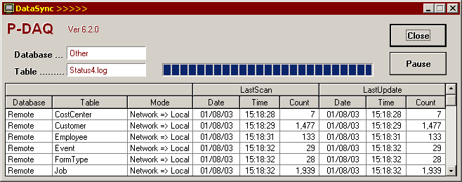
To begin the data transfer process, click the Continue button. To minimize the program on the screen, click the B-DAQ logo.

To expedite the flow of data to and from the server, tables can be scanned, uploaded, or downloaded in real time by clicking the associated table name.

P-Check
P-Check is used to continuously monitor the status of some key B-DAQ system applications, and is also used to provide local B-DAQ system administrators with information about system updates, and problems with the P-DAQ database.

When one of the monitored applications fails to execute or when there is a database problem, up to 3 administrators and 3 supervisors can be notified automatically via email. This ensures that B-DAQ system applications that are scheduled to run are indeed running as required.

To execute, double click the P-Check icon in the BDAQ\Shared directory on the server.

P-Check should be left running on the server at all times. (When minimized, the application will appear in the task list on the bottom right-hand corner of the PC)

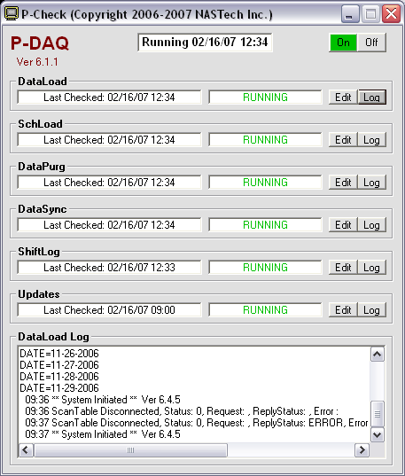

The top center of the screen displays the status and the current time. The top right of the screen provides an On and Off button to start and stop all of the check processes.

The following is the applications and processes that may be monitored:
DataLoad Checks to make sure that DataLoad.exe is running and that there are no communication issues with the host computer.
SchLoad Checks to make sure that SchLoad.exe is running and that there are no communication issues with the host computer.
DataPurg Checks to make sure DataPurg has executed at the scheduled time.
DataSync Checks to make sure that DataSync is running on all Press Computers. Shift supervisors can also be notified to remind the pressman re-run the application upon failure.
ShiftLog Checks to make sure that there are no HOLDS in the ShiftLog older than 14 days. If so, the Administrator will be required to manually COMPLETE them on the server.
Updates Checks for the latest updates on our website, and provides the B-DAQ administrator with a list or current and available system applications.

P-Check will send a Daily report of all running applications and processes at 9am during weekdays to the B-DAQ administrator(s).

Schedules should be set up in such a way to ensure that enough time has passed to allow an application that is scheduled with the windows scheduler to have executed. For example, if DataPurg is scheduled to run weekly, then the schedule for DataPurg should be set to check DataPurg weekly as well.

Each of the applications and processes displays the last time the associated check was performed, the status of the check, an Edit button, and a Log button.

The Log button is used to display the log file for the associated process on the bottom of the screen.

Clicking the Edit button opens the Edit screen for each process as described on the following page.
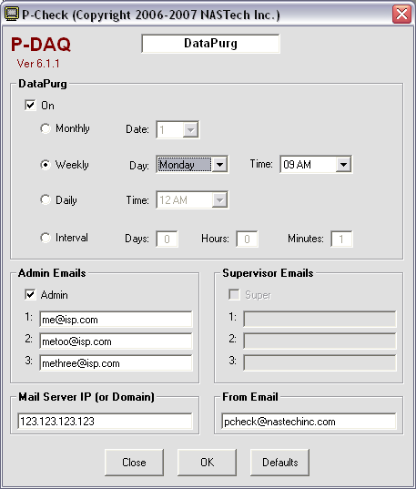

App Section Used to enable the check for the associated application or process, and to schedule the check on the selected date, time, or interval.
Admin Used to turn on the email feature and to list the administrator(s) email address(s). (Email settings are global to all processes)
Supervisor Used to turn on the email feature and to list the supervisor(s) email address(s). (Available for the DataSync application only)
Mail Server Enter the Mail Server’s IP Address or Domain name.
From Email The “From” property on the associated email.
Close Used to close the Edit window without applying changes.
OK Used to apply the changes.
Defaults Used to restore the default settings.

Appendix A Hardware Devices

EP-210
The Computerwise EP-210 module is used to collect data from the machine sensors, PLC’s or Switches. The following information is provided for quick reference only. For more detail or for information regarding hardware options installed, consult the EP-210 manual.

Before the EP-210 may be used with B-DAQ, the module must first be configured. Failure to do so may cause the module and other modules on the sub-net to operate improperly.

Configure
- Before you can use the EP210 with the B-DAQ system, you must configure the IP address of the unit. Each unit should have a unique IP address.
- When connected to the B-DAQ PC, the EP210 must be segregated from the existing network via an Ethernet Switch or a Router.
- When connecting multiple EP210’s you must use a Hub or a switch with enough ports for all units. See the Diagram on the next page for an illustration of this.
- To configure the unit’s IP address, Subnet Mask, or Default Gateway, you must connect the EP210 to a PC serial port with a serial crossover 9pin Female to 9pin Female cable and power the unit.
- Once connected, run HyperTerminal from the Windows Start Menu:
Start – Programs – Accessories – Communications – HyperTerminal.
- Type “EP210” as the name for the connection and click OK.
- Select the COM port you have connected the unit to and click OK.
- For Port Settings, set to 9600 Bits Per Sec, 8 Data Bits, None Parity, 1 Stop Bit, and Hardware Flow Control. Click OK.
- Once you have connected to the unit, hold the [CTRL] key and press the V key on your keyboard 3 times to enter setup mode.
- Type SHOW followed by [Enter] to view the current parameters.
- To make a change to a given parameter, type the parameter name, followed by the = equal sign, followed by the new value, followed by [Enter]. For example: MYIP=123.123.123.123[Enter]
- Repeat this process until all parameters have been set.
- When completed, type SAVE followed by [Enter].
- Disconnect and re-connect the unit from Power. Re-enter setup mode using HyperTerminal and type SHOW followed by [Enter] to double check the new parameters.

Install
- The EP210 is typically installed in close proximity to the signals it will acquire, but may also be installed where the B-DAQ bindery PC resides.

Connect
- The EP-210 is connected to the press signal terminal blocks with a DB-25 cable, and to the PC hub (or Switch or Router) with an Ethernet cable.

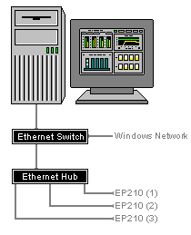

Modular Cables
The following diagram illustrates the basic modular cable requirements of the Bindery Management system. Unshielded twisted pair (UTP) cable is recommended for all modular cabling as it provides protection against electrical interference. It is also recommended that a suitable number of spare devices be kept on hand at all times.

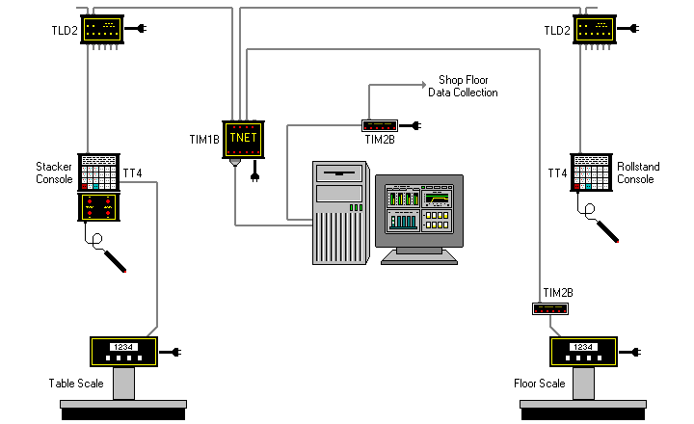

The maximum distance between self-powered components is 2,000 feet. The maximum distance between the TT4 and its power supplying component is limited to 100 feet.

The TLD2 line drivers are only needed if the distance from the TT4’s and the TIM1B exceeds 100 feet and no local power is available for the TT4 terminal.

The TIM2B is only needed if B-DAQ is to interface with the NASTech shop-floor data collection system, or to a floor scale indicator.
Modular Cable

Modular cables are standard 8 conductor "Silver Satin" or unshielded twisted pair (UTP) with RJ-45 connectors. The cable is wired straight through as shown in diagram (same color wire on same side of both connectors). While "Silver Satin" cable is acceptable in most installations, unshielded twisted pair (UTP) cable is recommended as it provides greater protection against electrical interference.

When using twisted pair cable, the pairs should be connected to the connectors as follows:

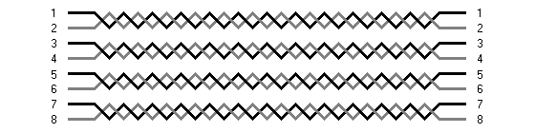

Proximity Sensors
Proximity Sensors are used to provide Gross Count to the system.

Proximity Sensors are purchased and installed by local plant personnel.

Proximity Sensors used should be of the 3 wire PNP (sourcing) type, providing a positive12v DC voltage.

NASTech recommends TURCK brand sensors of this type which have Schmidtt Triggers built in.

Install
- For best performance, all Proximity Sensors should be installed within 1/16 of an inch to the medium that it is sensing.

Connect
- Sensors are connected to the Terminal block provided by NASTech as per the included wiring diagram.

Troubleshoot
- When behaving erratically, make sure the Sensor is tightly connected to its chassis and that it is mounted perpendicular to the medium that it is sensing.
- Ensure that the unit is within 1/16 of the medium that it is sensing.
- Check all wiring from the sensor to the NASTech terminal block.

Appendix B Glossary of Terms
Count Complete | Event | = | Occurs when the required number of books have been produced.
Down-time | Time | = | From the time the machine stops until good books are again produced. By definition, down-time can only occur while the machine is running.
Version Started | Event | = | Occurs once a new job or version is loaded.
Idle-time | Time | = | Accumulated time between forms, and elapsed time for these operations as defined as Idle in the “Oper-code” table.
Makeready I (MR1) | Event | = | Occurs immediately following the version started event.
 | Time | = | Time from initial event to subsequent Makeready II event. Does NOT include Down-Time or Idle-Time.
 | Count | = | Number of these events that occurred during a specified period or for a specified job or version.
Makeready II (MR2) | Event | = | Occurs when Makeready I is active and the machine reaches the Cutoff Speed.
 | Time | = | Time from initial event until at least one good book is counted. Does NOT include Down-Time or Idle-Time.
 | Count | = | Number of these events that occurred during a specified period or for a specified job or version.
 | Waste | = | The number of waste books.
Net Speed |  |  | The number of books produced divided by Run hours.
Net Yield |  |  | The number of net books produced divided by (Run + Down-Time) hours.
Non-Charge Time | Time | = | All time accumulated while B-DAQ is in Stop Mode.
Machine Running | Event | = | Occurs once the first good book reaches the output of the machine.
 | Time | = | From the time of the initial good book until the required count is reached and then the machine speed drops below the Cutoff Speed.
 | Net | = | The number of good books that were saved during the event.
 | Waste | = | The number of waste books that were discarded during the event. Waste accumulated during Restarting is NOT included.
 | Count | = | Number of times the machine stopped during a specified period or for a specified job or version.
 | Waste | = | See Restart events.
Print-time | Time | = | All time that books are being produced (MR2 + Run + Restart).
 | Count | = | Books produced from the time the machine starts running until the end of the job or version, including Down-Time.
Restart Run | Event | = | When the machine speed reaches the Cutoff Speed after a machine stop event. This event is recorded if the associated stop occurred during Run.
 | Waste | = | All waste books produced from the time the machine stopped until good count is achieved.

