

Press Management System

NASTech, Inc.

User
Guide

Version 6
The software described in this document is furnished under a license agreement or nondisclosure agreement. The software may be used or copied only in accordance with the terms of the agreement. It is against the law to copy the software on any medium except as specifically allowed in the license or nondisclosure agreement. No part of this manual may be reproduced or transmitted in any form or by any means, electronic or mechanical, including photocopying and recording for any purpose without the express written permission of NASTech.

NASTech, Inc. reserves the right to make changes to this document and the software described herein at any time and without notice.

Copyright © 1996 - 2014 NASTech, Inc. All Rights Reserved.

NASTech, Inc.
2201 Long Prairie Rd.
Suite 107-338
Flower Mound, TX 75022
(888) 9-NASTECH
www.nastechinc.com

IBM is a registered trademark of International Business Machines Corporation.
Microsoft, MS, and MS-DOS are registered trademarks of Microsoft Corporation.
Windows is a trademark of Microsoft Corporation.
Pentium is a registered trademark of Intel Corporation.
NI-DAQ is a trademark of National Instruments, Inc.
Elo is a trademark of Elo Touch Systems Corporation.
TIM1B, TNET, TIM2B, TT4, are all trademarks of Computerwise Corporation.
Pennsylvania is a trademark of Pennsylvania Scale Corporation.
GSE is a trademark of GSE Scale Corporation.
Primac is a trademark of Vercom Systems Inc.
TURCK is a trademark of TURCK, Inc.
PDF995 is a trademark of Software995 Corperation.

Table of Contents

Chapter 1 Introduction 1
Overview 2
System Features 4
Web Press Support 4
Basic Measurements 4
Statistics 4
Events Recorded 5
Chapter 2 Hardware Installation 6
NASTech Supplied Devices 6
Customer Supplied Devices 7
Electrical Outlets 8
Input Signals 9
Output Signals 11
Install Press Computer Devices 12
System Cabling 13
PCI DAQ 13
EP210 DAQ 14
Peripheral Devices 15
Chapter 3 Software Installation 1
NASTech Supplied Software 1
Customer Supplied Software 1
Initial Installation 2
Server Installation 2
Server Configuration 3
Server SQL Setup 4
Press Installation 5
Press SQL Setup 5
Start P-DAQ 6
Client Setup 7
Client SQL Setup 7
Start PDAQ Client 8
Add Shortcuts 8
Software Updates 9
Manual Updates 9
Automatic Updates 11
Initialization File 12
Constants 12
Database 27
Shop-Floor Interface 27
Network 29
Telnet Interface 30
Edit 31
Label 35
Chapter 4 Press Module 1
Overview 1
Configuration Panel 2
Setup Folder 2
General 2
Roll Stand 4
Ink Meter 5
Delivery 6
Pallet 7
Diagnostics 8
Crew Folder 9
Job Folder 10
New Job Setup 12
Sub-Jobs 13
Zero M/R 15
Report 17
Signature Folder 18
Ganging 20
Performance Folder 21
Status Folder 22
Press Speed Graphic 24
Press Configuration 25
Floor Scale Graphic 26
Scale Adjust 27
Stacker / Pallet Graphic 28
Stacker Adjust 29
Pallet Adjust 30
View Button 31
Shift Notes 31
Shift Log 32
Shift Log Status 34
Oper/Reason Field 36
Multiple-Stop 37
Run Waste 38
Press Log 39
Pallet Log 40
Paper Log 41
Ink Log 42
Pallet Maintenance 43
Pallet Adjustments 44
Paper Maintenance 45
P-DAQ Tutorial 46
Chapter 5 Controlling Counts 1
Stacker Buttons 1
Stacker Switches 2
Floor Scales 2
Divert Gates 2
Laser Counters 2
Conveyor Systems 3
Chapter 6 Stacker Management 4
TT4 Terminal 4
Function Keys 4
Terminal Functions 6
Count Adjustments 9
Stacker Controls 9
Floor Scales 10
Divert Gates 10
Combine Pallets 11
Create Pallet 11
Delete Pallet 11
Chapter 7 Paper Management 1
TT4 Terminal 1
Function Keys 1
Add Stock 2
Remove Stock 2
Clear All Stock 3
Display Stock 3
Terminal Functions 4
Paper Folder 6
Paper Maintenance Screen 7
Chapter 8 Job Scheduling Module 1
Overview 1
Main Screen 1
Summary Screen 4
Signature Definition 6
Paper Definition 8
Ink Definition 9
Chapter 9 Press Status Module 1
Overview 1
Status Summary Screen 1
Status Detail Screen 2
Web Status 3
Chapter 10 Management / Reporting Module 4
Overview 4
Multiple Report View 6
Print Dialog Box 7
Email Dialog Box 8
Charts 9
Press Statistics 9
Stop Analysis 13
System Logs 14
Ink Log 14
Pallet Log 15
Paper Log 16
Press Log 17
Shift Log 18
Job Statistics 19
Job Statistics Report 19
Production Detail by Form 21
Press Statistics 24
EPA Statistics 24
Net Production Report 25
Press Speed & Waste 26
Press Statistics Report (Trend Analysis) 27
Press Statistics Report (YTD Averaging) 29
Production Analysis Report 31
Production Detail by Press 33
Daily Production Summary 36
Production Waste Report 37
Shift Summary Report 38
Stop Analysis Report 40
Crew Reporting 41
Press Statistics Report (Trend Analysis) 41
Press Statistics Report (YTD Averaging) 43
Production Analysis Report 45
Production Detail by Press 47
Production Summary Report 49
Shift Summary Report 51
Paper Statistics 52
Paper Analysis by Job 52
Paper Analysis by Vendor 54
Paper Usage by Job 1 56
Paper Usage by Job 2 58
Paper Usage by Press 60
Paper Usage by Date 62
Ink Statistics 63
Ink Usage by Date 63
Ink Usage by Job 64
Ink Usage by Shift 65
Ink Usage E.P.A. 66
Chapter 11 Utilities 1
Overview 1
P-Maint 1
DataComp 7
DataCopy 8
Auto DataCopy 8
DataDump 9
DataLoad 10
DataPurg 11
DataSync 12
DB_Maint 13
P-Check 15
Appendix A Hardware Devices 1
GSE 350 Floor Scale (TIM2B) 1
GSE 350 Table Scale (TT4) 2
GSE 350 Floor Scale (RS-232 Converter) 3
GSE 350 Table Scale (RS-232 Converter) 4
GSE 460 Floor Scale (Ethernet) 5
GSE 460 Table Scale (Ethernet) 6
GSE 675 Scales (RS-232 Converter) 7
GSE 675 Scales (Ethernet) 8
Pennsylvania Floor Scale 9
Pennsylvania Table Scale 10
TNET Controller 11
TIM2B Controller 12
TT4 Terminal 14
EP-210 17
LED Signs 19
RS-232 Converter 20
Modular Cables 21
Proximity Sensors 23
Appendix B Glossary 1

Chapter 1 Introduction
The NASTech Pressroom Data Acquisition system (P-DAQ) performs real-time data acquisition using advanced electronic press monitoring techniques. P-DAQ is comprehensive system designed to provide management at all levels with the information needed to ensure maximum pressroom efficiency.

P-DAQ supports all aspects of pressroom management including press productivity, performance, waste tracking, paper usage, ink usage and accurate skid counts. A real-time press status module increases efficiency in many areas outside the pressroom as well.

Many years of experience have gone into the design and development of this system. Simplicity, flexibility and high availability were the main criteria under which the software was developed. The system utilizes all the latest technology to provide a sound and long term solution for your business.

NASTech is committed to designing and developing the highest quality software possible and are confident that you will enjoy working with P-DAQ. We look forward to working with you and wish you every success in the future.

Visit our web site at www.nastechinc.com for current news and updates.

Overview
P-DAQ consists of four primary modules, all operating together to provide the highest level of real-time data possible without compromising the fail-safe requirements of the system. Using our unique Bi-directional Data Synchronization Technology, (BDST), the local and remote databases are continuously synchronized.
- The Press Module collects real-time data from each press. The pressman records labor and down-time reason codes. Waste, paper consumption and ink usage are also tracked.
- The Scheduling Module is used to define the requirements of the jobs prior to going to press. Data may be provided automatically by an installed scheduling system.
- The Press Status Module is used throughout the company to view real-time pressroom status information.
- The Management / Reporting Module is used to define the various master files used by the system and to produce the various charts and reports necessary to track and measure pressroom performance.

The File Server contains databases common to all modules. The Management computer may be used as the server on small Peer-to-Peer networks.

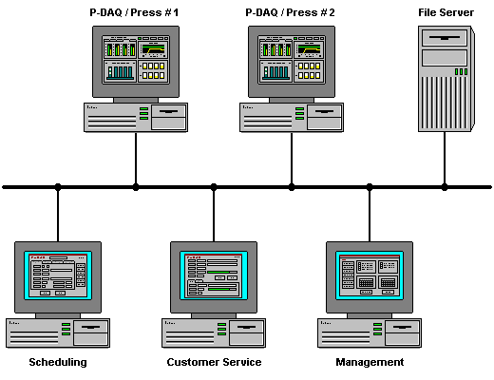

System Features
- Utilizes standard PC computer hardware
- Microsoft Windows-NT/2000/XP graphical interface
- Touch-screen technology
- Client / Server technology
- Shop-floor data collection interface

Web Press Support
- Up to 4 roll stands
- Up to 10 color units
- Up to 4 deliveries

Basic Measurements
- Gross impression count
- Press speed
- Good count by signature
- Good count by pallet
- Roll diameter
- Roll change
- Ink usage by color unit

Statistics
(Maintained by press, by date, by shift, and by job)
- Makeready I time
- Makeready II time + gross + waste
- Makeready III time + gross + waste (awaiting color OK)
- Run time + gross + waste
- Down time + waste (by reason code)
- Number of unscheduled stops
- Good count by form and run number

Events Recorded
- Shift change
- Form started
- Makeready I started
- Makeready II started
- Makeready III started (awaiting press OK - Optional)
- Run started
- Press stopped
- Press re-started
- Press speed change
- Roll change (Optional)
- Ink Consumed (Optional)
- Pallet complete
- Count complete
- Form complete

Chapter 2 Hardware Installation
Hardware components necessary for data acquisition are provided and vary depending on the actual press configuration and the features to be implemented.

NASTech Supplied Devices
NASTech is responsible for providing the following hardware devices when applicable:
- P-DAQ Console for each press, pre-installed with the following:
- ELO Touch Screen Monitor.
- APC UPS Battery Backup System.
- P-DAQ Press Interface Module.
- ComputerWise TNET (TIM1B) Controller. (Optional)
- ComputerWise TIM2B Controller (Optional).
- ComputerWise TT4 Terminal for each delivery, or, 1 per press when deliveries will share this device.
- ComputerWise TT4 Terminal for Roll Stand Station. For users of the P-DAQ Paper Management Sub-System. (Optional)
- ComputerWise TIM2B Controller for each delivery. For floor scales when used. (Optional)
- ComputerWise TIM2B Controller for each press. For users of the NASTech Shop Floor Data Collection System. (Optional)
- ComputerWise TLD2 Line Drivers as needed. (Optional).
- National Instruments Data Acquisition Card(s).
- Various cables as outlined on the System Cabling page of this guide. (Chapter 2 - Page 12)

Customer Supplied Devices
P-DAQ utilizes standard PC hardware. Since the printing press is being monitored in real-time, the faster the press the faster the computer should be.
The customer is responsible for providing the following hardware devices:
- Server computer:
- Windows NT, Windows 2000, or Windows XP.
- At Least a 450 MHz CPU, 40GB HD, 128MB RAM.
- SVGA Video Card, Network Interface Card.
- CD-ROM Drive, Floppy Drive.
- Data Back-Up device.
- Press Computers:
- Windows NT, Windows 2000, or Windows XP.
- At Least a 450 MHz CPU, 40GB HD, 128MB RAM.
- SVGA Video Card, Network Interface Card.
- CD-ROM Drive, Floppy Drive (Optional).
- 2 Serial Ports, 1 Parallel Port.
- Serial Port Card providing 2 additional serial ports.
- GSE Table Scale for each delivery, or 1 per press when deliveries will share this device. (Optional)
- GSE Floor Scale for each delivery. (Optional)
- GSE Floor Scale for the Rollstand station. (Optional)
- Stack Lights. 2 for systems without floor scales (Red, White), 4 for systems with floor scales (Red, White, Blue, Yellow).
- Sensors, Buttons, Switches and associated Electrical wiring.
- Laser Printer for Pallet Load Tickets and for Stock Tags as needed. (HP LaserJet 2300n - recommended)
- Parallel line drivers when used as local printer and printer exceeds recommended distance from computer.
- Flow Meters and Associated Counters for each Color Unit. (Optional)
- Various cables as outlined on the System Cabling page of this guide. (Chapter 2 - Page 12)

Electrical Outlets
- The customer is responsible for providing power to the system.
- The P-DAQ Press Interface Module is mounted on a swing out frame providing access to the back of the computer, keep this in mind when routing the wiring and when Installing AC power outlets in the P-DAQ Console.
- AC power outlets must be installed, knockouts in the P-DAQ console are provided to accommodate conduit. 4 AC outlets are recommended.
- AC power outlets are required for both the optional Sample Scales and for the optional Floor Scales.
- AC power outlets are required for the Laser Printer.
- AC power outlets may be required for the TT4 Terminals located at the Stacker(s) and at the Roll Stand station.

Input Signals
The customer is responsible for providing all input Sensor, PLC, and Control connections between the press and the P-DAQ Press Interface Module. (Note: All input wiring should be shielded to prevent noise)

The input signals to be used vary depending on the configuration of the press and the features of P-DAQ to be utilized. This section outlines the available options, and explains some common installation procedures. Upon installation, more detailed instructions and the necessary wiring diagrams will be provided.

Gross Impressions
- Gross Count - An inductive proximity sensor to monitor revolutions of the plate cylinder. This signal is used to count gross impressions and to derive press speed. This associated sensor is usually installed at the folder cutoff cylinder.
- Paper Present - A sensor used to indicate that paper is present. This is necessary if the press can run without paper. This is usually installed at the last physical color unit.
- PLC - Equivalent input for gross count, speed and paper present may be provided from the PLC. For instance, the PLC may provide a signal representing revolutions of the main shaft and a signal indicating that the folder clutch is engaged.
Net Impressions
- Start/Stop control - A (toggle switch or momentary contact) to indicate that good product is being produced. Separate controls may be installed to control each delivery when applicable.
- Master Start/Stop - A control can also be installed to control good count all deliveries. This is usually installed on the folder and used on presses with more than one delivery.
- Divert Gates - A sensor or PLC signal that indicates that the divert gate is closed.
- Lasers – A laser can also be mounted and wired to provide good count.
Load Tickets
- End of Load - A button (momentary contact) to indicate that the pallet is complete. Separate controls are necessary at each delivery when applicable. If automatic Palletizers are present, a sensor that indicates when each pallet has been completed.

Optional Input Signals
- Folder Active - This sensor is used to indicate that the folder is being used. This signal is generally picked up from the folder clutch solenoid. This is necessary when there is more than 1 folder available.
- Sheeter Active - This sensor is used to indicate that a sheeter is being used. This signal is generally picked up from the sheeter clutch solenoid. Necessary when there is both a sheeter and folder available.
- Blanket Wash - This sensor is used to indicate that a blanket wash has begun. The system will automatically turn off the good counter after a specified number of press revolutions have occurred. This one-shot signal is used to indicate that any of the upper or lower forms in use have been retracted.
- Waste Divert Gate - This automatic sensor is used to indicate that the waste divert gate has been engaged. P-DAQ will consider all signatures produced at this delivery to be waste.
- Good Divert Gate - This automatic sensor is used to indicate that the good divert gate has been engaged. This divert gate is a part of the conveyer system which delivers diverted waste to the waste bin. The purpose of this divert gate is to allow the conveyer system to be used to divert good signatures when a stacker failure occurs. The sensor informs P-DAQ to continue counting while good signatures are being diverted.
- Divert Override - This manual switch is used in conjunction with the divert gate when the waste conveyer system is not present. Its purpose is to inform P-DAQ to continue counting while good signatures are being diverted. This is only used when good signatures may not be delivered to the stacker due to stacker failure.
- End of Lift - input signal used in conjunction with automatic stackers. Indicates the current log has been completed.
- Roll Speed - A sensor or PLC signal which monitors revolutions of each roll.
- Roll Splice - A sensor or PLC signal to indicate that a splice has occurred.
- Ink Consumed - A digital signal whose rate indicates the rate of ink flow for each of the color units to be monitored.

Output Signals
The customer is responsible for providing all output Sensor, PLC, and Control connections between the P-DAQ Press Interface Module and the press. (Note: All wiring should be shielded to prevent noise)

The output signals to be used vary depending on the configuration of the press and the features of P-DAQ to be utilized. This section outlines the available options, and explains some common installation procedures. Upon installation, more detailed instructions and the necessary wiring diagrams will be provided.

Output signals may be used to control any external function such as lighting an indicator, sounding an alarm, initiating a press shutdown sequence, etc… In order to utilize these signals, a relay will be provided and the external device must be wired accordingly.

The available output signals are as follows:
- Waste - Waste being accumulated (red stack light).
- Count Complete - Count Complete (white stack light).
- Bin Full - Floor scale bin is full (blue stack light) (Optional).
- Scale unstable - Floor scale unstable (yellow stack light) (Optional).
- Force Form Change - Used to change forms for Zero M/R presses (Optional).
- Shutdown Press - Count & overrun complete (Optional).

The output signals can be set to behave as follows:
- Remain on while condition exists.
- Alternate on and off at a specified rate.
- Turn on for a specified time and then turn off.
- Trigger other output signals.

Install Press Computer Devices
- Install the serial port card. Refer to manufacturer’s documentation for details.
- Install the network interface card. Refer to manufacturer’s documentation for details.
- Install the Data Acquisition Card(s), the “Measurement and Automation” software and configure. Refer to National Instrument’s documentation for more details.
- Install the ELO Touch monitor software and configure. The monitor should be configured to use Serial Port 2. Refer to ELO’s documentation for more details.
- Install the Laser Printer and software drivers. Refer to the Manufacturer’s documentation for details.
- Connect the TNET Controller to Serial Port 1
- Connect the ELO Monitor to Serial Port 2, and to the Video card.
- Connect the TIM2B to Serial Port 3, and the Cat-5 to the Shop Floor Data Collection network (optional)
- Connect the UPS to Serial Port 4.

System Cabling

PCI DAQ
The following diagram illustrates the basic cabling requirements of the press management system utilizing PCI Data Acquisition cards and a Computerwise TNET sub-network for connectivity to scales.

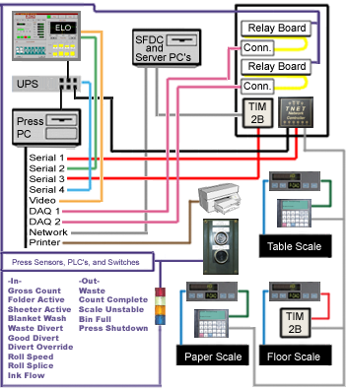

Electrical Wiring, supplied by user.
Video Cable, M14 to M14 supplied by manufacturer.
Serial Cable, F9 to M9 supplied by manufacturer.
Serial Cable, F9 to M9 supplied by manufacturer.
Ribbon Cable, F68 to F68 supplied by NASTech.
Serial DB25 Cable, F9 to M25, supplied by NASTech.
Serial Cable, F9 to F9 supplied by NASTech.
CAT5 Cables (straight through), supplied by user.
Parallel Printer Cable supplied by manufacturer.
Parallel Line Drivers supplied by user (Optional).
Cable supplied by Scale manufacturer. (Optional)

EP210 DAQ
The following diagram illustrates the basic cabling requirements of the press management system utilizing a sub-network of EP210 Data Acquisition cards and Ethernet connectivity to scales.

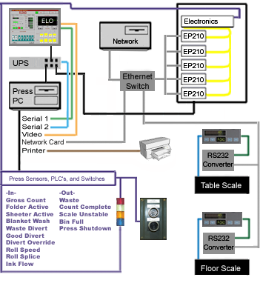

Electrical Wiring, supplied by user.
Video Cable, M14 to M14 supplied by manufacturer.
Serial Cable, F9 to M9 supplied by manufacturer.
Serial Cable, F9 to M9 supplied by manufacturer.
Serial Cable, F9 to F9 supplied by NASTech.
CAT5 Cables (straight through), supplied by user.
RS-232 (Gridconnect Net232 F-F) supplied by NAStech.
Parallel Printer Cable supplied by manufacturer.
Parallel Line Drivers supplied by user (Optional).
Cable supplied by Scale manufacturer. (Optional)

Peripheral Devices
The peripheral devices needed vary depending on the configuration of the press and the features of P-DAQ to be utilized. These devices are installed by the customer as per manufacturer installation procedures. They are to be connected to the system and configured as described in Appendix A at the back of this guide:

- GSE 350 Floor Scale (TIM2B)
- GSE 350 Table Scale (TT4)
- GSE 350 Floor Scale (RS-232)
- GSE 350 Table Scale (RS-232)
- GSE 460 Floor Scale (Ethernet)
- GSE 460 Table Scale (Ethernet)
- GSE 675 Scales (RS-232)
- GSE 675 Scales (Ethernet)
- PENN Table Scale
- PENN Floor Scale
- TNET Controller
- TIM2B Controller
- TT4 terminal
- EP210
- LED Sign
- RS-232 Converter

Chapter 3 Software Installation

NASTech Supplied Software
NASTech is responsible for providing the following software:
- National Instruments Measurement and Automation Software.
- ELO Touch Tools Software. (Optional)
- APC Power Chute Software. (Optional)
- P-DAQ Installation CDROM.

Customer Supplied Software
The customer is responsible for providing the following software:
- Server computer
- Windows NT, Windows 2000, or Windows XP.
- Microsoft Access.
- Microsoft SQL Server. (Optional)

- Press Computers:
- Windows NT, Windows 2000, or Windows XP.

Initial Installation
P-DAQ is installed onto your hard disk using a special installation program. The contents of the installation CD may be copied to your file server to simplify the installation for multiple presses. This must be the method used if a CD-ROM drive is not available on the P-DAQ press computer(s). The P-DAQ directory on the file server into which the system is installed must have read/write access from each of the client computers.

Server Installation
- Set Control Panel \ Regional Settings \ Short Date to “MM/dd/yy” and enter the correct date.
- Set Control Panel \ Regional Settings \ Time to “HH:mm:ss” and enter the correct time.
- Insert the installation CD in the CD-ROM drive.
- FROM CD - Locate the PDAQ-Server installation directory on the CD. Execute Setup.exe and follow the directions on the screen to set up P-DAQ.
- FROM WEB – Download the PDAQ_Server Installer from our Website support page. Unzip and Execute
- Select the location for the P-DAQ directory, and finish the installation.
- Note: After Installation, you may be prompted to restart the server as various DLL and OCX files may need to be registered in Windows. You may continue the installation and schedule this restart at a more convenient time if necessary.
- Copy the directories from the CD to the PDAQ\Install directory.
- Copy all the P-### directories from the Floppy Disk or CD to the PDAQ directory.
- Install SQL Database Software. Refer to Microsoft’s documentation for more information (Only if you will be using SQL databases).

Server Configuration
- Open the “System.ini” file located in the C:\PDAQ\Shared directory. Edit and save the file as follows:
- Init Path = "Init"
- Local Base Path = "\PDAQ"
- Network Base Path = "YourServer\PDAQ”
- ‘ DBTYPE = "SQL" (If you are using a SQL server Database, remove the ‘ (apostrophe) at the beginning of the line.
- Edit Security.ini in the PDAQ\Shared\Init directory. This will allow users to have read/write access to various programs. For example:
- [P-Sched]
- Default = "Read"
- Administrator = "Update"
- JOHN SMITH = “Update”
- Edit DataPurge.ini in the PDAQ\Shared\Init directory. DataPurge.exe allows redundant data to be deleted from the server. The entries made to this file should be specified in military time, a short period of time right after the scheduled network backup. The “DataPurge.exe” file may be left running on the server at all times, or you may schedule the task using Windows Scheduler to perform the purge on a weekly or monthly basis. For example:
- BegPurgeTime = 05:00
- EndPurgeTime = 06:00
- Edit DataSync.ini in the PDAQ\Shared\InitPress directory. “DataSync.exe” automatically transfers data to and from each press computer and the server. While this is a necessary function of the system, data should not be transferred while the server is performing its scheduled backup. The entries made to this file should be specified in military time, as a window of time at which the network backup occurs. For example, if the network backup begins at 2AM:
- Beg Save Time = 01:00
- End Save Time = 04:00
- Run P-Maint.exe from the PDAQ\Shared directory and update the Following Tables. These tables may be set up by NASTech personnel prior to installation. (For more help on running P-Maint, refer to the Utilities section of this guide):
- Press
- Cost Center
- OperCode
- Form Type
- Pallet Type

Server SQL Setup
- (Skip this section if you are not running SQL server).
- Install Microsoft SQL Server on P-DAQ Server.
- Execute “Start…Programs…Microsoft SQL Server…Query Analyzer”.
- Open “PDAQ\Shared\Database\PDAQ6.SQL.
- Execute SQL script to create PDAQ database(s).
- Set permissions for P-DAQ press and client computers.
- Execute “Start…Programs…Microsoft SQL Server…Import and Export Data”.
- If importing from Access Databases:
Select Source = Microsoft Access = “PDAQ\Shared\Database\Remote.mdb”.
- If importing from SQL Databases:
Select Source = Microsoft SQL = “PDAQ\Shared\Database\”.
- Select Destination = “PDAQ” database.
- Select ALL tables. Un-select ALL Queries.
- Continue with import.
- Execute “Start…Programs…Microsoft SQL Server…Import and Export Data”.
- Select Source = Microsoft Access = “PDAQ\Shared\Database\Stats.mdb”.
- Select Destination = “PDAQ” database.
- Select ALL tables. Un-select ALL Queries.
- Continue with import.

Press Installation
- Set up a user on the machine as an administrator.
- Log Into the machine with the user you just created.
- Set Control Panel \ Regional Settings \ Date to “MM/dd/yy” and enter the correct date.
- Set Control Panel \ Regional Settings \ Time to “HH:mm:ss” and enter the correct Date & Time.
- FROM CD - Execute “Setup.exe” from the PDAQ/Install/PDAQ-Press directory on the file server, or from the PDAQ-Press directory on the CD.
- FROM WEB – Download the PDAQ_Press Installer from our Website support page. Unzip and Execute.
- Follow the directions on the screen to set up P-DAQ. Install the software in the C:/Program Files directory, and finish the installation.
- Open the “System.ini” file located in the C:/Program Files (x86)/PDAQ directory. Edit and save the file as follows:
- Init Path = "Init"
- Local Base Path = "C:\Program Files\PDAQ"
- Network Base Path = "YourServer\PDAQ"
- ‘ DBTYPE = "SQL" (If you are using a SQL server Database, remove the ‘ (apostrophe) at the beginning of the line.

Press SQL Setup
- Create ODBC Data Source Name (DSN) called PDAQ for new PDAQ SQL Server database.
- Start - Settings - Control Panel - Administrative Tools - Data Sources - ODBC. Click “Add”. Select SQL Server, Click “Finish”.
- Name the database (PDAQ), and select the NASTech Server.
- NT or SQL authentication? It is recommended that NT authentication is used. If so, the NT password setup on the computer will allow access to the SQL database.
- NT or SQL authentication? If SQL authentication is used, the following lines of code MUST be added to the C:/ProgramFiles/PDAQ/System.ini file:
- DB Name = PDAQ
- Database = PDAQ
- User Name = your computer’s User Name
- Password = your SQL Password
- Click “Change Default DB to”, Select PDAQ Database, Click Next.

Start P-DAQ
- Go to Start Menu → Programs → PDAQ-Press Module → SysUpd, right-click the SysUpd icon and select Properties. Edit and save the shortcut as follows:
- Target: YourServer/PDAQ/Shared/SysUpd.exe
- Start In: C:/Program Files (x86)/PDAQ/
- Run Start Menu → Programs → PDAQ-Press Module → SysUpd and click the Update button.
- Run DataSync from the Desktop and click the Continue button.
- Data Sync will now transfer data from the server and populate the Remote database at the press. Please allow a few minutes for this process to take place.
- Start P-DAQ, when prompted; enter the pallet ID format. NASTech personnel will provide a list of pallet ID numbers prior to installation. You may also find the load ticket format in the associated Pressman.ini file located in the C:\Program Files\ PDAQ\Init directory.
- If you are using a check digit on your Load Tickets enter the prefix letter followed by 7 zeros. If you are not using a check digit, enter the letter prefix followed by 6 zeros.

Client Setup
- FROM CD - Execute “Setup.exe” from the PDAQ/Install/PDAQ-Client directory on the file server, or from the PDAQ-Client directory on the CD.
- FROM WEB – Download the PDAQ_Client Installer from our Website support page. Unzip and Execute.
- Follow the directions on the screen to set up P-DAQ. Install the software in the C:/Program Files (x86) directory.
- Open the “System.ini” file located in the C:/Program Files (x86)/PDAQ-Client directory. Edit and save the file as follows:
- Init Path = "Init"
- Local Base Path = "C:\Program Files(x86)\PDAQ-Client"
- Network Base Path = "YourServer\PDAQ"
- ‘ DBTYPE = "SQL" (If you are using a SQL server Database, remove the ‘ (apostrophe) at the beginning of the line.

Client SQL Setup
- Create ODBC Data Source Name (DSN) called PDAQ for new PDAQ SQL Server database.
- Start - Settings - Control Panel - Administrative Tools - Data Sources - ODBC
- Click “Add”. Select SQL Server, Click “Finish”.
- Name database (PDAQ), and select NASTech Server.
- NT or SQL authentication? It is recommended that NT authentication is used. If so, the NT password setup on the computer will allow access to the SQL database.
- NT or SQL authentication? If SQL authentication is used, the following lines of code MUST be added to the C:/ProgramFiles/PDAQ-Client/System.ini file:
- DB Name = PDAQ
- Database = PDAQ
- User Name = your computer’s User Name
- Password = your SQL Password
- Click “Change Default DB to”, Select PDAQ Database, Click Next.
- Test the connection.

Start PDAQ Client
- Go to Start Menu → Programs → PDAQ-Client Module → SysUpd, right-click the SysUpd icon and select Properties. Edit and save the shortcut as follows:
- Target: YourServer/PDAQ/Shared/SysUpd.exe
- Start In: C:/Program Files(x86)/PDAQ-Client/
- Run Start Menu → Programs → PDAQ-Client Module → SysUpd and click the Update button.
- Start P-Sched, P-Status, and P-Admin, from Start Menu → Programs → PDAQ-Client

Add Shortcuts
- You should also create a folder on the desktop called PDAQ. Add the following to the folder:
- Shortcut to P-Admin
- Shortcut to P-Status
- Shortcut to P-Sched
- Shortcut to the Tutorial, which is on the Server PDAQ/P-Tutorial/PDAQ-Tutorial.htm
- Shortcut to our Website which is www.nastechinc.com
- Shortcut to a new file called "Password.txt" (Create this file, add the following text, and save):
    - Username = yourcompanyname (all lowercase)
    - Password = support
- Let the users know that our UserGuide is available for viewing online. If you open it online versus downloading it, the worddoc contains hyperlinks in the Table of Contents. All of the report calculations are available there.

Software Updates
Customers will be notified by email when software updates are available for download. It is recommended that you update the software within a reasonable time frame as to avoid redundant support issues.

The PDAQ support page on our website always contains the latest updates, as well as version specific information relating to each updated program. Check our support pages periodically for additional information.

Manual Updates
Manual Updates to the software are handled as follows:
- Delete all files from the PDAQ/Shared/SoftwareUpdate directory.
- Download and save the .zip file to the PDAQ/Shared/SoftwareUpdate directory.
- Unzip the downloaded file and save its contents to the PDAQ/Shared/SoftwareUpdate directory.
- Updates can be installed on a press by press basis for testing purposes. To do so, edit and save (create if not present) the Update.ini file located in the PDAQ/Shared/Init directory to include the cost center number(s) to receive the update. For example:
- Update = 345
- Update = 456
- Update = All (Change back to this when testing is complete, to update all presses)
- Updates can be installed to the Press Computers at select days of the week, and select times of the day to ensure that local IT and NASTech support staff are available for troubleshooting. To do so, add the following to the [Constants] section of the Pressman.ini file. For example:
- Update Days = “MON,TUE,WED,THU,FRI”
- Update Times = “08:00-12:00,13:00-16:00
- Run Install.bat from the PDAQ/Shared/SoftwareUpdate directory and wait for completion.
- Run DataComp.exe from the PDAQ/Shared directory, and click the Continue button. If database field mismatches are present...
- With SQL 2003 and prior: Run the included Update2003.SQL script in SQL Query Analyser, and run DataCopy.exe from the Start Menu at EACH press between forms.
- With SQL 2005: Run the included Update2005.SQL script in SQL Query Analyser, and run DataCopy.exe from the Start Menu at EACH press between forms.
- Without SQL: Run DataCopy.exe from the PDAQ/Shared directory on the server, and from the Start Menu at EACH press between forms.
- Client PC Update: The updated files will be transferred and installed at each client computer automatically when each associated program is terminated and re-executed.
- Press PC Update: The updated files will be transferred and installed at each press computer automatically between forms, or to select press computers as per the entries in the Update.ini file.
- SysUpd.exe: The updated files may be transferred and installed manually to each Press/Client computer by running the SysUpd.exe program at the associated computer. NOTE: This option overrides the Update Day and Time parameters added to the Pressman.ini file.

.

Automatic Updates
Automatic software updates from our FTP site are handled as follows:

- Execute the NASTechFTP program from the PDAQ\Shared directory on the server. The updates will be downloaded to the server and the new files will be transferred automatically to each press/client computer.

- Allowing the NASTechFTP program to be continually running on the server ensures the latest versions of the software will be installed automatically as they become available.

- Automatic updates may be restricted to specified days of the week and at specified times during the day via the NASTechFTP.ini file located in the PDAQ\Shared\Init directory on the server.

- Using Windows “Scheduled Tasks”, you may schedule the NASTechFTP program to run at the specified time(s). The following is the procedure to set up the task:

- Choose Start\ControlPanel\SheduledTasks.
- Click “Add Scheduled Task”.
- Click “Next”.
- Click the “Browse” button and browse the server to the PDAQ\Shared directory and select NASTechFTP.exe.
- Follow the instructions to select the time and enter the user name and password when prompted if necessary.
- Check the box marked “Open Advanced Properties for this Task when I click Finish” button and click the Finish button.
- In the Run field, change the path to read exactly as in the following: C:\PDAQ\Shared\NASTechFTP.exe AUTO
- In the Start In field, make sure the path is as following: C:\PDAQ\Shared

Initialization File
The Pressman.ini file is used to set the editable parameters of the system. NASTech will provide a custom Pressman.ini file based on the parameters determined to be needed during the implementation phase of the project.

These parameters may be changed at any time by the customer when needed. Changes should be made to the Pressman.ini file that resides on the P-DAQ server in the P-### directories. Pressman.exe must be restarted when changes are made to this file.

The parameters are divided into multiple sections as described below. Entries may be added or modified as required. Upper and lower case may be used as desired with additional spacing for readability since all characters are converted to lower case and imbedded spaces are discarded prior to evaluation.

Constants
Parameter | Default | Description
Allow MR2 Entry | No | This entry allows Manual Entries to be added during Makeready 2.  Example: AllowMR2Entry = Yes
Auto Lift Gen  (Automatic Stackers) | No | Causes the system to force an end of lift when the number of signatures specified by the “Sigs / Lift” parameter on the signature panel has been delivered to the stacker. The “Stacker Modulo” parameter should be set to insure that all lifts are the same size.  Example: AutoLiftGen = Yes
Auto MR2 Entry | No | This entry automatically adds a Manual Entry for a press stop during Makeready 2. The Manual Entry cannot be deleted and the time cannot be changed.  Example: AutoMR2Entry = Yes
Auto Start Run | No | Tracks inactivity of waste scale to trigger run mode. When the difference between the gross count and the scale waste is equal to the parameter specified, the system automatically places the press into its “Running” status. The second parameter is used during the “Restarting” phase in the same manner.  Example: Auto Start Run = Yes, 1500, 500
Auto Set Scale | No | Used to automatically sync Floor Scale waste count to P-DAQ waste count at the end of Makeready. Parallels the “Set Scale Waste” option available to pressmen via the floor scale graphic.  Example: Auto Set Scale = Yes
Auto Ticket Gen  (Automatic Stackers) | No | Causes the system to force an end of pallet when the number of lifts specified by the “Lifts / Pal” parameter on the signature panel has been delivered to the pallet.  Example: AutoTicketGen = Yes
Aux Operation Codes  (Older Versions) |  | This entry can be used to limit the codes listed for selection of Manual Entries in the Shift Log to those with matching codes in the “OperData2” column of the “OperCode” table.  Example: Aux Operation Codes = “M”
Aux Reason Codes  (Older Versions) |  | This entry can be used to limit the codes listed for selection of down-time entries in the Shift Log to those with matching codes in the “OperData2” column of the “OperCode” table.  Example: Aux Reason Codes = “DT” | **
Blanket Wash Control  (Blanket Wash Sensor) | 0 | The number of revolutions of the impression cylinder to delay prior to the first bad signature entering delivery zone 1. Used when a Blanket Wash sensor is present.  The second number represents the number of sigs to produce before automatically turning the counters back on.  Example: Blanket Wash Control = 40, 100
Blanket Wash Delay  (Blanket Wash Sensor) | 0 | The number of revolutions of the impression cylinder to delay prior to the first bad signature entering delivery zone 1. Used when a Blanket Wash sensor is present.  Example: Blanket Wash Delay = 40 | **
Bypass MR-3 | no | P-DAQ tracks the time saving product prior to receiving the press OK. This parameter can be used to ignore this condition and follow MR-2 with Run status.  Example: Bypass MR-3 = yes
Capture Crew | No | Allows the capture of timesheet data for all members of the crew.  Example: Capture Crew = Yes
Chart Max Speed | 90000 | This is the maximum speed which may be plotted on the Speed Chart. Valid entries are 15000, 30000, 60000, 90000, 120000, 180000 or 240000.  Example: Chart Max Speed = 60000
Conveyer Min Speed | 0 | The minimum speed at which the conveyer runs when the press is not running. This entry is used to control the rate at which sigs on the conveyer are counted.  (Impressions per Hour)  Example: Conveyer Min Speed = 1000
Cost Center |  | Press cost center ID.  Example: Cost Center = “451”
Cost Center Desc |  | Type and model of press.  Example: Cost Center Desc = “Harris M-1000”
Crew ID | Emp ID | This entry defines whether the crew ID will be defined by the shift number or by the employee ID. Auto gets shift info from employee table, manual defaults from employee table and allows it to be changed.  (Shift, Emp ID, Auto, Manual)  Example: Crew ID = Emp ID
Cutoff Length | 24 | The cutoff length of the press.  Example: Cutoff Length = 22.7500
Default Idle Code |  | This entry is used to define the code used for Idle-time between forms.  Example: DefaultIdleCode = 0999
Default Lift Count | 2000 | This is the default number of signatures which make up a lift. The actual lift count is calculated by averaging the lifts on the first pallet. Valid entries are 100 to 20000 inclusive. If set to 0, then system always uses previous entries when not defined in schedule.  Example: Default Lift Count = 4000 | **
Default Lifts Per Skid | 12 | This is the default number of lifts which can be placed on a pallet. Actual number of lifts is calculated by the system from the first pallet. Valid entries are 1 to 100 inclusive. If set to 0, then system always uses previous entries when not defined in schedule.  Example: Default Lifts Per Skid = 16 | **
Default MR1 Code  Default MR2 Code  Default Run Code  Default Wash-up Code |  | P-DAQ needs to know the operation codes to use when passing information on to job costing. These entries define the default codes to be used.  Example: Default MR1 Code = “1000” | **
Default Run Waste |  | Used to default run waste codes based upon the total number of waste signatures produced. Enter the code, followed by the maximum number of waste sigs produced to be automatically attributed to the code. Used in conjunction with “Track Run Waste”  Example: Default Run Waste “3002”, 100  Default Run Waste “3003”, 200
Deliveries/Signature | 1 | This number indicates the number of deliveries which are fed with the same signature in an alternating fashion. If this entry is 2, then signatures can be delivered to 2 different deliveries at the same time.  Example: Deliveries/Signature = 2
Delivery Zones n |  | To further increase accuracy, P-DAQ can track the approximate number of signatures present on the conveyer belts for delivery n. Zone 1 represents the number of signatures between the folder and the end of the folder conveyer. Zone 2 is the number of signatures on the continuously running conveyer between the folder and the divert gate. Zone 3 is the number of signatures between the divert gate and the stacker. If a divert gate is not present, zone 3 should be set to 0. Values for zones 1, 2 and 3 are separated by commas. An optional forth parameter is used to define the form type. If the number of sigs present in any delivery zone is affected by shingling associated by the form type, make another entry for each form type. Otherwise, the default parameter will always be used.  Example: Delivery Zones 1 = 25,50,100  Example: Delivery Zones 1 = 13,25,50,CH16  Example: Delivery Zones 2 = 45,70,100  Example: Delivery Zones 2 = 24,35,50,CH16 | **
Emp Overlap Code |  | P-DAQ needs to know the non-chargeable operation code to use for shift overlap when passing information on to job costing. This is done to prevent double charging a job.  Example: Emp Overlap Code = “8001” | **
ERP |  | Specifies the ERP system used by the plant. Used to have the OperCode and not the OperAlternate to print on the ShiftDetail Report.  Example: ERP = GTC  ERP = Primac
Force Form Change | Error | Used to display warning message and/or force an error when starting a form that has already been run. The form is considered previously run if any MR-2 time has been accumulated for the form.  (warn, no, error)  Example: Force Form Change = no
Force Idle Mode | Error | This entry allows either a warning message or an error to be displayed when an employee signs off without shift relief or without an Idle code entered into the shift log.  (Warn, Error)  Example: Force Idle Mode = warn
Force MR1 Code  Force MR2 Code  Force Run Code  Force WSH Code | no | This entry is used in conjunction with the “Labor” parameter. This parameter causes the system to display an error when the associated code has not been entered into the Setup Folder of the main screen.  Example: Force MR1Code = Yes
Form Type List |  | Used to limit the form types to be used on a press by press basis.
Full Skid Tare | 0 | Used to enter weight of a skid used to hold signatures, this data is passed on to the WIP system to calculate the total weight of product to be shipped.  Example; Full Skid Tare = 150
Ganging  (Multi Delivery Presses) | no | Allows more than 1 job to be run at a time via multiple deliveries. Enables the job number field in the SIGS tab, this is the job number to be printed on the associated load ticket.  Example: Ganging = yes
Group Code Flag | no | Down-time reason codes may be grouped for selection. When this flag is turned on, P-DAQ displays the group codes first, followed by the reason codes for the selected group.  Example: Group Code Flag = yes | **
Grp Operation Codes  (Older Versions) |  | This entry can be used to limit the codes listed for selection of manual entries in the Shift Log to those with matching codes in the “OperGroup” column of the “OperCode” table.  Example: Grp Operation Codes = “00” | **
Grp Reason Codes  (Older Versions) |  | This entry can be used to limit the codes listed for selection of down-time entries in the Shift Log to those with matching codes in the “OperGroup” column of the “OperCode” table.  Example: Grp Reason Codes = “99” | **
Half Skid Tare | 0 | Used to enter the weight of the skid used in conjunction with a sheeter if present. The data is passed on to the WIP system to calculate total weight of product to be shipped.  Example: HalfSkidTare = 75
Help Link |  | Used to open P-DAQ tutorial via the View button on the main screen. This parameter is used to enter the path and file name of the tutorial files.  Example: Help Link = C:\Program Files\Internet Explorer\Iexplore.exe \\yourserver:\PDAQ\P-Tutorial\PDAQ-Tutorial.htm
Idle Code List |  | Used to enter the Idle codes for which a password is required. Used in conjunction with the “Idle Password” parameter.  Example: Idle Code List = 3450,3452,3456
Idle Password | No | Used to force the operator to get a supervisor password before entering an Idle code in the ShiftLog. Used in conjunction with the “Idle Code List” parameter.  Example: Idle Password = 368567
Ink Drying Time |  | Allows the Ink Drying time to be listed as the actual time on the load ticket for sheet fed presses. IE…Will be dry at…The load ticket will reflect the current time the ticket was produced plus this entry in minutes.  Example: Ink Drying Time = 5
Job Report | No | Allows for the printing of the “Production Detail by Form” report at the press. This parameter enables the Report button on the Job folder, and can also allow the report to print upon completion of each form.  Examples: Job Report = No  Job Report = Yes, Manual  Job Report = Yes, Auto
Job Sched Desc | C | P-DAQ normally displays the customer name to identify scheduled jobs. This parameter can be used to change the default display to the (J)ob or (F)orm description.  Example: Job Sched Desc = “F” | **
Job Sched Sort | “S” | Determines the default sorting of jobs on the job schedule screen. Jobs can be listed numerically in ascending order by (S)equence number or by (J)ob number.  Example: JobSchedSort = “J”
Laser Gap Count | 25 | Used to set the number of signatures of gap to change from ZMR to ZMR, or from SubJob to SubJob.  Example: LaserGapCount = 10
Labor | No | This entry is used to record Labor by operation code for use by cost accounting. Secondly, this entry is used to warn or force the pressman to enter the MR1 and Run codes in the Setup Folder of the main screen. Also allows these codes to be cleared for subsequent entry when a new form is started. The following are the possible entries and the associated results.  Examples:  Labor = Yes (Forces)  Labor = Yes, Warn (Warns)  Labor = Yes, Force, Clear (Forces, Clears)  Labor = Yes, Warn, Clear (Warns, Clears)
Load Master Job | Yes | Used to load the associated Master Job into the Sub-Job dialog box along with the associated Sub-Jobs.
Load Ticket Copies | 1 | Specifies the number of Load Tickets to be printed for completed pallets.  Example: Load Ticket Copies = 2 | **
Load Ticket Printer |  | Specifies the printer to be used for Load Tickets. Where “n” is the delivery number.  Example:  LoadTicketPrinter n =“\\SERVER\HPLaserjet4P”
Maintenance Log Interval | 0 | The number of seconds between updates to the Maintenance Log. This log is used to record the total number of impressions counted since P-DAQ was installed. The log may be used by other systems to determine blanket wear etc.  Example: Maintenance Log Interval = 120 | **
Maximum Slab Waste  (Web Presses) | 0 | The threshold for the amount of excessive slab waste (in pounds) which when exceeded will require an op-code.  Example: Maximum Slab Waste = 30
Maximum Slab Waste Sheet  (Sheet Fed Presses) | 0 | The threshold for the amount of excessive slab waste (quantity or pounds – see “Skid Slab Waste” parameter) which when exceeded will require an op-code.  Example: Maximum Slab Waste = 30
Mill Roll ID Tracking | no | Used to indicate that the Mill Roll ID number is normally used to identify the roll in the inventory system.  Example: Mill Roll ID Tracking = Yes
MR-1 Auxiliary Codes  (Older Versions) |  | This entry can be used to limit the codes listed for selection to those with matching codes in the “OperData2” column of the “OperCode” table.  Example: MR-1 Auxiliary Codes = “MR” | **
MR-1 Group Codes  (Older Versions) |  | This entry can be used to limit the codes listed for selection to those with matching codes in the “OperGroup” column of the “OperCode” table.  Example: MR-1 Group Codes = “01,02” | **
MR-1 Operation Codes  (Older Versions) |  | This entry can be used to limit the codes listed for operation code selection.  Example: MR-1 OperationCodes =“1400,1500” | **
MR-2 Auxiliary Codes  (Older Versions) |  | This entry can be used to limit the codes listed for selection to those with matching codes in the “OperData2” column of the “OperCode” table.  Example: MR-2 Auxiliary Codes = “MR” | **
MR-2 Group Codes  (Older Versions) |  | This entry can be used to limit the codes listed for selection to those with matching codes in the “OperGroup” column of the “OperCode” table.  Example: MR-2 Group Codes = “01,02” | **
MR-2 Operation Codes  (Older Versions) |  | This entry can be used to limit the codes listed for operation code selection.  Example: MR-1 Operation Codes=“2400,2500” | **
Operation Codes  (Older Versions) |  | This entry can be used to limit the codes listed for selection of manual entries in the Shift Log.  Example: MR-1 Operation Codes=“0151,0152” | **
Oper List Active | no | This entry can be used to limit the codes listed for selection of operation codes to those flagged in the OperCode table.  Example: Oper List Active = yes
Oper Sub-Cat Active | no | This entry can be used to activate the categorization of reason codes to Man, Machine, Material or External related.  Example: Oper Sub-Cat Active = yes
Pallet Type List |  | Allows more than 1 pallet type to be selected by press. The pallet type appears on associated load tickets. The available pallet types for all presses are defined in the PalletType table in the database.  Example: PalletTypeList = “Normal”, “Samples”
Pallet Warning | no | Used to display warning message when P-DAQ Stop button is pressed and when there is product in the stacker or pallet. Gives the operator the option to Ignore the warning, or cancel the stop request to make a count adjustment.  (yes, no)  Example: Pallet Warning = yes
Paper Usage  (Paper Management) | no | Used to indicate that the papet management sub-system is used and that paper transactions are sent to the cost accounting system.  Example: Paper Usage = yes | **
Piece Weight Divisor | 1 | This parameter allows the piece weight to be divided by the number specified in the Sigs/Imp field. It is used when you are producing more than 1-up, and the product is not to be cut.  Example: Piece Weight Divisor = #
Piece Weight Variance  (Floor Scales) | 3 | The allowable variance % between the calculated piece weight and measured piece weight before a warning message is displayed. Valid values are 1 to 5 inclusive.  Example: Piece Weight Variance = 5
Piece Weight Warn  (Floor Scales) | 500 | This parameter instructs P-DAQ to display the specified message if 500 good impressions have been produced and the operator has not yet performed an actual piece weight calculation. The count can be any positive number including 0.  Example: Piece Weight Warn = 500, “Derive Actual Piece Weight”
Press Cutoff Speed | 3000 minus  50% | This is the minimum (Turn On) speed which must be reached by the press in order to be considered running by P-DAQ. (Generally the minimum speed at which product can be saved). The second number is the (Turn off) speed reached by the press to be considered NOT running by P-DAQ. If there is no second number, the default is 50% of the cutoff (Turn On) speed.  (Impressions per Hour)  Example: Press Cutoff Speed = 4000, 1000 | **
Press Speed Variance | 1800 | This is the minimum change in press speed (IMP/HR) which is to be recoded in the Press Log.  Example: Press Speed Variance = 3000 | **
Press Type | W | Press type. Valid entries are (S)heet-fed, (W)eb.  Example: Press Type = “S”
Rated Speed | 60000 | The maximum rated speed of the press.  Example: Rated Speed = 70000
Reason Codes  (Older Versions) |  | This entry can be used to limit the codes listed for selection of down-time entries in the Shift Log.  Example: Reason Codes = “0951,0952” | **
Report Idle Time | no | Used to report the “Default Idle Code” to the cost accounting system.  Example: Report Idle Time = yes
Roll Core Diameter  (Paper Management)  (Web Presses) | 4.375 | This is the default core diameter to be used for roll stock if the same diameter core is to be used on all rolls.  Example: Roll Core Diameter = 4.00 | **
Roll Diameter Delay  (Paper Management)  (Web Presses) | 8.00 | This is the amount of time to delay the roll diameter calculation in order to get a more precise reading. This number should exceed the amount of time that it takes for the festoons to stabilize.  Example: Roll Diameter Delay = 7.00
Roll Min Diameter  (Paper Management)  (Web Presses) | 8.00 | This is the minimum diameter roll, which will be returned to inventory. Butt rolls below this value will be charged in their entirety to the current job.  Example: Roll Min Diameter = 6.50 | **
Roll Min Length  (Paper Management)  (Web Presses) | 0 | This is the minimum length in feet of paper that will be returned to inventory. Butt rolls below this value will be charged in their entirety to the current job.  Example: Roll Min Length = 5000 | **
Run Auxiliary Codes  (Older Versions) |  | This entry can be used to limit the codes listed for selection to those with matching codes in the “OperData2” column of the “OperCode” table.  Example: Run Auxiliary Codes = “RN” | **
Run Group Codes  (Older Versions) |  | This entry can be used to limit the codes listed for selection to those with matching codes in the “OperGroup” column of the “OperCode” table.  Example: Run Group Codes = “03” | **
Run Operation Codes  (Older Versions) |  | This entry can be used to limit the codes listed for operation code selection.  Example: Run Operation Codes = “0340,0350” | **
Scale Auto Adjust  (Floor Scales) | yes | This entry is used to automatically adjust the P-DAQ waste count by using the waste count from the Floor Scale. This feature is used when the Floor Scale is the primary counting device.  Example: Scale Auto Adjust = no
Scale Count Variance  (Floor Scales) | 5 | The allowable signature count variance for determining Floor Scale stability. Valid values are 1 to 20 inclusive.  Example: Scale Count Variance = 10 | **
Scale Timer Interval  (Floor Scales) | 3000 | The interval in milliseconds at which to read the Floor Scale(s). Valid intervals are 1000 to 5000 inclusive. Secodary number is the amout of time to pool for scale unstable.  Example: Scale Timer Interval = 2000,1500 | **
Sched Cost Centers |  | P-DAQ normally displays the schedule for all available presses when selecting a form to run. To limit the cost centers displayed, the cost centers desired may be specified separated by commas.  Example: Sched Cost Centers = “451,452” | **
Scheduling System |  | This entry is used for passing job related information to scheduling systems.  Example: Scheduling System = Primac
Sheeter Count Divisor  (Sheeter) | 1 | If an output sheeter is present and active, divide the gross count sensor to achieve the correct number of sheets delivered to the sheeter.  Example: Sheeter Count Divisor = 2
Sheeter Count Multiplier  (Sheeter) | 1 | If an output sheeter is present and active, multiply the gross count sensor to achieve the correct number of sheets delivered to the sheeter.  Example: Sheeter Count Multiplier = 2
Shift-2Date
Shift-3Date
Shift Report Printer |  | Specifies the printer to be used for Shift Reports.  Example:  Shift Report Printer =“\\SERVER\HPLaserjet4P”
Shift Summary Desc | C | P-DAQ normally displays the customer name on the employee shift summary report. This parameter can be used to print the (J)ob or (F)orm description instead.  Example: Shift Summary Desc = “F” | **
Shift Time-1  Shift Time-2  Shift Time-3 |  | Specifies the start time for shift 1, 2 and 3. At least 2 shifts must be defined and the duration of each shift must be the same.  Example: ShiftTime-1 = 07:00  ShiftTime-2 = 15:00  ShiftTime-3 = 23:00
Show Scale Total | No | Enables the viewing of all the signatures thrown into the associated waste bin during the course of a given job. A graphic will appear beneath the existing scale count graphic on the lower left side of the screen.  Example: Show Scale Total = Yes
Shut Down Count | 0 | This entry is used to define the number of impressions before count complete at which the shut down sequence is to be initiated.  Example: Shut Down Count = 200
Skid Min Quantity  (Paper Management)  (Sheet Fed Presses) | 0 | This is the minimum number of sheets which will be returned to inventory. Remaining quantities below this value will be charged in their entirety to the current job.  Example: Skid Min Quantity = 200
Skid Slab Waste  (Paper Management)  (Sheet Fed Presses) | “Weight” | Used to indicate how slab waste sheets are to be measured. When using a scale, this entry should be set to “weight”. When not using a scale, the Paper Attendant terminal will prompt for the amount of sheets to be discarded.  Example: Skid Slab Waste = “Sheets”
Speed Display Multiplier | 1 | This entry is used for display purposes to track speed in sigs per hour instead of impressions per hour.  Example: Speed Display Multiplier = 2
Speed Std Dev Pct  (Paper Management)  (Web Presses) | 1.00 | The maximum allowable standard deviation percentage of several consecutive speed readings before the speed is considered stable enough to be used for roll diameter calculation.  Example: Speed Std Dev Pct = 1.50 | **
Speed Timer Interval | 500 | The interval in milliseconds at which to read the hardware counters. Entries less than 100 should not be used on computers running at less than 400 megahertz. Valid intervals are 10 to 1000 inclusive.  Example: Speed Timer Interval = 250 | **
Stacker Demo | no | This entry is used for NASTech testing purposes to simulate end of lift signal when the stacker count reaches the signature lift count.  Example: Stacker Demo = yes
Stacker Modulo  (Automatic Stackers) | 0 | Used with “Auto Lift Gen” parameter to maintain a constant lift size when the lift size is to be pre-determined. The number represents the nearest integer to round to.  Example: Stacker Modulo = 10
Start Pallet ID |  | This entry is required and should have a unique alphabetic prefix for each press followed by 6 digits. An “x” suffix may be defined to request the system to generate a mod-10 check-digit.  Example: Start Pallet ID = “C000000x”
Stock Tag Copies  (Paper Management) | 1 | This entry is used to control how many butt-roll labels are to be printed.  Example: Stock Tag Copies = 2
Stock Tag Printer  (Paper Management) |  | Specifies the printer to be used for Stock Tags. Where “n” is the Rollstand number.  Example:  Stock Tag Printer n =“\\SERVER\HPLaserjet4P”
Stop Minimum Time | 0 | This is the time in seconds needed to elapse before a Press Stop or Automatic Manual Entry is to remain entered in the Shift Log.  Example: Stop Minimum Time = 90
Sub-Jobs | no | Allows more than 1 job to be run consecutively. The Auto option sets the To-Job number and the current Sub Job automatically when the Sub-Job quantity is reached. The Manual option allows the To-Job to be manually defined via the dropdown list. The No Load option is used to allow a different job number to print on the load ticket without loading Sub-Jobs.  Examples: Sub-Jobs = No  Sub Jobs = Yes, Manual  Sub Jobs = Yes, Auto  Sub Jobs = Yes, Auto, No Load
Switch Simulator | no | Used for testing purposes. Allows the DAQ monitor to be used to simulate hardware switches and buttons.  Example: Switch Simulator = yes
Test Mode | 0 | Used for testing purposes. Allows the system to be run in demo mode using demo data.  Example: Test Mode = 1
Test Param |  | This entry is reserved for NASTech testing purposes.
Track Run Waste | no | P-DAQ can track run waste and report run waste by reason code. Can be used in conjunction with “Default Run Waste”  Example: Track Run Waste = Yes
Update Days | “MON, TUE,  WED,  THU,  FRI” | Allows user to control when updates are allowed to install on the press computer. Multiple days of the week may be specified.  Example: Update Days = “MON, TUE”
Update Times | “08:00-16:00” | Allows user to control when updates are allowed to install on the press computer. Multiple times of the day may be specified. Example:  Update Times = “08:00-12:00, 13:00-16:00”
Use All Scales | Yes | Allows multiple Floor Scales to be used to count waste when using a single delivery on a given run.  Example: Use All Scales = No
User Param |  | This entry is reserved for NASTech testing purposes.
Use Scale Motion | No | With GSE scales, you can now use the Motion indicator on the scale to derive stability rather than average the last 3 readings. This serves to make the system more responsive to changes in signature waste without having to increase the poll rate. Scales must be re-programmed to activate this change.  Example: Use Scale Motion = Yes
Warn Count Complete | 0 | Allows the Count Complete indicator to illuminate before the count is actually complete. Used as a warning to the press operator that the end of the run is approaching. Number is in revolutions of the impression cylinder.  Example: Warn Count Complete = 1000
Wash-up Auxiliary codes  (Older Versions) |  | This entry can be used to limit the codes listed for selection to those with matching codes in the “OperData2” column of the “OperCode” table.  Example: Wash-up Auxiliary Codes = “WU”
 |  |  | **
Wash-up Group Codes  (Older Versions) |  | This entry can be used to limit the codes listed for selection to those with matching codes in the “OperGroup” column of the “OperCode” table.  Example: Wash-up Group Codes = “04”
 |  |  | **
Wash-up operation codes  (Older Versions) |  | This entry can be used to limit the codes listed for operation code selection.  Example: Wash-up Operation Codes = “0400”
 |  |  | **
Zero M/R | No | This entry allows P-DAQ to be configured to monitor Zero Makeready presses. Subsequent jobs can be preloaded via the Zero M/R screen. Additional paramters are used to trigger the ZMR-Phase indicators in CFG file. Numbers are To Go.  Example: Zero M/R = Yes,300,200

Database
Parameter | Default | Description
Data Path 1 |  | Specifies the location and name of the P-DAQ working database.
Data Path 2 |  | Specifies the location and name of the Master File and Scheduler database.
Data Path 3 |  | Specifies the location and name of the Statistical database.

Shop-Floor Interface
Parameter | Default | Description
Auto Start Tran | no | If reporting labor, this entry specifies whether or not to send “Operation Started” transactions to the NASTech shop-floor data collection system.
Auto Time Sheet | No | Used to automatically print the Shift Detail report upon sign-off.
Class Codes
Company |  | The company identifier to be used when reporting activity to the job costing system.  Example: Company = “001”
Department |  | The department identifier to be used when reporting activity to the job costing system.  Example: Company = “04”
Division |  | The division identifier to be used when reporting activity to the job costing system.  Example: Company = “02”
Force MR1 Code  Force MR2 Code  Force Run Code  Force Wsh Code | no | This entry is used in conjunction with the “Labor” parameter. This parameter causes the system to display an error when the associated code has not been entered into the Setup Folder of the main screen.  Example: Force MR1Code = Yes
Ink Test Emp
Ink Usage | no | Specifies whether or not to pass ink consumption data to the NASTech shop-floor data collection system.
Labor | no | Specifies whether or not to pass job costing & labor data to the NASTech shop-floor data collection system. Also, the EmpLog table is used to record each employee’s activity for the shift. This parameter can also be used to force or warn the operator if the make-ready and run operation codes are not specified.  Example: Labor = yes,force  Labor = yes,warn
Labor Lunch Oper
Labor Minimum Time | 0 | The minimum number of seconds that the press must be down before reporting the fault to the job Costing system.  Example: Labor Minimum Time = 120
Labor Prompt | Function | Specifies the initial prompt message which appears on the NASTech shop-floor data collection system.  Example: Labor Prompt = “Tran Type”
Labor Test Emp
Non-Charge Job Number | no | Causes a job number to be associated with non-chargeable transactions. If the parameter is “no”, the job number, form ID, etc are left blank.  Example: Non-Charge Job Number = yes
Paper Test Emp
Paper Usage  (Paper Management) | no | Used to indicate that paper transactions are sent to the cost accounting system.  Example: Paper Usage = yes
Parity | none | Specifies the parity to be used to communicate to the NASTech shop-floor data collection system. This entry must be compatible with the TIM2B to which the port is connected.
Port | 0 | Specifies the PC serial port to be connected to the NASTech shop-floor data collection system.
Report Idle Time | No | Determines weather the “Default Idle Code” gets transferred to the cost accounting system.  Example: Report Idle Time = Yes
Stopbits | 1 | Specifies the number of stop bits to be used when sending data to the NASTech shop-floor data collection system. This entry must be compatible with the TIM2B to which the port is connected.
Transaction Sequencing | no | A technique used to ensure that data sent to the NASTech shop-floor data collection system is properly received. May be used in conjunction with the “Transaction Validation” parameter.  Example: Transaction Sequencing = yes
Transaction Validation | no | A technique used to ensure that data sent to the NASTech shop-floor data collection system is properly received. May be used in conjunction with the “Transaction Sequencing” parameter.  Example: Transaction Validation = yes
Work In Process | no | Specifies whether or not to pass WIP pallet transactions to the NASTech shop-floor data collection system.

Network
Parameter | Default | Description
Parity | none | Specifies the parity to be used to communicate with the delivery and roll stand data terminals. This entry must be compatible with the TIM1B to which the port is connected.  (odd, even, none)  Example: Parity = even
Port | 1 | Specifies the PC serial port to be used to communicate with the delivery and roll stand data terminals.  (1 or 2)  Example: Port = 1
Speed | 9600 | Specifies the baud rate to be used to communicate with the delivery and roll stand data terminals. This entry must be compatible with the TIM1B to which the port is connected.  Example: Speed = 9600
Stopbits | 1 | Specifies the number of stop bits to be used to communicate with the delivery and roll stand data terminals. This entry must be compatible with the TIM1B to which the port is connected.  (1 or 2)  Example: Stopbits = 2

Telnet Interface
Parameter | Default | Description
App Type |  | Application for Telnet communications.  Example: App Type = “Primac”
Conn Type |  | The connection type of the machine to be interfaced to.  Example: Conn Type = “Unidata”
Host Type |  | Operating system of machine to be interfaced to.  Example: Host Type = “Unix”
IP Address |  | IP address of the machine to be interfaced to.  Example: Parity = even
Password |  | The password set up on the host computer for access to the requested data.  Example: Password = “pdaqpress1”
Port No | 23 | The port number as predefined by the Telnet Connection.  Example: Port No = 23
User ID |  | The User Name set up on the host computer for access to the requested data.  Example: User ID = “pdaqpress1”

Edit
This section is used to alter the data edit criteria of the system. The entries in this section consist of a Field Name followed by an equal sign, followed by a series of keywords and their associated values. The keyword and values sets are separated by semicolons. The use of spaces is optional.

Keyword | Default | Description
type | 1 | 0 = Display Only  1 = Alphabetic or Numeric  2 = Alphabetic  3 = Numeric (no decimal)  4 = Numeric (decimal allowed)  5 = Date  6 = Time  8 = Yes/No
minl | 1 | Minimum number of characters which may be entered.  Example: minl=3
maxl |  | Maximum number of characters which may be entered.  Example: maxl=8
optreq | R | “R” = required, entry is required.  “O” = optional, entry may be left blank.  When left blank, the value defined by the “default” is inserted as if it were keyed by the operator.  Example: optreq=o
default |  | Default value to be used if user leaves the entry blank. If the data is optional this entry is displayed automatically.  Example: Default=1
format |  | Formats the parameter to allow for leading zeros, or the elimination of leading zeros.  Example: format=00 (adds a leading zero to single digit number)  Example: format=#0 (removes leading zero from 2 digit number)
minv |  | Minimum numeric value which may be entered.  Example: minv=1
maxv |  | Maximum numeric value which may be entered.  Example: maxv=999
scaler | 2 | Maximum number of digits which may follow decimal point.  Example: scaler=2
pattern |  | A sequence of element size, type and constants. Multiple patterns are separated by commas. For example, a telephone number pattern might be: pattern=3N-4N, 3N-3N-4N
level | 1 | 0 = field may not be changed.  1 = field may only be changed when P-DAQ is in STOP mode.  2 = field may be changed at any time. (Check with NASTech before using this feature).
valdat |  | Used to define the valid entries for a given parameter. Valid entries are separated by commas.  Example: valdat=a,b,c,d
Verify | No | Verifies the employee against the Employee table.  Example: verify=yes
The following describes the default edit criteria for each entry field. The last group defines the edit criteria for entry fields on the remote terminals. To alter the edit criteria, place the command in the Edit section of the Pressman.ini file. To force a 7 digit numeric job number, enter the following command.

Parameter | Default Edit Criteria
BarcodeID | "type=20; minl=8; maxl=8"
CoreDiameter | “type=4; maxl=5; scaler=3; minv=3.5; maxv=6”
CoreWeight | “type=4; maxl=5; scaler=2; minv=0; maxv=99.99”
CrewEmpID | “type=1; maxl=6; optreq=o; level=2”
CrewEmpName | “type=1; maxl=30; optreq=o; level=2”
CrewID | “type=1; maxl=4; optreq=o; level=2; valdat=a,b,c,d”
JobNo | “type=1; maxl=8”
JobDesc | “type=1; maxl=30; level=2”
JobCust | “type=1; maxl=6; level=2”
JobCustName | “type=1; maxl=30; level=2”
JobQuantity | “type=3; maxl=10; minv=1; maxv=99999999; level=2”
JobFormID | “type=1; maxl=6”
JobFormDesc | “type=1; maxl=30; level=2”
JobFormType | “type=1; maxl=6; level=2”
JobFormTypeDesc | “type=1; maxl=30”
JobFormRunNo | “type=1; maxl=6”
JobFormRerun | “type=3; maxl=3; minv=1; maxv=999”
JobFormSigs | "type=3; maxl=1; minv=1; maxv=8"
MillRollID | “type=1; minl=1; maxl=20; optreq=o”
MR1OperCode | “type=1; minl=2; maxl=6; level=2”
MR2OperCode | “type=1; minl=2; maxl=6; level=2”
WstOperCode | “type=1; minl=2; maxl=6; level=2”
RollPosition | “type=1; maxl=1; valdat=U,L”
RunOperCode | “type=1; minl=2; maxl=6; level=2”
SigID | “type=1; maxl=6; level=2”
SigDesc | “type=1; maxl=30; level=2”
SigJobNo | “maxl=8;opreq=o”
SigType | “maxl=6;opreq=o”
SigWidth | “type=4; maxl=6; scaler=3; minv=1.000; maxv=99.999; level=2”
SigLength | “type=4; maxl=6; scaler=3; minv=1.000; maxv=99.999; level=2”
SigQuantity | “type=3; maxl=10; minv=1; maxv=99999999; level=2”
SigOverrun | “type=3; maxl=3; minv=0; maxv=100; level=2”
SigPerImp | “type=3; maxl=1; minv=1; maxv=4”
SigDelUsed | “type=3; maxl=1; minv=1; maxv=4”
SigDelivery | “maxl=7”
SigPallet | “maxl=7”
SigLiftCount | "type=3; maxl=7; minv=1; maxv=999999; level=2"
SigLiftsPerSkid | "type=3; maxl=3; minv=1; maxv=999; level=2"
SigPerSkid | "type=3; maxl=7; minv=1; maxv=999999”
SigRouting | "type=1; optreq=o; maxl=15; level=2"
SkidWeight | “type=4; maxl=5; scaler=2; minv=0; maxv=99.99”
SlabWaste | “type=4; maxl=6; scaler=2; minv=0; maxv=999.99; optreq=o; default=0”
SlabWasteSheet | “type=3; maxl=4; minv=0; maxv=9999; optreq=o; default=0”
SlabWasteCode | “type=1; maxl=12; optreq=o”
WebProdDesc | “type=1; maxl=30; level=2”
WebProdID | “type=1; maxl=15; level=2”
WebProdWidth | “type=4; maxl=6; scaler=3; minv=20; maxv=60”
WebProdLength | “type=4; maxl=6; scaler=3; minv=12; maxv=60”
WebProdWeight | “type=3; maxl=3; minv=10; maxv=120”
WebUnits | “type=1; maxl=3; pattern=1N,1N-1N”
WrapWaste | “type=4; maxl=6; scaler=2; minv=0; maxv=999.99; optreq=o; default=0”
WrapWasteSheet | “type=3; maxl=3; minv=0; maxv=999; optreq=o; default=0”
WshOperCode | “minl=2;maxl=6;level=2”
UnitProdID | “type=1; maxl=15; level=2”
UnitProdDesc | “type=1; maxl=30; level=2”
UnitInkColor | “type=1; maxl=12; level=2”
UnitInkFactor | “type=4; maxl=10; scaler=4; minv=0; maxv=9999.9999;level=2”
UnitInkQty | “type=4; maxl=9; scaler=2; minv=0; maxv=99999.99”

Label
This section is used to alter selected headings within the system to match those used by your company. The entries in this section consist of a Keyword followed by an equal sign, followed by the new heading to be used. If the new heading is too long, it may be truncated.

Keyword | Default | Description
Crew | Crew | Heading on folder tab.
Crew: *** |  | Heading for associated text box.
Job | Job | Heading on folder tab.
Job: *** |  | Heading for associated text box.
Sigs | Sigs | Heading on folder tab.
Sigs: *** |  | Heading for associated text box.

*** Represents the original heading to be changed.
Examples:
Crew = “Emps” Changes heading on folder tab.
Crew: 1st Pressman = “Lead Pressman” Changes 1st pressman’s title
Job: Sigs/Form = “Num On”
Sigs: Sigs/Imp = “Number Up”

Chapter 4 Press Module

Overview
To run the system, double-click the desktop P-DAQ icon. To terminate, ensure that the system is in the Stop mode and click the End button. To enable the Stop button when the system is in Start Mode, click the Stop button.

HIDDEN FEATURE: (To enable the Stop button while the press is running, double click the Green Indicator, or hold the CTRL key and press S on the PC keyboard).

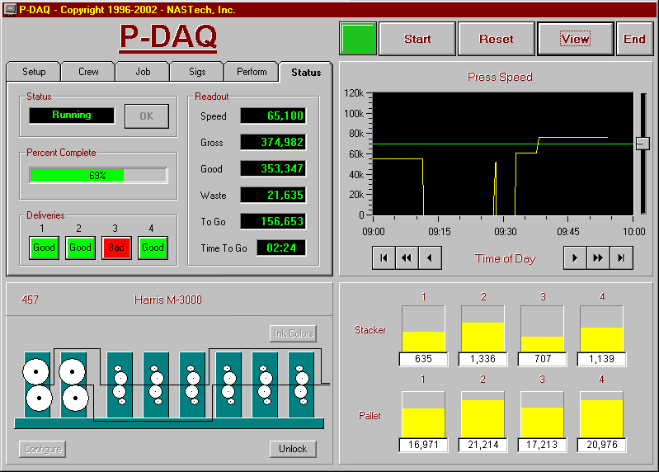

The main screen contains a header area and four sections. The caption at the top of the window contains copyright and licensing information. The P-DAQ logo, when pressed, will minimize the window. The buttons on the top right are used to Start/Stop and Reset the system, View the various event logs and to End the application.

Configuration Panel
The configuration panel contains a series of folders used to define the configuration of the press, to define the crew for each shift, to define the job specifications, and to view the status of the press. Each folder is described in detail in the following pages.

Setup Folder
The setup folder contains information regarding the configuration of the press and its deliveries.

General
This folder describes the press for which P-DAQ has been configured. The maximum values which apply are defined by the license agreement.
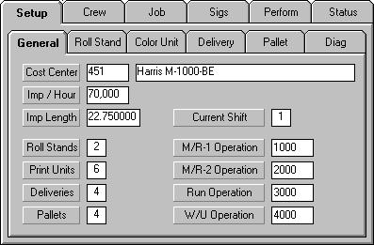
Details
Cost Center The press cost center and description. (Display Only)
Imp / Hour The rated running speed of the press. (Display Only)
Imp Length The impression length in inches. (Display Only)
Roll Stands The number of roll stands being used for the current form. (Display Only)
Print Units The number of color units being used for the current form. (Display Only)
Deliveries The number of deliveries being used for the current form. (Display Only)
Pallets The number of pallets being used for the current form.
Current Shift The current shift based on the current time and the shift start times defined in the Pressman.ini file.
M/R-1 Operation The Makeready 1 operation code to be reported for the associated job.
M/R-2 Operation The Makeready 2 operation code to be reported for the associated job.
Run Operation The Run operation code to be reported for the associated job.
W/U Operation The Wash-Up operation code to be reported for the associated job.

Roll Stand
This folder identifies the stock being used at each of the roll stands. The data displayed here is normally defined by the scheduling module and displayed here for reference only. The number of tabs present is based on the number of roll stands being used. This data may be modified if necessary.
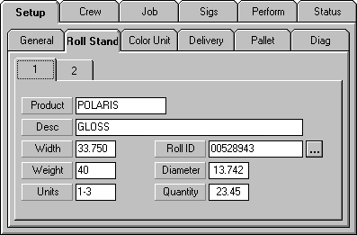
Details
Product The paper inventory product ID being used.
Desc The description of the stock being used.
Width The roll width of the stock being used.
Weight The basis weight of the stock being used.
Units The color units being used in conjunction with the roll stand. This field is updated automatically using the Rollstand / Color Unit graphic on the lower left of the main screen.
Roll ID The bar-coded roll number for the current roll. Used with the optional Paper Management Sub-System.
… Button opens the Paper Maintenance screen.
Diameter The calculated diameter of the current roll.
Quantity The calculated weight of the current roll.

Ink Meter
This folder identifies the ink being tracked by each associated ink meter and is only displayed when utilizing the ink tracking sub-system. The number of tabs present is based on the number of ink meters used. The data may be modified if necessary. The default values shown here are defined in the Pressman.CFG file.
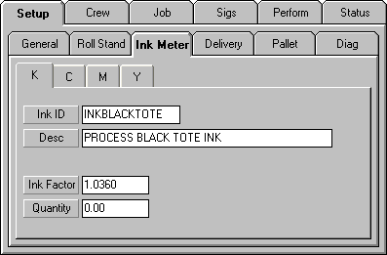
Details
K Ink Meter 1 set to monitor Black ink.
C Ink Meter 2 set to monitor Cyan ink.
M Ink Meter 3 set to monitor Magenta ink.
Y Ink Meter 4 set to monitor Yellow ink.
Ink ID The inventory product identifier for the ink being used.
Desc The description of the ink being used.
Ink Factor The multiplier used to convert readings from the ink flow meters to the units being reported to the costing system, usually pounds.
Quantity Amount of ink used for the current form, updated in real time.

Delivery
This folder identifies the signature being used in conjunction with each of the deliveries. The data displayed here is normally defined by the scheduling module and displayed here for reference only. The number of tabs present is based on the number of deliveries being used. This data may be modified if necessary.
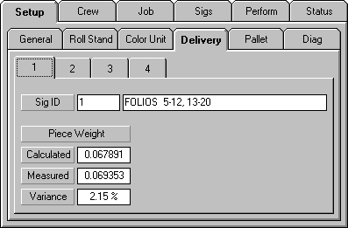
Details
Sig ID The signature identifier and its description. This information is printed on the pallet load ticket.
Calculated Weight The weight of each signature based on the size and basis weight of the stock being used.
Measured Weight The weight of each signature based on the actual sample signatures weighed.
Variance The percent difference between the calculated and measured piece weights.

Pallet
This folder identifies the signature being used in conjunction with each of the deliveries. The data displayed here is normally defined by the scheduling module and displayed here for reference only. The number of tabs present is based on the number of pallets being used. This data may be modified if necessary.

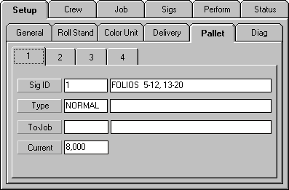
Details
Sig ID The signature identifier and its description being loaded on the associated pallet.
Type The pallet type being loaded. The valid pallet types are defined in a maintainable table.
To-Job The Sub-Job number and description. This is the current job number used when running Sub-Jobs. This number is printed on the Load Ticket for the associated Sub-Job.
Current The current number of signatures loaded on the current pallet.

Diagnostics
This folder is used for system diagnostic purposes as described below.
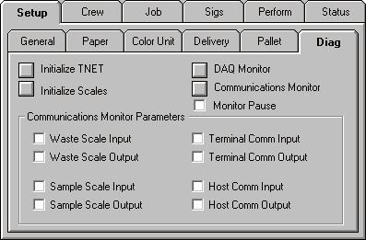
Details
Initialize TNET Used to set up internal TNET parameters for compatibility with P-DAQ.
Initialize Scales Used to set up internal Scale parameters for compatibility with P-DAQ.
HIDDEN FEATURE: (Holding the CTRL key on the keyboard while clicking this button sends an additional setup parameter to the GSE scale to allow the user to use the ZERO buttonon the scale head.)
DAQ Monitor Used to monitor the DAQ card(s) inputs and outputs in real time.
Comm. Monitor Opens the Communications Monitor.
Monitor Pause Pauses the monitoring of devices so you can focus on a single transaction.
Waste Scale I/O Allows the monitoring of communications between the system and the Floor Scale.
Sample Scale I/O Allows the monitoring of communications between the system and the Sample Scale.
Term. Comm. I/O Allows the monitoring of communications between the system and the delivery and rollstand terminal stations.
Host Comm. I/O Allows for the monitoring of communications between the system and the NASTech Shop Floor Data Collection System.

Crew Folder
This folder identifies the various operators on the associated shift. This information should be defined prior to the start of each shift.
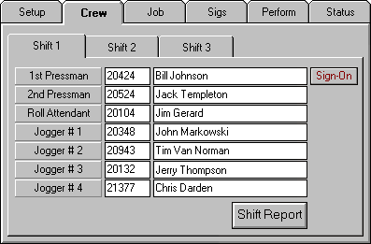
Details
1st Pressman Employee ID and name printed on Load Ticket and used to report press time to the costing system.
Sign-On Used to sign-on to the associated shift. During shift overlap, two pressmen may be signed-on to different shifts at the same time.
Sign-Off Used to sign-off of the associated shift.
2nd Pressman Employee ID and name used for reference only.
Roll Attendant Employee ID and name used when reporting paper usage to the shop-floor data collection system.
Jogger # 1 - 4 Employee ID and name for associated delivery. Printed on Load Tickets for pallets produced at the delivery.
Shift Report Used to print a shift detail report for the 1st Pressman of the selected shift.

Job Folder
This folder identifies the current job and form being run. The data displayed here is normally defined by the scheduling module but may be modified by clicking in the associated fields.
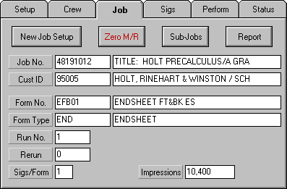
Details
New Job Setup This button is used to select a new job/form to run from the schedule. The New Job Setup screen is explained in further detail on the following pages.
Zero M/R Enabled only when using Zero Makeready presses, as defined in the Pressman.ini file. The Zero M/R screen is explained in further detail on the following pages.
Sub-Jobs Enabled only when using Sub-Jobs, as defined in the Pressman.ini file. The Sub-Jobs screen is explained in further detail on the following pages.
Report Enabled only when using Job Report parameter, as defined in the Pressman.ini file. The Report screen is explained in further detail on the following pages.
Job No. The job number and description of the job being run.
Cust ID The optional customer ID and the customer name.
Form No. The form number and description of the form being run.
Form Type The form type and description of the form being run. The valid types are defined in the Form Type table as edited by P-Maint.
Run No. The run number of the form being run.
Re-Run The rerun number of the form on press. A number greater than 0 is used to define a spoilage run. The reason for the spoilage can be entered by entering a hyphen followed by the appropriate reason code (Ex. “1-BPLT”).
Sigs/Form The number of different signatures being delivered.
Impressions The total number of impressions required to be printed. This number includes any required bindery spoilage.

New Job Setup
The New Job Setup button allows the Pressman to select a Job/Form to be run. If the Job/Form is not in the schedule, the Close button will display a series of dialog boxes that will prompt for the required information. The tabs at the top of the screen represent the presses that the Job/Form was scheduled for. Jobs can be selected from other press schedules if allowed.
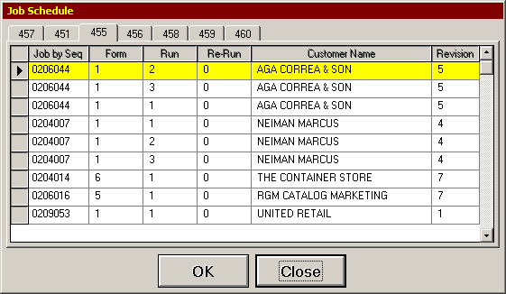
Details
Job by Seq Displays the job number. Sorted by the sequence number defined in the Scheduling Module (P-Sched). Clicking the Job by Seq heading will alternately display the list by job number.
Form The form number.
Run The run number.
Re-Run The re-run number.
Customer Name The customer name. Clicking the Customer Name heading will alternately display the job and form description.
Revision The revision number.
OK Enters the selected job/form data into the system and closes the dialog box.
Close Used to close the dialog box, and to prompt for the job, form, run and re-run numbers to be manually entered.

Sub-Jobs
P-DAQ allows multiple jobs to be run sequentially. This is useful when running identical forms that are to be bound separately. The additional job numbers and quantities are either automatically downloaded from the job schedule, or manually entered in this dialog box. The dialog box is displayed by clicking the Sub-Jobs button in the Job folder. Sub-Jobs are displayed here and are run in descending order by quantity.
- The load tickets for each Sub-Job will reflect the job number defined in the To-Job field located in the Pallet Folder. The Auto parameter (defined in Pressman.ini section of this guide), automatically changes the To-Job number to that of the currently running Sub-Job. When the Manual option is used, the pressman must define the To-Job number for the current pallet manually via the dropdown list, and the End of Pallet button is used to switch from Sub-Job to Sub-Job.
- In Auto mode, once the complete Sub-Job quantity has been produced, a load ticket will automatically be printed for the associated pallet.
- In Auto mode, if multiple pallets are to be produced for the associated Sub-Job, once each pallet is full, you need to press the End of Pallet button to produce the Load Ticket with the exception of the last (partial) Sub-Job pallet, which will be produced automatically once the Sub-Job quantity is reached.
- Once the Sub-Job quantity has been produced for the last Sub-Job, the final Load Ticket will be produced when the pressman presses the Stop button on the P-DAQ Main Screen at the end of the form.

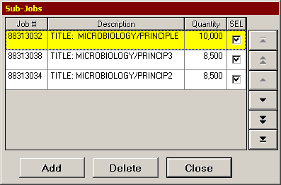
Details
Job # Displays the Sub-Job number.
Description Description of the Sub-Job.
Quantity The quantity requested. The number to be printed on the Load Ticket.
SEL The check marked boxes indicate the Sub-Jobs to be printed during the current run.
Add Used to add Sub-Jobs.
Delete Used to delete the selected Sub-Job(s).
Close Used to close the dialog box.

Zero M/R
P-DAQ may be configured to work in conjunction with Zero Makeready presses. These presses are designed to allow plate changes while the press is running. The idea is to switch from job to job without stopping the press. Once the first job is complete, the forms are retracted. The job is changed on the fly, and the forms for the next job are engaged.
- To set up P-DAQ to run Zero M/R jobs, enter the Job folder and click the New Job Setup button. Select the first job in the sequence.
- Set-up the job by entering into the Sigs Folder, the Setup Sub folders and configuring the Press as previously described in this section.
- To enter subsequent jobs, click the Zero M/R button on the Job folder, and the Zero M/R screen appears:

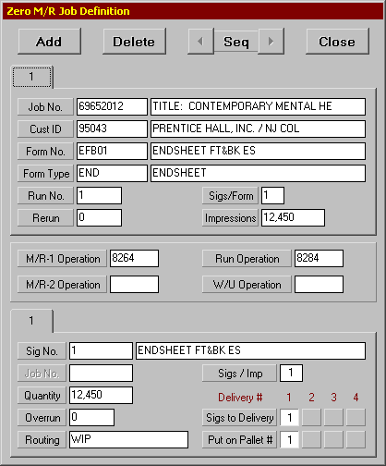
- All Zero M/R jobs to be run in succession must be entered into the Zero M/R screen before the Start button is pressed.
- To add a subsequent job, click the Add button, and select the job from the drop down list.
- Each Job will have a folder tab in which to enter the associated Form/Signature data.
- All Jobs MUST have the same delivery configuration as defined in the Sigs folder.
- If any Zero M/R job does not match both the form and delivery configuration of the first Zero M/R job, an error will occur, the red indicator will flash, and the Start button will be disabled.
- Once all Zero M/R jobs have been loaded, pressing the Start button will place the system into its Makeready 1 status.
- Once each Zero M/R job quantity has been produced, a load ticket will automatically be printed for the associated pallet.
- If multiple pallets are to be produced for the associated Zero M/R job, once each pallet is full, pressing the End of Pallet button will produce the associated Load Ticket.
- The P-DAQ status will change from Count Complete, to Makeready 2 once each successive Zero M/R job is complete.
- An optional signal may be provided to allow the press to change forms automatically; otherwise, it is the pressman’s responsibility to change the forms manually once each Zero M/R job is complete.
- Once the Zero M/R job quantity has been produced for the last Zero M/R job, the final Load Ticket will be produced when the pressman presses the Stop button on the P-DAQ Main Screen.
Details
Add Allows jobs to be added to the list.
Delete Used to delete the selected Zero M/R job.
Seq Used to re-sequence the jobs.
Close Used to close the dialog box.

Report
P-DAQ allows the Production Detail by Form report to be printed from the Job folder. Clicking the Report button opens the Job / Form Report dialog box.
P-DAQ may also be configured to automatically print the report at the completion of each form in addition as described in the Pressman.ini section of this guide.
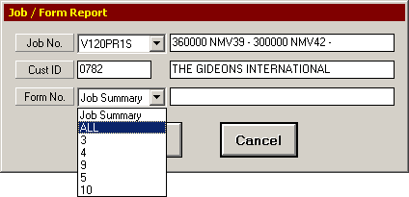
Details
Job No. The job number and description.
Cust ID The customer number and description.
Form No. The Form number and description, this dropdown allows for the selection of any or all forms on a particular job.
OK Used to print the selected report and to close the dialog box.
Cancel Used to close the dialog box with out printing a report.

Signature Folder
This folder identifies the associated signature. The data displayed here is normally defined in the scheduling module. The number of tabs present is based on the signatures associated to the current form as defined by the Job Folder. This data should checked prior to the run, and delivery information may be required when more than 1 delivery is present.
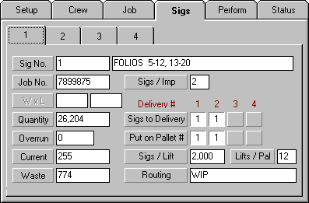
Details
Sig No. Signature ID and description.
Job No. The job number for the signature when using the “Ganging” feature as explained on the following pages.
W x L The width and length of the signature. These fields are not currently used by the system.
Quantity The number of signatures required.
Overrun The allowable overrun percentage for the signature.
Current The number of good signatures produced thus far.
Waste The number of waste signatures produced thus far.
Sigs/Imp The number of signatures of this type produced for each impression.
Sigs to Delivery The deliveries receiving the signature. Each button refers to a delivery. The value within the depressed button refers to the number of signatures of this type which are distributed to the delivery. Each time the button is pressed, the number within it is incremented by 1. A blank faced button is used to indicate that a delivery is not used for the signature. In the example above, we are getting 2 signatures of this type from each impression. The first signature is delivered to Delivery #1 and the second to Delivery #2. The same delivery may not be used for different signatures.
Put on Pallet # The value within the depressed button refers to the pallet on which the associated signatures are to be accumulated. Each time the button is pressed, the number within it is incremented by 1. A blank faced button is used to indicate that a pallet is not used for the signature. In the example above, we are getting 2 signatures of this type from each impression. The first signature is delivered to Delivery #1 and the second to Delivery #2, however, signatures from both deliveries are accumulated on the same pallet at position #1. The same pallet may not be used for different signatures.
Sigs / Lift The average number of signatures accumulated at the stacker for delivery to the pallet. This number is calculated by averaging the 5 largest lifts placed on the first pallet. This field is required when using the Auto Lift Gen functionality of the system as defined in the Pressman.ini file. This data may also be changed from the TT4 terminal located at the delivery station.
Lifts / Pal The number of lifts of the size defined in the Sigs / Lift field which can be placed on the pallet. This field is required when using the Auto Ticket Gen functionality of the system as defined in the Pressman.ini file. This data may also be changed from the TT4 terminal located at the delivery station.
Routing Optional entry which may be printed on the load ticket to identify the destination of the pallet.

Ganging
P-DAQ allows multiple jobs to be run at the same time via multiple deliveries. When producing product for more than 2 different jobs simultaneously, the Load Tickets for the pallets created at each delivery need to have a unique job number assigned for tracking purposes.
When Ganging is used, the job number entered in the Job No. field in the Sigs Folder is printed on the associated Load Tickets for each associated signature.
Details
Sig No. Signature ID and description.
Job No. The job number for the signature when using the “Ganging” feature.
W x L The width and length of the signature. These fields are not currently used by the system.
Quantity The number of signatures required.
Overrun The allowable overrun percentage for the signature.
Current The number of good signatures produced thus far.
Waste The number of waste signatures produced thus far.
Sigs/Imp The number of signatures of this type produced for each impression.

Performance Folder
This folder identifies performance statistics for the current form being run. The scheduled data (green bar) is derived from the schedule. The actual counts may be displayed by clicking on any of the displayed charts. The scheduled and actual data is displayed below each chart.
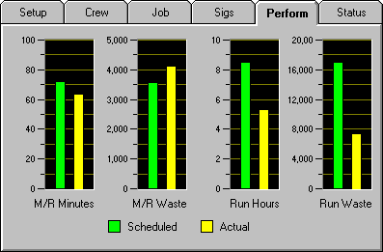
Details
M/R Minutes The scheduled and actual time spent for the press Makeready. This includes both MR-1 and MR-2 time.
M/R Waste The scheduled impression waste and the actual impression waste incurred during MR-2.
Run Hours The scheduled hours and actual hours for the run. This includes both MR-3 and Run time. Down-time is not included.
Run Waste The scheduled run waste and actual run waste incurred during MR-3 and Run time. Down-time restart waste is not included.

Status Folder
This folder is used to display the current status of the form being run.
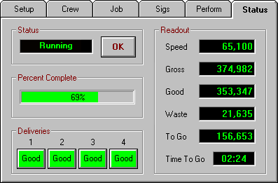
Details
Status The current system status.
Idle The system is in Stop mode and therefore is not monitoring the press at this time.
Makeready I The press is being set up for the current form to be printed, when the press is NOT running.
Makeready II The press is being set up for the current form to be printed, while the press is running. The color and registration is being adjusted.
Makeready III The press is producing good copy but awaiting the press OK. The OK button must be pressed when the press OK has been given. (Optional feature)
Running The press is producing good copy and the press OK has been given.
Down The press is down.
Restarting The press is being restarted after being down. Waste produced during this phase is attributed to the cause of the down-time.
Count Complete The required quantity of each signature has been produced but the press is still running.
Form Complete The required quantity of each signature has been produced, the stackers have been emptied, all load tickets have been produced and the system is in Stop mode.
Wash Up The required quantity of each signature has been produced, and the press speed has been slowed to below the cutoff speed.
Percent Complete Displays the percentage of the form that has been completed.
Deliveries Indicators for each of the deliveries denoting whether good or bad product is being counted.
Speed Actual running speed of the press.
Gross The current number of impressions produced. If the gross count needs to be adjusted for any reason, you may do so by clicking on the gross count display area.
Good The current number of good impressions produced. If the Good Count needs to be adjusted for any reason, you may do so by clicking on the Good Count display area.
Waste The current number of waste impressions produced. If the waste count needs to be adjusted for any reason, you may do so by clicking on the waste count display area.
To Go The number of impressions required to complete the run.
Time To Go The time remaining in hours and minutes, based on the current speed of the press.

Press Speed Graphic
This graphic displays press speed statistics for the past 24 hour period. The scheduled running speed of the press is also displayed. The data for prior hours is viewed by using the scroll buttons located below the chart. The chart displays 1 hour at a time or 12 minutes at a time in zoom mode. Zoom mode is toggled by clicking on the chart. Press stops may be easily located using the chart.
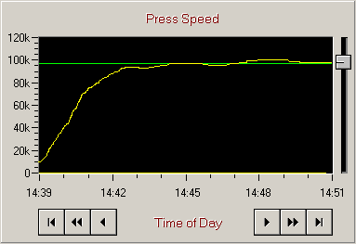
Details
Green Line The Scheduled running speed of the press if specified in the schedule, if not the rated speed of the press.
Yellow Line The actual running speed of the press.

Press Configuration
The graphic represents the current configuration of the press. Displayed is the maximum configuration of the press with grayed areas used to represent the roll stands and/or color units not being utilized for the current form. The press configuration is cleared by clicking the Configure button. To set the configuration, click a roll stand, then click the color units used by that roll stand. This is followed by the next roll stand being used and so forth. A color unit may be disabled by clicking on the respective unit. The configuration of the press defined by the graphic display is validated against the data specified within the setup folders. Once the configuration has been set, use the Lock button to prevent accidental changes.
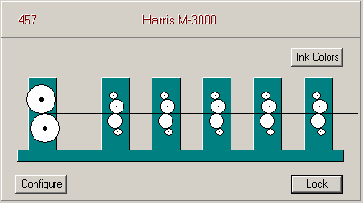
Details
Configure Clears the graphic for subsequent configuration.
Lock Locks the graphic to prevent unwanted changes during setup.
Ink Colors Used to graphically display the ink colors to be used. Display purposes only.

Floor Scale Graphic
This graphic is displayed on the lower left of the Status Folder after the Start button is pressed and only when Floor Scales are being used as the primary counting device. This graphic can be temporarily hidden by double-clicking on the Status tab.
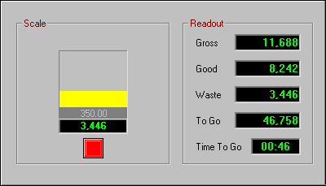
Details
Gross The current number of impressions produced.
Good The current number of good impressions produced.
Waste The current number of waste impressions that have been thrown into the bin.
To Go The number of impressions required to complete the run.
Time To Go The time remaining in hours and minutes, based on the current speed of the press.
Yellow Line Displays the current waste quantity in the bin as a percentage of the scale capacity.
Grey Line Represents the Tare Weight.
Black Line Represents the current waste count of the form.
Red Indicator Indicates that the scale is unstable.
Green Indicator Indicates that the scale is stable.

Scale Adjust
This dialog box can be displayed when P-DAQ is used in conjunction with Floor Scales. To open the dialog box, click the Floor Scale Graphic on the main screen. A parameter is available to automatically “Set Scale Waste” upon completion of Makeready, see the “Initialization File” section of this guide for more information about the “Auto Set Scale” parameter.
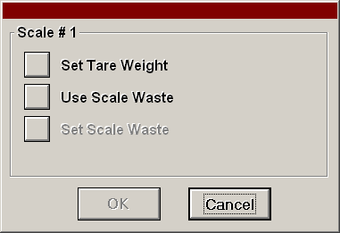
Details
Set Tare Weight Used to tare the contents of the bin.
Use Scale Waste Used to change P-DAQ (upper) waste counts to match that of the scale.
Set Scale Waste Used to change the Floor Scale (lower) waste counts to match that of P-DAQ (upper) waste counts.
OK Used to make the adjustment, and close the dialog box.
Cancel Used to close the dialog box without making the adjustment.

Stacker / Pallet Graphic
This graphic represents the current delivery configuration of the press. Displayed is the maximum configuration of the press with grayed areas used to represent the deliveries not being utilized for the current run. The stackers and pallets are enabled or disabled based on the specified configuration. The signature folder is used to define the delivery and pallet used by each signature being produced.

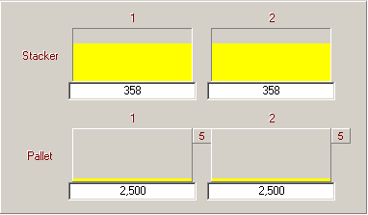
Details
Stacker The Stacker number and its associated quantity represented by the yellow bar and by the number displayed below.
Pallet The pallet number and its associated quantity represented by the yellow bar and by the number displayed below.
Small Square “5” in this example. This is the number of Lifts that have been produced for the associated pallet. This is only displayed when the Auto Lift Gen functionality is being used as defined in the Pressman.ini file.

Stacker Adjust
This dialog box is displayed when P-DAQ is used in conjunction with batch counters, automatic stackers or when the Auto Lift Gen functionality of the system is used, as defined in the Pressman.ini file. The dialog box is opened by clicking the Stacker Graphic on the main screen.
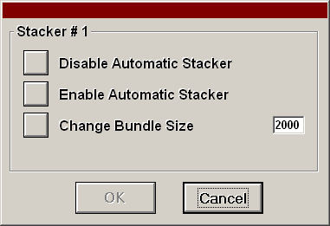
Details
Disable Automatic Stacker Used to disable the automatic stacker.
Enable Automatic Stacker Used to enable the automatic stacker.
Change Bundle Size Used to change the bundle size.
OK Used to make the adjustment, and close the dialog box.
Cancel Used to close the dialog box without making changes.

Pallet Adjust
This dialog box is displayed when clicking the pallet graphic.
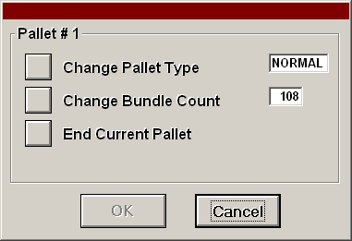
Details
Change Pallet Type Used to change the pallet type which is printed on the load ticket.
Change Bundle Count Used to define the number of Lifts/Bundles to be placed on the pallet.
End Current Pallet Used to prematurely end the pallet and produce a load ticket.
OK Used to make the adjustment, and close the dialog box.
Cancel Used to close the dialog box without making changes.

View Button
The View button provides access to various functions including System Logs and Maintenance. These Logs and Maintenance dialog boxes are described in the following pages.



Shift Notes
This dialog box is used to enter free-form comments for subsequent shifts.
The recipient should delete messages when they are no longer needed. The comments entered here are for Pressman use only and are not transferred to the reporting system.
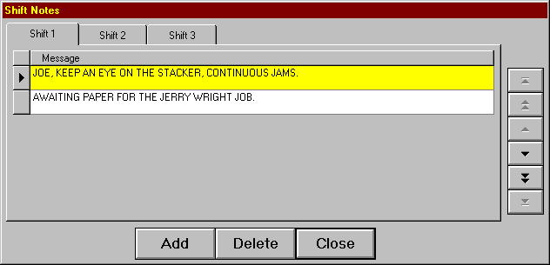
Details
Add Used to add a new entry to the list.
Delete Used to delete the selected entry from the list.
Close Used to close down the Shift Notes display.

Shift Log
This form is used to define activities as they relate to the activities performed on each shift. Entries are made to the shift log automatically whenever an event occurs. The events recorded are explained below:

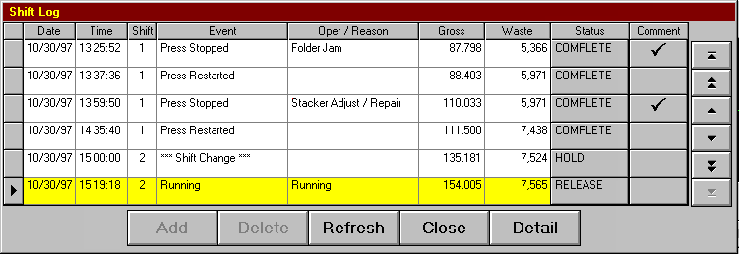

System Restart Occurs when P-DAQ has been restarted.
Shift Change Occurs when a new shift begins.
Form Started Occurs when the Start button is pressed.
Makeready I Occurs at the beginning of a new form.
Makeready II Occurs during Makeready when the press reaches the speed indicated by the Press Cutoff Speed entry in the Pressman.ini file.
Makeready III Occurs when the first good product for each signature is produced. Start Count Button pressed, Divert Gate Closed…
Running Occurs during Makeready III, when the OK Button on the Status folder is pressed.
Press Stopped Occurs when the press falls below the speed indicated by the Press Cutoff Speed entry in the Pressman.ini file, minus 1000 revolutions per hour.
Details
Date The Date of the event.
Time The Time of the event.
Shift The shift number
Event The P-DAQ generated event code.
Oper/Reason The reason code for the associated event.
Gross The gross count at the time of the event.
Waste The waste count at the time of the event.
Status The status of the transfer, see following page for details.
Comment Free form comments added by the pressman.
Add Used to add a Manual Entry to the Shift Log. This option is disabled when adding a manual entry is not allowed.
Delete Used to delete a manual entry previously added to the Shift Log. This option is enabled only for manual entries.
Refresh Used to re-display the Shift Log. New entries made by the system since the last refresh are displayed.
Close Used to close the Shift Log display.
Detail Used to display further detail associated with the selected item. Information includes crew and job level data.

Shift Log Status
Once an entry has been made to the Shift Log at the press, DataSync is used to transfer the data to the server. The Status field is used to indicate the status of this transaction. The possible automatic entries to this field are as follows:

HOLD This status indicates that this entry and the previous entry will not be released to the reporting system. Interaction from the operator is needed before the transaction can be released.
HOLDX This status indicates that this entry will not be released to the reporting system. Interaction from the operator is needed before the transaction can be released.
RELEASE This status indicates that this entry will be available for the reporting system once the Shift Log is closed.
RELEASEX This status indicates that the entry will be available for the reporting system once the Shift Log is closed, and also indicates that the previous entry has already been Completed.
COMPLETE This status indicates that the entry is available for the reporting system and cannot be changed.
When a Press Stopped event occurs, an entry is made in the log to record the exact date and time of the stop. Down-time entries are automatically placed on HOLD awaiting operator entry of the down-time reason code. These entries are given a RELEASE status when a reason is provided.
A Manual Entry is automatically placed on HOLD until an Op-code is selected. These entries are given a RELEASE status when a reason is provided.
When the Auto MR2 Entry parameter is set in the Pressman.ini file, a Manual Entry is automatically generated for a press stop during Makeready II and is automatically placed on HOLD until a Down-time reason code is selected. This type of Manual Entry cannot be removed or edited.
The ***Shift Change*** entry is also placed on HOLD automatically to prevent subsequent entries from being transferred to the reporting system, until the operator has had a chance to review the entries that have occurred on his or her shift.
A Comment button is provided to add a short free-form description of the problem or the reason for any excessive time spent during the operation. This information is printed on the Shift Log report.
P-DAQ will periodically attempt to complete processing of released entries. All entries up to the first entry on HOLD will be transferred to the Management / Reporting module. Once an entry has been marked as COMPLETE, it may no longer be modified.

Oper/Reason Field
As mentioned in the previous page, a HOLD generated by a Press Stopped event can only be RELEASED when the Pressman enters the Down-Time reason code. To enter a reason for the Press Stop, click in the Oper/Reason field of the Shift Log. Depending on the structure and location of your reason codes, P-DAQ will display a list of codes to be selected. Once the code has been located, click the code to enter the reason. The following is a sample Reason Code dialog box:
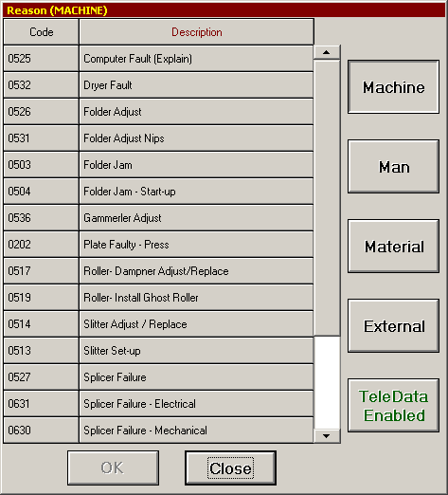

Reason codes can be categorized by the type of operation I.E. Makeready, Down-time, etc… Down-Time codes may also be categorized by responsibility, I.E. Man, Machine, Material, etc… Codes and code structure are determined by the Operation Code entries made to the Oper Code table using P-Maint.

Multiple-Stop
The Multiple-Stop Release dialog box is used when selecting a single Reason Code to describe multiple Press Stops. This is useful when the Press goes down more than once due to the same problem.

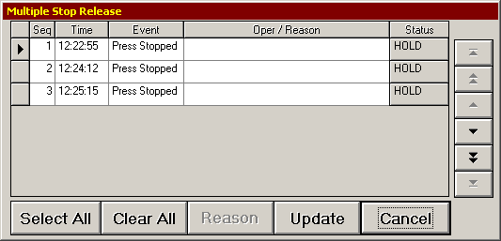
Details
Seq The sequence number to describe all stops currently on HOLD.
Time The time of the down event.
Event On this Dialog Box, this will display Press Stopped in all cases.
Oper/Reason Clicking in this field displays a list of codes to be selected.
Status The current status of the transaction.
Select All This button allows all events to be selected for editing.
Clear All This button de-selects all events.
Reason This button displays a list of codes to be selected and edits all selected codes.
Update Allows all changes to be uploaded to the server by changing the transaction to RELEASE.
Cancel This button closes the Dialog Box without making changes.

Run Waste
The Run Waste dialog box is used to select the reason code for waste signatures when P-DAQ is configured to track run waste. The Track Run Waste parameter is described in the Pressman.ini file section.

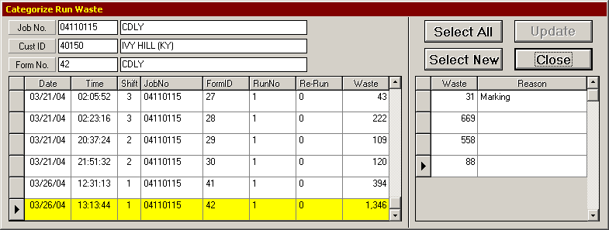
Details
Date The Date the associated waste was counted.
Time The Time the associated run event started.
Shift The Shift number.
FormID The Form number.
Run No The Run number.
Re-Run The Re-Run number.
Waste The total Run Waste signatures counted during the associated Run operation.
Select All Used to select all Run Waste events.
Select New Used to select the New Run Waste events.
Update Opens the dropdown list of opcodes to be selected for the selected events.
Close This button closes the Dialog Box.

Press Log
The Press Log is used to record events which relate to the operation of the press but are not significant to the shift log. Currently the only entries made to this log are press speed changes. These speed changes are determined by the amount specified in the Press Speed Variance entry in the Pressman.ini file.
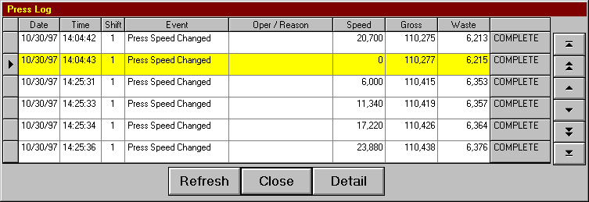
Details
Refresh Used to re-display the Press Log. New entries made by the system since the last refresh are displayed.
Close Used to close the Press Log display.
Detail Used to display further detail associated with the selected item. Information includes crew and job level data.

Pallet Log
The Pallet Log is used to record events related to the completion and adjustment of each pallet, and can be used to reprint load tickets if necessary.
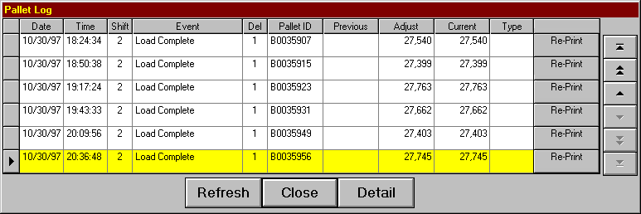
Details
Refresh Used to re-display the Pallet Log. New entries made by the system since the last refresh are displayed.
Close Used to close the Pallet Log display.
Detail Used to display further detail associated with the selected item. Information includes crew and job level data.
Re-Print Used to reprint the load ticket.

Paper Log
The paper log is used to record events which relate to the roll stands. The events recorded are as follows:
Roll Started Occurs at the start of a job and after the splice occurs and a new roll is begun.
Roll Complete Occurs at the end of a form and after the splice occurs.
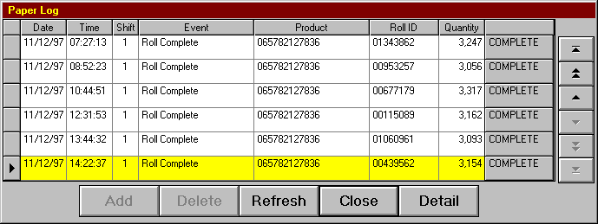
Details
Add Used to add a manual entry to the Paper Log. This may be done for un-scheduled maintenance or for recording multiple reasons for an un-scheduled stop. This option is disabled when adding a manual entry is not appropriate.
Delete Used to delete a manual entry previously added to the Paper Log. This option is enabled only for manual entries.
Refresh Used to re-display the Paper Log. New entries made by the system since the last refresh are displayed.
Close Used to close the Paper Log display.
Detail Used to display further detail associated with the selected item. Information includes crew and job level data.

Ink Log
The ink log is used to record events which relate to the ink being consumed. An entry is made in the log for each color unit when a form has been completed.
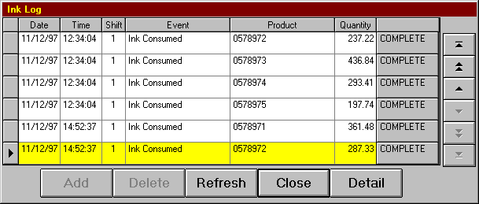
Details
Add Used to add a manual entry to the Ink Log. This may be done for un-scheduled maintenance or for recording multiple reasons for an un-scheduled stop. This option is disabled when adding a manual entry is not appropriate.
Delete Used to delete a manual entry previously added to the Ink Log. This option is enabled only for manual entries.
Refresh Used to re-display the Ink Log. New entries made by the system since the last refresh are displayed.
Close Used to close the Ink Log display.
Detail Used to display further detail associated with the selected item. Information includes crew and job level data.

Pallet Maintenance
The Pallet Maintenance screen is used to adjust pallets associated with the currently running form. The tabs on the top of the screen are used to view the pallets produced for each delivery.

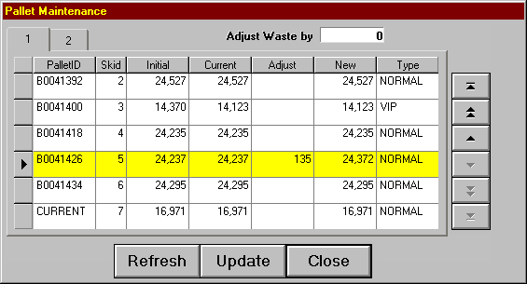
Details
Pallet ID The unique pallet ID number.
Skid The Pallet Sequence number.
Initial Number of signatures on the pallet when the load ticket was produced.
Current The current number of signatures on the pallet.
Adjust Used to open the adjustment dialog box, and to display the number of signatures to add to, or subtract from the current quantity once the update button is clicked.
New The new quantity once the update has been performed.
Type The Pallet type as defined in the Pallet Dialog box.
Refresh Used to re-display the Pallet Maintenance display. New entries made by the system since the last refresh are displayed.
Update Used to update all pallets which have been modified and to automatically reprint the adjusted Load Tickets.
Close Used to close the Pallet Maintenance display.

Pallet Adjustments
Go To adjust a pallet, click in its associated Adjust field. A dialog box will open allowing you to enter the amount to add to, or subtract from the pallet. Negative numbers are used to subtract the amount from the pallet.

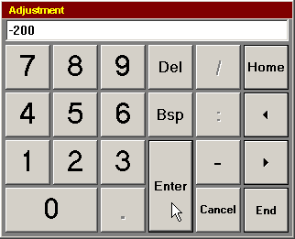

The “Adjust Waste by” field keeps a running tally of the adjustments. P-DAQ assumes when you deduct sigs from a pallet and do not move them to another pallet that you have thrown them away, and will adjust the waste count accordingly. When simply moving sigs from one pallet to another, the “Adjust Waste by” field should be “0” once all adjustments have been made.

Individual adjusted load tickets will automatically be reprinted as well after the update button is pressed.

If a pallet is to be completely discarded, subtract the total number of signatures from it. When you have done this, PDAQ will automatically re-sequence all pallets for the current form and reprint all of the load tickets with updated sequence numbers. The “Skid Numbers Changed - Continue?” dialog box will warn the operator of this condition

Paper Maintenance
The Paper Maintenance screen is used to view and/or adjust roll stock which has been queued up at the roll stand. The roll stock waiting to be consumed is entered here or from the TT4 terminal located at the roll stand. The currently active roll for each roll stand is the topmost item of the list.
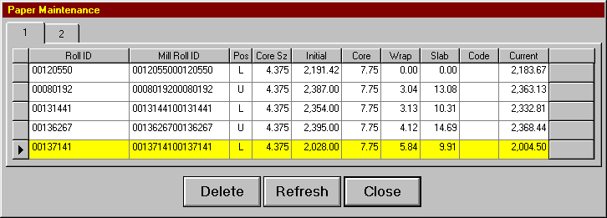
Details
Roll ID The barcode roll identifier of the roll waiting to be consumed. This may be the mill roll identifier.
Mill Roll ID The associated mill roll identifier.
Position (U)pper or (L)ower.
Core Sz The core diameter.
Initial The roll weight as stored in inventory.
Core The core weight.
Wrapper The wrapper weight in pounds.
Slab The slab waste in pounds.
Code The code which identifies reasons for excessive slab waste.
Current The current roll weight excluding waste.
Delete Used to remove a roll from the list. This is generally done when a roll queued up for one press is moved to another press. Moving a roll from one roll stand to another on a multi-web press does not require that it be deleted first.
Refresh Used to re-display the Paper Maintenance display. New entries made by the system since the last refresh are displayed.
Close Used to close the Paper Maintenance display.

P-DAQ Tutorial
The P-DAQ Tutorial is a HTML based help system used by the pressman at the press for help with various procedures.

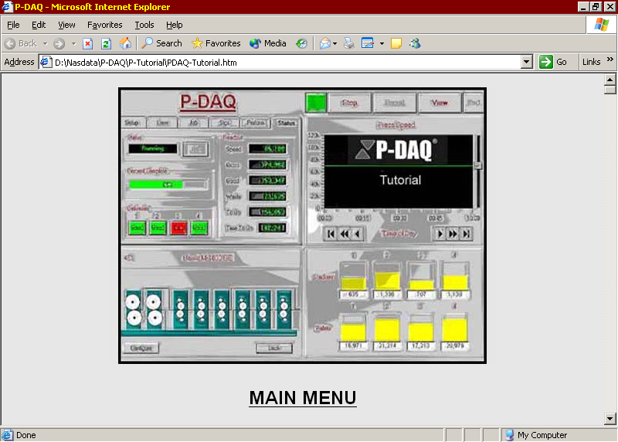

Install the Tutorial on the P-DAQ Server:
- Copy the contents of the CD (P-Tutorial) to the C:\PDAQ directory on the PDAQ Server.
- In the C:\PDAQ\P-### directories, edit the Pressman.ini file for each press to include the following line of code in the Constants section:
- Help Link = "C:\Program Files\Internet Explorer\Iexplore.exe \\YourPdaqServerName\PDAQ\P-Tutorial\PDAQ-Tutorial.htm"

Run the Tutorial at the Press:
- To run the Tutorial, each Press computer must have permission to run Internet Explorer, and permission to open the files from the server.
- Once the Pressman.ini file has been updated at each press, click the View button, followed by the Help button to open.

Run the Tutorial from the Client:
- To run the Tutorial, each client computer must have permission to run Internet Explorer, and permission to open the files from the server.
- Create a shortcut on the desktop to:
- \\yourPdaqServer\PDAQ\P-Tutorial\PDAQ-Tutorial.htm

Chapter 5 Controlling Counts
Counts can be controlled using a variety of different methods as described in the following:

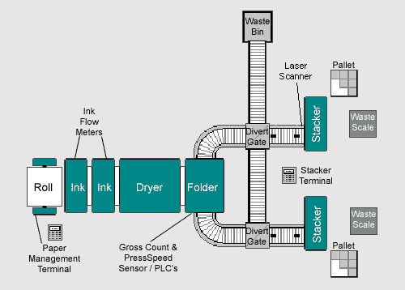

Stacker Buttons
- A Master Start/Stop button located at the folder / sheeter can be used to control good and waste count at all deliveries.
- Individual Start/Stop buttons may also be located at each delivery to control good and waste count on a delivery by delivery basis.
- When using a button, the net counters are automatically turned of when the press stops, and must be reinitialized once good product is again being produced.
- An optional blanket wash sensor may be installed to automatically turn off the net counter once the first bad signature reaches each of the stackers. Count must be reinitialized once good product is again being produced.

Stacker Switches
- Start/Stop switches located at the folder / sheeter can be used to control good and waste count.
- When the press stops, the net counters must be manually turned off, and must be turned back on once good product is again being produced.

Floor Scales
- Pressing the Start button on the P-DAQ Main Screen automatically accounts for (Tares) the weight of the waste bin and its contents.
- Before loading or unloading a waste bin, the pressman/stacker attendant must wait for the Scale Unstable light to turn off before proceeding. Loading a new waste bin also accounts for (Tares) the weight of the bin.
- During Makeready, the stacker attendant simply throws waste product into the waste bin. The calculated piece weight is used to count waste signatures at this point.
- Once there is sufficient ink coverage, an actual piece weight measurement is performed using the sample scale. This is done by selecting the sample option on the scale indicator, placing the requested number of signatures on the sample scale, and by selecting the All Other Options/Set Piece Weight option on the TT4 Stacker Terminal. This will automatically adjust makeready product previously thrown into the bin during makeready.
- Makeready and Run waste is simply thrown into the waste bin and counted accordingly.

Divert Gates
- When using Divert Gates, diverting good product to the stacker will automatically initiate good count.
- Likewise, diverting waste product to the waste bin controls the waste count accordingly.

Laser Counters
- When using Laser counters, good count is initialized once good product passes the laser.
- When using Laser counters, waste count is initialized when the system counts gross, and product does not pass the laser.

Conveyor Systems
- P-DAQ can be configured to track product on the conveyer system. In some cases, you may want to include the product on the conveyer for count purposes.
- When using Laser counters, product is not counted as good until it reaches the laser. To include the signatures on the conveyer system, use the Delivery Zones parameter outlined in the Initialization File section of this guide.
- When using Laser counters, and when using the Delivery Zones parameter, you must also set the Conveyer Min Speed parameter as outlined in the Initialization File section of this guide. This will delay the press status to allow for the signatures to pass the laser.
- When using the Delivery Zones parameter in conjunction with Zero-Makeready jobs, once the last good signature to be produced reaches the conveyer system, the job is considered complete. The load ticket will include the signatures on the conveyer at that instant in time. It is important to make sure that these signatures reach the stacker and are put on the current pallet.
- When using the Delivery Zones parameter in conjunction with Zero-Makeready jobs, P-DAQ assumes there will be a “gap” of 25 signatures, these signatures are considered Makeready waste for the next job.

Chapter 6 Stacker Management

TT4 Terminal
Each stacker may be equipped with a data entry terminal for use by the stacker attendant. The terminal may be equipped with a bar-code wand or scanner for scanning Load Tickets as well.

The terminal may also be used to interface to the sample scale to perform pallet count adjustments.

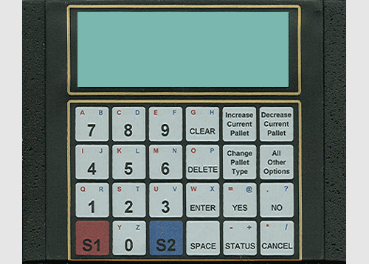

Function Keys
Increase Current Pallet Used to increase the count on the current pallet by the amount of signatures on the sample scale.
Decrease Current Pallet Used to decrease the count on the current pallet by the amount of signatures on the sample scale.
Change Pallet Type Used to change the pallet type which is printed on the associated load ticket.
All Other Options 1. Increase Pallet – Used to increase any pallet when the count to be increased is known.
2. Decrease Pallet – Used to decrease any pallet when the count to be decreased is known.
3. Combine Pallets – Used to combine two load tickets into one.
4. Create Pallet – Used to create a new pallet and load ticket.
5. New Pallet Type – Used to define the pallet type to be printed on the load ticket.
6. Set Pallet Cap – Used to define the pallet capacity.
7. Set Tkt Count – Used to define the count on load ticket counts when the counts are to remain consistant.
8. Set Piece Wgt – Used to transfer the piece weight from the sample scale to the floor scale.
9. Del. Config – Used to view the delivery configuration as defined by the P-DAQ main screen.
Status Used to view the current status of the run.

Terminal Functions
The following describes the functions available to the stacker attendant. The transaction may be cancelled at any point by pressing the Cancel key.

Function | Code | Prompt | Comment
Create Pallet | 17 | Delivery | The delivery you are operating. This prompt is bypassed when the system can determine the delivery.
 |  | From Pallet | The pallet whose quantity is to be reduced.
 |  | Quantity | The number of signatures to remain on the specified pallet.
 |  | Update (Y/N) | Enter Y to complete the transaction. A new Load Ticket is printed when the resultant pallet is a previously completed pallet.
Decrease Current Pallet | 12 | Delivery | The delivery you are operating. This prompt is bypassed when the system can determine the delivery.
 |  |  | The system display the current pallet and 4 prior pallets if present.
 |  | Quantity | The number of signatures to be removed from the current pallet.
 |  | Update (Y/N) | Enter Y to complete the transaction. A new Load Ticket is printed when changing a previously completed pallet when the new quantity is greater than zero.
Decrease Pallet Count | 22 | Delivery | The delivery you are operating. This prompt is bypassed when the system can determine the delivery.
 |  | Pallet | Select the pallet by scanning the bar-code pallet ID or by specifying the skid sequence number.
 |  | Quantity | The number of signatures to be removed from the specified pallet.
 |  | Update (Y/N) | Enter Y to complete the transaction. A new Load Ticket is printed when changing a previously completed pallet when the new quantity is greater than zero.
Define Pallet Type | 14 | Delivery | The delivery you are operating. This prompt is issued when changing the current pallet and when more than a single delivery is being used.
 |  | Pallet | The pallet whose type is to be changed.
 |  | Pallet Type | Scan the pallet type.
 |  | Update (Y/N) | Enter Y to complete the transaction. A new Load Ticket is printed when changing a previously completed pallet.
 |  | To Pallet | The new pallet to contain all signatures from both pallets.
 |  | Quantity | The number of signatures to be moved to the specified pallet.
 |  | Update (Y/N) | Enter Y to complete the transaction. A new Load Ticket is printed when the resultant pallet is a previously completed pallet.
Increase Current Pallet | 11 | Delivery | The delivery you are operating. This prompt is bypassed when the system can determine the delivery.
 |  |  | The system displays the current pallet and 4 prior pallets if present.
 |  | Quantity | The number of signatures to be added to the current pallet dtermined
 |  | Update (Y/N) | Enter Y to complete the transaction. A new Load Ticket is printed when changing a previously completed pallet.
 |  | Quantity | The number of signatures to be added to the specified pallet.
 |  | Update (Y/N) | Enter Y to complete the transaction. A new Load Ticket is printed when changing a previously completed pallet.
 |  | Logs/Pallet | The number of logs which can be placed on the pallet.
 |  | Update (Y/N) | Enter Y to complete the transaction.
Set Piece Weight |  |  | This function transfers the piece weight measurement from the sample scale to the floor scale.
Set Ticket Count | 16 | Load Tickets | Enter the number of Load Tickets to be printed for completed pallets. The minimum number of pallets is defined in the Pressman.ini file.
 |  | Update (Y/N) | Enter Y to complete the transaction.
Status | Cancel or ? | none | When at the Function prompt, the information will toggle each time the key is depressed.

Count Adjustments

Stacker Controls
- If you forgot to press the Start/Stop button to indicate that good product is being saved, and the amount to add to the good count is KNOWN: At the TT4 Terminal, press the All Other Options button, select Increase Pallet and follow the prompts to enter the number of signatures to increase to the count, and update.
- If you forgot to press the Start/Stop button to indicate that good product is being saved, and the amount to add to the good count is NOT KNOWN: First make sure that the piece weight is has been set. Then, place the total number of signatures to be adjusted on the table scale. From the TT4 Terminal, press the Increase Current Pallet button. The count is automatically adjusted.
- If you forgot to press the Start/Stop button to indicate that waste product is being produced, and the amount to subtract from the good count is KNOWN: At the TT4 Terminal, press the All Other Options button, select Decrease Pallet and follow the prompts to enter the number of signatures to subtract from the count, and update.
- If you forgot to press the Start/Stop button to indicate that waste product is being produced, and the amount to subtract from the good count is NOT KNOWN: First make sure that the piece weight is has been set. Then, place the total number of signatures to be adjusted on the scale. From the TT4 Terminal, press the Decrease Current Pallet button. The count is automatically adjusted. Throw the adjusted signatures in the waste bin.
- All adjustments to pallet counts MUST be made before the Pressman presses the Stop and Reset buttons on the P-DAQ Mainscreen in preparation for the next run.

Floor Scales
- If you forgot to press the Start/Stop button to indicate that good product is being saved, and the amount to add to the good count is KNOWN: At the TT4 Terminal, press the All Other Options button, select Increase Pallet and follow the prompts to enter the number of signatures to increase to the count, and update.
- If you forgot to press the Start/Stop button to indicate that good product is being saved, and the amount to add to the good count is NOT KNOWN: First make sure that the piece weight is has been set. Then, place the total number of signatures to be adjusted on the table scale. From the TT4 Terminal, press the Increase Current Pallet button. The count is automatically adjusted.
- If you counted signatures as good and need to discard them, simply throw the waste signatures in the bin.
- The P-DAQ good count can be adjusted to use the Floor Scale count by clicking on the Floor Scale Graphic. Select Use Scale Waste from the list and the P-DAQ count will be automatically adjusted.
- All adjustments to pallet counts MUST be made before the Pressman presses the Stop and Reset buttons on the P-DAQ Mainscreen in preparation for the next run.

Divert Gates
- In case of a stacker jam, where good product is diverted and counted as waste, a count adjustment is needed. At the TT4 Terminal, press the All Other Options button, select Increase Pallet and follow the prompts to enter the number of signatures to increase to the good count, and update.
- If you forgot to open the divert gate and waste product has entered the stacker, from the TT4 Terminal, press the All Other Options button, select Decrease Pallet and follow the prompts to enter the number of signatures to subtract from the good count, and update.
- All adjustments to pallet counts MUST be made before the Pressman presses the Stop and Reset buttons on the P-DAQ Mainscreen in preparation for the next run.

Combine Pallets
- If you pressed the End of Pallet button prematurely, press the End of Pallet button again when the pallet is actually complete. This will cause two Load Tickets to be produced for 1 physical pallet. From the TT4 Terminal, press the All Other Options button, select Combine Pallets, and select the 2 tickets to be combined, follow the prompts and discard the incorrect load tickets. A new Load Ticket will be printed automatically.
- This procedure is also used when producing samples. Start the first pallet; press the End of Pallet button to begin the sample production. Press the End of Pallet button again when the sample production is complete. Press End of Pallet again when the original pallet is actually completed. You now have 2 Load Tickets for the original pallet and 1 Load Ticket for the samples. Repeat above procedure to combine the 2 Load Tickets for the original pallet.

Create Pallet
- If you forgot to press the End of Pallet button, wait until the second physical pallet is complete, and then press the End of Pallet button. You now have 2 pallets with only 1 Load Ticket. From the TT4 Terminal, press the All Other Options button, select Create New Pallet, when prompted, enter the estimated number of signatures on the first pallet. Discard the incorrect Load Ticket, 2 new Load Tickets will be printed automatically.

Delete Pallet
- If you have decided to discard an entire pallet, you must deduct the entire quantity. At the TT4 Terminal, press the All Other Options button, select Decrease Pallet and follow the prompts to enter the total number of signatures on the pallet, and update.
- This procedure will cause the pallet sequence numbers to be incorrect. To re-sequence and automatically re-print all the Load Tickets with the updated sequence numbers, the pressman must open the Pallet Maintenance screen located under the View Button, and click the Update button. More information about this procedure is available in the Pallet Maintenance section of this guide.

Chapter 7 Paper Management

TT4 Terminal
The P-DAQ Paper Management System is used to track paper consumption. Paper usage is tracked by job, by press, by shift, and by crew.

Each Rollstand / Skid station is equipped with a data entry terminal for use by the Paper attendant. The terminal may be equipped with a bar-code wand or scanner for scanning stock barcodes as well.

Depending on any default parameters set up in the Pressman.ini file, not all of the prompts included in this section will be displayed to the operator. Transactions may be cancelled at any point by pressing the Cancel key.

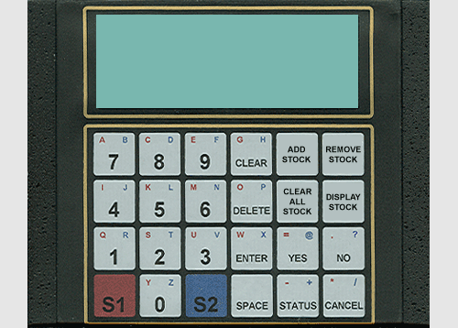

Function Keys
Add Stock Used to add a Roll or Skid to the paper queue.
Remove Stock Used to remove a Roll or Skid from the paper queue.
Clear All Stock Used to remove all Rolls or Skids from the paper queue.
Display Stock Used to display Roll or Skid paper parameters.

Add Stock
Rolls must be queued prior to mounting. Using the TT4 terminal, a series of prompts are used to enter the necessary roll parameters. Many of the following may be defaulted in the Pressman.INI file, and many parameters may be loaded from an in house inventory system. The procedure for adding rolls is as follows:
- Push the Add Stock button.
- Enter the Rollstand number.
- Scan the Barcode, or enter the Barcode number manually.
- Scan the Mill Roll ID, or enter the number manually.
- Enter U, or L for Upper or Lower.
- Enter the Product ID.
- Enter the Stock Width.
- Enter the Basis Weight of the stock.
- Enter the Core Diameter.
- Enter the Quantity.
- Enter the Core Weight.
- Weigh and enter the Wrapper Waste.
- Weigh and enter the Slab Waste.
- Scan or enter the Waste Reason Code.
- Push the Y button to Update.

Remove Stock
Rolls can be removed from the list. Using the TT4 terminal, a series of prompts are used to enter the necessary parameters. The procedure for removing rolls is as follows:
- Push the Remove Stock button.
- Enter the Rollstand number.
- Scan the Barcode, or enter the Barcode number manually.
- Push the Y button to Update.

Clear All Stock
All rolls can be removed from the list. Using the TT4 terminal, a series of prompts are used to enter the necessary parameters. Once Rolls / Skids are removed, the system will provide a Stock Tag with the remaining quantity of each unfinished Roll / Skid. The procedure for removing all rolls is as follows:
- Push the Clear All Stock button.
- Enter the Rollstand number. (If more than 1)
- Push the Y button to Update.

Display Stock
Information pertaining to each roll can be displayed. Using the TT4 terminal, a series of prompts are used to enter the necessary parameters. The procedure for displaying roll parameters is as follows:
- Push the Display Stock button.
- Enter the Rollstand number. (If more than 1)
- Scan the Barcode, or enter the Barcode number manually.
- Push the Enter button.

Terminal Functions
The following describes the functions available to the Paper attendant.

Function | Code | Prompt | Comment
Add / Change Stock | 31 | Rollstand | The Rollstand to add the roll to. This prompt will be bypassed when only 1 Rollstand is available.
 |  | Barcode | The system will prompt for the barcode to be entered or scanned.
 |  | Mill Roll ID | The system will prompt for the Mill Roll ID to be entered or scanned.
 |  | Roll Position  (U,L) | The system will prompt for the roll position to be entered. U=Upper, L=Lower
 |  | Product ID | The system will prompt for the Product ID. This prompt will be bypassed if this can be read from inventory system.
 |  | Stock Width | The system will prompt for the Stock Width. This prompt will be bypassed if can be read from inventory system.
 |  | Basis Weight | The system will prompt for the Basis Weight of the stock. This prompt will be bypassed if this can be read from inventory system.
 |  | Core Diameter | The system will prompt for the diameter of the core unless defaulted in Pressman.ini.
 |  | Quantity | The system will prompt for the Quantity. This prompt will be bypassed if this can be read from inventory system.
 |  | Core Weight | The system will prompt for the weight unless defaulted in Pressman.ini.
 |  | Wrapper Waste | The system will prompt for the Wrapper Waste to be entered, or, this weight will be automatically read from the scale.
 |  | Slab Waste | The system will prompt for the Slab Waste weight / quantity to be entered, OR this weight will be automatically read from the scale and the prompt will be skipped.
 |  | Waste Reason | The system will prompt for the Waste Reason code to be entered or scanned when the weight or # of Sheets exceeds the predefined weight / quantity as defined in Pressman.ini.
 |  | Update (Y/N) | Enter Y to complete the transaction. Enter N to cancel the transaction.
Clear All Stock | 33 | Rollstand | Used to Clear All stock from the paper queue. The Rollstand to remove the Roll from. This prompt will be bypassed if only 1 Rollstand is available.
 |  | Update (Y/N) | Enter Y to complete the transaction.  Enter N to cancel the transaction.
Discard Waste | 35 | Rollstand | Used to add additional waste to slab off for sheets ejected from an input sheeter. This can also be used on Rolls for additional paper cut off the roll at the input side.
 |  | Update (Y/N) | Enter Y to complete the transaction.  Enter N to cancel the transaction.
Display Stock | 34 | Rollstand | The Rollstand to display the Roll from. This prompt will be bypassed if only 1 Rollstand is available.
Load Functions Keys | <SPC> |  | The function keys are loaded with the values defined within the Pressman.ini file. Once initialized, the function keys retain their values. To load, press the space key followed by the enter key.
Remove Input Stock | RIS | Update (Y/N) | Used to simulate an end of roll splice signal when paper is manually ejected.
Remove Stock | 32 | Rollstand | The Rollstand to remove the roll from. This prompt will be bypassed if only 1 Rollstand is available.
 |  | Barcode | The system will prompt for the barcode to be entered or scanned.
 |  | Update (Y/N) | Enter Y to complete the transaction. Enter N to cancel the transaction.

Paper Folder
The Setup / Roll Stand Folder displays information pertaining to each roll.

Details
Product The paper inventory product ID being used.
Desc The description of the stock being used.
Width The roll width of the stock being used.
Weight The basis weight of the stock being used.
Units The color units being used in conjunction with the roll stand. This field is updated automatically using the Rollstand / Color Unit graphic on the lower left of the main screen.
Roll ID The bar-coded roll number for the current roll.
… Used to open the Paper Maintenance screen.
Diameter The calculated diameter of the current roll.
Quantity The calculated weight of the current roll, or the quantity of sheets.

Paper Maintenance Screen
The Paper Maintenance screen is used to view and/or adjust stock which has been queued up at the Rollstand / Skid station. The stock waiting to be consumed is entered from the TT4 terminal located at the Rollstand / Skid station. The currently active Roll / Skid is the topmost item of the list.

Details
Roll ID The barcode roll identifier of the stock waiting to be consumed. This may be the Mill Roll identifier.
Mill Roll ID The associated Mill Roll identifier.
Position (U)pper or (L)ower roll position.
Core Sz The core diameter.
Initial The roll weight as stored in inventory, or the sheet count as stored in inventory.
Core The core weight.
Wrapper The wrapper weight in pounds.
Slab The slab waste in pounds, or the slab waste in quantity of sheets.
Code The code which identifies reasons for excessive slab waste.
Current The current roll weight excluding waste, or the current quantity in sheets.
Delete Used to remove a roll from the list. This is generally done when a roll queued up for one press is moved to another press. Moving a roll from one roll stand to another on a multi-web press does not require that it be deleted first.
Refresh Used to re-display the Paper Maintenance display. New entries made by the system since the last refresh are displayed.
Close Used to close the Paper Maintenance display.

Chapter 8 Job Scheduling Module

Overview
The Job Scheduling module is used to store the jobs which are scheduled to run on press. The data defined here is stored until the Pressman selects the job from the P-DAQ console. This saves time and eliminates the need for the Pressman to enter the information required to monitor job activity.

Main Screen
The main screen is used to define the job and form to be run. This screen also defines the number of different signatures on the form and the expected hours and waste for the form.
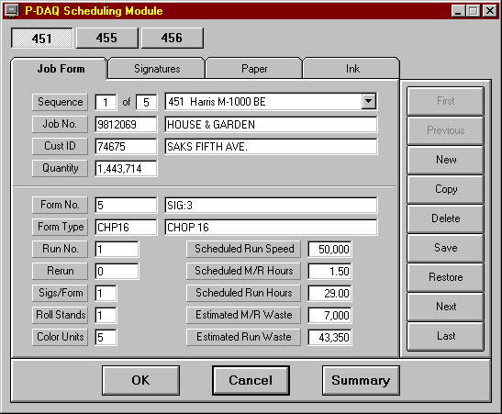
Details
Sequence The current job being viewed and the total number of jobs in the schedule.
Job No. The job number and description of the job being run. The job description is displayed automatically if present on the job master file.
Cust ID The customer ID and customer name. The customer name is displayed automatically if present on the Customer master file.
Press ID The press the job is scheduled to run on. The job may be moved to different press by selecting the press from the drop down list.
Form No. The form number and description of the form being run.
Form Type The form type and description of the form being run. The description is displayed automatically if present on the Form Type master file.
Run No. The run number of the form being run.
Rerun The rerun number of the form on press.
Sigs/Form The number of different signatures being delivered.
Roll Stands The number of roll stands used for this job.
Color Units The number of color units used for this job.

The scheduled hours and waste figures are used by P-DAQ to compare actual hours and waste to that of the schedule. These figures are also graphed in the Press Module (Performance Screen) for pressmen to determine whether or not he or she is performing on schedule.

Controls
First View first job in the schedule. Disabled if job sequence number 1 is currently being displayed.
Previous View prior job in the schedule. Disabled if job sequence number 1 is currently being displayed.
New Creates a new job sequence number and clears all fields for subsequent entry.
Copy Copies the data from the currently displayed job to a new job sequence number. The copied job definition may then be selectively modified to define the specifications of the new job.
Delete Deletes the currently displayed job from the schedule. A warning message is displayed to help eliminate accidental deletions.
Save Saves the current job schedule in the database.
Restore Reads the data from the database for the current job. This function is used to negate any and all changes made to the current job since the last time it was saved to the database.
Next View next job in the schedule. Disabled if the last job sequence number is currently being displayed.
Last View last job in the schedule. Disabled if the last job sequence number is currently being displayed.

Screen Menu Options
OK Saves the current job and exits the program.
Cancel Exits the program without saving the current job.
Summary Displays the Job Summary screen. The current job remains selected.

Summary Screen
This screen is used to quickly locate a record to be edited. Records may also be deleted and their priorities may be increased or decreased.
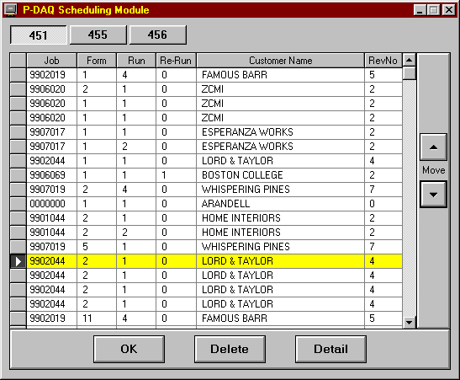
Details
Customer Name The job or the form description may be displayed in lieu of the customer name by adding a parameter to the constants section of the P-Sched.ini file as follows:
Job Sched Desc = “J”
or
Job Sched Desc = “F”
Move UP Increase the priority of the currently selected record.
Move DOWN Decrease the priority of the currently selected record.
Screen Menu Options
OK Saves the current record and exits the program.
Delete Delete the currently selected record. A warning message is displayed to help eliminate accidental deletions.
Detail Display the Job Detail screen. The currently selected record is displayed on the Main Screen.

Signature Definition
This folder identifies the associated signature. The data displayed here is normally defined by the scheduling module and displayed here for reference only. The number of tabs present is based on the signatures associated to the current form. This data may be modified if necessary.
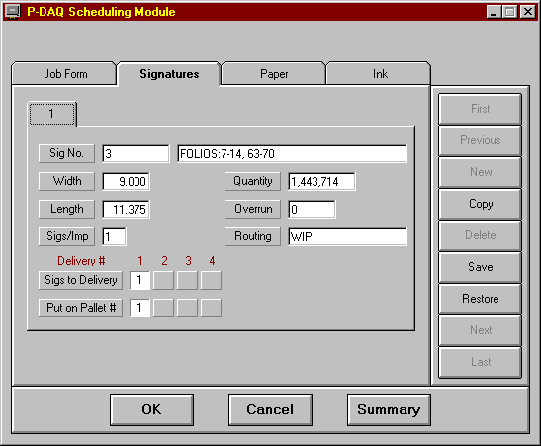
Details
Sig No. Signature ID and description.
Width The width of the signature.
Length The length of the signature.
Quantity The number of signatures required.
Overrun The allowable overrun for the signature.
Current The number of good signatures produced thus far.
Waste The number of waste signatures produced thus far.
Sigs/Imp The number of signatures of this type produced for each impression.
Sigs/Del The deliveries receiving the signature. Each button refers to a delivery. The value within the depressed button refers to the number of signatures of this type which are passed to the delivery. Each time the button is pressed, the number within is incremented by 1. A blank faced button is used to indicate that a delivery is not used for the signature. In the example above, we are getting 2 signatures of this type from each impression. The first signature is delivered to Delivery #1 and the second to Delivery #2. The same delivery may not be used for different signatures.
Sigs/Pal The pallets receiving the signature. Each button refers to a pallet position. The value within the depressed button refers to the number of signatures of this type which are accumulated on the pallet. Each time the button is pressed, the number within is incremented by 1. A blank faced button is used to indicate that a pallet position is not used for the signature. In the example above, we are getting 2 signatures of this type from each impression. The first signature is delivered to Delivery #1 and the second to Delivery #2, however, signatures from both deliveries are accumulated on the same pallet at position #1. The same pallet may not be used for different signatures.
Lift Count The average number of signatures accumulated at the stacker for delivery to the pallet. This number is calculated by averaging the 5 largest lifts placed on the first pallet. This data may be changed from the terminal located at the delivery station.
Lifts/Skid The number of lifts of the size defined above which can be placed on the pallet. This data may be changed from the terminal located at the delivery station.
Routing Optional entry which may be printed on the load ticket to identify the destination of the pallet.

Paper Definition
This folder identifies the stock being used at each of the roll stands. The data displayed here is normally defined by the scheduling module and displayed here for reference only. The number of tabs present is based on the number of roll stands being used. This data may be modified if necessary.
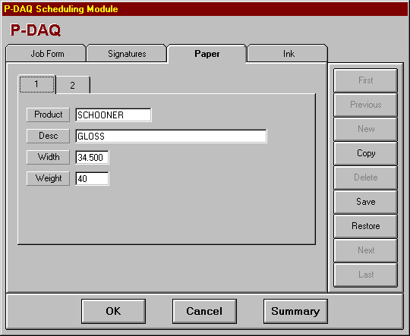
Details
Product The paper inventory product ID being used.
Desc The description of the stock being used.
Width The roll width of the stock being used.
Weight Basis weight of the stock being used.

Ink Definition
This folder identifies the ink to be used in conjunction with each of the color units. If one or more of the color units will not be used, the ink information may be omitted.
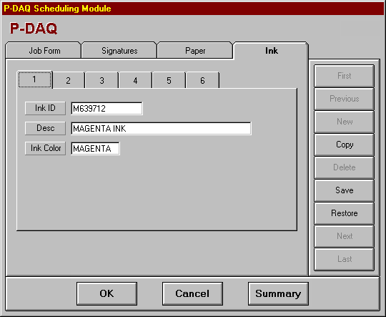
Details
Ink ID The inventory product identifier for the ink being used.
Desc The description of the ink being used.
Ink Color The color of the ink being used.

Chapter 9 Press Status Module

Overview
P-Status can be used by scheduling, customer service, and management to determine the current status of jobs on press.

Status Summary Screen
This screen is used to view the status of up to 20 presses at once. To view status details, click any field for the associated press, job or form.

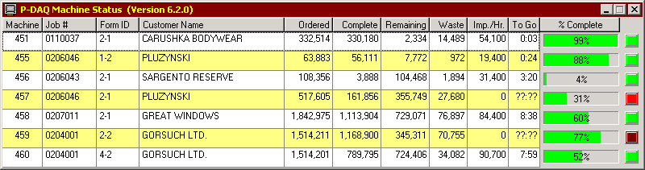
Details
Machine The cost center number.
Job # The job number.
Form ID The form, run and rerun numbers.
Customer Name The customer name.
Ordered The quantity requested.
Complete The total number of completed net signatures.
Remaining The number of remaining net signatures.
Waste The current waste sigs for the associated form.
Imp/Hr. The speed of the press in impressions per hour.
To Go The time to go based on the current speed.
% Complete The percentage of completed signatures.

Status Detail Screen
The folder tabs represent the presses which may be viewed. Once selected, the current status is displayed. The status is then updated approximately every 15 seconds. The last date and time the status was updated is displayed below the form description. If for any reason, the status cannot be updated for 60 seconds or more, the red indicator to the right will turn on and begin to flash. This can occur if the Network Server is not available or when a system back up is in process.
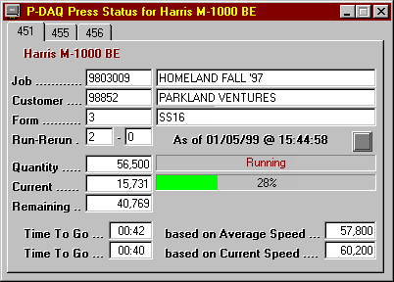
Details
Job The job number and associated description.
Customer The customer number and name.
Form The form and form description.
Run-Rerun The run and rerun numbers.
Quantity The quantity requested.
Status The current press status.
Current The total number of completed signatures.
% Complete The percentage of the form which is complete.
Remaining The number of remaining signatures.
Waste The total waste for the associated form.
Imp/Hr. The speed of the press in impressions per hour.
To Go (Average) The time to go based on the average speed.
To Go (Current) The time to go based on the current speed.

Web Status
P-Status can be configured to allow users to access Press Status from the browser. When running on the P-DAQ server, the program writes the status of all of your presses to an HTML file that is automatically copied to your web server or to a local network share.
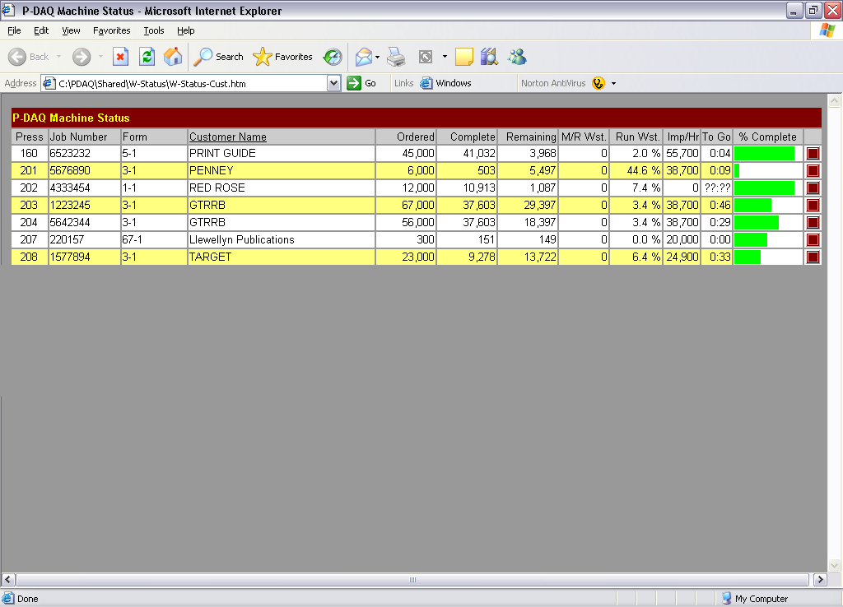
To enable this feature, the path to the location where the HTML files are to be stored and the update/refresh rate needs to be added to the [CONTANTS] section of the P-Status.ini file located in the PDAQ\Shared\Init directory on the P-DAQ server as in the following example:
Web Server Path = \\yourwebserver\P-Status
Web Update Time = 10 (between 5 and 30 seconds)
To create and update the files, the P-Status.exe program should be scheduled to run on the server and be left running at all times.
Once these files are available on your web server, users should be given access to HTML document as in the following example:
www.yourwebserver.com/P-Status/P-Status-Cust.htm -or-
C:\PDAQ\P-Status\P-Status-Cust.htm
Once the page is opened, users can toggle between Customer Name, Form Description, or Job Description view by clicking the associated column heading.

Chapter 10 Management / Reporting Module

Overview
The Management / Reporting module is used to display and/or print selected reports. Each report contains selection criteria that may be specified to limit the amount of data reported.
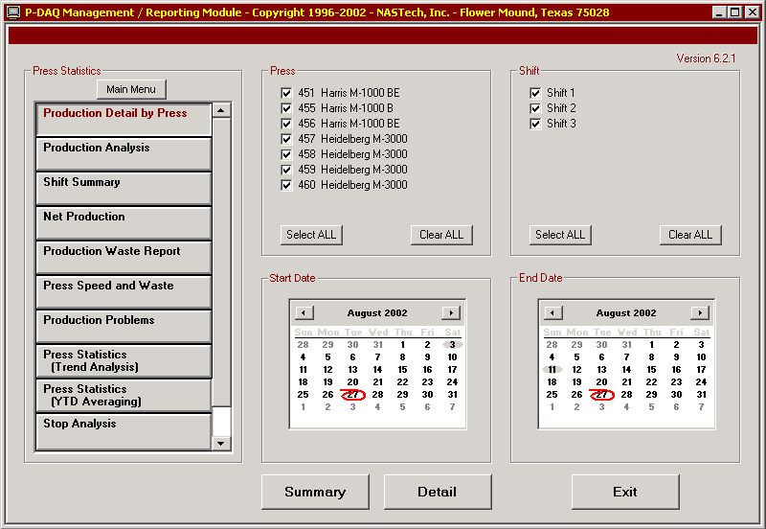
The reports available are presented as a series of buttons, each of which may be selected when required. As new reports are made available, additional buttons are automatically added.
When a report is selected, the four panels to the right are used to specify the selection criteria required for the particular report. Once the selection criterion has been specified, the report may be displayed by clicking on the Summary, Detail, or Process button. Once a report has been displayed, you may open a new report by clicking the Open Report button. Opened reports can be reviewed by using the drop down list. Reports are closed using the Close Report button.
Once a report is displayed, it may be printed in its entirety or selectively by page.

Upon selecting a report and by clicking the Process, Summary, or Detail button, the P-DAQ reporting system analyzes the system logs and builds a summary database which summarizes all data needed for the selected report.

When a report is not run periodically, the next time you run the report, the system needs to update the summary databases. Depending on the amount of data to be summarized, this process may take a while and the given report may not display right away. There are a few ways to make sure that the summary databases are up to date as outlined in the following procedures:

- From the P-Admin main screen, without selecting a report, click the Process button. This will summarize all data for all reports at one time. Performing this task periodically reduces the amount of time it takes for reports to display.

- Using Windows “Scheduled Tasks”, you may schedule P-Admin to run periodically, and the summary databases to be updated automatically. This ensures that the summary databases are always up to date. The following is the procedure to set up the task on the P-DAQ Server:

- Choose Start\ControlPanel\ScheduledTasks.
- Click “Add Scheduled Task”.
- Click “Next”.
- Click the “Browse” button and browse the server to the PDAQ\Shared directory and select the P-Admin.exe file.
- Follow the instructions to select the time and enter the user name and password when prompted.
- Check the box marked “Open Advanced Properties for this Task when I click Finish” button and click the finish button.
- In the Run field, change the path to read exactly as in the following: C:\PDAQ\Shared\P-Admin.exe AUTO
- In the Start In field, make sure the path is as following: C:\PDAQ\Shared

Multiple Report View
Multiple reports can be opened simultaneously. Once a report is open, the
Open Report button is used to produce another report. Once multiple reports are opened, you may toggle the reports to be viewed using the dropdown list. To close the associated report, use the Close Report button.

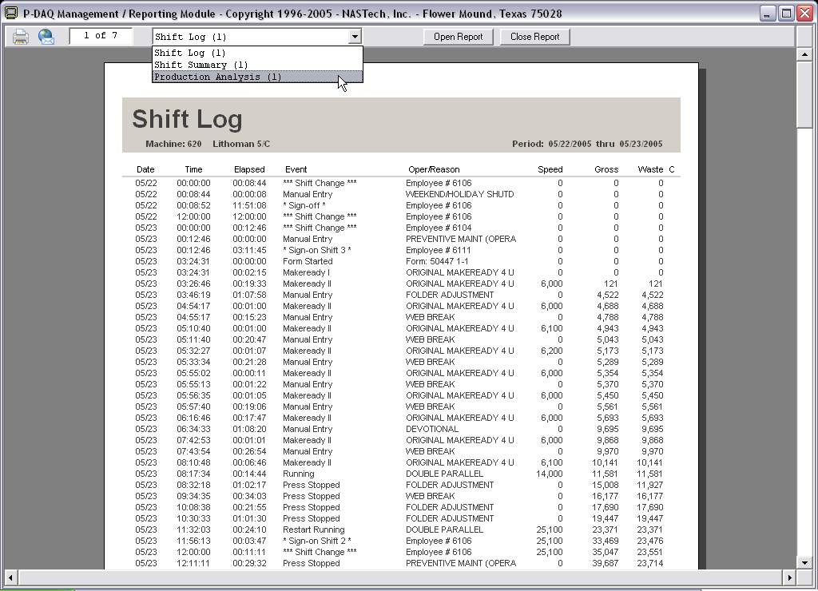

Print Dialog Box
Reports can be printed selectively or in their entirety using the print dialog box.

Select the printer to print to, select all pages or enter a page range as shown, and click the Print button.

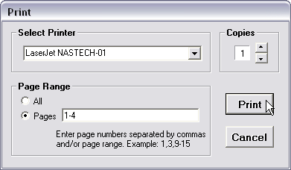

Email Dialog Box
Reports can be sent via email using the default email program on the associated client computer. Third party software called “PDF995” is required to convert the report into a PDF file. Please contact a NASTech representative for more information about this software.

Select all pages or enter a page range as shown, and click the Send button.

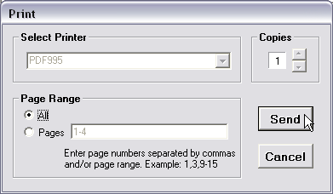

P-Admin will automate the PDF conversion process, open the email client, and attach the PDF file to the message.

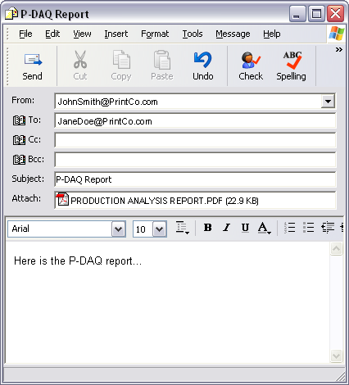

Charts

Press Statistics
The Press Statistics Report Charts can be customized for your plant. There are 12 charts in total, they are titled as follows:
- Makeready Waste
- Run Waste
- Net Yield
- Print Time
- Makeready Time
- Net Speed
- Stop Time
- Impressions Per Stop
- Average Initial Makeready Time
- Average Initial Makeready Waste
- Average Subsequent Makeready Time
- Average Subsequent Makeready Waste
These charts are available for both the Press Statistics / Trend Analysis reports, and for the Press Statistics / Year to Date reports. Both of these reports are also available by Crew/Operator, and by Crew/Shift.

P-Admin allows you to print any 1, 2 or 4 of these charts on the associated report.

You may also have multiple reports set up, for example, you can have a Press Statistics / Trend Analysis 1, and a Press Statistics / Trend Analysis 2... You can then choose to display any combination of the charts on each of these reports. For example:

Press Statistics 1 (Trend Analysis)

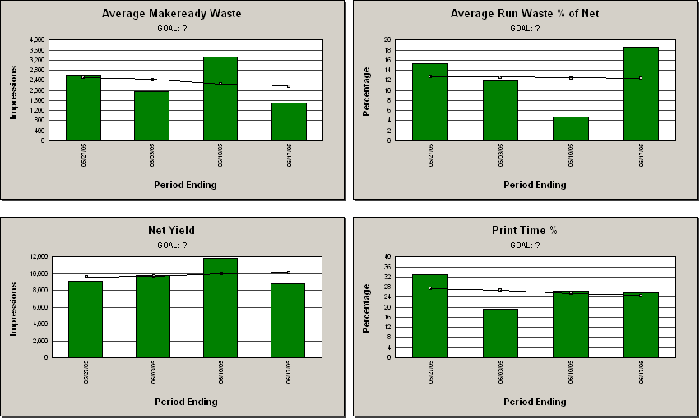
Press Statistics 2 (Trend Analysis)

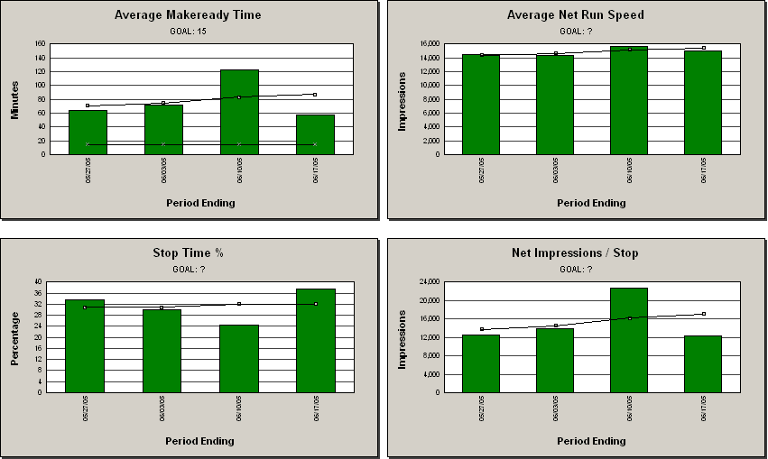

You may also choose to not predefine the charts; in this case the user will be prompted to select the charts he or she wishes to view on the associated report. For example:

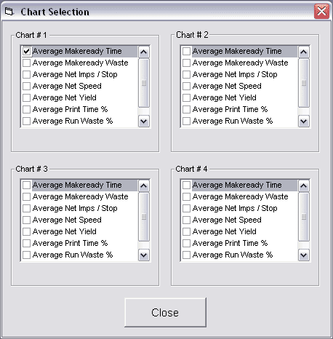

You may predefine, or the user can select 1 or 2 charts for viewing; in this case, the chart(s) will expand to fit the entire width of the screen. For example:

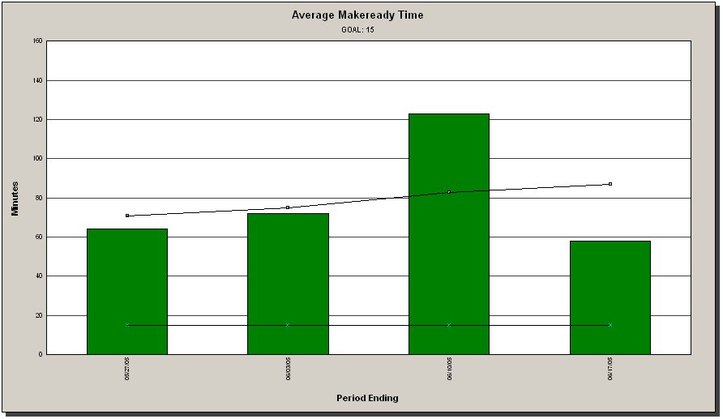

To predefine the charts to be viewed, edit the P-Admin.ini file located in the PDAQ\Shared\Init directory on the server. Contact a NASTech representative for further assistance in editing this file.

To predefine the Goal lines used on these reports, add the goals to the Press Goal table using the P-Maint program. Contact a NASTech representative for further assistance in editing this database table.

Stop Analysis
The Stop Analysis Reports chart the top ten reasons for press stops based on 4 different criteria. They are as follows:
- Occurrences
- Down-Time
- Waste
- Cost
For Example:
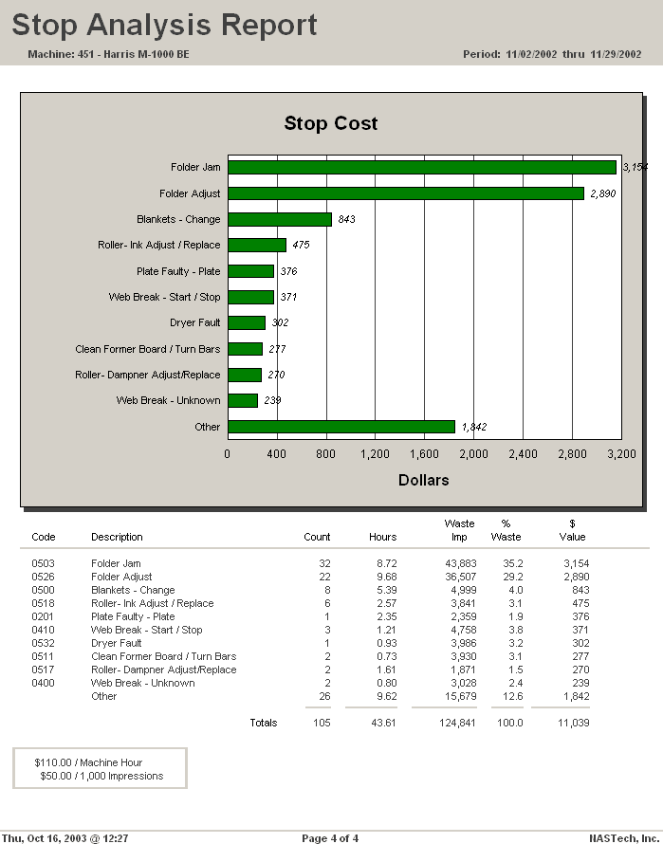
In order to calculate cost, you must define the cost center’s Rate per Hour, and Rate per 1000 Impressions. Set these numbers up in the Cost Center table using the P-Maint program. Contact a NASTech representative for further assistance in editing this database table.

System Logs

Ink Log
This report shows the amount of ink consumed for each color unit used for the associated form. These events occur at the completion of the form. The report is displayed in chronological order.
Heading
Heading The Press number, description, and the time period for the report.
Body
Date The actual date on which the associated event occurred.
Time The actual time at which the associated event occurred.
Unit The associated color unit.
Product The inventory product ID and description of the ink which was consumed.
Quantity The quantity of ink consumed. The unit of measure is determined by the factor specified for the associated press color unit.
Job Number The associated job number.
Form/Run/Re-Run The form, run, and re-run numbers.
Footing
Footing The date and time the report was run, the page number and the company name.

Pallet Log
This report shows the pallets that were produced during a specified period of time. Adjustments made to the pallets are also shown. The report is displayed in chronological order.
Heading
Heading The press number, description, and the time period for the report.
Body
Date The actual date on which the associated pallet was created or adjusted.
Time The actual time at which the associated pallet was created or adjusted.
Event Indicates whether the pallet was created or adjusted.
Seq The pallet sequence number.
Pallet ID The unique pallet identifier for the pallet.
Quantity The original pallet quantity or the quantity after the adjustment was made.
Job Number The job number for which the pallet was produced.
Sig ID The Signature identifier for the associated job.
Description The description of the product on the pallet.
Type The type of product on the pallet. Used to indicate samples, VIP’s etc.
Footing
Footing The date and time the report was run, the page number and the company name.

Paper Log
This report shows the roll stock that was consumed during a specified period of time. The report is displayed in chronological order.
Heading
Heading The press number, description, and the time period for the report.
Body
Date The actual date on which the associated event occurred.
Time The actual time at which the associated event occurred.
Event The entry made when a reading is taken, or when the counter has been reset.
Pos The Position of the roll (upper or lower) on the roll stand. Web Presses.
Prod ID The inventory product ID of the stock which was consumed.
Roll ID The bar-code roll ID of the roll consumed.
Quantity The amount of stock consumed. Number of Pounds for Web Presses. Number of Sheets for Sheet-Fed Presses.
Wrap The amount of Wrapper waste in pounds. Web Presses.
Slab The amount of Slab-off waste in pounds. Web Presses.
Core The amount of Core Waste remaining on a roll when the roll will not be returned to inventory. Web Presses.
Job Number The job for which the stock was consumed.
Form The Form and Run numbers for which the stock was consumed.

Footing
Footing The date and time the report was run, the page number and the company name.

Press Log
This report shows the press speed fluctuations that occurred for a specified period of time. The press speed must change by the amount specified by the Press Speed Variance parameter in the Pressman.ini file. The report is displayed in chronological order.
Heading
Heading The press number, description, and the time period for the report.
Body
Date The actual date on which the associated event occurred.
Time The actual time at which the associated event occurred.
Elapsed The elapsed hours, minutes and seconds of the event.
Event The description of the event.
Speed The speed of the press at the time the event occurred.
Gross The gross impression count for the currently running form at the time the event occurred.
Waste The calculated impression waste for the currently running form at the time of the event.
Footing
Footing The date and time the report was run, the page number and the company name.

Shift Log
This report shows the events that have occurred on press for a specified period of time. The report is displayed in chronological order.
Heading
Heading The press number, description, and the time period for the report.
Body
Date The actual date on which the associated event occurred.
Time The actual time at which the associated event occurred.
Elapsed The elapsed time of the event.
Event The description of the event.
Oper/Reason The description of the operation performed or the reason for the Down-Time.
Speed The speed of the press at the time the event occurred.
Gross The gross impression count for the currently running form at the time the event occurred.
Waste The calculated impression waste for the currently running form at the time of the event.
Comments The comments entered by the Pressman to provide additional information about the associated event.
Footing
Footing The date and time the report was run, the page number and the company name.

Job Statistics

Job Statistics Report
This report shows Makeready and Run statistics for a specified job. All Forms, runs and Re-Runs for the specified job are printed. Totals are provided for the entire job.
Demographics
Job Number The number and description of the job for which the report was requested.
Customer # The customer ID and name for which the job was run.
Body
Form/Run/Re-Run The form ID for each of the forms associated with the job being reported.
Description The description of the form and the form type.
Start Date The date this occurrence of the form was started.
Start Time The time this occurrence of the form was started.
M/R Hours The number of hours expended for Makeready I and Makeready II.
Run Hours The number of hours expended for Makeready III and the Run.
Down-Time The number of hours expended for Down-Time including press restarts.
M/R Impressions The number of waste impressions accumulated during Makeready.
Gross Impressions The total impressions accumulated for the form. Includes all impressions from the beginning to the end of the form.
Ordered The quantity ordered.
Net Impressions The number of net impressions accumulated during Makeready III and the Run.
Run/Waste % The percentage of waste which occurred during MR3 + Run. =(MR 3 Waste + Run Waste + Restart Waste) / Net Impressions * 100
Footing
Footing The date and time the report was run, the page number and the company name.

Production Detail by Form
This report shows Makeready, Run, and Down-Time statistics for one or more forms within a specified job. If all forms for the job are selected, a summary report will also be displayed for the entire job. The following describes both the Detail and Summary report options. The Summary report does not break out Down-Time statistics and does not break out stop codes.
Heading
Heading The press the form was run on, and the start and end dates for the form.
Demographics
Job Number The job number and associated description.
Form ID The form ID for each of the forms associated with the job being reported, and the signature numbers.
Run The Run number for each of the associated forms being reported.
Re-Run The occurrence of the particular Run. Used if the form and run is run on different occasions.
Customer The customer ID and associated customer name.
Ordered The order quantity.
Shift Detail
Shift The shift number.
Gross (Imp) The total accumulated gross count by shift.
Net (Imp) The total accumulated net count by shift.
Waste (Imp) The total accumulated waste count by shift.
% Waste Net The percentage of waste which occurred during MR3 + Run. =(MR 3 Waste + Run Waste + Restart Waste) / Net Impressions * 100
Print-Time = (MR2 + MR3 + Run) in hours.
Event Detail
Gross (Imp) Includes gross impressions accumulated during MR2. Also includes gross impressions accumulated during Production (MR3 + Run + Down-Time +Restarting), Production/DT, and Non/Charge.
Net (Imp) Includes net impressions accumulated during Production (MR3 + Run + Down-Time +Restarting).
Waste (Imp) Includes waste impressions accumulated during MR2. Also includes gross impressions accumulated during Production (MR3 + Run + Down-Time +Restarting) Production/DT, and Non-Charge.
Hours Total Time for the associated event in hours.
Pct The percentage of time for the associated event.
Num The number of occurrences for the associated event.
Speed Detail
Gross The average gross impressions per hour during Press/Run (MR3 + Run + Restart). = Gross Impressions / Run Hours.
Net The average net impressions per hour during Press/Run (MR3 + Run + Restart). = Net Impressions / Run Hours.
Yield
Gross The average number of gross impressions per hour during Press/Run (MR3 + Run + Restart). = Gross Impressions / Run Hours.
Net The average number of net impressions per hour during Press/Run (MR3 + Run + Restart). = Net Impressions / Run Hours.
Stop Detail
Stops M = Makeready, I = Idle. (Detail Report only)
Code The down time code.
Description The code description.
Waste (Imp) The total waste impressions accumulated for the associated event.
Hours The total time for the associated event in hours.
Pct The percentage of the total time for the associated event.
Num The number of occurrences for the associated event.
Manual Entries Waste impressions, hours, time percentage, and number of occurrences by form. (Detail Report only).
System Entries Waste impressions, hours, time percentage, and number of occurrences by form. (Detail Report only).
Idle Entries Waste impressions, hours, time percentage, and number of occurrences by form. (Detail Report only).
Down-Time Summary of all Down-Time by waste impressions, hours, time percentage and occurrences. Summarizes all Down-Time including Manual Entries, System Entries and Idle Entries. (Summary Report only).
Footing
Footing The date and time the report was run, the page number and the company name.

Press Statistics

EPA Statistics
This report shows gross, net, and waste counts, ink and paper usage by form and by press for the selected day.
Heading
Heading The press the form was run on, and the start and end dates for the report.
Body
Date The date.
Form Type The associated form type.
Ink Used The total ink in pounds used by the associated form.
Paper Used The total paper in pounds used by the associated form.
Gross Imps The total gross impressions used by the associated form.
M/R Imps The total MR waste impressions used by the associated form.
Waste Imps The total waste impressions used by the associated form.
Good Imps The total net impressions used by the associated form.
Footing
Footing The date and time the report was run, the page number and the company name.

Net Production Report
This report lists all jobs run on the specified press for the requested period. The jobs are listed in the order in which they were run.
Heading
Heading The press number, description, and the time period for the report.
Body
Job # The job identification number.
Customer Name The customer’s name.
Job Description The description of the job.
Form-Run The form and run numbers.
Form Type The form type.
Net Imps The number of impressions produced.
Ordered The number of impressions requested.
Last Activity The date and time of the last activity for this form.
Footing
Footing The date and time the report was run, the page number and the company name.

Press Speed & Waste
This report lists the speed and waste percentages for all jobs run on the specified press(s) for the requested period. The jobs are listed in the order in which they were run.
Heading
Heading The time period for the report.
Body
Press # The press number.
Date The actual date on which the associated event occurred.
Job # The job identification number.
Form-Run The form and run numbers.
Net Imps The number of net impressions produced.
Ordered The number of impressions ordered.
Overs The number of overs produced.
Over % = Overs / Ordered * 100
MR Imps Number of Makeready impressions produced.
Run-Waste % The percentage of waste which occurred during MR3 + Run. =(MR 3 Waste + Run Waste + Restart Waste) / Net Impressions * 100
Run Speed = Net Impressions / (MR3 + Run hours).
Form Desc The form description.
Footing
Footing The date and time the report was run, the page number and the company name.

Press Statistics Report (Trend Analysis)
This report shows press statistical information summarized weekly by press and by shift. This report can display 4 charts simultaneously out of 12 possible charts. Multiple reports can be setup via the P-Admin.ini file to display different charts or combinations of these charts.
Heading
Heading The press number, description, and the time period for the report.
Shift The shift number(s).
Charts
- Average Makeready Waste impressions is charted for each week in the specified period. Goal and trend lines are also charted.
- Average Makeready Time is charted for each week in the specified period. Goal trend lines are also charted.
- Average Initial Makeready Time is charted for each week in the specified period. Goal and trend lines are also charted.
- Average Subsequent Makeready Time is charted for each week in the specified period. Goal and trend lines are also charted.
- Average Initial Makeready Waste impressions is charted for each week in the specified period. Goal and trend lines are also charted.
- Average Subsequent Makeready Waste impressions is charted for each week in the specified period. Goal and trend lines are also charted.
- Average Run-Waste as a percentage of gross run impressions is charted for each week in the specified period. Goal and trend lines are also charted.
- Net Yield is charted for each week in the specified period. Goal and trend lines are also charted.
- Net Impressions is charted for each week in the specified period. Goal and trend lines are also charted.
- Net Speed is charted for each week in the specified period. Goal and trend lines are also charted.
- Stop Time percentage is charted for each week in the specified period. Goal and trend lines are also charted.
- Average Impressions per Stop is charted for each week in the specified period. This is the average number of impressions to start saving after a press stop. Goal and trend lines are also charted.
Body
Period Ending The date of the last day of the week. The first and last days of the week are defined in the P-Admin.ini file.
Net Impressions The number of net impressions produced in the specified period.
M/R Count The number of Makereadies performed during the specified period.
M/R-1 Hours The number of hours expended for Makeready I for the specified period.
M/R-2 Hours The number of hours expended for Makeready II for the specified period.
M/R Waste The number of waste impressions accumulated during Makeready for the specified period.
Stop Count The number of Press-Stops which occurred during Makeready III and Press Running for the specified period.
Stop Hours The total Down-Time which occurred during Makeready III and Press Running for the specified period.
Run-Waste The percentage of waste which occurred during MR3 + Run. =(MR 3 Waste + Run Waste + Restart Waste) / Net Impressions * 100
Run Hours The number of hours expended for Makeready III and Press Running for the specified period.
Print Hours The number of hours expended for Makeready II, Makeready III and Press Running for the specified period.
Total Hours The total hours for the selected period.
Net Speed = Net Impressions / Print Time (MR2 + MR3 + Run) * 100
% Run-Waste The percentage of waste which occurred during MR3 + Run. =(MR 3 Waste + Run Waste + Restart Waste) / Net Impressions * 100
Net Yield = Net Impressions / (MR3 + Run + Down-Time hours)
Print-Time % = Print Hours (MR2 + MR3 + Run) / Scheduled Hours * 100
Footing
Footing The date and time the report was run, the page number and the company name.

Press Statistics Report (YTD Averaging)
This report shows press statistical information summarized weekly by press and by shift. This report can display 4 charts simultaneously out of 12 possible charts. Multiple reports can be setup via the P-Admin.ini file to display different charts or combinations of these charts.
Heading
Heading The press number, description, and the time period for the report.
Press # The press number.
Charts
- Average Makeready Waste impressions is charted for each week in the specified period. Goal and YTD averages are also charted.
- Average Makeready Time is charted for each week in the specified period. Goal and YTD averages are also charted.
- Average Initial Makeready Time is charted for each week in the specified period. Goal and YTD averages are also charted.
- Average Subsequent Makeready Time is charted for each week in the specified period. Goal and YTD averages are also charted.
- Average Initial Makeready Waste impressions is charted for each week in the specified period. Goal and YTD averages are also charted.
- Average Subsequent Makeready Waste impressions is charted for each week in the specified period. Goal and YTD averages are also charted.
- Average Run-Waste as a percentage of gross run impressions is charted for each week in the specified period. Goal and YTD averages are also charted.
- Net Yield is charted for each week in the specified period. Goal and YTD averages are also charted.
- Net Impressions is charted for each week in the specified period. Goal and YTD averages are also charted.
- Net Speed is charted for each week in the specified period. Goal and YTD averages are also charted.
- Stop Time percentage is charted for each week in the specified period. Goal and YTD averages are also charted.
- Average Impressions per Stop is charted for each week in the specified period. This is the average number of impressions to start saving after a press stop. Goal and YTD averages are also charted.

Body
Period Ending The date of the last day of the week. The first and last days of the week are defined in the P-Admin.ini file.
Net Impressions The number of net impressions produced in the specified period.
M/R Count The number of Makereadies performed during the specified period.
M/R-1 Hours The number of hours expended for Makeready I for the specified period.
M/R-2 Hours The number of hours expended for Makeready II for the specified period.
M/R Waste The number of waste impressions accumulated during Makeready for the specified period.
Stop Count The number of Press-Stops which occurred during Makeready III and Press Running for the specified period.
Stop Hours The total Down-Time which occurred during Makeready III and Press Running for the specified period.
Run-Waste The total waste accumulated during Makeready III and Press Running for the specified period.
Run Hours The number of hours expended for Makeready III and Press Running for the specified period.
Print Hours The number of hours expended for Makeready II, Makeready III and Press Running for the specified period.
Total Hours The total hours for the selected period.
Net Speed = Net Impressions / (MR3 + Run)
% Run-Waste The percentage of waste which occurred during MR3 + Run. =(MR 3 Waste + Run Waste + Restart Waste) / Net Impressions * 100
Net Yield = Net Impressions / (MR-3 + Run + Down-Time hours).
Print-Time % = Print Hours (MR2 + MR3 + Run) / Total Hours * 100
Footing
Footing The date and time the report was run, the page number and the company name.

Production Analysis Report
This report summarizes key operating indicators for the specified period. The report may include statistical data for multiple presses and/or shifts. The following describes both the Detail and Summary report options. The Summary report combines shift statistics for all shifts.
Heading
Heading The press number, description, and the time period for the report.
Shift The shift number(s).
Counts
Gross Impressions The total number of impressions accumulated for the specified period.
Net Impressions The total number of net impressions accumulated for the specified period.
Net Signatures The total number of net signatures accumulated for the specified period.
Net Yield = Net Imp / (MR3 + Run + Down-Time + Wash-Up Hours).
Makeready
Number The number of Initial, Subsequent and Total Makereadies.
M/R-1 The time for Initial, Subsequent, and total MR1 in hours.
M/R-2 The time for Initial, Subsequent, and total MR2 in hours.
Waste The number of waste impressions accumulated during Initial, Subsequent and Total Makereadies, and the average number of Impressions per Makeready.
Stops
Number The number of Press-Stops which occurred for the specified period. Only those stops incurred during Makeready III and Press Running are included
Time The total number of Down-Time hours expended for the specified period. Only the Down-Time incurred during Makeready III and Press Running are included.
Wash-Up
Wash-Up The total Wash-Up time in hours.
Waste
Run Total waste impressions during Run, and the Run-Waste percentage. = (MR3 + Run + Restarting) / Net Impressions * 100
Idle The number of impressions accumulated during Idle-Time.
Total Signatures Total waste impressions, and total Run-Waste percentage. = Total Waste / Net Impressions * 100
Productivity
Print-Time Total Print-Time (MR2 + MR3 + Run)
Print-Time% = (Print-Time / Scheduled-Time).
Sched Total Scheduled Time in hours.
Idle Total Idle-Time in hours.
Total Total Time in hours.
Shift Detail
Period Ending The date.
Shift The shift number.
Gross Imps Gross impressions.
MR Waste Total MR waste impressions (MR2 + MR3).
Run-Waste Total Run-Waste (MR3 + Run + Restart).
Net Imps Total net impressions.
Net Sigs Total net signatures.
Waste Imps Total waste impressions.
Tot Wst / Net = Total Waste / Net Impressions * 100.
Run Wst / Net The percentage of waste which occurred during MR3 + Run. =(MR 3 Waste + Run Waste + Restart Waste) / Net Impressions * 100
Footing
Footing The date and time the report was run, the page number and the company name.

Production Detail by Press
This report summarizes pressroom activity by operation and Down-Time for the associated shift(s) and press during the specified period. The following describes both the Detail and Summary report. The Summary report does not break out Down-Time statistics and does not break out stop codes.
Heading
Heading The press(s) the form was run on, and the start and end dates for the form.
Shift Detail
Shift The shift number.
Gross (Imp) The total accumulated gross count by shift.
Net (Imp) The total accumulated net count by shift.
Waste (Imp) The total accumulated waste count by shift.
% Waste Net The percentage of waste which occurred during MR3 + Run. =(MR 3 Waste + Run Waste + Restart Waste) / Net Impressions * 100
Print-Time = (MR2 + MR3 + Run) in hours.
Event Detail
Gross (Imp) Includes gross impressions accumulated during MR2. Also includes gross impressions accumulated during Production (MR3 + Run + Down-Time +Restarting), Production/DT, and Non/Charge.
Net (Imp) Includes net impressions accumulated during Production (MR3 + Run + Down-Time +Restarting).
Waste (Imp) Includes waste impressions accumulated during MR2. Also includes gross impressions accumulated during Production (MR3 + Run + Down-Time +Restarting), Production/DT, and Non/Charge.
Hours Total time for the associated event in hours.
Pct The percentage of time for the associated event.
Num The number of occurrences for the associated event.

Speed Detail
Gross The average gross impressions per hour during Press Run (MR3 + Run + Restart). = Gross Impressions / Run Hours.
Net The average net impressions per hour during Press Run (MR3 + Run + Restart). = Net Impressions / Run Hours.
Yield
Gross The average number of gross impressions per hour during Press Run (MR3 + Run + Restart). = Gross Impressions / Run Hours + Downtime + Washup.
Net The average number of net impressions per hour during Press Run (MR3 + Run + Restart). = Net Impressions / Run Hours + Downtime + Washup.
Stop Detail
Stops I = Idle
D = Downtime (Summary Report)
M = Manual Entry Downtime (Detail Report)
S = Press Stopped Downtime (Detail Report)
Code The Down-Time code.
Description The code description.
Waste (Imp) The total waste impressions accumulated for the associated event.
Hours The total time for the associated event in hours.
Pct The percentage of the total time for the associated event.
Num The number of occurrences for the associated event.
Manual Entries waste impressions, hours, time percentage, and number of occurrences by form. (Detail Report only).
System Entries Waste impressions, hours, time percentage, and number of occurrences by form. (Detail Report only).
Idle Entries Waste impressions, hours, time percentage, and number of occurrences by form. (Detail Report only).
Down-Time Summary of all Down-Time by waste impressions, hours, time percentage and occurrences. (Summary Report).

Footing
Footing The date and time the report was run, the page number and the company name.

Daily Production Summary
This report summarizes daily pressroom activity by press and by shift. Includes the number of Makereadies, The total number of impressions produced, and the total Print-Time in hours.
Heading
Heading The date of the report.
Press # The Cost Center number.
Shift Data
Form Detail The associated job, form, run, re-run, and form description.
Run Detail Makeready Time in hours, (Number of Makereadies), and rounded net quantities by form.
Print-Time The total hours of Print-Time (MR2 + MR3 + Run) during the shift.
Totals
Total Net The total number of impressions accumulated for the specified shift.
Total # of MR The total number of Makereadies for the entire day.
Total # of Net The total number of net impressions produced on the associated press for the entire day.
Grand Total # M/R The total number of Makereadies performed on the associated press for the entire day.
Footing
Footing The date and time the report was run, the page number and the company name.

Production Waste Report
This report summarizes daily waste percentage statistics for selected presses.
Heading
Heading The time period for the report.
Body
Press # The Cost Center number.
Date The date the form was run.
Shift The associated shift number.
Job The associated job number.
Job Name The associated job description.
Form The form number.
Run The Run number.
Gross Imps The total impressions accumulated during the specified period.
Waste Count The total number of waste impressions accumulated for the specified period.
Net Count The total number of net impressions accumulated for the specified period.
Waste % The percentage of waste which occurred during MR3 + Run. =(MR 3 Waste + Run Waste + Restart Waste) / Net Impressions * 100
Footing
Footing The date and time the report was run, the page number and the company name.

Shift Summary Report
This report summarizes pressroom activity by operation and Down-Time for the requested period and shift(s). The following describes both the Detail and Summary report. The Summary report does not break out Down-Time statistics and does not break out stop codes.
Heading
Heading The press number, and the start and end dates for the report.
Shift The shift number(s).
Gross Count The total impressions accumulated during the specified period.
Net Count The total number of net impressions accumulated for the specified period.
Waste Count The total number of waste impressions accumulated for the specified period.
Event Detail
S,M,I These print based upon whether the code is (I)dle, entered as a (M)annual Entry, or if the operation code was the initial cause of a press (S)top.
Code The operation code of the associated activity. The body of the report is sorted by this code.
Description The description of the operation code.
Count The total number of occurrences of the associated operation or Down-Time.
Hours The total number of hours expended for the associated operation or Down-Time.
Gross The number of gross impressions.
Good The number of net impressions.
Waste Imp The total number of waste impressions accumulated during the specified period.
Waste % Waste for the associated operation or Down-Time as a percentage of the total waste. = Waste / Total Waste * 100
Manual Entries Waste impressions, hours, time percentage, and number of occurrences by shift. (Detail Report only).
System Entries Waste impressions, hours, time percentage, and number of occurrences by shift. (Detail Report only).
Idle Entries Waste impressions, hours, time percentage, and number of occurrences by shift. (Detail Report only).
Down-Time Summary of all Down-Time by waste impressions, hours, time percentage and occurrences. (Summary Report).
Footing
Footing The date and time the report was run, the page number and the company name.

Stop Analysis Report
This report is used to analyze Press-Stops based on several different criteria. Several charts are produced which rank the reasons for the stops.
Heading
Heading The selected press numbers, press description, and the start and end dates for the report.
Charts
- Top 10 causes of Press-Stops based on frequency of the stop.
- Top 10 causes of Press-Stops based on Down-Time hours.
- Top 10 causes of Press-Stops based on accumulated waste.
- Top 10 causes of Press-Stops based on aggregate cost.
Body
Oper Code The Press-Stop code.
Description The reason for the Press-Stop.
Count The number of Press-Stops for the specified period.
Hours The total number of Down-Time hours expended for the Press-Stop.
Waste Imp The total number of waste impressions accumulated as a result of restarting the press after the Press-Stop.
% Percentages of total Stops, total Waste, total Hours, and total Cost is displayed dependant of the report page.
$ Value The dollar value based on the machine rate and the cost per 1000 impressions based on the values defined in P-Maint.
Footing
Footing The date and time the report was run, the page number and the company name.

Crew Reporting

Press Statistics Report (Trend Analysis)
This report shows press statistical information summarized weekly by press and by crew.
Heading
Heading The press number, description, and the time period for the report.
Charts
- Average Makeready Waste impressions is charted for each week in the specified period. Goal and Trend lines are also charted.
- Average Run-Waste as a percentage of gross run impressions is charted for each week in the specified period. Goal and Trend lines are also charted.
- Net Yield is charted for each week in the specified period. Goal and Trend lines are also charted.
- Print-Time Percentage is charted for each week in the specified period. Goal and Trend lines are also charted.
Body
Period Ending The date of the last day of the week. The first and last days of the week are defined in the P-Admin.ini file.
Net Impressions The number of net impressions produced in the specified period.
M/R Count The number of Makereadies performed during the specified period.
M/R-1 Hours The number of hours expended for Makeready I for the specified period.
M/R-2 Hours The number of hours expended for Makeready II for the specified period.
M/R Waste The number of waste impressions accumulated during Makeready for the specified period.
Stop Count The number of Press-Stops which occurred during Makeready III and Running for the specified period.
Stop Hours The total Down-Time which occurred during Makeready III and Press Running for the specified period.
Run-Waste The total waste accumulated during Makeready III and Press Running for the specified period.
Run Hours The number of hours expended for Makeready III and Press Running for the specified period.
Print Hours The number of hours expended for Makeready II, Makeready III and Press Running for the specified period.
Total Hours The total hours for the selected period.
Net Speed = Net Impressions / Print Hours (MR2 + MR3 + Run) * 100
% Run-Waste The percentage of waste which occurred during MR3 + Run. =(MR 3 Waste + Run Waste + Restart Waste) / Net Impressions * 100
Net Yield = Net Impressions / (MR-3 + Run + Down-Time hours)
Print-Time % = Print Hours (MR2 + MR3 + Run) / Scheduled Hours * 100
Footing
Footing The date and time the report was run, the page number and the company name.

Press Statistics Report (YTD Averaging)
This report shows press statistical information summarized weekly by press and by crew.
Heading
Heading The press number, description, and the time period for the report.
Charts
- Average Makeready Waste impressions is charted for each week in the specified period. Goal and YTD averages are also charted.
- Average Run-Waste as a percentage of gross run impressions is charted for each week in the specified period. Goal and YTD averages are also charted.
- Net Yield is charted for each week in the specified period. Goal and YTD averages are also charted.
- Net Impressions per Press-Stop is charted for each week in the specified period. Goal and YTD averages are also charted.
Body
Period Ending The date of the last day of the week. The first and last days of the week are defined in the P-Admin.ini file.
Net Impressions The number of net impressions produced in the specified period.
M/R Count The number of Makereadies performed during the specified period.
M/R-1 Hours The number of hours expended for Makeready I for the specified period.
M/R-2 Hours The number of hours expended for Makeready II for the specified period.
M/R Waste The number of waste impressions accumulated during Makeready for the specified period.
Stop Count The number of Press-Stops which occurred during Makeready III and Press Running for the specified period.
Stop Hours The total Down-Time which occurred during Makeready III and Press Running for the specified period.
Run-Waste The total waste accumulated during Makeready III and Press Running for the specified period.
Run Hours The number of hours expended for Makeready III and Run for the specified period.
Print Hours The number of hours expended for Makeready II, Makeready III and the Press Running for the specified period.
Total Hours The total hours for the selected period.
Net Speed = Net Impressions / Print Hours (MR2 + MR3 + Run)* 100.
% Run-Waste The percentage of waste which occurred during MR3 + Run. =(MR 3 Waste + Run Waste + Restart Waste) / Net Impressions * 100
Net Yield = Net Impressions / (MR-3 + Run + Down-Time hours)
Print-Time % = Print Hours (MR2 + MR3 + Run) / Scheduled Hours * 100.
Footing
Footing The date and time the report was run, the page number and the company name.

Production Analysis Report
This report summarizes key operating indicators for the specified period. The report may include statistical data for multiple presses and/or crews. The following describes both the Detail and Summary report. The Summary report does not break out shift statistics by shift number.
Heading
Heading The press number, description, and the time period for the report.
Shift The shift number(s).
Counts
Gross ImpressionsThe total number of impressions accumulated for the specified period.
Net Impressions The total number of net impressions accumulated for the specified period.
Net Signatures The total number of net signatures accumulated for the specified period.
Net Yield = Net Impressions / (MR3 + Run + Down-Time hours).
Makeready
Number The number of Initial, Subsequent and total Makereadies.
MR1 The time for Initial, Subsequent, and total MR1 in hours.
MR2 The time for Initial, Subsequent, and total MR2 in hours.
Waste The number of waste impressions accumulated during Initial, Subsequent and total Makereadies, and the average number of impressions per Makeready.
Stops
Number The number of Press-Stops which occurred for the specified period. Only those stops incurred during Makeready III and Press Running are included
Time The total number of Down-Time hours expended for the specified period. Only the Down-Time incurred during Makeready III and Press Running are included.
Wash-Up
Wash-Up The total Wash-Up time in hours.
Waste
Run Total waste impressions during Run, and the Run-Waste percentage. = (MR3 + Run + Restarting) / Net Impressions * 100
Idle The number of Impressions accumulated during Idle-Time.
Total Signatures Total waste impressions, and total Run-Waste percentage. = Total Waste / Net Impressions.
Productivity
Print-Time = (MR2 + MR3 + Run) in hours.
Print-Time % (Print-Time / Scheduled-Time * 100).
Sched Total Scheduled Time in hours.
Idle Total Idle-Time in hours.
Total Total Time in hours.
Shift Detail
Period Ending The date.
Shift The shift number.
Gross Imps Gross impressions.
MR Waste Total MR waste impressions (MR2 + MR3).
Run-Waste Total Run-Waste (MR3 + Run + Restart).
Net Imps Total net impressions.
Net Sigs Total net signatures.
Waste Imps Total waste impressions.
Tot Wst / Net = Total Waste / Net Impressions.
Run Wst / Net The percentage of waste which occurred during MR3 + Run. =(MR 3 Waste + Run Waste + Restart Waste) / Net Impressions * 100
Footing
Footing The date and time the report was run, the page number and the company name.

Production Detail by Press
This report summarizes pressroom activity by operation and Down-Time for the associated crew(s) and press during the specified period. The following describes both the Detail and Summary report. The Summary report does not break out Down-Time statistics and does not break out stop codes.
Heading
Heading The press number the form was run on, and the start and end dates for the form.
Shift Detail
Shift The shift number.
Gross (Imp) The total accumulated gross count by shift.
Net (Imp) The total accumulated net count by shift.
Waste (Imp) The total accumulated waste count by shift.
% Waste Net The percentage of waste which occurred during MR3 + Run. =(MR 3 Waste + Run Waste + Restart Waste) / Net Impressions * 100
Print-Time = (MR2 + MR3 + Run) in hours.
Event Detail
Gross (Imp) Includes gross impressions accumulated during MR2. Also includes gross impressions accumulated during Production (MR3 + Run + Down-Time + Restarting), Production/DT and Non/Charge.
Net (Imp) Includes net impressions accumulated during Production (MR3 + Run + Down-Time +Restarting).
Waste (Imp) Includes waste impressions accumulated during MR2. Also includes gross impressions accumulated during Production (MR3 + Run + Down-Time +Restarting), Production/DT, and Non/Charge.
Hours Total Time for the associated event in hours.
Pct The percentage of time for the associated event.
Num The number of occurrences for the associated event.
Speed Detail
Gross The average gross impressions per hour during Press/Run (MR3 + Run + Restart). = Gross Impressions / Run Hours.
Net The average net impressions per hour during Press/Run (MR3 + Run + Restart). = Net Impressions / Run Hours.
Yield
Gross The average number of gross impressions per hour during Press/Run (MR3 + Run + Restart). = Gross Impressions / Run Hours.
Net The average number of net impressions per hour during Press/Run (MR3 + Run + Restart). = Net Impressions / Run Hours.
Stop Detail
Stops M = Makeready, I = Idle. (Detail Report only)
Code The Down-Time code.
Description The code description.
Waste (Imp) The total waste impressions accumulated for the associated event.
Hours The total time for the associated event in hours.
Pct The percentage of the total time for the associated event.
Num The number of occurrences for the associated event.
Manual Entries Waste impressions, hours, time percentage, and number of occurrences by form. (Detail Report only).
System Entries Waste impressions, hours, time percentage, and number of occurrences by form. (Detail Report only).
Idle Entries Waste impressions, hours, time percentage, and number of occurrences by form. (Detail Report only).
Down-Time Summary of all Down-Time by waste impressions, hours, time percentage and occurrences. (Summary Report).
Footing
Footing The date and time the report was run, the page number and the company name.

Production Summary Report
This report shows production information summarized weekly by press and by crew.
Heading
Heading The press number the form was run on, and the start and end dates for the form.
Charts
- Net impressions are charted for each week in the specified period.
- Run-Waste as a percentage of net impressions is charted for each week in the specified period.
Body
Week Beginning The date of the first day of the week (Sunday).
Yield
Gross Count The total number of impressions accumulated for the specified period.
Net Count The total number of net impressions accumulated for the specified period.
Speed
Gross = Gross Count / (MR-2 + MR-3 + Run Hours)
Net = Net Impressions / (MR-2 + MR-3 + Run Hours)
Waste
Makeready The number of waste impressions accumulated during Makeready for the specified period.
Running The total waste accumulated during Makeready III and Run for the specified period.
Restart The total number of waste impressions accumulated as a result of restarting the Press after Makeready III and Run Down-Time for the specified period.
Imps / Stop = Restart Waste / Number of Stops
Time
Makeready I The number of hours expended for Makeready I for the specified period. Down-Time incurred during Makeready I is included in this number. The Down-Time which occurred during Makeready I is displayed in parenthesis to the right of this number.
Makeready II The number of hours expended for Makeready II for the specified period. Down-Time incurred during Makeready II is included in this number. The Down-Time which occurred during Makeready II is displayed in parenthesis to the right of this number.
Running The total number hours expended during Makeready III and Run for the specified period.
Down-Time The total number of Down-Time hours expended for the specified period. Down-Time incurred during Makeready I and Makeready II is NOT included in this number.
Total Time The total hours for the selected period.
Footing
Footing The date and time the report was run, the page number and the company name.

Shift Summary Report
This report summarizes pressroom activity by operation and Down-Time for the requested period and shift(s).
Heading
Heading The press number the form was run on, and the start and end dates for the form.
Counts
Gross Count The total impressions accumulated during the specified period.
Net Count The total number of net impressions accumulated for the specified period.
Waste Count The total number of waste impressions accumulated for the specified period.
Body
S,M,I These print based upon whether the code is (I)dle, entered as a (M)annual Entry, or if the operation code was the initial cause of a press (S)top.
Code The operation code of the associated activity. The body of the report is sorted by this code.
Description The description of the operation code.
Count The total number of occurrences of the associated operation or Down-Time.
Hours The total number of hours expended for the associated operation or Down-Time.
Waste Imp The total number of waste impressions accumulated during the specified period.
Waste % Waste for the associated operation or Down-Time as a percentage of the total waste. = Waste / Total Waste * 100
Footing
Footing The date and time the report was run, the page number and the company name.

Paper Statistics

Paper Analysis by Job
This report is used to analyze paper usage on a job and form basis.
Heading
Heading The press number the paper was run on.
Demographics
Job No. The job number and job description.
Form The form, run and re-run numbers.
Product ID The product ID number and the product description.
Customer The customer name.
Width The width of the roll.
Basis The basis weight of the stock.
Definitions
Gross Weight Weight of roll including Wrapper Weight and Core Weight.
Net Weight Weight of Roll excluding Wrapper Weight and Core Weight.
Total Waste = Slab Waste + Core Waste + MR Waste + Run Waste
End Weight Weight of remaining product IE… Stump Weight or Core Waste.
Body
Roll The roll sequence number.
Roll ID The internal barcode roll ID.
Slab Waste Weight of paper cut off to prep the Roll.
Start Weight = Net Weight – Slab Waste
Core / Stump End Roll Weight (excludes core weight) that is either discarded (Core Waste) or returned to inventory (Stump Weight).
% MR Waste MR Waste as a percent of Start Weight. = MR Waste / (Start Weight – End Weight) * 100.
% Run-Waste Run-Waste as a percent of Start Weight. = Run-Waste / (Start Weight – End Weight) * 100.
% Tot Waste Total waste as a percent of Net Weight. = Total Waste / Net Weight * 100.
Gross Imps Gross impressions produced from the roll.
MR Wst Imps MR waste impressions produced from the roll.
Run Wst Imps Run waste impressions produced from the roll.
Projected Length Projected length of the paper based on: (Start Weight-End Weight), the width of the roll, and the basis weight.
Actual Length Length of paper consumed in feet. = Cutoff Length * Impressions
Var% Paper length variance from projected length. = Actual Length / Projected Length * 100
Web Brk Number of web break occurrences with the roll.
Footing
Footing The date and time the report was run, the page number and the company name.

Paper Analysis by Vendor
This report is used to analyze paper usage by mill.
Heading
Heading The press the paper was run on.
Demographics
Job No. The job number and job description.
Form The form, run and re-run numbers.
Product ID The product ID number and the product description.
Customer The customer name.
Width The roll width.
Basis The basis weight of the stock.
Definitions
Gross Weight Weight of roll including Wrapper Weight and Core Weight.
Net Weight Weight of Roll excluding Wrapper Weight and Core Weight.
Total Waste = Slab Waste + Core Waste + MR Waste + Run Waste
End Weight Weight of remaining product IE… Stump Weight or Core Waste.
Body
Roll ID The internal barcode roll ID.
Slab Waste Weight of paper cut off to prep the Roll.
Slab Reason The reason code given for excessive slab if applicable.
Start Weight = Net Weight – Slab Waste
Core / Stump End Roll Weight (excludes core weight) that is either discarded (Core Waste) or returned to inventory (Stump Weight).
% MR Waste MR Waste as a percent of Start Weight. = MR Waste / (Start Weight – End Weight) * 100.
% Run-Waste Run-Waste as a percent of Start Weight. = Run-Waste / (Start Weight – End Weight) * 100.
% Tot Waste Total waste as a percent of Net Weight. = Total Waste / Net Weight * 100.
Gross Imps Gross impressions produced from the roll.
MR Wst Imps MR waste impressions produced from the roll.
Run Wst Imps Run waste impressions produced from the roll.
Projected Length Projected length of the paper based on: (Start Weight-End Weight), the width of the roll, and the basis weight.
Actual Length Length of paper consumed in feet. = Cutoff Length * Impressions
Var% Paper length variance from projected length. = Actual Length / Projected Length * 100
Web Brk Number of web break occurrences with the roll.
Footing
Footing The date and time the report was run, the page number and the company name.

Paper Usage by Job 1
This report is used to analyze paper usage on a job and form basis.
Heading
Heading The press the paper was run on.
Demographics
Job No. The job number and job description.
Form The form, run and re-run numbers.
Product ID The product ID number and the product description.
Customer The customer name.
Width The roll width.
Basis The basis weight of the stock.
Definitions
Gross Weight Weight of roll including Wrapper Weight and Core Weight.
Net Weight Weight of Roll excluding Wrapper Weight and Core Weight.
Total Waste = Slab Waste + Core Waste + MR Waste + Run Waste
End Weight Weight of remaining product IE… Stump Weight or Core Waste.
Body
Form-Run The form, run and re-run numbers for the requested job.
Roll The roll sequence number.
Roll ID The internal barcode roll ID.
Roll Width Roll width.
Basis Weight Basis weight of the paper.
Slab Waste Weight of paper cut off to prep the Roll.
Slab Reason The reason code given for excessive slab if applicable.
Start Weight = Net Weight – Slab Waste
Core / Stump End Roll Weight (excludes core weight) that is either discarded (Core Waste) or returned to inventory (Stump Weight).
Gross Imps Gross impressions produced from the roll.
M/R Waste Makeready waste impressions produced from the roll.
Run Waste Run waste impressions produced from the roll.
Total Waste = Slab Waste + Core Waste + MR Waste + Run Waste
% Tot Waste Total waste as a percent of Net Weight. = Total Waste / Net Weight * 100.
Gross Imps Gross impressions produced from the roll.
Footing
Footing The date and time the report was run, the page number and the company name.

Paper Usage by Job 2
This report is used to analyze paper usage on a job and form basis.
Heading
Heading The press the paper was run on.
Demographics
Job No. The job number and job description.
Form The form, run and re-run numbers.
Product ID The product ID number and the product description.
Customer The customer name.
Width The roll width.
Basis The basis weight of the stock.
Definitions
Gross Weight Weight of roll including Wrapper Weight and Core Weight.
Net Weight Weight of Roll excluding Wrapper Weight and Core Weight.
Total Waste = Slab Waste + Core Waste + MR Waste + Run Waste
End Weight Weight of remaining product IE… Stump Weight or Core Waste.
Body
Form-Run The form, run and re-run numbers for the requested job.
Roll The roll sequence number.
Roll ID The internal barcode roll ID.
Mill Roll ID The Mill Roll ID.
Roll Width Roll width.
Basis Weight Basis weight of the paper.
Start Weight = Net Weight – Slab Waste
Tot Wst Total waste in Pounds (web) or Sheets (sheet fed).
% Wst Total waste as a percent of Net Weight. = Total Waste / Net Weight * 100.
Projected Length Projected length of the paper based on: (Start Weight-End Weight), the width of the roll, and the basis weight.
Actual Length Length of paper consumed in feet. = Cutoff Length * Impressions
Var% Paper length variance from projected length. = Actual Length / Projected Length * 100
Gross Imps Gross impressions produced from the roll.
M/R Waste Makeready waste impressions produced from the roll.
Run Waste Run waste impressions produced from the roll.
Stump Weight End Roll Weight (excludes core weight) that is either discarded (Core Waste) or returned to inventory (Stump Weight).
Footing
Footing The date and time the report was run, the page number and the company name.

Paper Usage by Press
This report is used to analyze paper usage by date for a given press.
Heading
Heading The press the paper was run on.
Demographics
Date The date.
Shift The shift number.
Product ID The roll product ID.
Description The paper description.
Weight The basis weight of the stock.
Paper Size The width of the roll.
Definitions
Gross Weight Weight of roll including Wrapper Weight and Core Weight.
Net Weight Weight of Roll excluding Wrapper Weight and Core Weight.
Total Waste = Slab Waste + Core Waste + MR Waste + Run Waste
End Weight Weight of remaining product IE… Stump Weight or Core Waste.
Body
Roll ID The internal barcode roll ID.
Mill Roll ID The Mill Roll ID.
Roll Width Roll width.
Basis Weight Basis weight of the paper.
Start Wgt = Net Weight – Slab Waste
Core Wst End Roll Weight (excludes core weight) that is either discarded (Core Waste) or returned to inventory (Stump Weight).
Total Wgt Total paper quantity in Pounds (web) or Sheets (sheet fed).
Stump Weight End Roll Weight (excludes core weight) that is either discarded (Core Waste) or returned to inventory (Stump Weight).
Gross Cnt Gross impressions produced from the roll.
Job # The job number.
Form-Run The form and run numbers for the job.
Footing
Footing The date and time the report was run, the page number and the company name.

Paper Usage by Date
This report is used to analyze paper usage by date.
Heading
Heading The press the paper was run on.
Definitions
Gross Weight Weight of roll including Wrapper Weight and Core Weight.
Net Weight Weight of Roll excluding Wrapper Weight and Core Weight.
Total Waste = Slab Waste + Core Waste + MR Waste + Run Waste
End Weight Weight of remaining product IE… Stump Weight or Core Waste.
Body
Date The date.
Job # The job number.
Form-Run The form and run numbers for the job.
Roll ID The internal barcode roll ID.
Slab Waste Weight of paper cut off to prep the Roll.
Start Weight = Net Weight – Slab Waste
Core / Stump End Roll Weight (excludes core weight) that is either discarded (Core Waste) or returned to inventory (Stump Weight).
Total Used Total paper quantity in Pounds (web) or Sheets (sheet fed).
% Tot Waste Total waste as a percent of Net Weight. = Total Waste / Net Weight * 100.
Gross Count Gross impressions produced from the roll.
Product ID The roll product ID.
Footing
Footing The date and time the report was run, the page number and the company name.

Ink Statistics

Ink Usage by Date
This report summarizes ink usage by date.
Heading
Heading The press the ink was used on.
Body
Gross Count The total impressions accumulated during the specified period.
Net Count The total number of net impressions accumulated for the specified period.
Waste Count The total number of waste impressions accumulated for the specified period.
Op Code The operation code of the associated activity. The body of the report is sorted by this code.
Description The description of the operation performed or the reason for the Down-Time.
Count The total number of occurrences of the associated operation or Down-Time.
Hours The total number of hours expended for the associated operation or Down-Time.
Waste Imp The total number of waste impressions accumulated during the specified period.
Waste % Waste for the associated operation or Down-Time as a percentage of the total waste. = Waste / Total Waste * 100.
Footing
Footing The date and time the report was run, the page number and the company name.

Ink Usage by Job
This report summarizes pressroom activity by operation and Down-Time for the requested period and shift(s).
Heading
Heading The press the ink was used on.
Body
Gross Count The total impressions accumulated during the specified period.
Net Count The total number of net impressions accumulated for the specified period.
Waste Count The total number of waste impressions accumulated for the specified period.
Op Code The operation code of the associated activity. The body of the report is sorted by this code.
Description The description of the operation performed or the reason for the Down-Time.
Count The total number of occurrences of the associated operation or Down-Time.
Hours The total number of hours expended for the associated operation or Down-Time.
Waste Imp The total number of waste impressions accumulated during the specified period.
Waste % Waste for the associated operation or Down-Time as a percentage of the total waste. = Waste / Total Waste * 100.
Footing
Footing The date and time the report was run, the page number and the company name.

Ink Usage by Shift
This report summarizes pressroom activity by Operation and Down-Time for the requested period and shift(s).
Heading
Heading The press the ink was used on.
Body
Gross Count The total impressions accumulated during the specified period.
Net Count The total number of net impressions accumulated for the specified period.
Waste Count The total number of waste impressions accumulated for the specified period.
Op Code The operation code of the associated activity. The body of the report is sorted by this code.
Description The description of the operation performed or the reason for the Down-Time.
Count The total number of occurrences of the associated operation or Down-Time.
Hours The total number of hours expended for the associated operation or Down-Time.
Waste Imp The total number of waste impressions accumulated during the specified period.
Waste % Waste for the associated operation or Down-Time as a percentage of the total waste. = Waste / Total Waste * 100.
Footing
Footing The date and time the report was run, the page number and the company name.

Ink Usage E.P.A.
This report summarizes pressroom activity by operation and Down-Time for the requested period and shift(s).
Heading
Heading The press the ink was used on.
Body
Gross Count The total impressions accumulated during the specified period.
Net Count The total number of net impressions accumulated for the specified period.
Waste Count The total number of waste impressions accumulated for the specified period.
Op Code The operation code of the associated activity. The body of the report is sorted by this code.
Description The description of the operation performed or the reason for the Down-Time.
Count The total number of occurrences of the associated operation or Down-Time.
Hours The total number of hours expended for the associated operation or Down-Time.
Waste Imp The total number of waste impressions accumulated during the specified period.
Waste % Waste for the associated operation or Down-Time as a percentage of the total waste. = Waste / Total Waste * 100.
Footing
Footing The date and time the report was run, the page number and the company name.

Chapter 11 Utilities

Overview
The P-DAQ system contains several programs designed to perform system maintenance, to perform system updates, and to be used when P-DAQ is to communicate with other systems. The following describes these programs in detail.

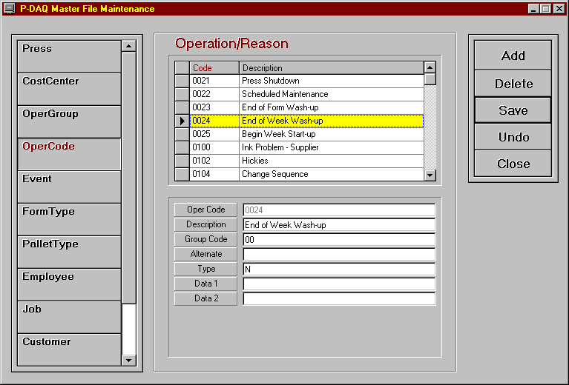

P-Maint
P-Maint is used to update tables that are stored in the Database.

To execute, from the client computer (this client must have permission as per the Security.ini file on the server), choose Start/Programs/PDAQ-Client/P-Maint.

The buttons on the left side of the screen represent the tables to be edited. To edit a table, click on its associated button and use the center of the screen to enter the associated data.
The following pages list the fields to be edited and give a brief explanation of the required entries.
Code / Description fields
Code This field is used to display the operation code, press number, employee number, etc…
Description This field is used to provide a description of the code to be used.
Press
Press The unique press number assigned by NASTech.
Cost Center The cost center number assigned to the press.
Roll Stands The number of roll stands.
Color Units The number of color units.
Cost Center
Cost Center The cost center number assigned to the press.
Description A description of the press, IE. “Harris-M3000”
Cutoff length The cutoff length of the Impression cylinder.
Rate/Hour The hourly rate of the press in dollars.
Rate/M Imp The average cost of materials per 1000 impressions.
Oper Group
Group Code The group code.
Description A description of the associated group.
Oper Code
Oper Code The Oper Code number.
Description A description of the code.
Group Code The associated group the code belongs to.
Alternate The code to be used to report the associated activity to the Cost Accounting system.
Type Indicates weather the Code is: Chargeable (leave blank) Non Chargeable (N), Idle (I), Spoilage (S).
Machine Related Indicates that the code is related to a press fault, stacker jam etc... Yes (Y), or No (N).
Man Related Indicates that the code is related to human error. Yes (Y), or No (N).
Material Related Indicates that the code is related to material problems. Yes (Y), or No (N).
External Cause Indicates that the code is related to an external problem. Yes (Y), or No (N).
Makeready 1 Indicates that the code is a makeready 1 code. Yes (Y), or No (N).
Makeready 2 Indicates that the code is a makeready 2 code. Yes (Y), or No (N).
Run Indicates that the code is a run code. Yes (Y), or No (N).
Wash-up Indicates that the code is a Wash-up code. Yes (Y), or No (N).
Press Stop Indicates that the code is a Press Stop code. Yes (Y), or No (N).
Manual Entry Indicates that the code is available for a Manual Entry. Yes (Y), or No (N).
Run Waste Indicates that the code is a Run Waste Code. Yes (Y), or No (N).
Data 1 Used to define additional data to be sent to Cost Accounting, usually when gross or net counts are to be sent along with the associated record.
Data2 Used to define Makereadies as Initial (I), or Subsequent (S).
OperListQuery
Center The cost center number assigned to the press.
Oper Code The associated operation code.
Description The description of the operation code.
Active Indicates that the code is valid for the associated press. Y or N.
OperTeleData
Cost Center The operation code.
Category The category, I.E. Man, Machine, Material, External…
Event
Event Code The NASTech assigned Event Code.
Description The description of the code.
Reason Reqd Denotes whether a reason is required for the associated event. True or False.
OperCode The default Operation Code for the associated event.
FormType
Form Type The form type code.
Description The description of the form type.
PalletType
Pallet Type The pallet type code.
Description The description of the pallet type.
Employee
Emp ID The Employee number.
Name The Employee’s name.
Job
Job Number The job number.
Description The description of the job.
Cust ID The customer number.
Cust Name The customer name.
Quantity The required quantity to be produced.
Master Job The associated master Job number, used when the job is a Sub-Job.
Customer
Cust ID The Customer ID number.
Company Name The Company name.
PaperMill
Mill ID The Mill ID number.
Mill Name The Mill’s name.
Product
Product The paper stock product ID.
Description The description of the stock.
Type The Stock Type. I.E. Matte, Gloss…
U/M
Width The width of the roll.
Length The length of the roll.
Basis Weight The basis weight of the stock.
PressGoal
Cost Center The cost center number designated for the press.
MR Waste Imps Expected MR waste impressions.
Run Waste % Expected Run Waste percentage.
Net Yield Imps Expected net yield impressions.
Print Time % Expected Print Time percentage.
Imps / Stop Expected impressions per Stop. This is the number of Restart impressions it takes to save good signatures after the press stops.
Net Speed Expected net speed.
Stop Time % Expected Stop Time percentage.

DataComp
In some cases when the software is updated, new fields are added, deleted or changed in the P-DAQ database. DataComp is used to compare tables in the current database to the new tables in the updated database to indicate any changes that have been made.

DataComp should be executed on the Server and on the Press Computer whenever a system update is provided.

To execute on the Server, double click the DataComp icon in the PDAQ\Shared directory.

To execute on the Press Computer, choose Start/Programs/PDAQ-Press Module/DataComp.
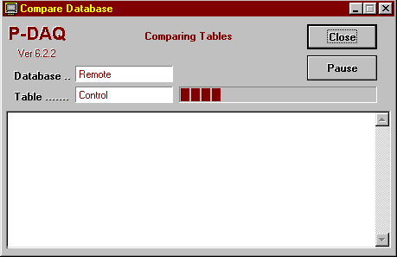

To begin the compare process, click the Continue button. Any table structure that has been changed will appear in the display area of the screen.
If new fields have been added, use the DataCopy program to copy the old data to the new table as described in the following pages.

DataCopy
In some cases when the software is updated, new fields are added, deleted or changed in the P-DAQ database. DataCopy is used to copy tables in the current database to the new tables in the updated database.

DataCopy should be executed on the server and on the Press Computer whenever DataComp shows a difference between the current and new database structures. However, when using SQL server, Data Copy is not required to be run on the server. A SQL script is provided for this purpose.

To execute from the Server, double click the DataComp.exe in the PDAQ\Shared directory.

To execute from the Press Computer, choose Start/Programs/PDAQ-Press Module/DataComp.
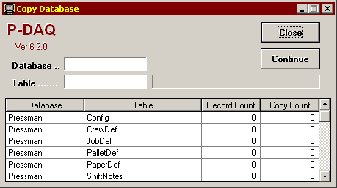
To begin the copy process, click the Continue button.

Auto DataCopy
DataCopy can be configured to run automatically on the first Tuesday of every month, after 9am when a new form is started. This feature was added to manage the size of the Stats.mdb file at press.

To turn this feature on, open the DataSync.ini file located in the PDAQ/Shared/InitPress directory…

- Add the following parameter to the [Constants] section of the file:
  - AutoDataCopy = Yes

- Add the following to the very bottom of the file:
  - Database Name = "Other"
  - Copy Mode = "Update"
  - Table Name = "DataCopy"
- Save the file.

DataDump
Data Dump is used to extract data from PDAQ databases to be sent via email to NASTech personnel for troubleshooting purposes.

To execute, double click the DataDump icon in the PDAQ\Shared directory on the server.

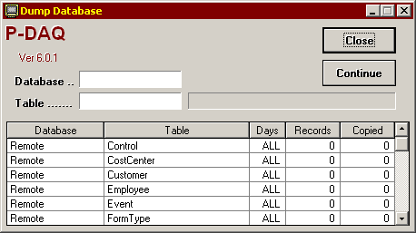

The default records to be copied are pre-determined by the DataDump.ini file located in the PDAQ\Shared\Init directory on the server. Under normal circumstances, the default values will suffice. However, during troubleshooting, a NASTech representative may ask the customer to include more or less data. To do so, on the Data Dump screen, enter the number of days prior to the current date to include in the Days field for each table to be copied.

To begin the dump process, click the Continue button. Any table that has been copied will appear in the body of the program.

When completed, the copied databases will appear in the PDAQ\Shared\Database\Dump directory on the server. The entire Dump directory should be Zipped and e-mailed to NASTech personnel for evaluation.

DataLoad
Data Load is used to extract and transfer data from the Primac Master Files to the P-DAQ remote database. The DataLoad download criterion is user defined in the DataLoad.ini file located in the PDAQ\Shared\Init directory on the server. The file itself contains a description of each required parameter.

To execute, double click the DataLoad.exe in the PDAQ\Shared directory on the server.

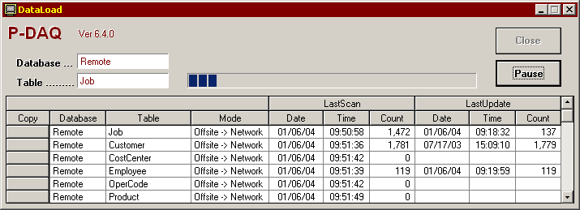

To begin the copy process, click the Continue button. To expedite the flow of data to and from the server, tables can be copied in real time by clicking the associated Copy button.

DataLoad should be left running on the server at all times, however, you may Schedule the task as outlined in the following:

Using Windows “Scheduled Tasks”, you may schedule DataLoad to run periodically. The following is the procedure to set up the task:

- Choose Start\ControlPanel\SheduledTasks.
- Click “Add Scheduled Task”.
- Click “Next”.
- Click the “Browse” button and browse the server to the PDAQ\Shared directory and select the DataLoad.exe file.
- Follow the instructions to select the time and enter the user name and password when prompted.
- Check the box marked “Open Advanced Properties for this Task when I click Finish” button and click the finish button.
- In the Run field, change the path to read exactly as in the following: C:\PDAQ\Shared\DataLoad.exe AUTO
- In the Start In field, make sure the path is as following: C:\PDAQ\Shared

DataPurg
DataPurg is used to delete un-needed historical data from the system. The tables to be purged and the data to be retained are both pre-determined by the DataPurg.ini file located in the PDAQ\Shared\Init directory of the server. Under normal circumstances, the default values should suffice.

To execute, double click the DataPurg icon in the PDAQ\Shared directory on the server.

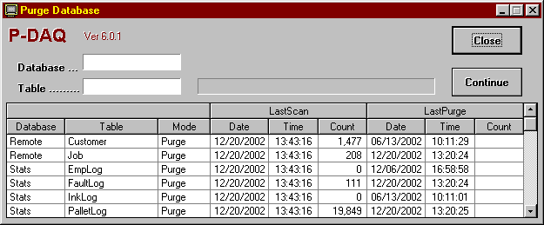

To begin the Purge process, click the Continue button.

DataPurg can be left running on the server, however it is recommended that you Schedule the task as outlined below. It is also recommended that DataPurg be scheduled at a time right after the network backup is performed.

Using Windows “Scheduled Tasks”, you may schedule the DataPurg to run periodically. The following is the procedure to set up the task:

- Choose Start\ControlPanel\SheduledTasks.
- Click “Add Scheduled Task”.
- Click “Next”.
- Click the “Browse” button and browse the server to the PDAQ\Shared directory and select the DataPurg.exe file.
- Follow the instructions to select the time and enter the user name and password when prompted.
- Check the box marked “Open Advanced Properties for this Task when I click Finish” button and click the finish button.
- In the Run field, change the path to read exactly as in the following: C:\PDAQ\Shared\DataPurg.exe AUTO
- In the Start In field, make sure the path is as following: C:\PDAQ\Shared

DataSync
DataSync is used to transfer data to and from the Press Computer and the Server. DataSync should be left running on the Press Computer AT ALL TIMES.

To execute, double click the DataSync icon on the Press Computer’s desktop.

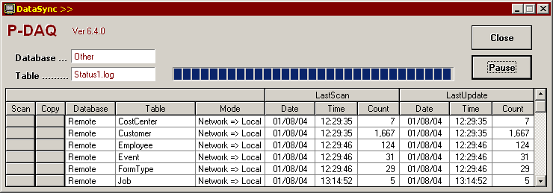

To begin the data transfer process, click the Continue button. To minimize the program on the screen, click the P-DAQ logo.

To expedite the flow of data to and from the server, tables can be scanned, or copied in real time by clicking the associated Scan or Copy button.

DB_Maint
DB_Maint is used to edit the Summary Database tables used by P-Admin to generate reports. Editing data with this tool will change the numbers on all those reports which use the associated data.

DISCLAIMER: Any changes made to this data, and any problems related to the editing of this data, will NOT be supported by NASTech personnel. When problems with reports are reported, NASTech personnel will require that the summary tables be re-built before troubleshooting.

Changes made to the summary tables will not affect the raw data collected by the system. Any changes made can be un-done by utilizing the rebuild functionality of P-Admin as discussed in the P-Admin - Overview section of this Guide.

To execute, double click DB_Maint in the PDAQ/Shared directory on the P-DAQ Server.

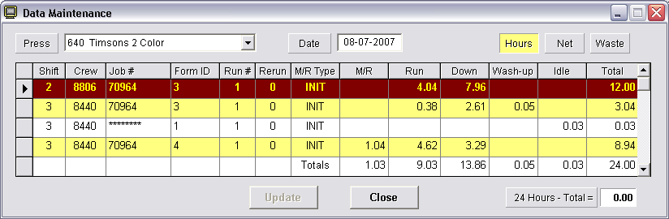

Select the Press and Date of the data to be edited using the dropdown lists provided.

Select the statistics you wish to modify using the Hours, Net, or Waste buttons.

Click in the associated table cell of the record you want to modify and the “Update Statistics” screen opens.
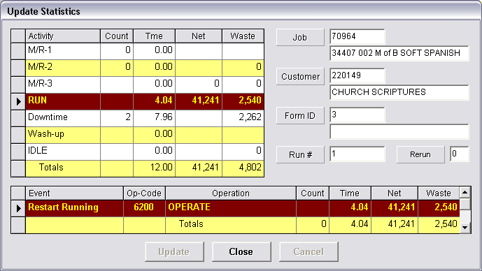

Click the associated Time, Net, or Waste record to be edited and enter the new numbers on the dialog box presented.

When you are finished, click the Update button to complete the transaction.

.

P-Check
P-Check is used to continuously monitor the status of some key P-DAQ system applications, and is also used to provide local P-DAQ system administrators with information about system updates, and problems with the P-DAQ database.

When one of the monitored applications fails to execute or when there is a database problem, up to 3 administrators and 3 supervisors can be notified automatically via email. This ensures that P-DAQ system applications that are scheduled to run are indeed running as required.

To execute, double click the P-Check icon in the PDAQ\Shared directory on the server.

P-Check should be left running on the server at all times. (When minimized, the application will appear in the task list on the bottom right-hand corner of the PC)

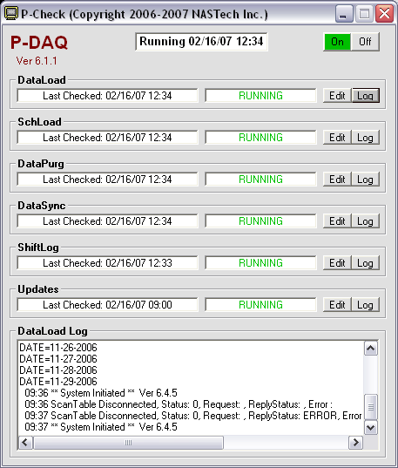

The top center of the screen displays P-Check’s status and the current time. The top right of the screen provides an On and Off button to start and stop all of the check processes.

The following is the applications and processes that may be monitored:
DataLoad Checks to make sure that DataLoad.exe is running and that there are no communication issues with the host computer.
SchLoad Checks to make sure that SchLoad.exe is running and that there are no communication issues with the host computer.
DataPurg Checks to make sure DataPurg has executed at the scheduled time.
DataSync Checks to make sure that DataSync is running on all Press Computers. Shift supervisors can also be notified to remind the pressman re-run the application upon failure.
ShiftLog Checks to make sure that there are no HOLDS in the ShiftLog older than 14 days. If so, the Administrator will be required to manually COMPLETE them on the server.
Updates Checks for the latest updates on our website, and provides the P-DAQ administrator with a list or current and available system applications.

P-Check will send a Daily report via email of all running applications and processes at 9am during weekdays to the P-DAQ administrator(s).

Schedules should be set up in such a way to ensure that enough time has passed to allow an application that is scheduled with the windows scheduler to have executed. For example, if DataPurg is scheduled to run weekly, then the schedule for DataPurg should be set to check DataPurg weekly as well.

Each of the applications and processes displays the last time the associated check was performed, the status of the check, an Edit button, and a Log button.

The Log button is used to display the log file for the associated process on the bottom of the screen.

Clicking the Edit button opens the Edit screen for each process as described on the following page.
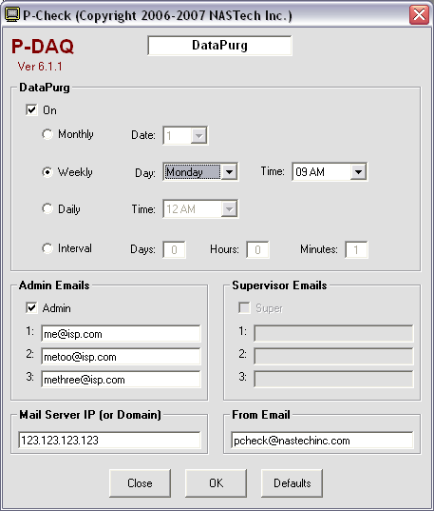

App Section Used to enable the check for the associated application or process, and to schedule the check on the selected date, time, or interval.
Admin Used to turn on the email feature and to list the administrator(s) email address(s). (Email settings are global to all processes)
Supervisor Used to turn on the email feature and to list the supervisor(s) email address(s). (Available for the DataSync application only)
Mail Server Enter the Mail Server’s IP Address or Domain name.
From Email The “From” property on the associated email.
Close Used to close the Edit window without applying changes.
OK Used to apply the changes.
Defaults Used to restore the default settings.

Appendix A Hardware Devices

GSE 350 Floor Scale (TIM2B)
The system can be configured to use GSE Floor scales via the Computerwise TNET sub-network at each delivery The Scale is installed by the customer as per the manufacturer’s installation procedures and as outlined in the following:

Install
- When installing multiple scales, scale bases must be wired to the correct indicator panels as the scales are calibrated accordingly.
- The Floor Scale load cells are wired to the indicator panel as per the manufacturer’s installation procedures.

Connect
- The Floor Scale is wired to the TIM2B controller with a NASTech supplied MaleDB25 - FemaleDB9 serial cable (straight through).
- The Floor Scale TIM2B must be addressed properly as outlined in Appendix F.

Configure
- From the P-DAQ main screen, enter the Setup / Diagnostics folder and click the initialize scales button.

Troubleshoot
- Check all wiring, and make sure the TIM2B is connected and addressed properly.
- Click the Initialize Scales button from the Setup / Diagnostics Panel on the P-DAQ main screen and watch the Indicator panel, if the unit is communicating with P-DAQ, you will see the indicator flash the configuration parameters.
- Data transmission can be viewed via the Waste Scale Input / Output buttons from the Setup / Diagnostics Panel on the P-DAQ main screen.
- The scale can be zeroed by removing the bin, and by pressing the “zero” button on the indicator panel.

GSE 350 Table Scale (TT4)
The system can be configured to use GSE Table scales via the Computerwise TNET sub-network. The Scale is installed by the customer as per the manufacturer’s installation procedures and as outlined in the following:

Install
- When installing multiple scales, scale bases must be wired to the correct indicator panels as the scales are calibrated accordingly.
- The Table Scale’s load cell is wired to the indicator panel as per the manufacturer’s installation procedures.
- Table scales should be installed in close proximity to the stacker attendant.
Connect
- The Table Scale is wired to the TT4 terminal with a NASTech supplied MaleDB9 - FemaleDB9 serial cable (crossover).
- The Table Scale TT4 must be connected and addressed properly as outlined in Appendix G.

Configure
- From the P-DAQ main screen, enter the Setup / Diagnostics folder and click the initialize scales button.

Troubleshoot
- Check all wiring, and make sure the TT4 is connected and addressed properly.
- Click the “Initialize Scales” button from the Setup / Diagnostics Panel on the P-DAQ main screen and watch the Indicator panel, if the unit has proper communication with P-DAQ, you will see the indicator flash the configuration parameters.
- Data transmission can be viewed via the “Sample Scale Input / Output” buttons from the Setup / Diagnostics Panel on the P-DAQ main screen.
- The scale can be zeroed by removing any product from the scale, and by pressing the “zero” button on the indicator panel.

GSE 350 Floor Scale (RS-232 Converter)
The system can be configured to use GSE 350 Floor scales via an RS-232 Ethernet to Serial converter. The Scale is installed by the customer as per the manufacturer’s installation procedures and as outlined in the following:

Install
- When installing multiple scales, scale bases must be wired to the correct indicator panels as the scales are calibrated accordingly.
- The Floor Scale load cells are wired to the indicator panel as per the manufacturer’s installation procedures.

Connect
- The Floor Scale indicator is wired to the RS-232 Converter with a NASTech supplied MaleDB25 - FemaleDB9 serial cable (straight through).
- The RS-232 Converter is wired to the Ethernet Switch using a straight through CAT-5 Cable.

Configure
- The RS-232 converter must be configured with a unique IP address and Port as outlined in the RS-232 instructions in this appendix.
- From the P-DAQ main screen, enter the Setup / Diagnostics folder and click the initialize scales button.

Troubleshoot
- Check all wiring, and make sure the RS-232 converter is connected and addressed properly.
- Click the Initialize Scales button from the Setup / Diagnostics Panel on the P-DAQ main screen and watch the Indicator panel, if the unit is communicating with P-DAQ, you will see the indicator flash the configuration parameters.
- Data transmission can be viewed via the Waste Scale Input / Output buttons from the Setup / Diagnostics Panel on the P-DAQ main screen.
- The scale can be zeroed by removing the bin, and by pressing the “zero” button on the indicator panel.

GSE 350 Table Scale (RS-232 Converter)
The system can be configured to use GSE 350 Table scales via an RS-232 Ethernet to Serial converter. The Scale is installed by the customer as per the manufacturer’s installation procedures and as outlined in the following:

Install
- When installing multiple scales, scale bases must be wired to the correct indicator panels as the scales are calibrated accordingly.
- The Table Scale’s load cell is wired to the indicator panel as per the manufacturer’s installation procedures.
- Table scales should be installed in close proximity to the stacker attendant.

Connect
- The Table Scale is wired to the RS-232 converter with a NASTech supplied MaleDB9 - FemaleDB9 serial cable (crossover).
- The RS-232 Converter is wired to the Ethernet Switch using a straight through CAT-5 Cable.

Configure
- The RS-232 converter must be configured with a unique IP address and Port as outlined in the RS-232 instructions in this appendix.
- From the P-DAQ main screen, enter the Setup / Diagnostics folder and click the initialize scales button.

Troubleshoot
- Check all wiring, and make sure the RS-232 converter is connected and addressed properly.
- Click the “Initialize Scales” button from the Setup / Diagnostics Panel on the P-DAQ main screen and watch the Indicator panel, if the unit has proper communication with P-DAQ, you will see the indicator flash the configuration parameters.
- Data transmission can be viewed via the “Sample Scale Input / Output” buttons from the Setup / Diagnostics Panel on the P-DAQ main screen.
- The scale can be zeroed by removing any product from the scale, and by pressing the “zero” button on the indicator panel.

GSE 460 Floor Scale (Ethernet)
The system can be configured to use GSE 460 Floor scales. The Scale is installed by the customer as per the manufacturer’s installation procedures and as outlined in the following:

Install
- When installing multiple scales, scale bases must be wired to the correct indicator panels as the scales are calibrated accordingly.
- The Floor Scale load cells are wired to the indicator panel as per the manufacturer’s installation procedures.

Connect
- The 460 is wired to the Ethernet Switch using a straight through CAT-5 Cable.

Configure
- The IP address of the unit and all other configuration parameters are set up using the GSEIPSetup.exe program which is available for download via the P-DAQ support pages of our website. The setup parameters are outlined in the GSE IP Setup section of this appendix.
- From the P-DAQ main screen, enter the Setup / Diagnostics folder and click the initialize scales button.

Troubleshoot
- Check all wiring, and make sure the 460 is connected and addressed properly.
- Click the Initialize Scales button from the Setup / Diagnostics Panel on the P-DAQ main screen and watch the Indicator panel, if the unit is communicating with P-DAQ, you will see the indicator flash the configuration parameters.
- Data transmission can be viewed via the Waste Scale Input / Output buttons from the Setup / Diagnostics Panel on the P-DAQ main screen.
- The scale can be zeroed by removing the bin, and by pressing the “zero” button on the indicator panel.

GSE 460 Table Scale (Ethernet)
The system can be configured to use GSE 460 Table scales. The Scale is installed by the customer as per the manufacturer’s installation procedures and as outlined in the following:

Install
- When installing multiple scales, scale bases must be wired to the correct indicator panels as the scales are calibrated accordingly.
- The Table Scale’s load cell is wired to the indicator panel as per the manufacturer’s installation procedures.
- Table scales should be installed in close proximity to the stacker attendant.

Connect
- The 460 is wired to the Ethernet Switch using a straight through CAT-5 Cable.

Configure
- The IP address of the unit and all other configuration parameters are set up using the GSEIPSetup.exe program which is available for download via the P-DAQ support pages of our website. The setup parameters are outlined in the GSE IP Setup section of this appendix.
- From the P-DAQ main screen, enter the Setup / Diagnostics folder and click the initialize scales button.

Troubleshoot
- Check all wiring, and make sure the 460 is connected and addressed properly.
- Click the “Initialize Scales” button from the Setup / Diagnostics Panel on the P-DAQ main screen and watch the Indicator panel, if the unit has proper communication with P-DAQ, you will see the indicator flash the configuration parameters.
- Data transmission can be viewed via the “Sample Scale Input / Output” buttons from the Setup / Diagnostics Panel on the P-DAQ main screen.
- The scale can be zeroed by removing any product from the scale, and by pressing the “zero” button on the indicator panel.

GSE 675 Scales (RS-232 Converter)
The system can be configured to use a GSE 675 Sample/Floor scale combo unit via an RS-232 Ethernet to Serial converter. The Scale is installed by the customer as per the manufacturer’s installation procedures and as outlined in the following:

Install
- The Indicator/Sample scale base of the 675 should be installed in close proximity to the stacker attendant.
- The Floor Scale platform should be installed within 100 feet of the base unit.

Connect
- The Floor Scale load cells are wired to the Aux port of the sample scale indicator panel as per the manufacturer’s installation procedures.
- The Scale indicator is wired to the RS-232 Converter with a NASTech supplied MaleDB25 - FemaleDB9 serial cable (straight through).
- The RS-232 Converter is wired to the Ethernet Switch using a straight through CAT-5 Cable.

Configure
- The IP address of the unit and all other configuration parameters are set up using the GSEIPSetup.exe program which is available for download via the P-DAQ support pages of our website. The setup parameters are outlined in the GSE IP Setup section of this appendix.
- From the P-DAQ main screen, enter the Setup / Diagnostics folder and click the initialize scales button.

Troubleshoot
- Check all wiring, and make sure the RS-232 converter is connected and addressed properly.
- Click the Initialize Scales button from the Setup / Diagnostics Panel on the P-DAQ main screen and watch the Indicator panel, if the unit is communicating with P-DAQ, you will see the indicator flash the configuration parameters.
- Data transmission can be viewed via the Waste Scale Input / Output buttons from the Setup / Diagnostics Panel on the P-DAQ main screen.
- The scale can be zeroed by removing the bin, and by pressing the “zero” button on the indicator panel.

GSE 675 Scales (Ethernet)
The system can be configured to use a GSE 675 Sample/Floor scale combo unit via an RS-232 Ethernet to Serial converter. NOTE: These scales can only be used on presses with a single delivery. The Scale is installed by the customer as per the manufacturer’s installation procedures and as outlined in the following:

Install
- The Indicator/Sample scale base of the 675 should be installed in close proximity to the stacker attendant.
- The Floor Scale platform should be installed within 100 feet of the base unit.

Connect
- The Floor Scale load cells are wired to the Aux port of the sample scale indicator panel as per the manufacturer’s installation procedures.
- The 675 is wired to the Ethernet Switch using a straight through CAT-5 Cable.

Configure
- The IP address of the unit and all other configuration parameters are set up using the GSEIPSetup.exe program which is available for download via the P-DAQ support pages of our website. The setup parameters are outlined in the GSE IP Setup section of this appendix.
- From the P-DAQ main screen, enter the Setup / Diagnostics folder and click the initialize scales button.

Troubleshoot
- Check all wiring, and make sure the 675 is connected and addressed properly.
- Click the “Initialize Scales” button from the Setup / Diagnostics Panel on the P-DAQ main screen and watch the Indicator panel, if the unit has proper communication with P-DAQ, you will see the indicator flash the configuration parameters.
- Data transmission can be viewed via the “Sample Scale Input / Output” buttons from the Setup / Diagnostics Panel on the P-DAQ main screen.
- The scale can be zeroed by removing any product from the scale, and by pressing the “zero” button on the indicator panel.

Pennsylvania Floor Scale
The system can be configured to use Pennsylvania Floor scales at each delivery as the primary counting device, determining net count by counting waste product. When using floor scales, a Start / Stop control or equivalent signal is still needed to indicate that Makeready is complete. The Scale is installed and wired by the customer as per the manufacturer’s installation procedures and as outlined in the following:

Install
- When installing multiple scales, scale bases must be wired to the correct indicator panels as the scales are calibrated accordingly.
- The Floor Scale load cells are wired to the indicator panel as per the manufacturer’s installation procedures.

Connect
- The Floor Scale is wired to the TIM2B controller with a NASTech supplied MaleDB25 - FemaleDB9 serial cable (straight through).
- The Floor Scale TIM2B must be addressed properly as outlined in Appendix F.

Troubleshoot
- Check all wiring, and make sure the TIM2B is addressed properly.
- Click the “Initialize Scales” button from the Setup / Diagnostics Panel on the P-DAQ main screen and watch the Indicator panel, if the unit has proper communication with P-DAQ, you will see the indicator flash the configuration parameters.
- Data transmission can be viewed via the “Waste Scale Input / Output” buttons from the Setup / Diagnostics Panel on the P-DAQ main screen.
- The scale can be zeroed by removing the bin, and by pressing the “zero” button on the indicator panel.

Pennsylvania Table Scale
The system can be configured to use Pennsylvania Table scales to make pallet count adjustments as needed and is used to provide actual piece weight measurements for the Floor Scale. The Scale is installed by the customer as per the manufacturer’s installation procedures and as outlined in the following:

Install
- When installing multiple scales, scale bases must be wired to the correct indicator panels as the scales are calibrated accordingly.
- The Table Scale’s load cell is wired to the indicator panel as per the manufacturer’s installation procedures.
- Table scales should be installed in close proximity to the stacker attendant.
Connect
- The Table Scale is wired by customer to the TT4 terminal with a NASTech supplied MaleDB9 - FemaleDB9 serial cable (straight through).
- The Table Scale TT4 must be connected and addressed properly as outlined in Appendix G.

Troubleshoot
- Check all wiring, and make sure the TT4 is connected and addressed properly.
- Click the “Initialize Scales” button from the Setup / Diagnostics Panel on the P-DAQ main screen and watch the Indicator panel, if the unit has proper communication with P-DAQ, you will see the indicator flash the configuration parameters.
- Data transmission can be viewed via the “Sample Scale Input / Output” buttons from the Setup / Diagnostics Panel on the P-DAQ main screen.
- The scale can be zeroed by removing any product from the scale, and by pressing the “zero” button on the indicator panel.

TNET Controller
The Computerwise TNET (TIM1B) controller is used to poll data from TT4 terminals and TIM2B controllers for the transmitting of the data to the Press Computer for processing.

The TNET controller is installed by the customer as per the manufacturer’s installation procedures and as outlined in the following:

Install
- The TNET controller is attached to the Press Interface Module with the NASTech supplied screws.
- The TNET controller must be powered using the supplied transformer, connected to the Uninterruptible Power Supply.
Connect
- The TNET controller is connected serial port 1 on the Press Computer with the NASTech supplied MaleDB25 – FemaleDB9 cable.

Configure
- From the P-DAQ main screen, enter the Setup / Diagnostics folder and click the “Initialize TNET” button. This procedure should be performed only during initial installation, but can be performed to re-initialize in case of any errors.

Troubleshoot
- Check all wiring, and make sure the TNET is connected properly.

TIM2B Controller
The Computerwise TIM2B controller is used to transmit data from the Press Computer to the NASTech Shop Floor Data Collection System; it is also used to transmit data between the Floor Scale and the TNET controller.

The TIM2B is installed and addressed by the customer as per the manufacturer’s installation procedures and as outlined in the following:

Install
- When Interfaced to the NASTech Shop Floor Data Collection System, the TIM2B controller is attached to the Press Interface Module with the NASTech supplied screws.
- When Interfaced to the Floor Scale, the TIM2B controller is located in close proximity to the scale indicator.
- The TIM2B controller is powered by the TNET controller if the cable does not exceed 100 feet. If the distance between the TIM2B and the TNET controller exceeds 100 feet, the unit must be powered using the supplied transformer. See appendix X for more information regarding peripheral device cabling.
Connect
- When Interfaced to the NASTech Shop Floor Data Collection System, the TIM2B controller is connected serial port 3 on the Press Computer with the NASTech supplied MaleDB25 – FemaleDB9 cable.
- When interfaced to the Floor Scale, the unit is connected to the TNET controller with a straight through CAT-5 cable. The Unit is connected to the Floor Scale head with the NASTech supplied MaleDB25 – FemaleDB9 cable.
Configure
- When interfaced to the NASTech Shop Floor Data Collection System, the TIM2B must have a unique address as defined in the SFDC system.
- When interfaced to the Floor Scale, the TIM2B must be addressed in the following manner: Delivery 1 = 61, Delivery 2 = 62, Delivery 3 = 63, and Delivery 4 = 64.

Address
- To address the TIM2B, open the case and locate the binary switches. The switches, when toggled into the on position will increment the address by the following values:
- Switch 1 = 1
- Switch 2 = 2
- Switch 3 = 4
- Switch 4 = 8
- Switch 5 = 16
- Switch 6 = 32
- Switch 7 = 64
- Switch 8 = 128
- For Address 61: On – Off – On – On – On – On – Off – Off
- For Address 62: Off – On – On – On – On – On – Off – Off
- For Address 63: On – On – On – On – On – On – Off – Off
- For Address 64: Off – Off – Off – Off – Off – Off – On – Off
- For Shop Floor: Configure to match the unique number as set up in NDC-Plus for the associated station.

Troubleshoot
- Check all wiring, and make sure the TIM2B is connected properly.
- If the TIM2B controller is not addressed properly, it may cause the unit, any connected devices, and any conflicting devices to fail.
- The unit contains 7 LED’s. Under normal operation, the LED’s should behave as follows:
- LED 1 = Solid.
- LED 2 = Off.
- LED 3 = Off.
- LED 4 = Slow blink while transmitting.
- LED 5 = Slow blink while receiving.
- LED 6 = Fast blink. (If the LED is out, the address is wrong.)
- TNET = Fast blink. (If the LED is out, the “Pressman.cfg” file is configured improperly.)

TT4 Terminal
The Computerwise TT4 terminal is used to collect and transfer data to the Press Computer from the delivery station and the roll stations. The following information is provided for quick reference only. For more detail or for information regarding hardware options installed, consult the TT4 manual.
Before a stacker or roll stand TT4 terminal may be connected and used with P-DAQ, the terminal must first be configured. Failure to do so may cause the terminal and other terminals on the system to operate improperly.

Install
- The stacker TT4 should be installed in close proximity to the stacker attendant(s).
- The roll stand TT4 should be installed in close proximity to the roll stand attendant.

Connect
- Both the stacker and roll stand TT4 terminals are connected to the TNET Controller located in the P-DAQ Console with straight through CAT-5 cables. The TT4 terminals are powered by the TNET controller if the cable does not exceed 100 feet. If the distance between the TT4 and the TNET controller exceeds 100 feet, the unit must be powered using the supplied transformer. See Appendix H for more information regarding peripheral device cabling.

Configure
- First, enter the set-up mode by pressing the shift keys in the following order: S2 - S1 - S2
- Once in the set-up mode, the contents of each of the internal registers are presented for review or modification. To modify the displayed register, enter the correct sequence of 0's and 1's. If the register values are to remain unchanged, pressing the ENTER key will cause the unit to proceed to the next register or prompt. It should be noted that not all registers and prompts are available on all models. The following page lists all registers and the values needed to operate the TT4C with the P-DAQ system:

 | SR# | 12345678 | Comments
 | SR1 | 00000010 | 9600 baud, 8 bit, no parity.
 | SR2 | 00100000
 | SR3 | 00000000
 | SR4 | 10100000 | Enable wand input.
 | SR5 | 11111111 | Decode all bar-code symbologies.
 | SR6 | 00000010 | For auxiliary port if present. Set to be compatible with external device. Consult hardware reference manual.
 | SR7 | 00000000
 | SR8 | 11111111 | Enable external switch option.

 | OPERATING MODE | 3.
 | UNIT ADDRESS | Unique number for the P-DAQ system. The following represents the proper addressing for all available TT4 terminals:  Delivery 1 = 11  Delivery 2 = 12  Delivery 3 = 13  Delivery 4 = 14  Roll stand 1 = 01  Roll stand 2 = 02  Roll stand 3 = 03  Roll stand 4 = 04
 | DISPLAY SCALE | 001
 | OPTIONS | 000.

Function Key Definition
Once a terminal is set up, it may be connected to the system. With P-DAQ executing, the function keys may be loaded with the pre-defined values. The TT4C function keys are loaded with values as defined by P-DAQ.
If the station is new, the function keys will be loaded with the standard factory settings. When the unit is displaying the Function prompt, pressing the SPACE key followed by the ENTER key will program the function keys. The message F1-F8 LOADED is displayed upon successful completion of the download.

Troubleshoot
- Check all wiring, and make sure the TT4 is connected and powered properly.
- If a previously functioning station begins to behave erratically, the station should be reset to factory default settings before re-initiating the set-up procedure. Unless otherwise specified in the hardware reference manual, the procedure to reset the terminal to factory default settings is as follows:
- Disconnect the TT4 from power.
- Press and hold both the S1 and S2 keys.
- Apply power, and wait for power-up reset to complete.
- Release S1 and S2 keys and remove power.
- Re-apply power and re-configure the terminal.

EP-210
The Computerwise EP-210 module is used to collect data from the press sensors, PLC’s or Switches. The following information is provided for quick reference only. For more detail or for information regarding hardware options installed, consult the EP-210 manual.

Before the EP-210 may be used with P-DAQ, the module must first be configured. Failure to do so may cause the module and other modules on the sub-net to operate improperly.

Configure
- Before you can use the EP210 with the P-DAQ system, you must configure the IP address of the unit. Each unit should have a unique IP address.
- When connected to the P-DAQ PC, the EP210 must be segregated from the existing network via an Ethernet Switch or a Router.
- When connecting multiple EP210’s you must use a Hub or a switch with enough ports for all units. See the Diagram on the next page for an illustration of this.
- To configure the unit’s IP address, Subnet Mask, or Default Gateway, you must connect the EP210 to a PC serial port with a serial crossover 9pin Female to 9pin Female cable and power the unit.
- Once connected, run HyperTerminal from the Windows Start Menu:
Start – Programs – Accessories – Communications – HyperTerminal.
- Type “EP210” as the name for the connection and click OK.
- Select the COM port you have connected the unit to and click OK.
- For Port Settings, set to 9600 Bits Per Sec, 8 Data Bits, None Parity, 1 Stop Bit, and Hardware Flow Control (or none). Click OK.
- Once you have connected to the unit, hold the [CTRL] key and press the V key on your keyboard 3 times to enter setup mode.
- Type SHOW followed by [Enter] to view the current parameters.
- To make a change to a given parameter, type the parameter name, followed by the = equal sign, followed by the new value, followed by [Enter]. For example: MYIP=123.123.123.123[Enter]
- Repeat this process until all parameters have been set.
- When completed, type SAVE followed by [Enter].
- Disconnect and re-connect the unit from Power. Re-enter setup mode using HyperTerminal and type SHOW followed by [Enter] to double check the new parameters.

Install
- The EP210 is typically installed in the press cabinet in close proximity to the signals it will acquire, but may also be installed in the P-DAQ console.

Connect
- The EP-210 is connected to the press signal terminal blocks with a DB-25 cable, and to the PC hub (or Switch or Router) with an Ethernet cable.

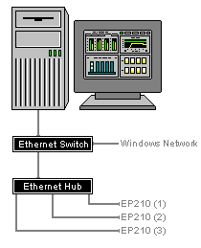

LED Signs
P-DAQ can be configured to use an LED sign to display press status information on a press by press basis. The following describes how to cable and setup an LED Sign.

Connect
- Connect the LED sign to an AC power outlet.
- Connect an Ethernet (cat 5 - straight through) from the computer to a HUB. Connect an Ethernet (cat 5 - straight through) from the HUB to the Ethernet Port on the LED sign.

Configure
- The sign parameters are defined in the Pressman.CFG file and are to be set up by NASTech personnel.
- The following are some of the things that may be displayed:
- Cost Center
- Job Number
- Press Speed
- Gross Count
- Net Count
- Waste
- Time To Go
- Quantity To Go

RS-232 Converter
P-DAQ can be configured to use an RS-232 serial to Ethernet converter to connect the sales to an Ethernet HUB. This allows direct connectivity to the scales without the use of a TT4 terminal, or a TIM2B.

Connect
- Connect the RS232 converter between the HUB and scale head using a straight through CAT-5 cable and power the device with the included transformer.

Configure
- Run the Lantronix Device Installer located on the included CD.
- Select the new device if present.
- Click the Assign IP button on the toolbar.
- Assign a unique IP address. The MAC address is located on the back of the NET232 if needed.
- Select the Web Configuration tab.
- Ensure that the IP address is correct. Click the GO button on the toolbar.
- Click OK. The user ID and password are not required.
- Select the Apply Factory Defaults from the menu. Click YES.
- Click the GO button on the toolbar.
- Select “Serial Settings” from the menu.
- Set the flow control to Xon/Xoff
- Click the OK button at bottom of screen.
- Select Connection from the menu.
- Ensure that the Local Port is set to 10001. If not, change it and click the OK button.
- Click Apply Settings on menu.

Troubleshoot
- Check all wiring, and make sure the RS-232 converter is connected and powered properly.

Modular Cables
The following diagram illustrates the basic modular cable requirements of the Press Management system. Unshielded twisted pair (UTP) cable is recommended for all modular cabling as it provides protection against electrical interference. It is also recommended that a suitable number of spare devices be kept on hand at all times.

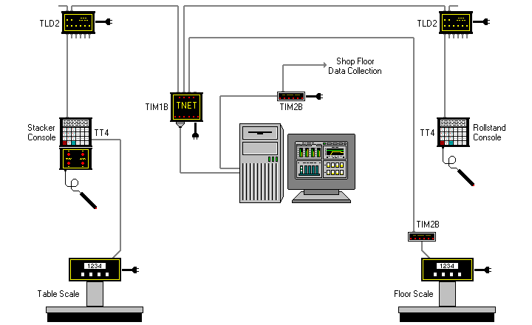

The maximum distance between self-powered components is 2,000 feet. The maximum distance between the TT4 and its power supplying component is limited to 100 feet.

The TLD2 line drivers are only needed if the distance from the TT4’s and the TIM1B exceeds 100 feet and no local power is available for the TT4 terminal.

The TIM2B is only needed if P-DAQ is to interface with the NASTech shop-floor data collection system, or to a floor scale indicator.
Modular Cable
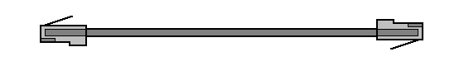
Modular cables are standard 8 conductor "Silver Satin" or unshielded twisted pair (UTP) with RJ-45 connectors. The cable is wired straight through as shown in diagram (same color wire on same side of both connectors). While "Silver Satin" cable is acceptable in most installations, unshielded twisted pair (UTP) cable is recommended as it provides greater protection against electrical interference.

When using twisted pair cable, the pairs should be connected to the connectors as follows:

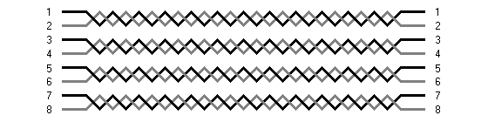

Proximity Sensors
Proximity Sensors are used to provide Gross Count to the system. They can also be used to provide signals from Divert Gates, and to provide Roll Speed signals when using the Paper Management sub-system.

Proximity Sensors are purchased and installed by local plant personnel.

Proximity Sensors used should be of the 3 wire PNP (sourcing) type, providing a positive12v DC voltage.

NASTech recommends TURCK brand sensors of this type which have Schmidtt Triggers built in.

Install
- For Gross Count, the Sensors are typically installed at the cutoff cylinder of the folder, but may be installed on the main shaft as well.
- For Divert Gate signals, the Sensors are typically installed to provide 12v DC when the divert gate is closed.
- For Roll Speed, the Sensors are typically in close proximity to the roll shaft.
- For best performance, all Proximity Sensors should be installed within 1/16 of an inch to the medium that it is sensing.

Connect
- Sensors are connected to the Terminal block provided by NASTech as per the included wiring diagram.

Troubleshoot
- When behaving erratically, make sure the Sensor is tightly connected to its chassis and that it is mounted perpendicular to the medium that it is sensing.
- Ensure that the unit is within 1/16 of the medium that it is sensing.
- Check all wiring from the sensor to the NASTech terminal block.

Appendix B Glossary
Count Complete | Event | = | When the required number of each unique signature has been produced.
Down-time | Time | = | From the time the press stops until good signatures are again produced. By definition, down-time can only occur while Makeready III or Press Running is active.
Form Started | Event | = | Start button depressed after a new job is defined or the system reset button is pressed.
Idle-time | Time | = | Accumulated time between forms, and elapsed time for operations defined as Idle in the “Opercode” table.
Makeready I (MR1) | Event | = | Immediately following the Form Started event.
 | Time | = | Time from initial event to Makeready II event. Does NOT include Down-Time or Idle-Time.
 | Count | = | Number of events that occurred during a specified period or for a specified job or form.
Makeready II (MR2) | Event | = | When Makeready I is active and the press reaches the Press Cutoff Speed.
 | Time | = | Time from initial event until at least one good signature of each unique signature on the form is counted. Does NOT include Down-Time or Idle-Time.
 | Count | = | Number of events that occurred during a specified period or for a specified form.
 | Waste | = | The number of impressions or signatures that were discarded during the event.
Makeready III (MR3) | Event | = | When Makeready II is active and at least one good signature of each unique signature on the form is counted.
 | Time | = | From the time of the initial event until the press OK is indicated by the pressman. Does NOT include Down-Time or Idle-Time.
 | Net | = | The number of impressions or signatures that were saved during the event.
 | Waste | = | The number of impressions or signatures that were discarded during the event. Waste accumulated during a press Re-Start is NOT included.
Net Speed |  |  | The number of net impressions produced divided by (MR3 + Run) hours.
Net Yield |  |  | The number of net impressions produced divided by (MR3 + Run + Down-Time) hours.
Non-Charge Time | Time | = | All time accumulated while P-DAQ is in Stop Mode.
Press Running | Event | = | When Makeready III is active and the press OK is indicated by the pressman.
 | Time | = | From the time of the initial until the required signature counts are accumulated and then the press speed drops below the Press Cutoff Speed.
 | Net | = | The number of impressions or signatures that were saved during the event.
 | Waste | = | The number of impressions or signatures that were discarded during the event. Waste accumulated during Restarting is NOT included.
 | Count | = | Number of times the press stopped during a specified period or for a specified job or form.
 | Waste | = | See Restart events.
Print-time | Time | = | All time that Ink is being printed (MR2 + MR3 + Run + Restart).
 | Count | = | Impressions produced from the time the Press starts running until the end of the form, including Down-Time.
Restart MR3 | Event | = | When the press speed reaches the Press Cutoff Speed after a press stop event. This event is recorded if the associated press stop occurred during Makeready III.
 | Time | = | From the time the press speed reaches the Press Cutoff Speed until the time at least one good signature of each unique signature on the form is counted.
Restart Run | Event | = | When the press speed reaches the Press Cutoff Speed after a press stop event. This event is recorded if the associated press stop occurred during Run.
 | Waste | = | All impressions produced from the time the press stopped until good count is achieved.
Schmidtt Trigger |  |  | A Schmitt trigger is a comparator circuit that incorporates positive feedback. When the input is higher than a certain chosen threshold, the output is high; when the input is below another (lower) chosen threshold, the output is low; when the input is between the two, the output retains its value.

