

Pallet Tracking System

NASTech, Inc.

User
Guide

Version 6.0
The software described in this document is furnished under a license agreement or nondisclosure agreement. The software may be used or copied only in accordance with the terms of the agreement. It is against the law to copy the software on any medium except as specifically allowed in the license or nondisclosure agreement. No part of this manual may be reproduced or transmitted in any form or by any means, electronic or mechanical, including photocopying and recording for any purpose without the express written permission of NASTech.

NASTech, Inc. reserves the right to make changes to this document and the software described herein at any time and without notice.

Copyright © 2006 - 2008 NASTech, Inc. All Rights Reserved.

NASTech, Inc.
2201 Long Prairie Rd.
Suite 107-338
Flower Mound, TX 75022
(888) 9-NASTECH
www.nastechinc.com

Microsoft, MS, and MS-DOS are registered trademarks of Microsoft Corporation.
MS-SQL, and MS-Access are registered trademarks of Microsoft Corporation.
Windows is a trademark of Microsoft Corporation.
Pentium is a registered trademark of Intel Corporation.
PDF995 is a trademark of Software995 Corporation.
Table of Contents

Chapter 1 Introduction 1
Overview 2
System Features 3
Events Recorded 3
Statistics 3
Chapter 2 Hardware Installation 4
NASTech Supplied Devices 4
Customer Supplied Devices 4
Install Devices 5
Chapter 3 Software Installation 1
NASTech Supplied Software 1
Customer Supplied Software 1
Pre-Installation 2
Server Installation 2
System Parameters 3
System.ini 3
User Security 3
WipTrack.ini 5
Server SQL Setup 6
Map Setup 7
Map Creation 7
Map Database 8
WipTrack.ini 9
Client Installation 10
Client SQL Setup 10
Start P-TRAQ Client 11
Shortcuts 11
Software Updates 12
Initialization Files 14
WipTrack.ini 14
Chapter 4 Main Screen 1
Overview 1
Toolbar 2
Tree View 3
Map View 4
Chapter 5 Markers 1
New Marker 2
Edit Marker 3
Delete Marker 4
Move Marker 4
Set Room Location 4
Zones 5
Zone Maintenance 6
Zone Menu 7
Depth Maintenance 8
Chapter 6 Toolbar 1
Map Name 1
Availability 1
Job Search 2
Aging 3
Cycle Count 4
Chapter 7 Tree View 1
Maintenance 1
Pallet 1
Vendor 2
Inquiry 3
Job 3
Reports 4
Aging 4
Creation 6
Cycle Count 8
Job 10
Job With Date Range 12
Job With Comments 14
Location 16
History 18
Chapter 8 Map View 1
Geographical Level 1
Facility Level 1
Warehouse Level 2
Request Cycle Count 2
Cancel Cycle Count 2
Zone Info 3
Zone Level 4
Allocate Storage 4
Depth Maintenance 4
Availability 5
Allocation 5
Bay Overload 5
Print Placards 6
Pallet Information 7
Chapter 9 Utilities 8
Overview 8
DataCopy 8
DataLoad 9
SysUpd 10
User Security 11
Appendix A RF Controllers 1

Chapter 1 Introduction
The NASTech Pallet Tracking system (P-TRAQ) is used to track pallets both within a given facility, and throughout multiple facilities companywide. The system was designed to provide users with the real-time information needed to ensure maximum warehouse efficiency.

P-TRAQ supports all aspects of warehouse management including pallet tracking, pallet editing, warehouse transfers, and bay maintenance.

Many years of experience have gone into the design and development of this system. Simplicity and flexibility were the main criteria under which the software was developed. The system utilizes all the latest technology to provide a sound and long term solution for your business.

NASTech is committed to designing and developing the highest quality software possible and are confident that you will enjoy working with P-TRAQ. We look forward to working with you and wish you every success in the future.

Visit our web site at www.nastechinc.com for current news and updates.

Overview
P-TRAQ consists of three primary modules, all operating together to provide the highest level of real-time data possible without compromising the fail-safe requirements of the system.
- The Server Module contains the database, programs that are used to communicate with remote warehouses and hand-held devices, and system maintenance programs.
- The Client Module is used by Facility staff to access the tracking features and reports available by the system.
- The RF Module is used by forklift drivers to receive, store and maintain pallets.

System Features
- Utilizes standard PC computer hardware
- Microsoft Windows-NT/2000/XP graphical interface
- Client / Server technology
- RF data collection interface

Events Recorded
- Pallet Created
- Pallet Received
- Location Stored
- Pallet Consumed

Statistics
- Date Created
- Pallet Count
- Pallet Location

Chapter 2 Hardware Installation
Hardware components necessary for data acquisition are provided and vary depending on the actual configuration and the features to be implemented.

NASTech Supplied Devices
NASTech is responsible for providing the following hardware devices when applicable:
- None at this time.

Customer Supplied Devices
P-TRAQ utilizes standard PC hardware. The customer is responsible for providing the following hardware devices:
- Server computer
- Windows NT, Windows 2000, or Windows XP.
- At Least a 450 MHz CPU, 40GB HD, 128MB RAM.
- SVGA Video Card, Network Interface Card.
- CD-ROM Drive.
- Serial Port.
- Data Back-Up device.
- Client Computers:
- Windows NT, Windows 2000, or Windows XP.
- At Least a 450 MHz CPU, 40GB HD, 128MB RAM.
- SVGA Video Card, Network Interface Card.
- CD-ROM Drive.
- Printer (Optional).
- RF Terminals:
- VT100 Emulation compatibility.
- WI-FI enabled.
- Windows CE Operating system.
Install Devices
Please refer to the manufacturer’s documentation for installation procedures for the following devices.
- Install the serial port card if not currently available.
- Install the network interface card if not currently available.
- Install the Laser Printer and software drivers.
- Connect the RF Controller to the network.
- Assign an IP Address on the network for the controller.

Chapter 3 Software Installation

NASTech Supplied Software
NASTech is responsible for providing the following software:
- PTRAQ_Server.exe.
- PTRAQ_Client.exe.

Customer Supplied Software
The customer is responsible for providing the following software:
- Server computer
- Windows NT, Windows 2000, or Windows XP.
- Microsoft Access.
- Microsoft SQL Server. (Optional)

- Client Computers:
- Windows NT, Windows 2000, or Windows XP.

Pre-Installation
The P-TRAQ Server and Client programs are to be installed on the server and client computers as described in this chapter.

The system is installed onto the Server and Client computers using custom installation programs. The installation programs should be copied to the file server to simplify the installation for multiple client computers.

Please follow the installation procedures as written and do not proceed until all prior steps have been completed successfully.

The P-TRAQ directory on the file server into which the system is installed must have read/write access from each of the client computers.

NASTech personnel will provide custom map images for your facility. Please ensure that you have these prior to installation.

Server Installation
- Create a C:\PTRAQ directory and a C:\PTRAQ\Install directory on the PTRAQ server.
- Download the installation programs from the following links:
- http://www.nastechinc.com/SUPPORT/PTRAQSupport/Install/PTRAQ_Server.exe
- http://www.nastechinc.com/SUPPORT/PTRAQSupport/Install/PTRAQ_Client.exe
- Save the downloaded installation programs to the C:\PTRAQ\Install directory.
- Execute PTRAQ_Server.exe and follow the directions on the screen to set up P-TRAQ.
- Note: After Installation, you may be prompted to restart the server as various DLL and OCX files may need to be registered in Windows. You may continue the installation and schedule this restart at a more convenient time if necessary.
- Create a directory with your company name into the C:\PTRAQ\Shared directory. (IE… C:\PTRAQ\Shared\MyCompany)
- Copy the Map image files sent to you by NASTech personnel to the C:\PTRAQ\Shared\MyCompany directory.

System Parameters

System.ini
Open the “System.ini” file located in the PTRAQ\Shared directory. If you have changed the default location of the PTRAQ directory on the server, you must change the Local and Network base path’s in this file as in the following:
- Application = "P-TRAQ"
- Init Path = "Init"
- Local Base Path = "YourDrive:\YourDirectory\PTRAQ"
- Network Base Path = "YourDrive:\YourDirectory\PTRAQ"

User Security

WIP_Security.ini
Open the “WIP_Security.ini” file located in the PTRAQ\Shared\Init directory. Verify that the company ID, division and valid systems are correct (“W” is for Wip, which is the default):
- [Constants]
- CompanyID = 1
- Division = "01"
- ValidMenus = "W"

Run WIP_Security.exe from the PTRAQ/Shared directory. For a full description of this program see the Utilities section of this document.

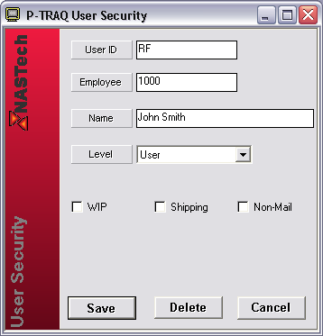

All P-TRAQ client users will require set-up in this program to define their security level, and this can be done at any time prior to them accessing the program. The user who will be doing the initial set-up of the warehouses and racks should be entered into this program at this time and will require a security level of super user. Enter the user’s Windows User ID, select “Super User” from the drop-down list provided, and click the Save button.
WipTrack.ini

There are some basic system parameters that need to be set up on the server at this time.

Open WipTrack.ini in the PTRAQ\Shared\Init directory and edit the following parameters as described in the following:

(Additional parameters may be edited in the file at a later time. These parameters are described in the Initialization File section of this guide.)

Parameter | Default | Description
Company Name |  | The name of your company which will appear on the top of Facility level maps and on system reports.  Example: CompanyName = “ABC Printing”
Company | 1 | Internal Company number.  Example: Company = 1
Division | 1 | The division number. Used when there are multiple divisions in your company.  Example: Division = 1
Loc Format |  | The format for rack locations at your facility.  Example: Loc Format = "WWZ-BBB-L"  W – warehouse, Z – zone (rack),  B – Bay (across), L – Level (up)
Bay Type | Numeric | Sets the horizontal counting method for rack locations as numeric or alphabetic.  Example: Bay Type = Numeric
Level Type | Alpha | Sets the vertical counting method for rack levels as numeric or alphabetic.  Example: Bay Type = Alphabetic

Server SQL Setup
- Install Microsoft SQL Server on P-TRAQ Server.
- Execute “Start…Programs…Microsoft SQL Server…Query Analyzer”.
- Open “PTRAQ\Shared\Database\PTRAQ.SQL”.
- Execute the SQL script to create PTRAQ database(s).
- Set permissions for P-TRAQ client computers.

Map Setup

Map Creation
The P-TRAQ system contains a host of geographical maps including a world map, all of the continents, and some countries. Prior to installation, NASTech personnel will provide the geographical maps where all of your facilities are located.

NASTech personnel will also provide maps of your actual facilities once the required floor plans or blueprints have been made available. This will also be done prior to installation.

Physical changes made to any facility must also be reflected in new images, and new Warehouse Level Map images must also be made available when applicable.

NASTech personnel will assist with map images as per the maintenance agreement.

To add or change maps locally, use an image editor that can export images in Enhanced Metafile (.emf) format.

Facility Level and Warehouse Level maps must be drawn to scale. As an example, for a facility measuring 1000 feet by 1000 feet, the exported file’s properties should be 1000 pixels wide by 1000 pixels high.

Map Database
Before viewing your facility with P-TRAQ, you MUST add the associated map image(s) to the Map Database. The map database can be edited using Microsoft Access or Microsoft SQL.

With MS Access, map entries are located in the Map Def table of the PTRAQ.mdb database located on the server in the C:\PTRAQ\Shared\Database directory.

With SQL, map entries are located in the Map Def table of the PTRAQ database located on the SQL server.

Before adding the maps to the database, designate a map code to describe all of the warehouses in your plant. For example, “Warehouse 1” may be referred to as WH1.

The following example shows the map hierarchy of a facility located in New York City:

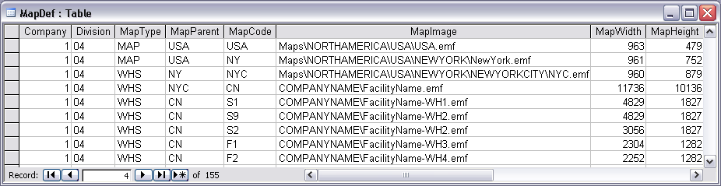

When adding a Facility Level or Warehouse Level map to the table, add “WHS” as the MapType, add the city or state where the facility is located as the MapParent, add the distinguishable code for the map, add the path to the actual image in the MapImage field, and add the MapWidth and MapHeight in pixels of the actual image.

NASTech personnel will provide the MapWidth and MapHeight entries on any maps provided by us.

Once the map has been added to the database, you may link to it when adding Markers as described on the Markers section of this guide.

WipTrack.ini
Before viewing your facility with P-TRAQ, you MUST add the associated map image(s) to the WipTrack.ini file located in the PTRAQ\Shared\Init directory on the server.

This file can be edited with a typical text editor such as Microsoft Windows Notepad as in the following example:

The following example shows the map hierarchy of a facility located in Los Angeles California:

Node Name = "Map View"
Node Name = "~USA", "MAP", "USA"
Node Name = "~~California","MAP", "CA"
Node Name = "~~~Los Angeles Printing","MAP", "SDP"
Node Name = "~~~~WH #1 (WH1)", "WHS", "WH1"
Node Name = "~~~~WH #2 (WH2)", "WHS", "WH2"

Client Installation
- Execute PTRAQ_Client.exe from the PTRAQ\Install directory on the file server.
- Follow the directions on the screen to set up P-TRAQ. Install the software in the C:\Program Files directory.
- Open the “System.ini” file located in the C:\Program Files\PTRAQ directory. Edit and save the file as follows:
- Init Path = "Init"
- Local Base Path = "C:\Program Files\PTRAQ"
- Network Base Path = "YourServerIPaddress\PTRAQ"
- DBTYPE = "SQL"

Client SQL Setup
- Create ODBC Data Source Name (DSN) called PTRAQ for new PTRAQ SQL Server database.
- Start - Settings - Control Panel - Administrative Tools - Data Sources - ODBC
- Click “Add”. Select SQL Server, Click “Finish”.
- Name database (PTRAQ), and select the PTRAQ Server.
- NT or SQL authentication? It is recommended that NT authentication is used. If so, the NT password setup on the computer will allow access to the SQL database.
- NT or SQL authentication? If SQL authentication is used, the following lines of code MUST be added to the C:/ProgramFiles/PTRAQ-Client/System.ini file:
- DB Name = PTRAQ
- Database = PTRAQ
- User Name = your computer’s User Name
- Password = your SQL Password
- Click “Change Default DB to”, Select PTRAQ Database, Click Next.
- Test the connection and click OK.

Start P-TRAQ Client
- Go to Start Menu → Programs → PTRAQ-Client Module → SysUpd, right-click the SysUpd icon and select Properties. Edit and save the shortcut as follows:
- Target: YourServer/PTRAQ/Shared/SysUpd.exe
- Start In: C:/Program Files/PTRAQ/
- Run Start Menu → Programs → PTRAQ-Client Module → SysUpd and click the Update button.

Shortcuts
- You should also create a folder on the desktop called P-TRAQ. Add the following to the folder:
- Shortcut to C:\Program Files\PTRAQ
- Shortcut to our Website which is www.nastechinc.com
- Shortcut to a new file called "Password.txt" (Create this file, add the following text, and save):
- Username = yourcompanyname (all lowercase)
- Password = support
- Let the users know that our UserGuide is available for viewing online. If you open it online versus downloading it, the MS Word document contains hyperlinks in the Table of Contents.

Software Updates
Customers will be notified by email when software updates are available for download. It is recommended that you update the software within a reasonable time frame as to avoid redundant support issues.

The P-TRAQ support page on our website always contains the latest updates, as well as version specific information relating to each updated program. Check our support pages periodically for additional information.

Manual Updates

Manual Updates to the software are handled as follows:
- Delete all files from the C:\PTRAQ\Shared\SoftwareUpdate directory on the server.
- Download SoftUpd.zip from the following link:
- http://www.nastechinc.com/SoftwareRelease/PTRAQ/SoftUpd.zip
- Save the .zip file to the C:\TRAQ\Shared\SoftwareUpdate directory on the server.
- Unzip the downloaded file and save its contents to the C:\PTRAQ\Shared\SoftwareUpdate directory on the server.
- Run Install.bat from the C:\PTRAQ\Shared\SoftwareUpdate directory on the server. Click the Continue button and wait for completion.
- Run DataComp.exe from the C:\PTRAQ\Shared directory on the server, and click the Continue button. If database field mismatches are present...
- Run the included Update.SQL script in SQL Query Analyzer, and run DataCopy.exe from the Start Menu at EACH client computer.
- SysUpd.exe: The updated files may be transferred and installed manually to each client computer by running the SysUpd.exe program at the associated computer.

Initialization Files
The following describes the initialization files in detail in cases where modifications are required. In each file, the parameters are divided into multiple sections as outlined. Upper and lower case may be used as desired with additional spacing for readability since all characters are converted to lower case and imbedded spaces are discarded prior to evaluation.

WipTrack.ini
[Constants]

Parameter | Default | Description
Company Name |  | The name of your company which will appear on the top of Facility level maps and on system reports.  Example: CompanyName = “ABC Printing”
Company | 1 | Internal Company number.  Example: Company = 1
Division | 1 | The division number. Used when there are multiple divisions in your company.  Example: Division = 1
Loc Format |  | The format for rack locations at your facility.  Example: Loc Format = "WWZ-BBB-L"  W – warehouse, Z – zone (rack),  B – Bay (across), L – Level (up)
Bay Type | Numeric | Sets the horizontal counting method for rack locations as numeric or alphabetic.  Example: Bay Type = Numeric
Level Type | Alphabetic | Sets the vertical counting method for rack levels as numeric or alphabetic.  Example: Bay Type = Alphabetic
Menu Width | 3600 | Sets the default tree view menu screen width.  Example: Menu Width = 3600 | **
Menu Hide | No | Defaults the tree view menu to the hidden position.  Example: Menu Hide = Yes | **
Rack Color Full | Dark Green | Sets the color to be used for full bays.  Example: Rack Color Full = RGB(0,98,17)
 |  |  | **
Rack Color Partial | Light Green | Sets the color to be used for partially full bays.  Example: Rack Color Partial = RGB(0,157,28)
Job Color Full | Blue | Sets the color to be used for bays containing the job as searched.  Example: Job Color Full = RGB(0,0,160)
Job Color Partial | Blue | Sets the color to be used for bays containing the job as searched.  Example: Job Color Partial = RGB(0,0,200)
Aging Color Full | Dark Brown | Sets the color to be used for bays containing dated pallets as searched.  Example: Aging Color Full = RGB(118,76,36)
Aging Color Partial | Light Brown | Sets the color to be used for bays containing dated pallets as searched.  Example: AgingColorPartial=RGB(187,166,146)

Database

This section is used to define the path to the database, and to define the IP Address and IP Post of the server PC.

Parameter | Default | Description
Data Path |  | Specifies the full path of the P-TRAQ database.  IE: DataPath = X:\PTRAQ\Shared\Database
Base IP Address |  | Specifies the network IP address of the server PC.  IE: BaseIpAddress = 000.000.000.000
Base IP Port |  | Specifies the port number to be used for communication with the server PC.  IE: BaseIPPort= 23

Company Tree

This section is used to define the nodes on the tree view. Included are the main nodes as defined by the system, and a hierarchy of maps to define warehouse locations within your company. The “~” denotes the level in the tree.

Parameter | Default | Description
Node Name | Maintenance | Main Maintenance node
Node Name | ~Pallet
Node Name | ~Vendor
Node Name | Inquiry | Main Inquiry node
Node Name | ~Job
Node Name | Reports
Node Name | ~Aging
Node Name | ~Creation
Node Name | ~Cycle Count
Node Name | ~Discard
Node Name | ~Job
Node Name | ~Job With Date Range
Node Name | ~Job With Comments Only
Node Name | ~Location
Node Name | ~Pallet History
Node Name | Purge | Main Purge node
Node Name | ~Inventory Purge
Node Name | ~Pallet Purge
Node Name | Map View | Main Map node
Node Name | ~World
Node Name | ~~North America
Node Name | ~~~USA
Node Name | ~~~~Wisconsin
Node Name | ~~~~~Facility1
Node Name | ~~~~~~Warehouse1
Node Name | ~~~~~~Warehouse2

Edit

This section is used to alter the data edit criteria of the system. The entries in this section consist of a Field Name followed by an equal sign, followed by a series of keywords and their associated values. The keyword and values sets are separated by semicolons. The use of spaces is optional.

Keyword | Default | Description
type | 1 | 0 = Display Only  1 = Alphabetic or Numeric  2 = Alphabetic  3 = Numeric (no decimal)  4 = Numeric (decimal allowed)  5 = Date  6 = Time  8 = Yes/No
minl | 1 | Minimum number of characters which may be entered.  Example: minl=3
maxl |  | Maximum number of characters which may be entered.  Example: maxl=8
optreq | R | “R” = required, entry is required.  “O” = optional, entry may be left blank.  When left blank, the value defined by the “default” is inserted as if it were keyed by the operator.  Example: optreq=o
default |  | Default value to be used if user leaves the entry blank. If the data is optional this entry is displayed automatically.  Example: Default=1
format |  | Formats the parameter to allow for leading zeros, or the elimination of leading zeros.  Example: format=00 (adds a leading zero to single digit number)  Example: format=#0 (removes leading zero from 2 digit number)
minv |  | Minimum numeric value which may be entered.  Example: minv=1
maxv |  | Maximum numeric value which may be entered.  Example: maxv=999
scaler | 2 | Maximum number of digits which may follow decimal point.  Example: scaler=2
pattern |  | A sequence of element size, type and constants. Multiple patterns are separated by commas. For example, a telephone number pattern might be: pattern=3N-4N, 3N-3N-4N
level | 1 | 0 = field may not be changed.  1 = field may only be changed when P-TRAQ is in STOP mode.  2 = field may be changed at any time. (Check with NASTech before using this feature).
valdat |  | Used to define the valid entries for a given parameter. Valid entries are separated by commas.  Example: valdat=a,b,c,d
Verify | No | Verifies the validity of the employee against the Employee table.  Example: verify=yes
The following describes the default edit criteria for each entry field. The last group defines the edit criteria for entry fields on the remote terminals. To alter the edit criteria, place the command in the Edit section of the Pressman.ini file. To force a 7 digit numeric job number, enter the following command.

Parameter | Default Edit Criteria
Zone Depth | "type=20; minl=8; maxl=8"

Chapter 4 Main Screen

Overview
To run the system, double-click the desktop P-TRAQ icon.

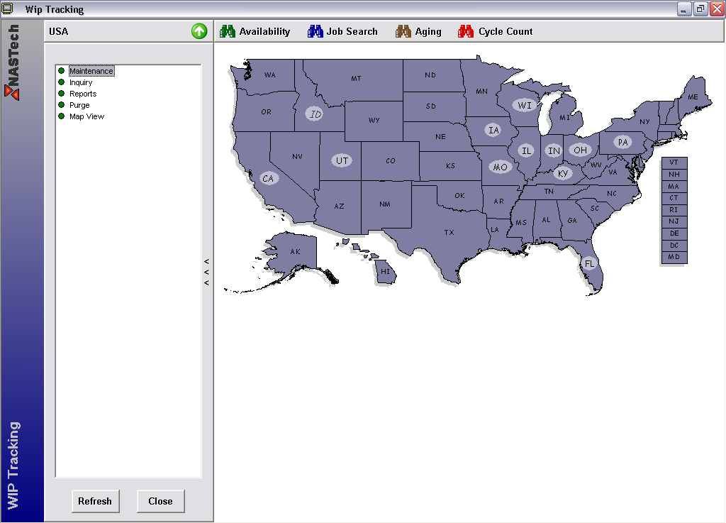

This is the main screen. The main screen contains a Toolbar, the Tree View and the Map View.

Each section of the screen is defined on the following pages of this chapter.

Toolbar
The Toolbar section of the screen contains the current map name, and buttons to control the various functions of the system.
Details
Map Name As in the above example, “USA” is the name of the currently viewed map.
Up Arrow Used to ascend up a level to the parent map if applicable.
Left Arrow Used to go back to the previous map.
Availability Turns on Availability mode (Default Mode)
Job Search Turns on Job Search Mode.
Aging Turns on Aging Mode.
Cycle Count Turns on Cycle Count Mode.

Tree View
The Tree View is used to select the Maintenance, Inquiry, and Report functions of the system, and to view a hierarchy of available maps.
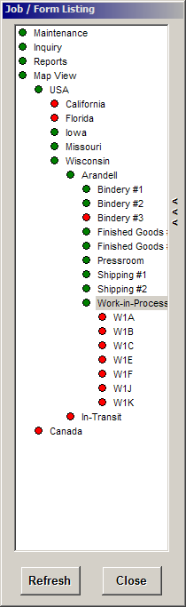
Details
Maintenance Used to access the Pallet and Vendor Maintenance screens.
Inquiry Used to access the Job inquiry functions.
Reports Used to access the Reports.
Map View Used to display the map hierarchy and to change the currently displayed map.
<<<, >>> Arrows are used to show or hide the Tree View.

Map View
The Map View displays the currently selected map.

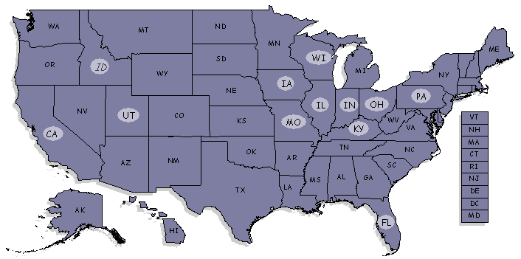 | 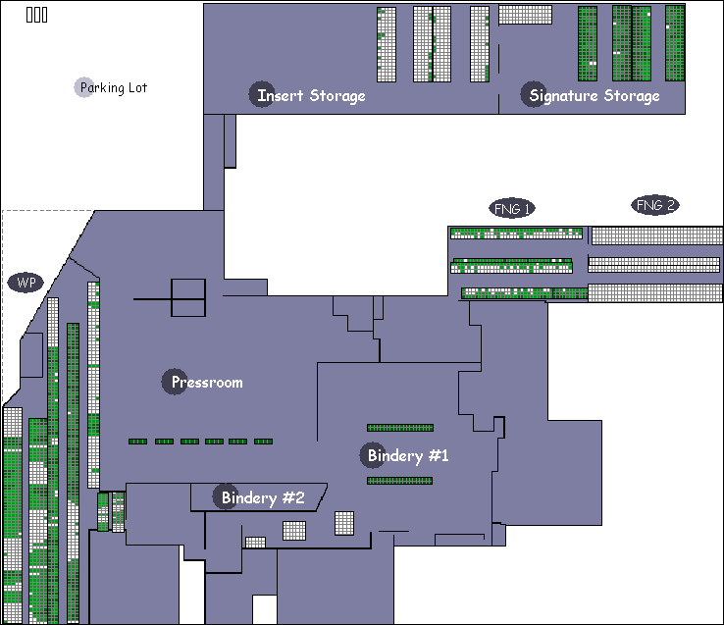
Fig 4.4a | Fig. 4.4b
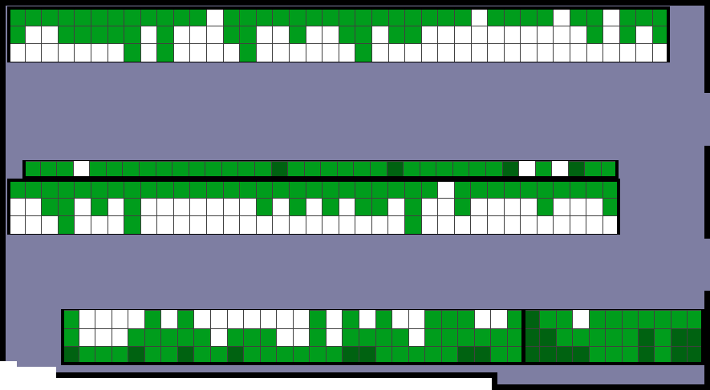 | 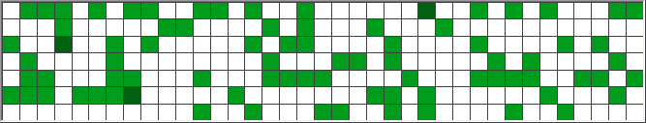
Fig 4.4c | Fig 4.4d
Details
Geographical Level Geographical Level Maps are used to display warehouse locations when multiple warehouses are available. Markers as shown in Fig 4.4a are used to link to subsequent geographical maps, or directly to Facility level maps.
Facility Level Facility Level Maps as shown in Fig 4.4b are drawn to scale and are displayed from top view. These maps contain both markers used to zoom in to warehouse levels, and clickable zones used to zoom in directly to a given zone.
Warehouse Level Warehouse Level Maps as shown in Fig 4.4c, also displayed from top view, contain clickable zones used to zoom in to the zone level maps.
Zone Level Zone Level Maps as shown in Fig 4.4d are displayed from left to right view and represent the view a person would have if they were standing in front of the zone and facing the zone.

Chapter 5 Markers
This chapter explains the procedures used to set up markers, and to draw zone locations within a given warehouse. Also included are procedures to draw rooms when warehouse additions or any other physical changes to your facility have been completed.

Markers (as shown in Fig 5.3a) are used to link to subsequent maps when viewing Geographical Level or Facility Level Maps. They can also be used to name a given city or an area of your facility without linking.

Markers are saved to the Map Marker table of the PTRAQ.mdb database.

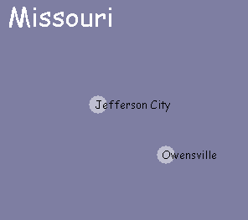
Fig 5.3a

When viewing a Geographical or Facility Level Map, right-click on the map to access the Marker dropdown menu.

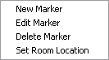
New Marker

Selecting the New Marker menu option opens the Map Marker Maintenance dialog box.

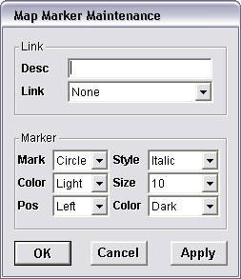

Desc The name of the Marker as it will be displayed on the screen.
Link Dropdown box to link the Marker to the map from the database.
Mark Dropdown used to select the shape of the Marker.
Color The Color of the Marker.
Pos The position of the Marker in relation to the Marker Description (center, left or right).
Style The style of the Marker Description font (regular, italic, bold or bold italic).
Size The size of the Marker Description font size.
Color The color of the Marker Description font color.
Edit Marker

Selecting the Edit Marker menu option opens the Map Marker Maintenance dialog box. This menu option is only available upon right-clicking an existing Marker.

Desc The name of the Marker as it will be displayed on the screen.
Link Dropdown box to link the Marker to the map from the database.
Mark Dropdown used to select the shape of the Marker.
Color The Color of the Marker.
Pos The position of the Marker in relation to the Marker Description (center, left or right).
Style The style of the Marker Description font (regular, italic, bold or bold italic).
Size The size of the Marker Description font size.
Color The color of the Marker Description font color.
Delete Marker

Selecting the Delete Marker menu option deletes the selected Marker. This menu option is only available upon clicking an existing Marker. A dialog box will be presented to verify the deletion.

Move Marker

To move a marker, hold down the CTRL key on the keyboard, then click and drag the Marker to its new location.

Set Room Location

The Set Room Location menu option is used to set the reference point of a given warehouse on the Facility Map.

This option is only available while viewing a Facility Level Map, and is only available upon right-clicking a Marker. After selecting this option, click in the top left-hand corner of the Warehouse on the associated Facility Map.

This should be performed prior to drawing any zones in the warehouse. If this is performed after zones have been added, the zones on the screen will be moved in relation to the new reference point.

Zones
Zones are the graphical representation of the actual storage racks for the pallets in a warehouse. When zones are displayed within the warehouse, the assumption is that the user is looking at the zone from the top.

Zones may only be created and edited while viewing a Warehouse Level Map only.

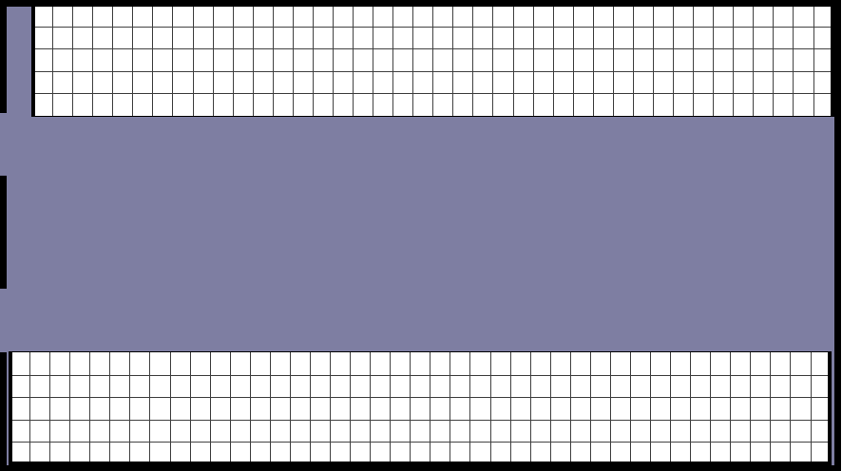
Fig 5.7a

To create a new Zone click on an area that does not currently contain a zone, hold the mouse button down, and drag the cursor to draw an outline of the new Zone as shown in Fig 5.7b.

The thick black lines surrounding ¾ of the existing zones as shown in Fig 5.7b are used to represent the rear and sides of the associated zone. By default, Zones will be drawn from the first rear bay extending outward left to right as if facing the zone.

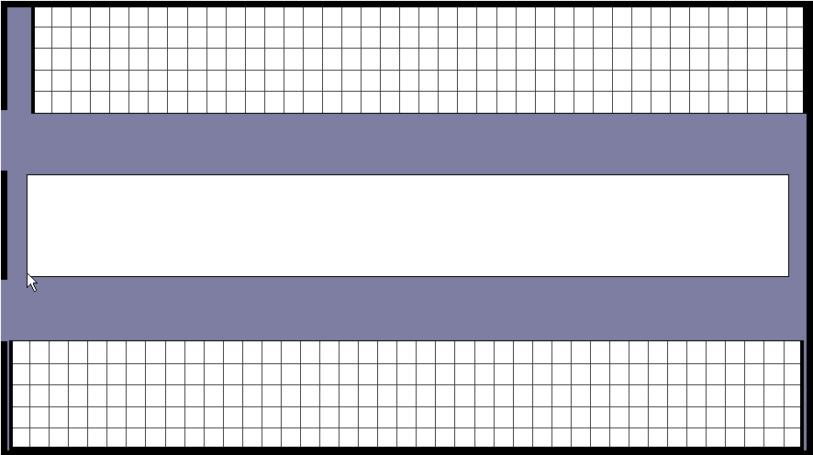
Fig 5.7b

Zone Maintenance
Once you release the mouse button the Zone Maintenance dialog box is displayed.

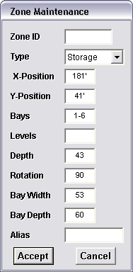

Zone ID The Zone ID number.
Type Dropdown list used to designate the zone as a Consumer, Shredder, Storage, or Vendor location. The consumer and shredder locations zero the quantity on the pallet. An example of a consumer location would be the bindery.
X-Position The horizontal position in the warehouse of the rear first bay.
Y-Position The vertical position in the warehouse of the rear first bay.
Bays The number of horizontal bays.
Levels The number of vertical levels.
Depth The number of pallets that can be stored in the bay.
Rotation Rotate the zone so it can represent the correct orientation within the warehouse.
Bay Width The horizontal size of the bay in inches.
Bay Depth The vertical size of the bay in inches.
Alias The alias is another name for the zone. This field is optional and gives you the ability to use a more familiar name for a special zone. Zones with an alias can only have one bay (horizontal) and one level (vertical).
Accept Creates the zone once all required fields have been updated.
Cancel Cancels the transaction.

Zone Menu
Right-Clicking an existing Zone on a Warehouse Level Map opens the Zone Menu.

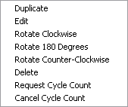

Duplicate Makes a copy of the selected Zone and opens the Zone Maintenance dialog box to make the necessary changes to the new Zone.
Edit Opens the Zone Maintenance dialog box to allow changes to be made to the selected Zone.
Rotate Clockwise Rotates the selected zone 90 degrees clockwise.
Rotate 180 Rotates the selected zone 180 degrees.
Rotate Counter Rotates the selected zone 90 degrees counter-clockwise.
Delete Deletes the selected zone. A dialog box will be presented to confirm the deletion.
Request Cycle Count Used to create a Cycle Count for the zone with today’s date.
Cancel Cycle Count Used to delete the Cycle Count that already exists for this zone.

Depth Maintenance
To change the depth of an existing zone location, click the bay location on a Zone Level Map, and select Depth Maintenance from the menu.

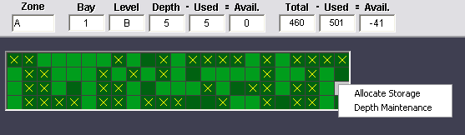

Selecting the Depth Maintenance option opens the Depth Maintenance Screen.

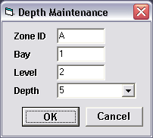

Select the Depth of the Zone from the dropdown list or enter an amount up to 99. If the zone can hold an unlimited amount, you can enter “-1” or choose “Unlimited” from the dropdown box. If the location is set to an unlimited depth, it will never show up as having an overflow condition. Click the OK button to complete.

Chapter 6 Toolbar
The Toolbar section of the screen contains the current map name, and buttons to control the various functions of the system.

Map Name
The Map Name section displays the name of the currently viewed map.
The Up Arrow is used to ascend up a level to the parent map if applicable.

Availability
The Availability button turns on Availability mode. When viewing Facility Level, Warehouse Level, or Zone Level Maps, the bays are colored using green and white to provide a graphical representation of bay availability.

Fig 6.1a

As shown in Fig 6.1a, bays colored in Dark Green represent full bays.

Bays colored in a Light Green color represent partially full bays.

Bays shown in white represent empty bays.

Job Search
The Job Search button turns on Job Search mode and expands the Job Toolbar to allow entry of the customer, job and/or part number that you want to search for.

After entering a Customer ID or a Job Number (and/or optional Part ID), the user can start the associated search by clicking the green arrow button. The red X button is used to cancel the search.

When viewing Facility Level, Warehouse Level, or Zone Level Maps, the bays are colored using blue and white to provide a graphical representation of the location of pallets for the associated job.

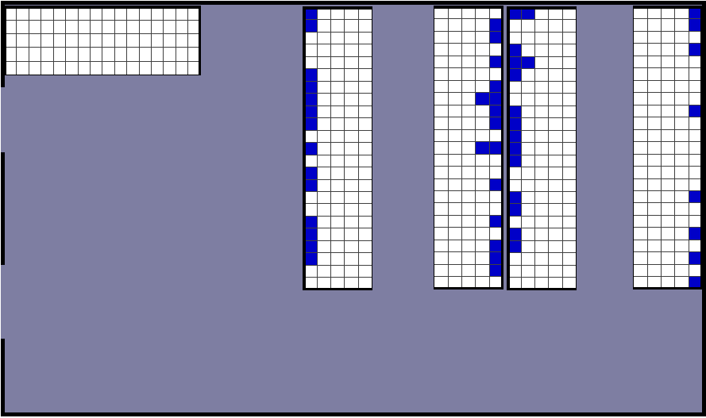
Fig 6.2a

As shown in Fig 6.2a, bays colored in Blue represent those bays that contain pallets for the associated job.

Aging
The Aging button turns on Aging mode and expands the Aging Toolbar to allow entry of the associated search parameters.

After selecting the search basis (Creation Date or Last Activity Date), and the age of the pallets, the user can start the associated search by clicking the green arrow button. The red X button is used to cancel the search.

When viewing Facility Level, Warehouse Level, or Zone Level Maps, the bays are colored using brown and white to provide a graphical representation of the location of the associated pallets.

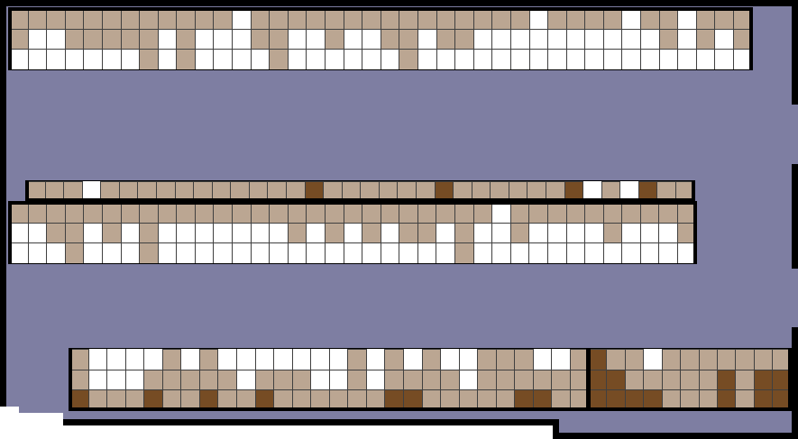
Fig 6.3a

As shown in Fig 6.3a, bays colored in Dark Brown represent bays full of pallets that fit the search criterion.

Bays colored in a Light Brown color represent bays partially full of pallets that fit the search criterion.

Bays shown in white represent those bays that do not contain pallets that fit the search criterion.

Cycle Count
The Cycle Count Button turns on Cycle Count Mode.

After clicking the Cycle Count Button the user can start the associated search by clicking the green arrow button. The red X button is used to cancel the search.

When viewing Facility Level, Warehouse Level, or Zone Level Maps, the bays are colored using red and white to provide a graphical representation of the bays that are marked for a cycle count.

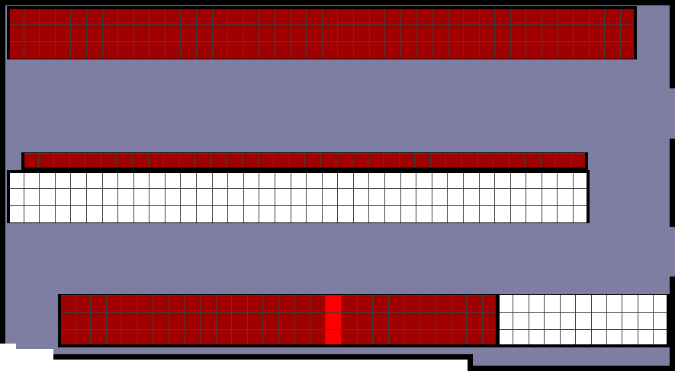
Fig 6.3a

As shown in Fig 6.3a, bays colored in Dark Red represent bays that are marked for a cycle count.

Bays colored in a Light Red color represent bays for which the cycle count procedure has been partially completed.

Bays colored in a White color represent bays for which the cycle count procedure has been fully completed.

Chapter 7 Tree View

Maintenance
The Maintenance Tree View Option allows you to add new or modify existing Pallets and Vendors.

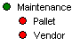

Pallet
Selecting the Pallet menu option opens the Pallet Maintenance screen.

When viewing an existing Pallet in the Zone Map, selecting this option will automatically fill in all fields from the database for subsequent editing. Otherwise, all fields will be blank.

If you enter an existing Pallet ID, the system will automatically fill in all fields for the associated Pallet from the database for editing. You may also enter a job number which will present a list of all Pallets for the associated Job for selection.

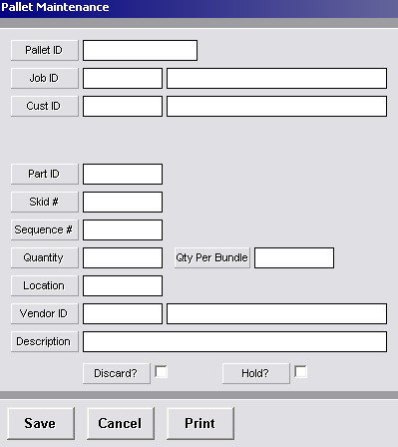
Hold? Checking this field will set the status of the pallet to “on hold”. Pallets marked as “on hold” will not be identified to the forklift driver as available.
Save Saves the associated record.
Cancel Cancels the addition or modification.
Print Prints the Pallet information.

Vendor
Selecting the Vendor menu option opens the Vendor Maintenance screen.

If you enter an existing Vendor ID, the system will automatically fill in all fields for the associated Vendor from the database for editing.

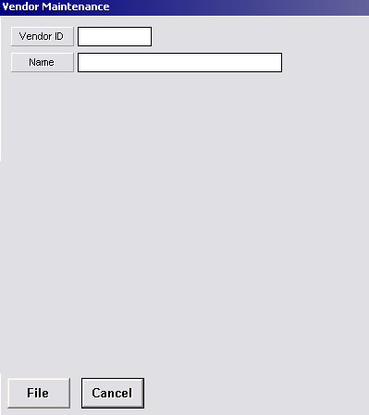

File Saves the associated record.
Cancel Cancels the addition or modification.

Inquiry
The Inquiry Tree View Option allows you to perform a Job Inquiry search.

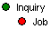

Job
Selecting the Job menu option expands the Job Heading to allow entry of the job number you wish to search for.

After entering a Customer ID, Job Number or optional Part ID, clicking the green arrow button starts the associated search. The red X button is used to cancel the inquiry.

Reports
The Inquiry Tree View Option allows you to perform a Job Inquiry search.

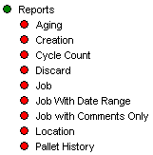

Aging
Selecting the Aging menu option opens the WIP Inventory Aging dialog box.

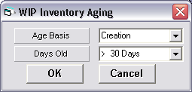

Age Basis Used to search for pallets by Creation date, or by the Last Transaction date.
Days Old Used to select the number of days to search.
OK Used to generate the report.
Cancel Used to cancel the report.

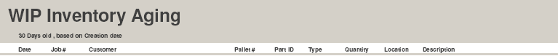

Date The Creation date of the pallet.
Job # The Job Number.
Customer The Customer Name.
Pallet # The Pallet Number.
Part ID The Part ID Number.
Type The Pallet Type.
Quantity The Quantity on the pallet.
Location The Location of the pallet.
Description The optional Description of the pallet.

Creation
Selecting the Creation Menu option opens the WIP Inventory by Creation Date Dialog box.

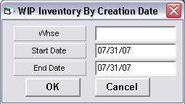

Whse The warehouse to search.
Start Date The Starting Date of the search. Clicking in this text field brings up a calendar. The user can click on a specific date on the calendar and the date will populate this field.
End Date The Ending Date of the search. Clicking in this text field brings up a calendar. The user can click on a specific date on the calendar and the date will populate this field.
OK Used to generate the report.
Cancel Used to cancel the report.
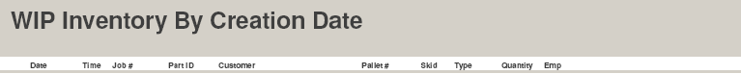

Date The Creation date of the pallet.
Time The Creation Time of the pallet.
Job # The Job Number.
Part ID The Part ID Number.
Customer The Customer Name.
Pallet # The Pallet Number.
Skid The Skid Number.
Type The Pallet Type.
Quantity The Quantity on the pallet.
Emp The Employee Number.

Cycle Count
Selecting the Cycle Count Menu option opens the Cycle Count Dialog box.

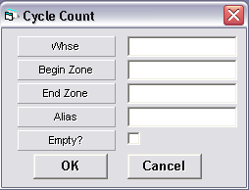

Whse The warehouse to search.
Begin Zone The Starting Zone.
End Zone The Ending Zone of the search.
Alias Another name for the given zone.
Empty? Allows empty bay locations to be displayed on the report.
OK Used to generate the report.
Cancel Used to cancel the report.
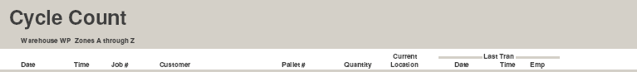

Date The Date the Cycle Count was completed.
Time The Time the Cycle Count was completed.
Job # The Job Number.
Customer The Customer Name.
Pallet # The Pallet Number.
Quantity The Quantity on the pallet.
Location The Location of the pallet.
Date The Last Transaction Date of the pallet.
Time The Last Transaction Time of the pallet.
Emp The Employee Number who completed the last transaction.

Job
Selecting the Job Menu option opens the WIP Inventory by Job Dialog box.

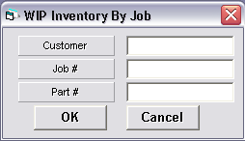

Customer The Customer Number.
Job # The Job Number.
Part # The Part Number.
OK Used to generate the report.
Cancel Used to cancel the report.
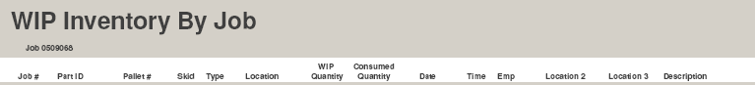

Job # The Job Number.
Part ID The Customer Name.
Pallet # The Pallet Number.
Skid The Skid Number.
Type The Pallet Type.
Location The Location of the job’s pallet.
Pallet # The Pallet Number.
WIP Quantity The Quantity on the pallet.
Consumed Quant. The Consumed Quantity.
Date The Date the pallet was created.
Time The Time the pallet was created.
Emp The Employee Number who completed the last transaction.
Location 2 The second Location.
Location 3 The third Location.
Description The optional Description of the pallet

Job With Date Range
Selecting the Job With Date Range Menu option opens the WIP Inventory by Job With Date Range Dialog box.

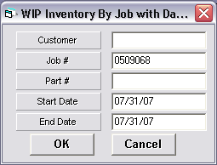

Customer The Customer Name.
Job # The Job Number.
Part # The Part Number.
Start Date The Starting Date of the search. Clicking in this text field brings up a calendar. The user can click on a specific date on the calendar and the date will populate this field.
End Date The Ending Date of the search. Clicking in this text field brings up a calendar. The user can click on a specific date on the calendar and the date will populate this field.
OK Used to generate the report.
Cancel Used to cancel the report.

Job # The Job Number.
Part ID The Customer Name.
Pallet # The Pallet Number.
Skid The Skid Number.
Type The Pallet Type.
Location The Location of the job’s pallet.
Pallet # The Pallet Number.
WIP Quantity The Quantity on the pallet.
Consumed Quant. The Consumed Quantity.
Date The Date the pallet was created.
Time The Time the pallet was created.
Emp The Employee Number who completed the last transaction.
Location 2 The second Location.
Location 3 The third Location.
Description The optional Description of the pallet

Job With Comments
Selecting the Job With Comments Menu option opens the WIP Inventory by Job With Comments Dialog box.

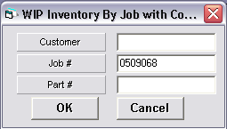

Customer The Customer Name.
Job # The Job Number.
Part # The Part Number.
OK Used to generate the report.
Cancel Used to cancel the report.

Job # The Job Number.
Part ID The Customer Name.
Pallet # The Pallet Number.
Skid The Skid Number.
Type The Pallet Type.
Location The Location of the job’s pallet.
Pallet # The Pallet Number.
WIP Quantity The Quantity on the pallet.
Consumed Quant. The Consumed Quantity.
Date The Date the pallet was created.
Time The Time the pallet was created.
Emp The Employee Number who completed the last transaction.
Location 2 The location of the pallet previous to its current location.
Location 3 The location of the pallet, previous to location 2.
Description The optional Description of the pallet.

Location
Selecting the Location Menu option opens the WIP Inventory by Location Dialog box.

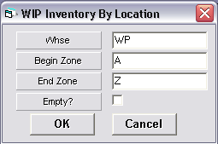

Whse The Warehouse to search.
Begin Zone The Starting Zone.
End Zone The Ending Zone of the search.
Empty? Allows empty bay locations to be shown on the report.
OK Used to generate the report.
Cancel Used to cancel the report.
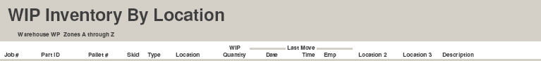

Job # The Job Number.
Part ID The Customer Name.
Pallet # The Pallet Number.
Skid The Skid Number.
Type The Pallet Type.
Location The Location of the job’s pallet.
WIP Quantity The Quantity on the pallet.
Consumed Quant. The Consumed Quantity.
Date The Date the pallet was created.
Time The Time the pallet was created.
Emp The Employee Number who completed the last transaction.
Location 2 The location of the pallet previous to its current location.
Location 3 The location of the pallet, previous to location 2.
Description The optional Description of the pallet.

History
Selecting the History Menu option opens the WIP pallet History Dialog box.

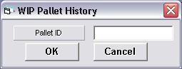

Pallet ID The Pallet ID.
OK Used to generate the report.
Cancel Used to cancel the report.

Job # The Job Number.
Part ID The Part Number.
Skid The Skid Number.
Date The Date the pallet was created.
Time The Time the pallet was created.
Quantity The Quantity on the pallet.
Location The Location of the pallet.
Emp The Employee Number who completed the last transaction.
Description The optional Description of the pallet.

Chapter 8 Map View
The Map View displays the currently selected map. The following explains the procedures used to navigate the Map View.

Geographical Level
Geographical Level Maps as shown in Fig 8.1a are used to display warehouse locations when multiple warehouses are available. Markers are used to link to subsequent geographical maps, or directly to Facility level maps.

Fig 8.1a

Facility Level
Facility Level Maps as shown in Fig 8.1b are drawn to scale and are displayed from top view. These maps contain both markers used to zoom in to warehouse levels, and clickable zones used to zoom in directly to a given zone.

Fig 8.1b

Right-Clicking on a given point on a Facility Level map displays the Marker Menu as described in the Screen Setup chapter of this guide.

Warehouse Level
Warehouse Level Maps as shown is Fig 8.2a are also displayed from top view, contain clickable zones used to zoom in to the zone level maps.

Fig 8.2a

Procedures

Clicking and dragging from a given point on a Warehouse Level map allows a new zone to be drawn as described in the Screen Setup chapter of this guide.

Right-Clicking an existing zone opens the Zone Menu as described in the Screen Setup chapter of this guide.

Clicking an existing zone while holding the CTRL key allows an existing zone to be relocated within the warehouse (as described in the Screen Setup chapter of this guide).

Right-Clicking an area of the warehouse that does not currently contain a zone opens the Cycle Count Menu.

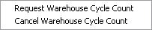

Request Cycle Count
The Request Warehouse Cycle Count Menu option is used to request a cycle count for the entire warehouse. Requesting a Cycle count must be done before forklift operators are asked to do a cycle count in the warehouse. The forklift operator will use the RF function called “Cycle Count” to complete the cycle count for each location in the warehouse.

Cancel Cycle Count
The Cancel Warehouse Cycle Count Menu option is used to cancel the Cycle Count request.

Zone Info
Moving the mouse over an existing column of bays expands the toolbar to display the Zone Info toolbar.

Zone ID The alphabetical Zone location.
X-Pos The Horizontal position of the top left corner of the Zone as it relates to the warehouse.
Y-Pos The Vertical position of the top left corner of the Zone as it relates to the warehouse.
Bays The number of Bays wide.
Levels The number of Bays tall.
Depth The number pallets that can be stored in the Bay location.
Rotate The position of the top left corner of the Zone as it relates to the upper left corner of the warehouse.
Bay The current Bay location under the mouse.
Alias Another name for the Bay location.

Zone Level
Zone Level Maps as shown in Fig 8.4a are displayed from left to right view as if standing in front of the Zone.

Fig 8.4a

Procedures

Clicking on a bay location displays the Bay Maintenance Menu.

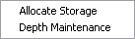

Right Clicking on a bay location displays the Bay Info Menu.

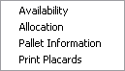

Allocate Storage
Used to allocate storage to a certain job and part ID. When pallets are ready to be stored for the job and part ID, one of the locations allocated will display on the RF screen as a recommended storage location for the pallet. Pallets from other jobs or part ID’s will not be denied storage in the location. The allocated storage location is just a recommended location in order for warehouse management to organize jobs in the warehouse.

Depth Maintenance
The Depth Maintenance menu option is used to set a new depth of the bay location. This overrides the number set for the associated Bay Location as it relates to the entire Zone. The depth can be set to zero, any number or the word, “Unlimited”. Setting the depth to unlimited is used to stop the zone display from showing an overflowing location. This is useful when the amount of space in the location can not be determined or is unimportant. A pallet can be moved to a location that shows on the zone display to be overflowing but physically has space. Therefore, the depth of a location is used for informational purposes only and not as a limitation.

Availability
The Availability menu option is used to view the Zone in Availability Mode.

Allocation
The Allocation menu option is used to view the Zone in Allocation Mode.

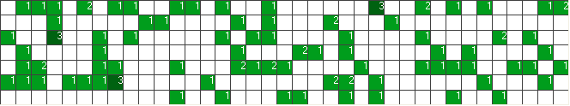

In Availability Mode, the numbers displayed represent the number of pallets in each Bay location.

In Job Search Mode, the numbers displayed represent the number of pallets for the associated job which are stored in the associated Bay location.

In Aging Mode, the numbers displayed represent the number of pallets that fit
the search criteria which are stored in the associated Bay location.

Bay Overload
When the number of pallets stored in a Bay Location in the database exceeds the maximum allowable number that can be stored in the physical location, the system will draw a yellow X through the Bay Location, as shown below.

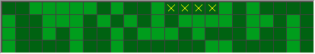

Print Placards
The Print Placards menu option displays the Print Placards Screen. Placards are used to identify Bay Locations. The Barcodes should be adhered to the actual Bay Location for scanning with the RF controller.

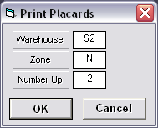

Warehouse The Warehouse.
Zone The Zone ID.
Number Up The number of copies to print.
OK Prints the Placards.
Cancel Cancels the request.

Once the required parameters have been entered, clicking the OK button prints the placards in PDF format.

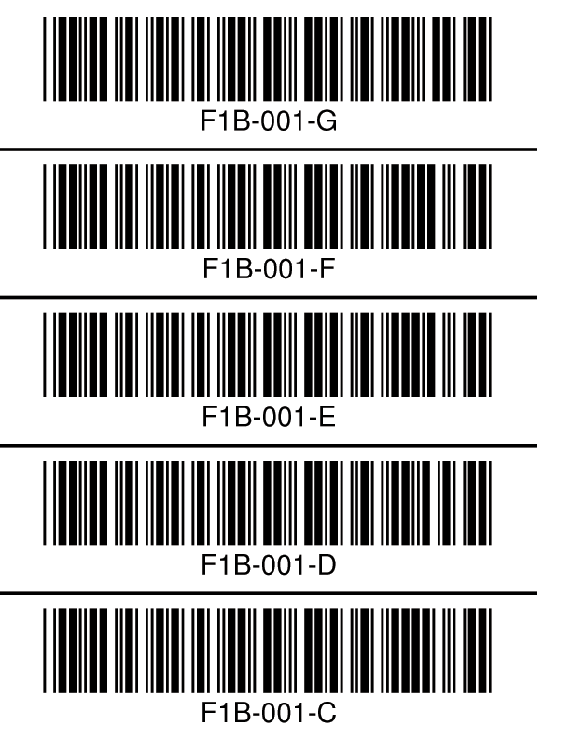

Pallet Information
The Pallet Information menu option displays the Pallet Information Screen.

The left side of the screen lists all the pallets stored in the associated Bay location.

The right side of the screen displays the pallet information of the currently selected pallet.

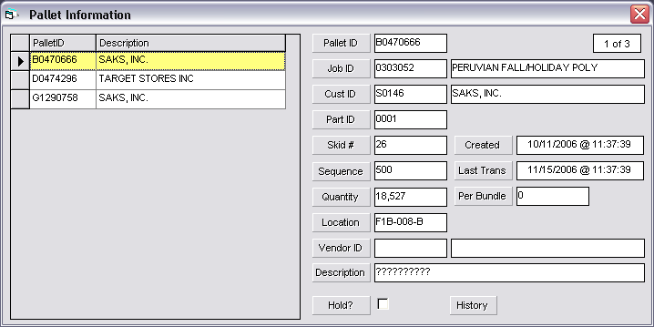

Pallet ID The Pallet ID.
Job ID The Job number and description.
Customer ID The Customer number and name.
Part ID The Part ID.
Skid # The Skid number and creation date.
Creation Date Date the pallet was created.
Sequence Used to identify the pallet’s sequence in production.
Last Trans Date the pallet was last moved or it’s quantity was changed.
Location The Bay location ID.
Vendor ID The Vendor number and name.
Description This is the description of the pallet. It is for reporting purposes.
Hold? Checking this field will set the status of the pallet to “on hold”. Pallets marked as “on hold” will not be identified to the forklift driver as available.
History Used to generate and view the pallet history report.

Chapter 9 Utilities

Overview
The P-TRAQ system contains several programs designed to perform system maintenance, to perform system updates, and to be used when P-TRAQ is to communicate with other systems. The following describes these programs in detail.

DataCopy
In some cases when the software is updated, new fields are added, deleted or changed in the P-TRAQ database. DataCopy is used to copy tables in the current database to the new tables in the updated database.

DataCopy should be executed on the server and on the whenever the current database structure has been modified. However, when using SQL server, Data Copy is not required to be run on the server.

To execute from the Server, double click the DataCopy.exe in the PTRAQ\Shared directory.
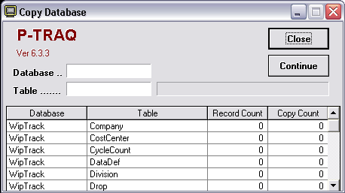

- To begin the copy process, click the Continue button.

DataLoad
Data Load is used to extract and transfer data from the Primac Master Files to the P-TRAQ database. The DataLoad download criterion is user defined in the DataLoad.ini file located in the C:\PTRAQ\Shared\Init directory on the server. The file itself contains a description of each required parameter.

To execute, double click the DataLoad.exe in the C:\PTRAQ\Shared directory on the server.

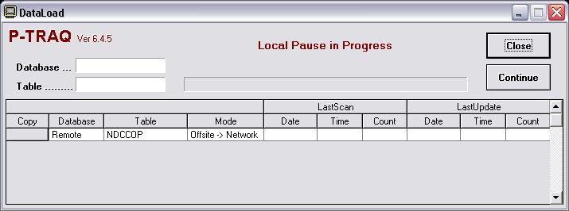

To begin the copy process, click the Continue button. To expedite the flow of data to and from the server, tables can be copied in real time by clicking the associated Copy button.

DataLoad should be left running on the server at all times, however, you may Schedule the task as outlined in the following:

Using Windows “Scheduled Tasks”, you may schedule DataLoad to run periodically. The following is the procedure to set up the task:

- Choose Start – ControlPanel – SheduledTasks
- Click “Add Scheduled Task”.
- Click “Next”.
- Click the “Browse” button and browse the server to the PTRAQ\Shared directory and select the DataLoad.exe file.
- Follow the instructions to select the time and enter the user name and password when prompted.
- Check the box marked “Open Advanced Properties for this Task when I click Finish” button and click the finish button.
- In the Run field, change the path to read exactly as in the following: C:\PTRAQ\Shared\DataLoad.exe AUTO
- In the Start In field, make sure the path is as following: C:\PTRAQ\Shared

SysUpd
SysUpd is used to copy the latest Programs for the server whenever a system update is performed.

To execute, double click the SysUpd icon on the Client Computer’s desktop.

To begin the update process, click the Update button.

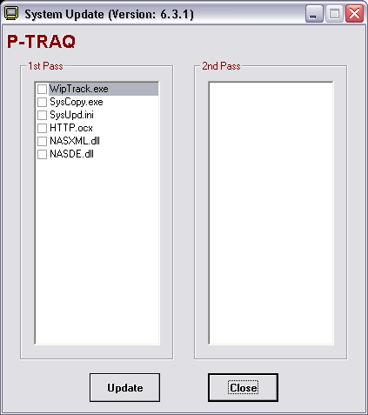

WIP_Security
User Security is used to set the security level or overall access of users of the system. This program is used for two distinct purposes. The first is to record the security level of P-TRAQ client users. The user ID pertains to the Windows user ID and the level dictates the amount of editing control the user has in the P-TRAQ program. The employee field is not accessible in this option. The second purpose of the program is to allow RF users to gain access to the WIP RF menu. In this situation, the user ID is always “RF” and the employee field must be entered with a valid employee ID. This employee ID is supplied by an outside system to the P-TRAQ database. After a valid employee ID is entered, the employee name will display in the name field, as verification of the employee ID. The level field is not used in this situation.

To execute, double click the WIP_Security.exe in the PTRAQ\Shared directory on the server.

User ID For Client software users, enter the Windows logon ID. For RF users, enter RF in this field.
Employee The Employee number of the RF user whose security level is to be modified. For Client software users, this field is not accessible.
Name The Employee name of the RF user is displayed here for verification purposes.
Level Used to select the security level as User, Manager, Admin, or Super User.
User Level An employee with User Level access can run reports, use the inquiry options, create and edit pallets.
Manager Level Manager Level employees can edit racks within a division, print placards and allocate racks to a job in addition to all other User Level Functions.
Admin Level Admin Level employees can create warehouses within a division in addition to all other Manager Level Functions.
Super User Level Super User Level employees can perform all system functions across all company-wide divisions.

WIP This check box is only used for RF users. Check the WIP box if the RF user can access the WIP RF menu.
Shipping This check box is only used for customers that have a custom addition to P-TRAQ.
Non-Mail This check box is only used for customers that have a custom addition to P-TRAQ.

Appendix A RF Controllers
While the P-TRAQ system supports most RF controllers on the market, please contact NASTech personnel before purchasing one to ensure compatibility.

Install
- Install as per the manufacturer’s instructions.

Connect
- The RF controller is typically connected to your PC using the serial port.

Configure
- The RF controller communicates to the P-TRAQ server computer over Ethernet port 50080.

Troubleshoot
- Ensure that the PC to which the controller is connected has access over the network to the P-TRAQ server computer.
- Ensure that the unit is connected properly to the PC’s serial port.

